基础软件开发技术实践智能软件工程实验报告
实验四 基于大语言模型的人类编写代码的代码审查

姓名 | 杨夕 | 院系 | 软件学院
学号 | 2023113078 | 任课教师 | 刘佳琨
指导教师 | 刘佳琨 | 实验地点 | 格物213
实验时间 | 7.3
实验得分 |  | 研讨得分
报告得分 |  | 实验总分

一、实验目的

1. 理解大语言模型在代码审查任务中的应用原理。
2. 掌握 Prompt Engineering 的基本思想与设计方法。
3. 理解不同代码上下文对大语言模型性能的影响。
4. 能够利用大语言模型完成 Merge Prediction 任务。
5. 能够利用大语言模型自动生成代码审查意见。
6. 能够分析不同 Prompt 设计和上下文信息对代码审查结果的影响。

二、实验内容

- 配置好以下环境：
Python3.14：基本环境
Openai:调用deepseek-v4-pro
requests：调用 GitHub REST API
pandas：数据清洗与表格化存储
matplotlib/seaborn：数据可视化
tqdm：进度条展示，监控采集进度
- 配置Github Token与deepseek-v4-pro对应的api key
- 编写python脚本来实现基于大语言模型的代码审查，并将结果保存在csv文件中

三、实验结果

不同代码上下文构建样例：
- Context Type 1 — 仅包含 Diff：
Diff summary:
Modified files (1):
- src/utils/io.py
Additions: 4, Deletions: 2
Note: the dataset does not contain actual unified diff patches, so this summary uses file-level change metadata.
- Context Type 2 — Diff + PR 描述：
PR Description:
Fixes an issue where config files with explicit encoding caused JSON decode errors on Windows.
This PR updates file open call to include explicit encoding and adds a sanity check.
- Context Type 3 — Diff + Commit Message：
Commit Messages:
fix: open file with explicit utf-8 encoding
---
chore: add sanity check for missing keys
- Context Type 4 — Diff + PR 描述 + Commit Messages + 修改文件列表：
Diff summary: ...
PR Description: ...
Commit Messages: ...
Modified Files:
- src/utils/io.py
- tests/test_io.py

不同prompt构建样例：
Zero-shot Prompt：
You are a senior GitHub code reviewer.
Based on the provided pull request context, answer the following:
1. Merge Prediction: should this PR be merged? Answer Yes or No.
2. Review Comment: provide a concise, practical code review comment that explains strengths, issues, and improvement suggestions.
Include your reasoning in the response.
Use only the context below and do not invent extra facts.

Few-shot Prompt：
You are a senior GitHub reviewer. Learn from the examples and apply the same style.
For the new pull request, provide Merge Prediction and Review Comment.

Examples:
Context:
Diff summary:
- src/app.py
Additions: 15, Deletions: 2
PR Description:
Fixes a null pointer exception in the request handler.

Response:
Merge Prediction: Yes.
Review Comment: The change addresses the null pointer in the handler. Please add a unit test for the new branch and add a brief comment explaining the failure mode.

Context:
Diff summary:
- src/auth.py
Additions: 30, Deletions: 5
PR Description:
Improves authentication state handling.

Response:
Merge Prediction: No.
Review Comment: The logic change may break token refresh; missing tests and unclear error handling. Add regression tests and clarify token expiry handling.

Chain-of-Thought Prompt：
You are a senior GitHub code reviewer.
Based on the provided pull request context, think step by step and analyze the PR context before giving your answer.
1) List high-level intent from PR description and commits.
2) Point out risky code changes from the diff and why.
3) Provide a final Merge Prediction (Yes/No) with brief justification.
4) Provide concrete review comments and suggested fixes.

Role-based Prompt：
You are a meticulous senior engineer and reviewer with 10+ years experience in Python codebases.
Task:
- Provide a short Merge Prediction line: "Merge: Yes" or "Merge: No".
- Provide a bullet list of 3 concrete review items: each item should include (issue, severity, suggested fix).
- If tests are missing, explicitly list tests to add.

Python脚本运行截图：
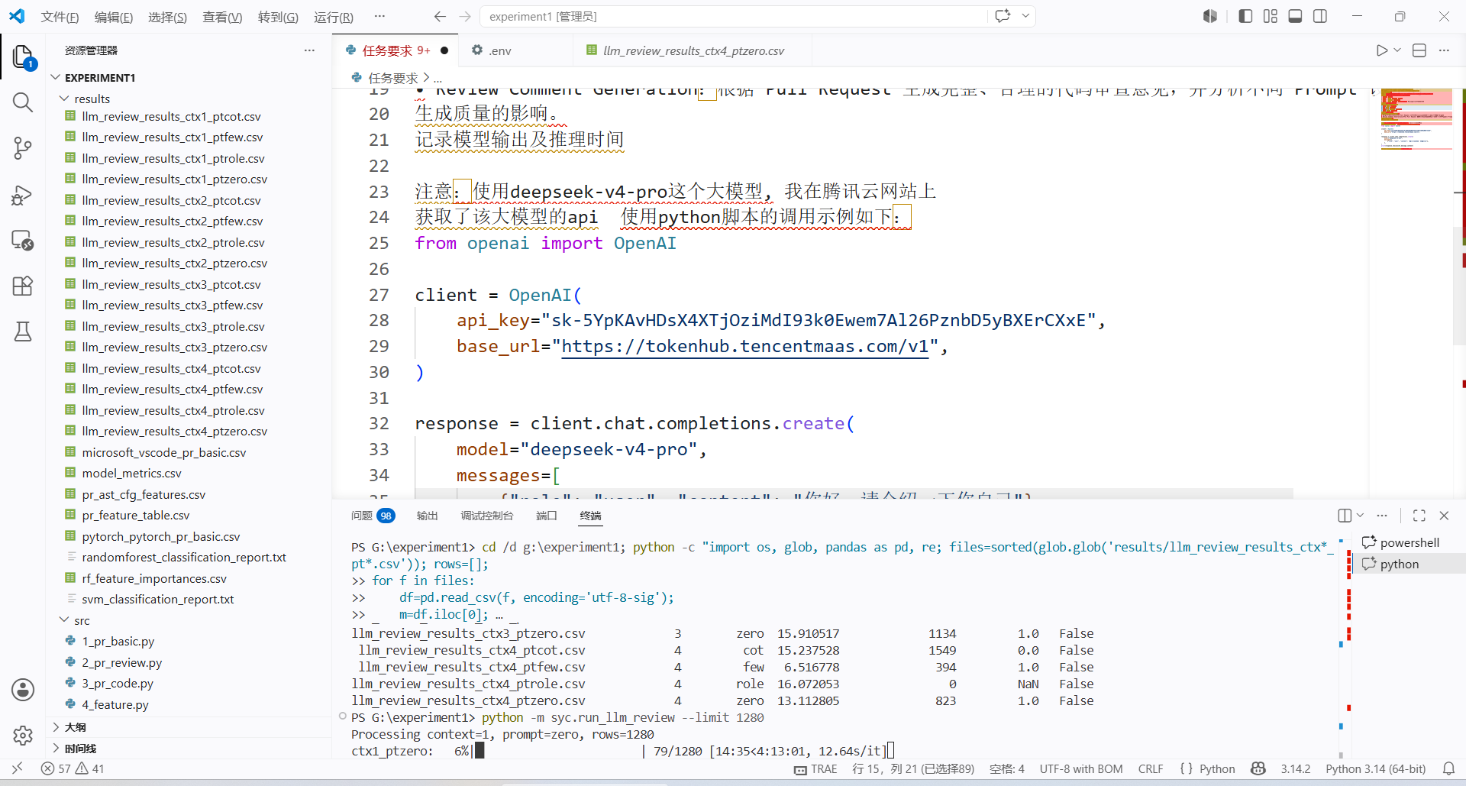
代码审查意见样例：
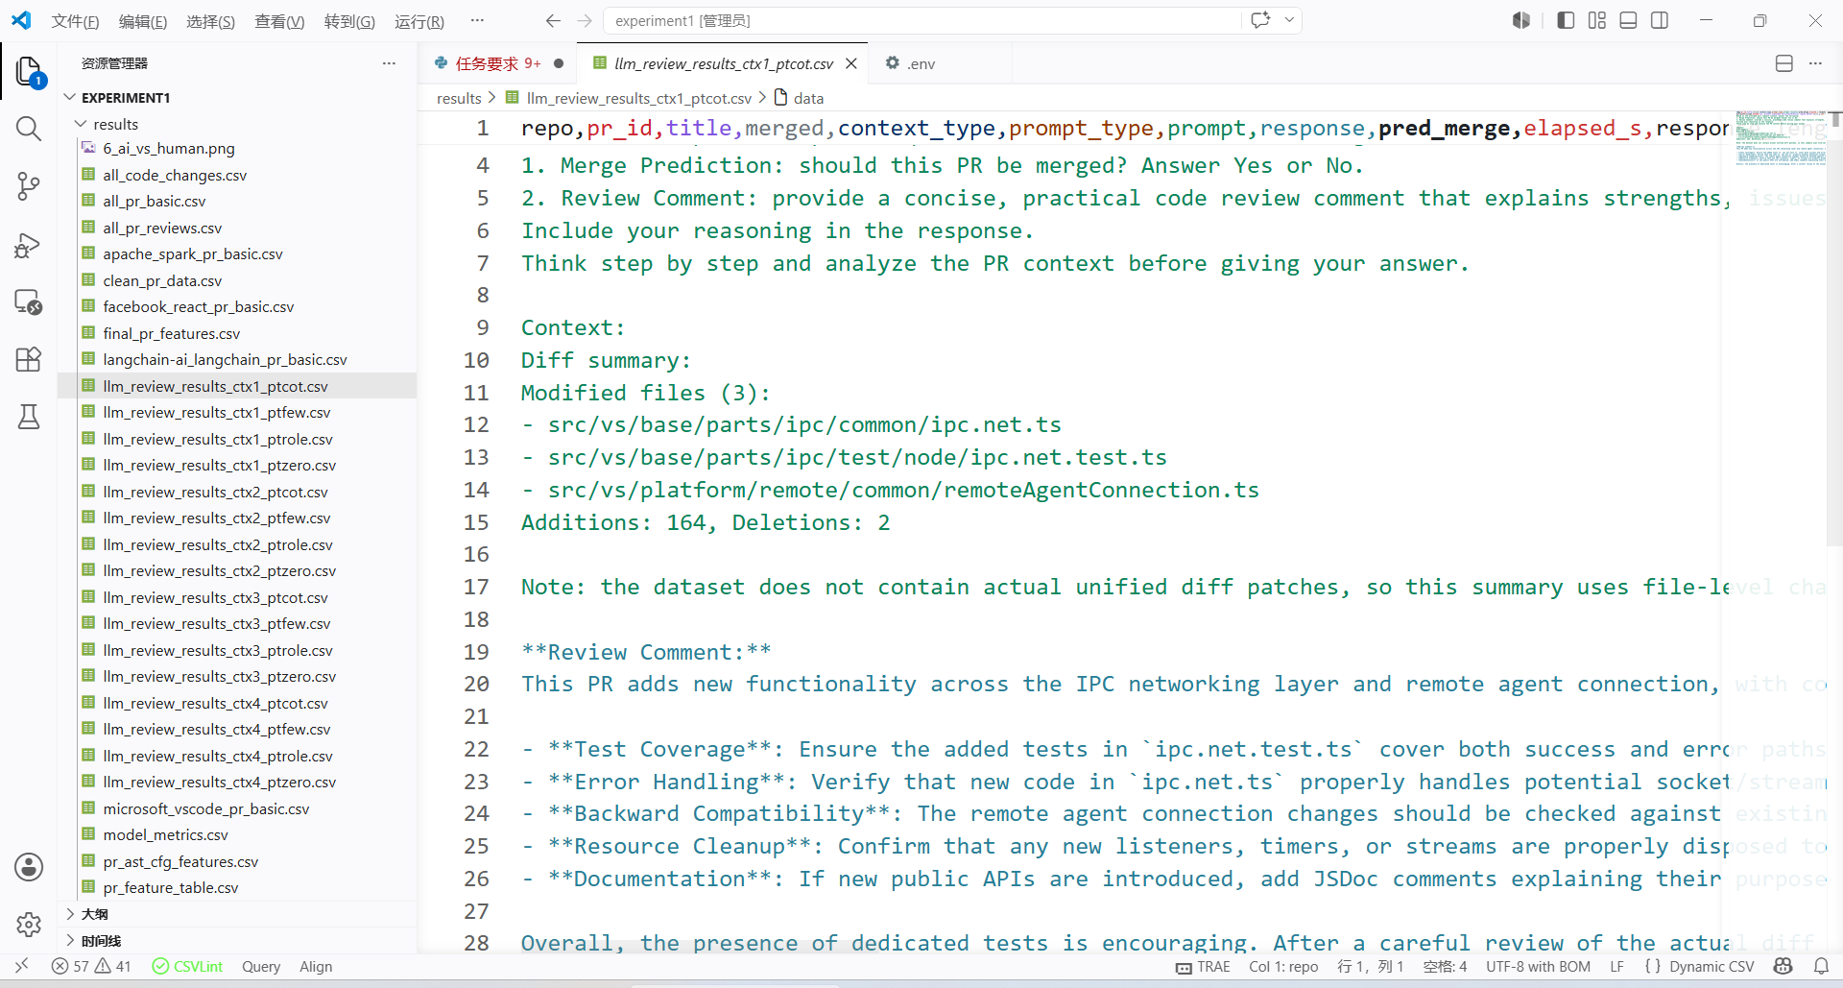

不同 Prompt与代码上下文设计性能比较：
性能概览：
1.延迟（观测）: 单次请求大致在 6–16 秒之间，响应越长通常越慢总体上 zero/few 较快，cot/role 较慢。
2.响应长度: cot 和 role 最长（常见 1k–2.4k 字符），few 与 zero 较短（约 300–800 字符）。
3.合并预测一致性: few-shot 更容易给出明确一致的 Merge 预测；zero 简洁但偶有模糊；cot 给出推理过程但预测有时不一致；role 有时很详尽但也出现空响应或格式异常。
审查意见质量: 上下文越丰富（类型4：Diff+PR描述+commits+文件列表），生成的审查意见越具体且实用；仅 Diff（类型1）能定位代码问题但缺背景，PR 描述（类型2）帮助判断高层意图，Commit messages（类型3）帮助判断意图/回归风险。
失败模式: 长 prompt（尤其 role/cot + 完整 diff）会遇到响应被截断或空响应，需要做截断/后处理；个别 prompt 与上下文组合会产生非结构化输出，需要解析容错逻辑。

四、实验中遇到的问题总结

要求：主要阐述实验过程中遇到的问题如何解决的。

要调用api得去申请对应的api key 最好是直接本地部署最方便

五、实验体会

脚本运行地太慢了 花了几个小时吧。。

指导教师评语：

日期：

