Process Mapping and Optimization Document

**1. Summary Analysis of Current Processes (As-Is Models)**

**1.1 Appointment Scheduling – As-Is**

**Steps:**  
1. Patient calls or visits to request appointment  
2. Admin checks availability manually  
3. Admin books appointment without conflict detection  
4. Patient receives confirmation (often delayed)

**Challenges Identified:**  
- Double bookings and scheduling conflicts due to lack of real-time system  
- No automated conflict detection  
- Delayed or missing appointment confirmations  
- Heavy manual workload on administrative staff

**1.2 Patient Check-In – As-Is**

**Steps:**  
1. Patient arrives and waits in queue  
2. Manual form filling  
3. Admin verifies details  
4. Patient waits until called for consultation

**Challenges Identified:**  
- Delays due to paper-based registration  
- Long verification queues  
- No real-time queue tracking  
- Patient dissatisfaction due to prolonged waiting

**1.3 Interdepartmental Communication – As-Is**

**Steps:**  
1. Admin identifies resource issue  
2. Sends manual email or walks over to IT  
3. Wait for acknowledgment  
4. Delay? (Yes/No decision)  
5. Resolution after follow-ups

**Challenges Identified:**  
- Poor coordination between departments  
- No centralized issue tracking  
- Delays in equipment/staff allocation  
- Repeated follow-ups needed

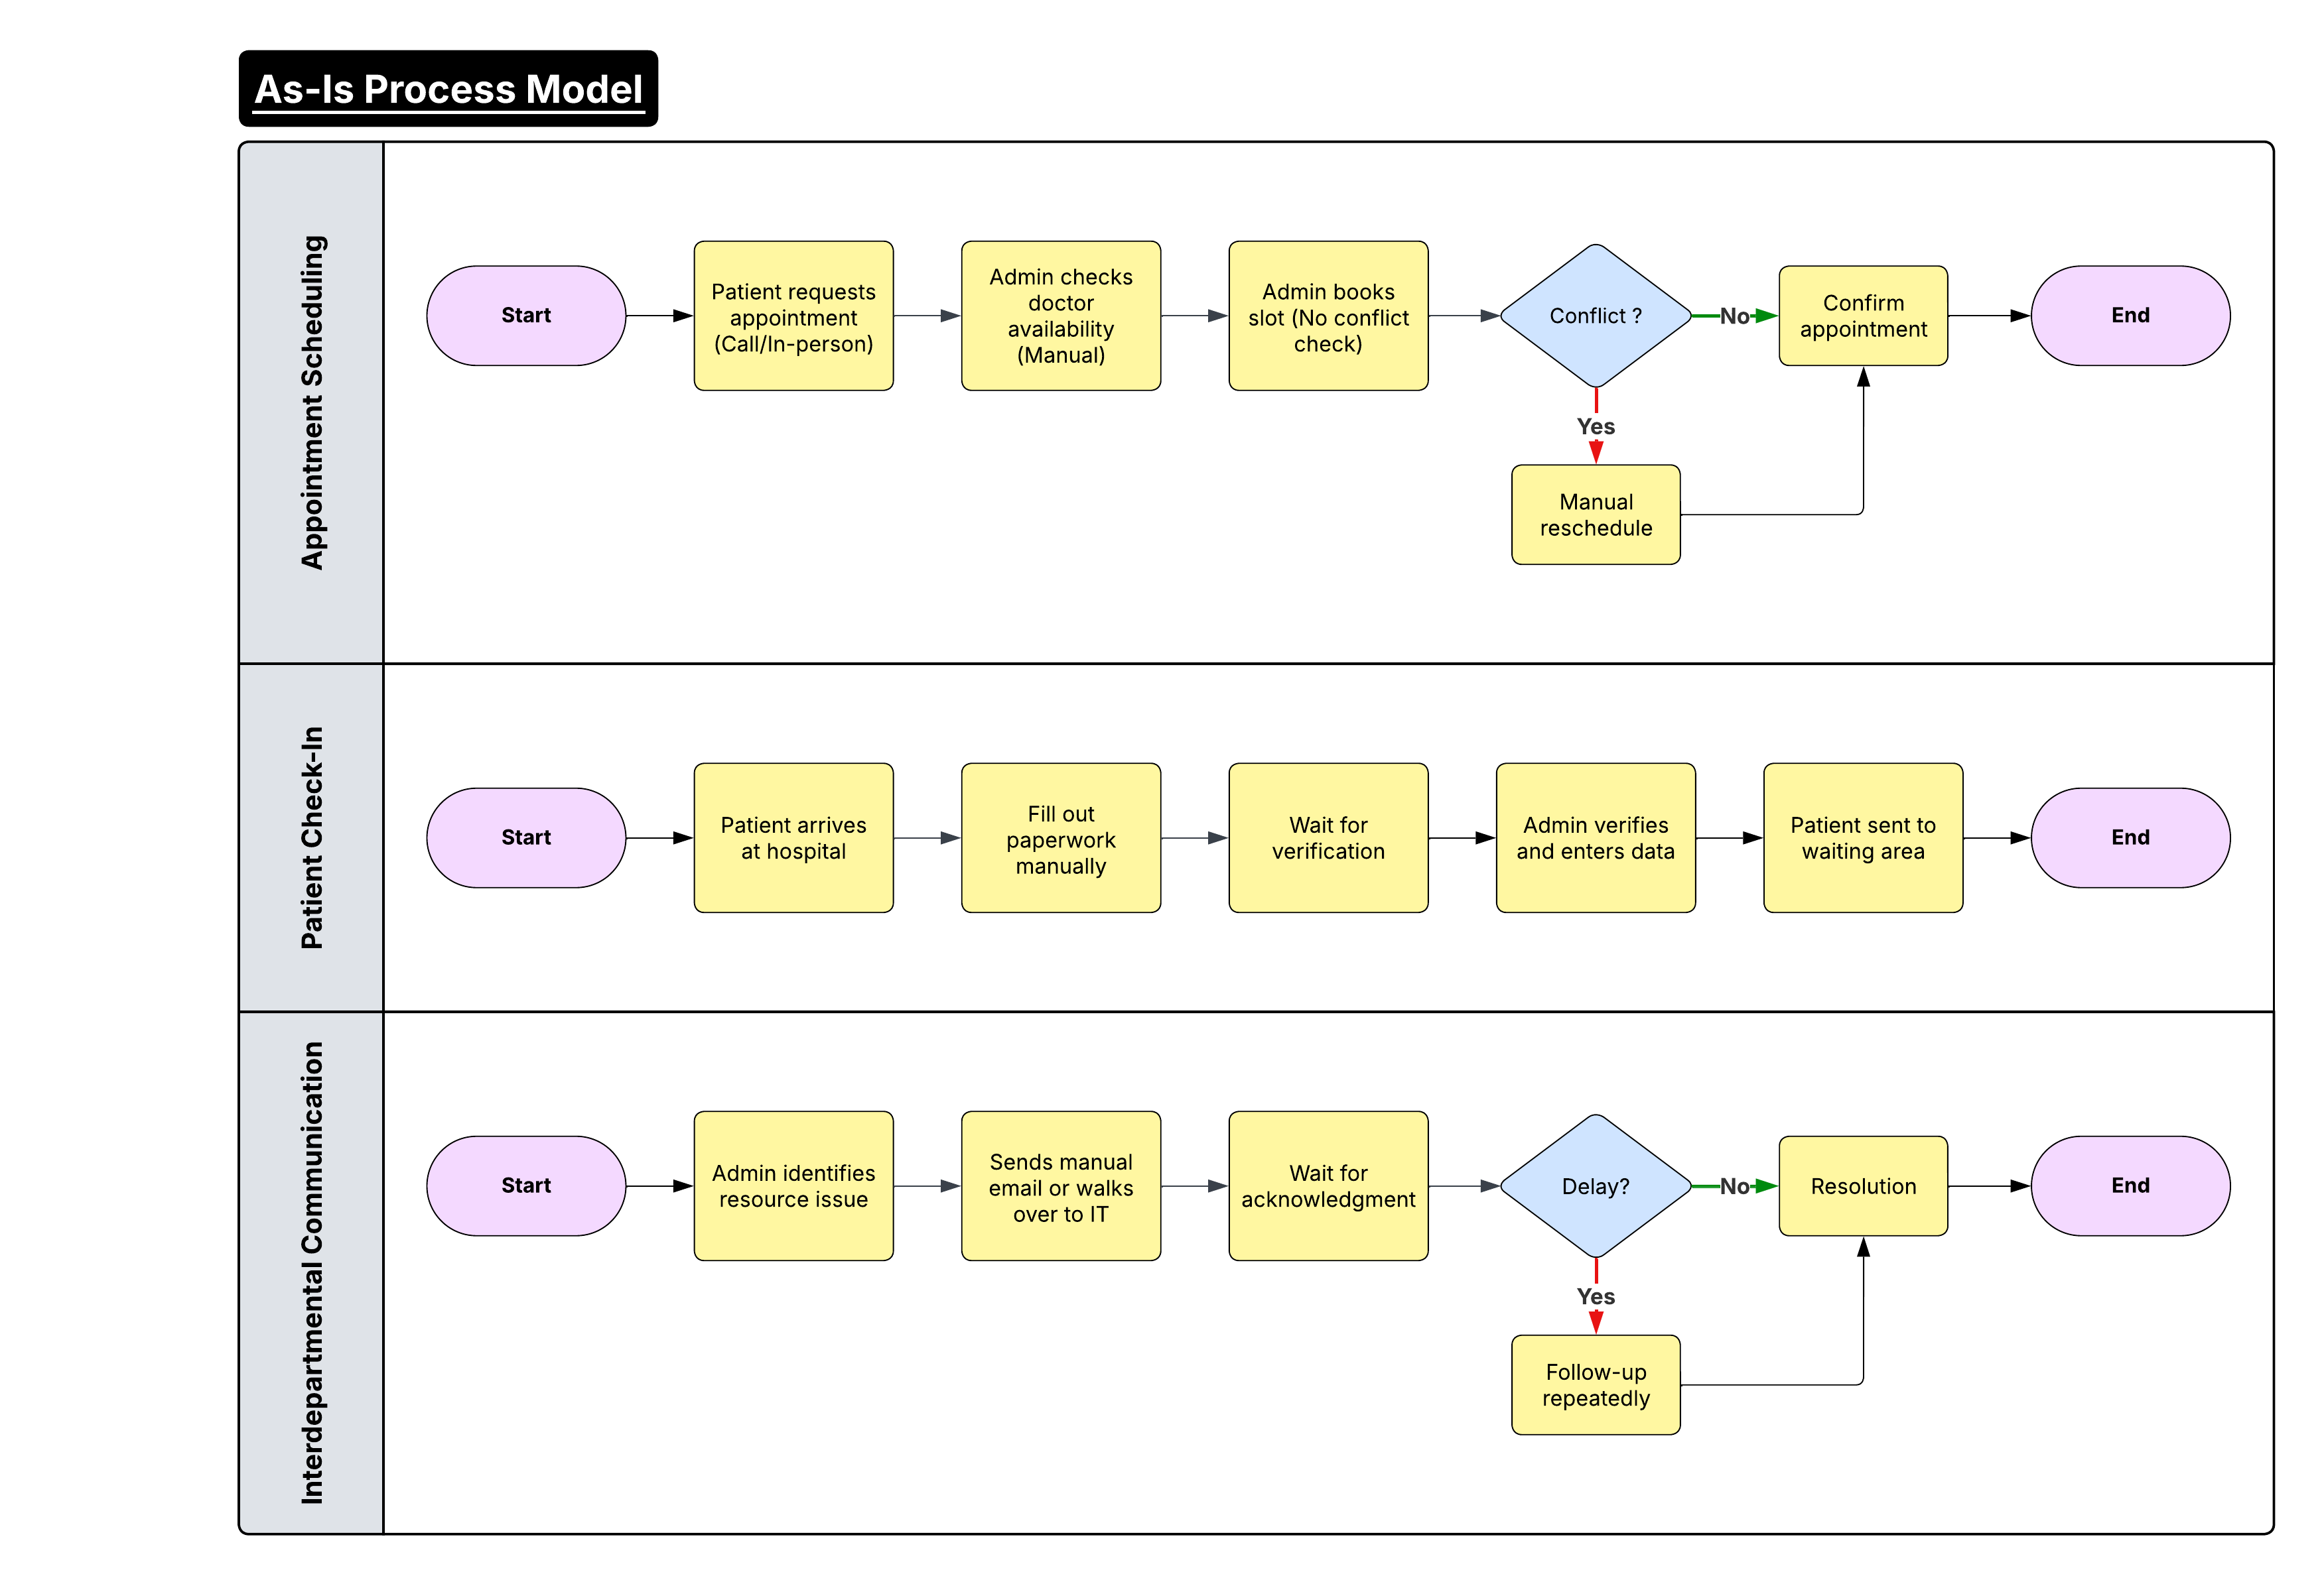

**2. Proposed Optimized Workflows (To-Be Models)**

**2.1 Appointment Scheduling – To-Be**

**Optimized Steps:**  
1. Patient submits request via mobile/web portal  
2. System checks doctor/resource availability in real time  
3. Conflict? (Yes/No decision)  
4. Suggest alternate time or confirm instantly  
5. Send SMS/email confirmation

**Improvements:**  
- Reduces double bookings  
- Automated conflict detection  
- Faster confirmations  
- Less manual effort for staff

**2.2 Patient Check-In – To-Be**

**Optimized Steps:**  
1. Patient arrives and uses kiosk/tablet or online pre-check-in  
2. System verifies ID & pre-filled info  
3. Patient enters digital queue  
4. Department notified

**Improvements:**  
- No paper forms  
- Real-time queue management  
- Reduced wait time  
- Higher patient satisfaction

**2.3 Interdepartmental Communication – To-Be**

**Optimized Steps:**  
1. Admin submits task via centralized dashboard  
2. System routes to correct department  
3. Staff updates status in real time  
4. Notification sent when resolved

**Improvements:**  
- Eliminates delays and miscommunication  
- Enables accountability and transparency  
- Streamlines coordination

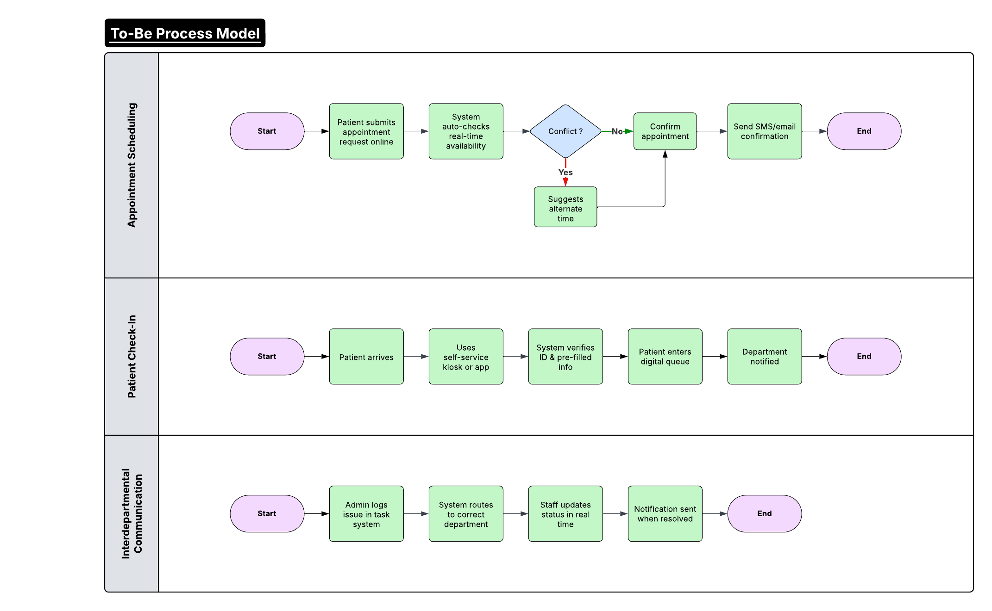

**3. Rationale Behind Proposed Solutions**

• **Automation** replaces manual, error-prone steps in scheduling and check-ins  
• **Dashboards** provide real-time task visibility and accountability  
• **Notifications** improve communication with patients and departments  
• **Self-service** empowers patients and frees up administrative time  
• Expected 20% reduction in patient wait times and 8+/10 improvement in satisfaction scores