Risk Register and SWOT Analysis

# 1. Risk Register

The following table outlines the identified risks for the HealthFirst Care project, categorized by type, and includes an assessment of their likelihood, impact, and recommended mitigation strategies.  
  
Note: Risk severity is calculated based on a 3x3 matrix combining Likelihood and Impact (Low, Medium, High).

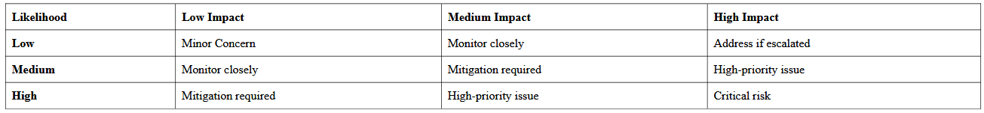

Risk ID: R001  
Description: Manual scheduling process causes delays and errors.  
Category: Operational  
Likelihood: High  
Impact: High  
Severity: Critical Risk  
Mitigation Strategy: Implement automated scheduling system.  
  
Risk ID: R002  
Description: Staff resistance to new digital tools.  
Category: Stakeholder  
Likelihood: Medium  
Impact: High  
Severity: High-priority Issue  
Mitigation Strategy: Conduct training and change management sessions.  
  
Risk ID: R003  
Description: Patient data breach due to poor cybersecurity.  
Category: Technical  
Likelihood: Medium  
Impact: High  
Severity: High-priority Issue  
Mitigation Strategy: Conduct regular data audits and improve encryption.  
Risk ID: R004  
Description: System downtime during peak hours.  
Category: Technical  
Likelihood: Medium  
Impact: Medium  
Severity: Mitigation Required  
Mitigation Strategy: Establish redundancy and support for downtime recovery.  
  
Risk ID: R005  
Description: Inconsistent resource utilization across departments.  
Category: Operational  
Likelihood: High  
Impact: Medium  
Severity: Mitigation Required  
Mitigation Strategy: Use a centralized resource tracking dashboard.

Risk ID: R006  
Description: Budget overruns due to underestimation of system costs.  
Category: Financial  
Likelihood: Low  
Impact: Medium  
Severity: Monitor closely  
Mitigation Strategy: Conduct detailed financial planning and maintain contingency reserve.  
  
Risk ID: R007  
Description: Delays in project approval due to non-compliance with healthcare regulations.  
Category: Regulatory & Compliance  
Likelihood: Low  
Impact: High  
Severity: Address if escalated  
Mitigation Strategy: Engage compliance officers early and conduct regular regulatory reviews.

Risk ID: R008

Description: Delay in lab report delivery during peak testing hours

Category: Operational

Likelihood: Low

Impact: Low

Severity: Minor Concern

Mitigation Strategy: Automate sample tracking and optimize lab workflow scheduling



# 2. Risk Assessment Matrix

The matrix below visualizes the severity of risks by mapping their likelihood against potential impact. Color codes:  
- Red: Critical Risk  
- Yellow: High-priority or Mitigation Required  
- Green: Monitor Closely / Minor Concern



# 3. SWOT Analysis

**Strengths**  
- Strong leadership commitment  
- Rich operational data and analytics  
- Established stakeholder engagement channels

**Weaknesses**  
- Manual workflows causing delays  
- Limited digital literacy among some staff  
- Disparate systems and data silos

**Opportunities**  
- Automation of core processes  
- Enhanced staff training and support programs  
- Integration of digital tools to boost efficiency

**Threats**

- Data breaches and cybersecurity risks  
- Stakeholder resistance to change  
- Regulatory compliance challenges

# 4. Conclusion

This report outlines major risks and strategic factors influencing the success of the HealthFirst Care project. By proactively addressing risks and leveraging organizational strengths, the project can mitigate threats, seize opportunities, and enhance its outcomes through informed planning and responsive execution.