Linux like Command Line Interface for C/C++ projects
Author
Abhishek Sagar, Juniper Networks
Visit: www.csepracticals.com
Last Updated : Aug 2022
2022

Contents
Introduction 1
Requirements 2
Header file Inclusions 4
Compilation 6
Sample commands 8
Terminology 8
Command Implementation 9
Parsing of LEAF values 11
Config Commands Implementation 12
Conclusion 12

Introduction

This is a Quick guide regarding how you can give your C/C++ linux project a linux like command like interface (CLI). Using this CLI you can interact with the project easily and also automate the project configuration.
Students, especially beginners, when do several linux or system programming projects, I find that the first basic difficulty they face is how to interact with the project – especially linux projects which usually do not have GUIs. I also see, students find an alternative and try to build Menu based approach instead as a means to provide front end interface to their linux projects. Well, that works for small projects with limited functionality, but soon fails when projects scales in size and functionality. Keeping that in mind, I have made a light-weighted useful C library which you can easily integrate with your existing projects using which you can develop project specific commands to interact/control your project/application.
Through this Document, I will tour you quickly using example how you can integrate this library in your project and develop useful commands.
This document do not discuss the internal details regarding design and implementation of the CLI interface. This document serves the purpose to help you to only “USE” this useful library to enable your project to have Command line interface.
I have intentionally made this course as fast paced quick guide course. I will try to wrap up as fast as I can !
The Video Tutorial for the same is present on Udemy here. If you have already purchased some of our courses, you can email to csepracticals@gmail.com asking for free access to the udemy course.

Requirements

First thing to do is to download the library on your linux machine. I assume you have git installed in your machine. If not, download the project from here: https://github.com/sachinites/CommandParser. But it is very bad that you do not have Github account.
Those who have git installed can download the project simply using git command:
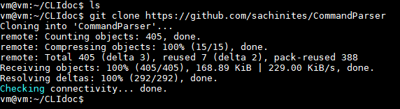
Figure 1 download project using git
The directory CommandParser will be created in your current directory. The src code of the CLI project is located in this directory. Also there is a sample file testapp.c which is the sample application making use of CLI library. You can also refer to this file regarding how to use the library.

Next, is to build the project.

Go inside the CommandParser directory and run make. This will compile the library. It will create an executable exe and static library libcli.a. You can run exe to take a look and feel about the CLI it renders. We will link our application with libcli.a library to make use of this library.
Note that, Makefile uses gcc compiler by default as library is intended to be used for C applications. However, If you are looking to integrate LIBCLI library with your C++ projects, then In Makefile, change first line to CC=g++ instead of CC=gcc. Rest of the procedure is same.

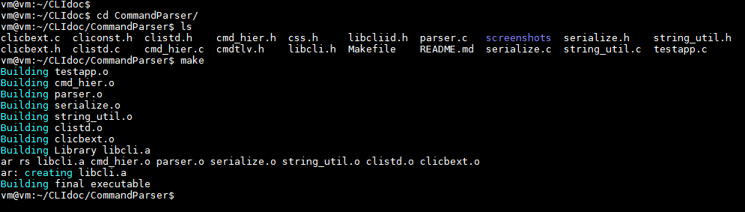
Figure 2 output of make command

There are four files in CommandParser dir namely : main1.c main2.c, main3.c and main4.c. Cut-paste them outside the CommandParser dir but inside the parent directory as show in figure 3. These main files contains some sequenced examples to implement the commands using library. We shall be discussing these main files in this quick tutorial.
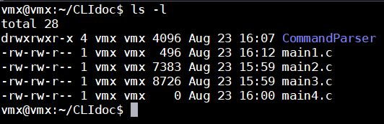
Figure 3 File organization

Header file Inclusions

Libcli library provides two header files as an interface to your external projects. In file main1.c, include the header files as below:
#include "CommandParser/cmdtlv.h"
#include " CommandParser/libcli.h"
In main(), call the below function right at the beginning of main:
init_libcli(); >> This initialize the library to be used by your application
and, at the end of main() , call the below two APIs :
support_cmd_negation(config); >> This adds ‘no’ support to config commands. More on this later.
start_shell(); >> This finally starts the shell interface. Any code after this function call is dead code.

After init_libcli(); in main() call the below APIs to import hooks from library.
param_t *show = libcli_get_show_hook();
param_t *debug = libcli_get_debug_hook();
param_t *config = libcli_get_config_hook();
param_t *clear = libcli_get_clear_hook();
param_t *run = libcli_get_run_hook();

So, at this point, your main1.c should look like in figure 5 :
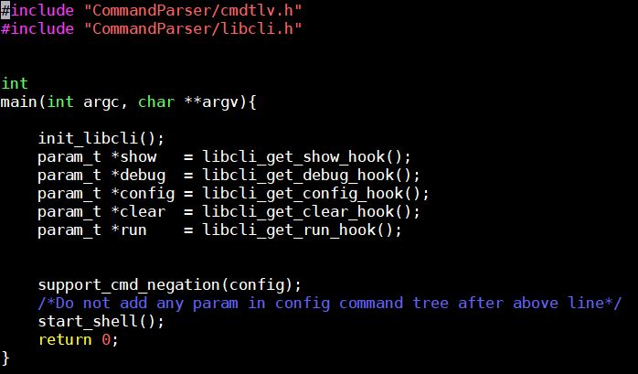
Figure 5 main1.c

Here, “show”, “debug”, “config”, “clear” and “run” are called hooks. Every project specific command that we will going to implement would start from one of these hooks. Infact, each of these hooks are root of their respective command tree. There will be separate command tree for each hook as a root.

Compilation

To compile the main1.c , use the following command shown in figure 6.
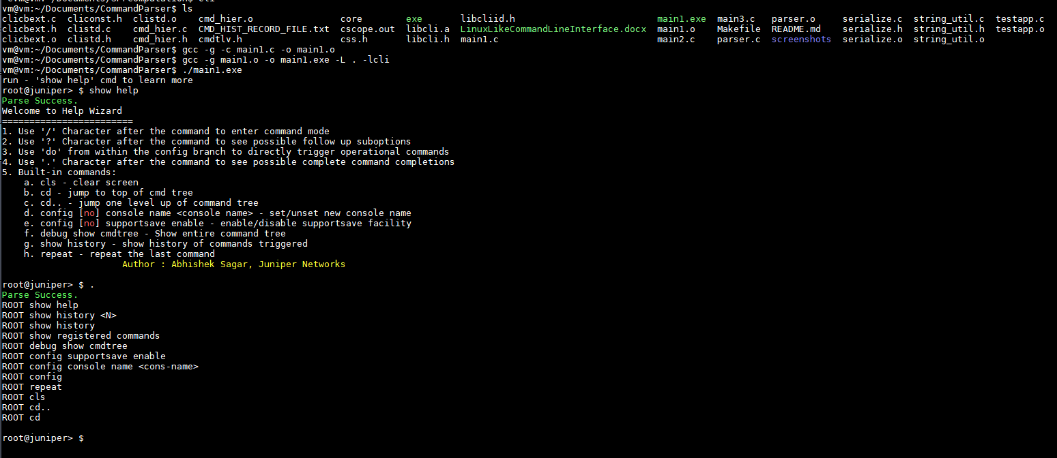
Figure 6 Compilation and run main1.exe
The first command compiles the main1.c to create object file main1.o. –I option tells compiler where to find header files included in main1.c.
The second command links our project with libcli library and create final executable – main1.exe. You can run this executable and play around the same default commands implemented. Also, use show help to get yourself familiar with the CLI. Try out “?”, “.”, “/” features. See the figure 6.

Sample commands

To provide as an example of how to implement the commands, we will take following two commands for illustration:
CMD1 : show node <node_name::string>
CMD2 : show node <node_name::string> loopback <lo ipaddress>
show

node

Command Tree
<node-name>

loopback

<lo-address>

Terminology

Get familiar with the terminology we will be using in the rest of the project.
CMD1 is composed of three words : “show”, “node” and “<node_name>”. These words are called params. “show” is a root param (hook) and is provided by library through API libcli_get_show_hook(); The params are divided into two types : CMD params and LEAF params.
CMD params : CMD params are those which are mere keywords in the command. “node” in CMD1 and CMD2 is CMD param. “loopback” is a CMD param in CMD2.
LEAF params : LEAF params are those which can have values. <node_name> in CMD1 and CMD2 are leaf params. <lo ipaddress> is a leaf param in CMD2.

Example of triggering CMD1 :
show node R1
show node R2
show node R3
Example of triggering CMD2 :
show node R1 loopback 122.1.1.1
show node R2 loopback 122.2.1.1
For every complete command you type, and press enter, there should be some functionality to be invoked. These functionalities are nothing but functions of our external projects. We will register our project specific function/routines to the commands so that, these commands, when triggered by the user result in executing our application routines/functions.

Command Implementation

Now, without wasting any further time, let us straight away implement our CMD1.
Before that, first we need to discuss the param constructor which actually initialize the new param – CMD or LEAF.
The constructor function is init_param. The arguments to this init_param is explained below. Each argument to the constructor is passed in the context whether the param is CMD or LEAF param.

void
init_param(param_t *param, /* pointer to param_t variable*/
param_type_t param_type, /* CMD if it is a CMD param , LEAF if it is a leaf param*/
char *cmd_name, /* <command name> for cmd param | always NULL for LEAF param*/
cmd_callback callback, /* Callback field, applicable to both CMD and LEAF param. NULL for incomplete commands */
user_validation_callback user_validation_cb_fn, /* always NULL for CMD param | Can be NULL Or valid function pointer for LEAF param */
leaf_type_t leaf_type, /* always INVALID for CMD param | leaf type (discuss shortly)*/
char *leaf_id, /* always NULL for CMD param , some <STRING> for LEAF param*/
char *help) ; /* Help String */

In the above definition of init_param() API, I have explained the meaning of each argument. Though some arguments needs detailed discussion.
Arg : cmd_callback callback;
This field is a pointer to applicable specific function which you want to invoke when user type out the command on shell upto this param and hit enter. If this field is left blank, the command exactly upto this param is said to be incomplete command.
The function prototype MUST be:
int <function_name> (param_t *param, ser_buff_t *tlv_buf, op_mode enable_or_disable) ;
where, ser_buff_t and op_mode are data types provided by library. We will discuss their use later. This function must always return 0.

Arg : user_validation_callback user_validation_cb_fn;
This field is a pointer to application specific function which you want to invoke in order to validate the value passed by the user for this param. This field is meaningful only for LEAF param.
The function prototype MUST be :
int <function_name> (char *value);
The value of the leaf param as typed out by the user on shell is passed as argument to this function as string. You can write your own logic how to validate this value further. This function must return either VALIDATION_SUCCESS or VALIDATION_FAILED as return value.
Other fields in the init_param() have been explained already.

Now, having roughly gone to the above constructor. I would recommend you to take a look at main2.c file in which I have implemented both CMD1 and CMD2 with good enough comments. Just compile main2.c like you compiled main1.c and run the executables. Trigger the new commands CMD1 and CMD2 and experience the library. Just trigger “.” and it will show all complete commands.

Parsing of LEAF values

Now, you must have seen function node_loopback_callback_handler() was invoked when you ran CMD2. CMD2 has two Leafs in it : node_name and loopback_address. We should be able to fetch the values of these two leaves in application code along with command code. For this purpose, we have macros.
For extracting command code , use macro : EXTRACT_CMD_CODE
For Iterating over leaf values:
TLV_LOOP_BEGIN
TLV_LOOP_END
We implement this functionality in the next version of our main src file i.e. main3.c. Take a look at the function: node_loopback_callback_handler() implementation in main3.c.
When we trigger CMD2, we get the following output as shown in figure 7:
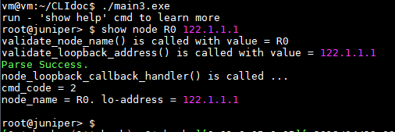
Figure 7

You can see, command code recvd is 2 which is CMDODE_SHOW_NODE_LOOPBACK (#define constant), and both the leaf values are printed. Please go through file main3.c and see how node_loopback_callback_handler() function is implemented.
Different leaf type supported are defined in CommandParser/libcliid.h file. Have a look.

Config Commands Implementation

Refer : main4.c file
Command implemented: config node <node_name> loopback <lo-address>
We come to the last section of this document: Implementing the config commands. Implementing config commands is no different than show commands, except the little catch.
When user configure something in application through config commands, at some point of time or later, he would like to un-configure the same configuration also. Config commands are intended to update/modify the application state, unlike show commands which only reads the application state.
There is already one inbuilt config command: config console name <name>
Try out this command and notice the change in cli prompt. Now un-configure the same using negate command:
config no console name <name you configure>. Notice the change again in cli prompt.
Thus, What user configure also needs to be un-configured at some point of time or whenever user wishes. All config commands can be negated using no keyword after config key word.
For your college/personal projects, you may want to change the name of the prompt as per your requirement. For this, modify the file CommandParser/cliconst.h and change the following line. You will have to recompile the library after this change to take effect.
#define DEFAULT_DEVICE_NAME "root@juniper".

Lastly, how application code would know whether the config command triggered is to configure Or unconfigure something. For this purpose, the last parameter of application routine is used. See the function: node_loopback_callback_handler() in which the last parameter is op_mode enable_or_disable.
The value of enable_or_disable is set to CONFIG_ENABLE if positive configuration command is triggered, else set to CONFIG_DISABLE for negative configuration command. If the command is show/clear/debug/run then this parameter is of no use and set to OPERATIONAL. Note that for config and its complementary negate command, you receive the same set of leaf values and command code.
Try implement one config command, and run negative version of it as an exercise. Check main4.c, (a successor file to main3.c) file in which I have implemented sample config commands

Conclusion

This library will give you quick Command like interface to enable you to provide CLI interface to your any C/C++ projects. Very handy and light weighted library. Isn’t it good ??
This library will also be required in doing various future projects of mine or yourself at academics or otherwise. Once you start using this libcli library, doors shall be opened to do more fascinating and bigger system programming projects.
Try out different easy utilities provided by library. See the output of show help command.
Src code is with you – you are the new owner of this library – modify/extend/replicate as you wish. From now, never dare to show your linux C/C++ projects with kiddo Menu interface, and show the CLI interface with all pride.

Do’s And Don’t’s

- Whenever you add a callback handler to a param, make sure you also register a command code with that param, else library will send cmd code as -1 to backend.
- You will see unexpected result if you mess up the parent-child relationship in the command tree. Library may also assert.
- It is recommended to use separate command handlers for all commands belonging to a separate command tree rooted at different hook. For example, Avoid using same cmd handler for show or config commands etc. It is just a good practice.
- Any error or bug – report it to me, I will fix it – my email : sachinites@gmail.com
Thanks.

