SIT103/SIT772: Database Fundamentals 4.2C: Mini-project Part 1

Q1

Telstra is the largest media and communications company in Australia. It also provides home phone, broadband Internet, pay TV and landline services. Telstra's cell phone and Internet offerings are among the best in the country. Its customers receive high-quality, low-cost goods and services. The telephone entity represents Telstra Mobile and provides products and services for pay television, Internet, mobile and fixed-line telephony. Telstra provides Internet and mobile services to Australian customers. This category includes the sale of cell phone handsets, cell phone accessories and cell phone plans (prepaid and post-paid). Telstra offers a variety of cell phone plans to meet the needs of its consumers. Prepaid plans are a good option for consumers who want to pay for services in advance. Telstra provides Internet and mobile services to customers in Australia, including pay TV, Internet, cell phones and landlines. This category includes the sale of cell phone equipment, accessories and cell phone plans (prepaid and post-paid). Telstra offers a wide range of cell phone plans to meet the needs of its consumers. Prepaid plans are ideal for customers who want to pay for their phone service in advance, while post-paid plans allow customers to pay for service after use. Telstra allows customers to purchase handsets and accessories.

Q2

Customers [ Customer_ID(PK), Name, Address, Phone_num, Email]

Customers_Plan[ Customer_Plan_ID (PK), Plan_ID(FK), Customer_ID(FK), Description]

Plans [Plan_ID(PK), Plan_Name,DataSpeed, Limit_data, Cost]

Payments [Payment_ID(PK), Order_ID(FK),Customer_ID(FK), Invoice_ID(FK), Payment_method]

Order [Order_ID(PK), Customer_ID(FK), Total_price, Order_Date]

Returns [Return_ID(PK), Customer_ID(FK), Order_ID(FK), Reason]

PhoneOrder [ PhoneOrder_ID(PK), Phone_ID(FK), Order_ID(FK), Price]

Phones [Phone_ID(PK), Maker,Price,System,Storage]

Invoice [ Invoice_ID, Price, Date,Tax]

Q3

In the first part (1NF), I gave nine entities connected separately and diagrammed them according to their relationships, where the plan part depends on the customer plan, the phone part depends on the phone order, and the invoice part depends on the payment.

For the second part (2NF), the customer, customer plan, plan, payment, and invoice are connected together separately, and the invoice part depends on the payment. The plan part depends on the customer plan

Connects Order, Payment, Mobile Order, and Mobile together, where the Mobile part depends on the Mobile Order.

For the third part (3NF), the customer plan includes the plan, the payment includes the invoice, the cell phone order includes the cell phone, and the order contains the cell phone order, the payment, and the return. The customer has a customer plan, an order, a cell phone, an invoice, and a payment. Therefore it eliminate Transitives dep.

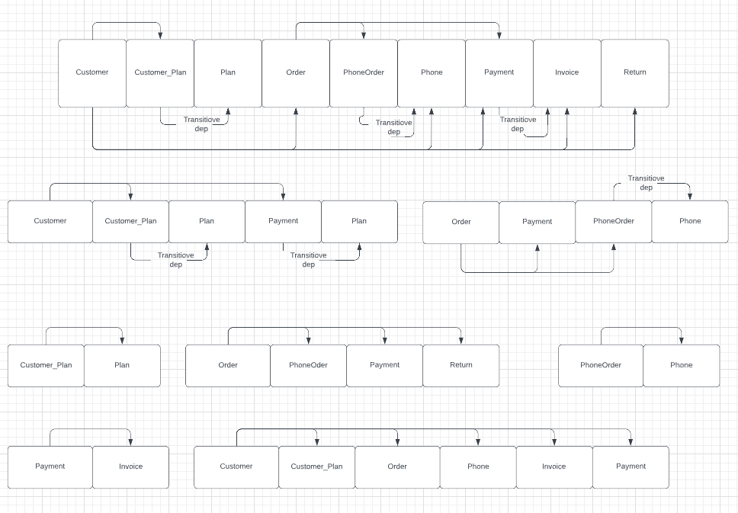

Q4

