Information Radiators

Yizheng he

221411294

The Information Radiators serves as a sizable visual indicator that highlights important information and prominently depicts the team's progress. The workflow is visualised so that everyone on the team can see and comprehend progress at any time when it is being stalled. It improves efficiency in inter-team activities and cooperation transparency when applied successfully. Most significantly, workflow records can be kept on the server, removing obstacles to collaboration and productivity. Everyone on the team can immediately understand the information radiator's design if it is straightforward and useful. When the process is being used, however, managers must promptly update the information to reflect changes and progress that are happening in real-time.

|  |  |  |
| --- | --- | --- |
| Three Tools of information  radiator | advantage | disadvantage |
| Waterfall | the process is simple and suitable for situations where the outcome is obvious. | where each step must be completed before the next step can be taken, lengthy and difficult to change approach to prototyping |
| Agile | it promotes revisiting and rewriting processes to meet expectations, which leads to better projects and faster project completion. | does not impose strict deadlines and can be challenging under pressure if not managed |
| Handwritten | of being simple to construct and suitable for small teams as an information radiator, as it is very low cost and may require a blackboard | of not being able to work on the cloud and having a very backward method of updating information |

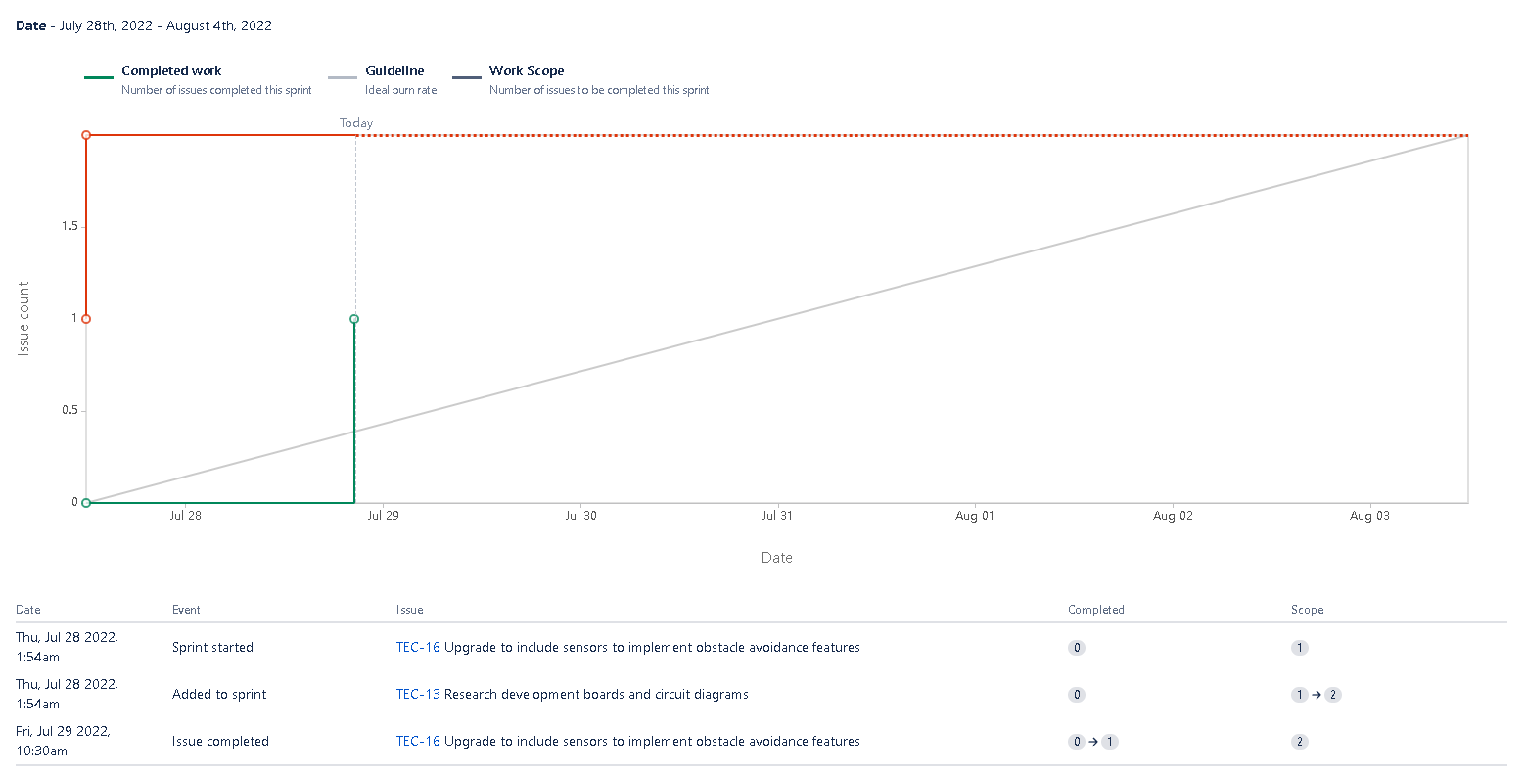

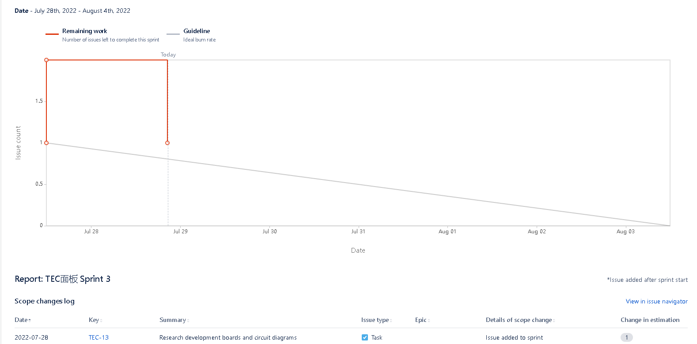

Burn-down charts show the work remaining on a project, while burn-up charts show how much work has been completed and the total progress of the project.

burn-down charts are suitable for workplace, because it shows the remaining workload, while burn-up charts are suitable for projects, because it can show the completed work and the total project progress

Burn-up charts are preferred because they show the progress of the entire work or project completion and the total scope.