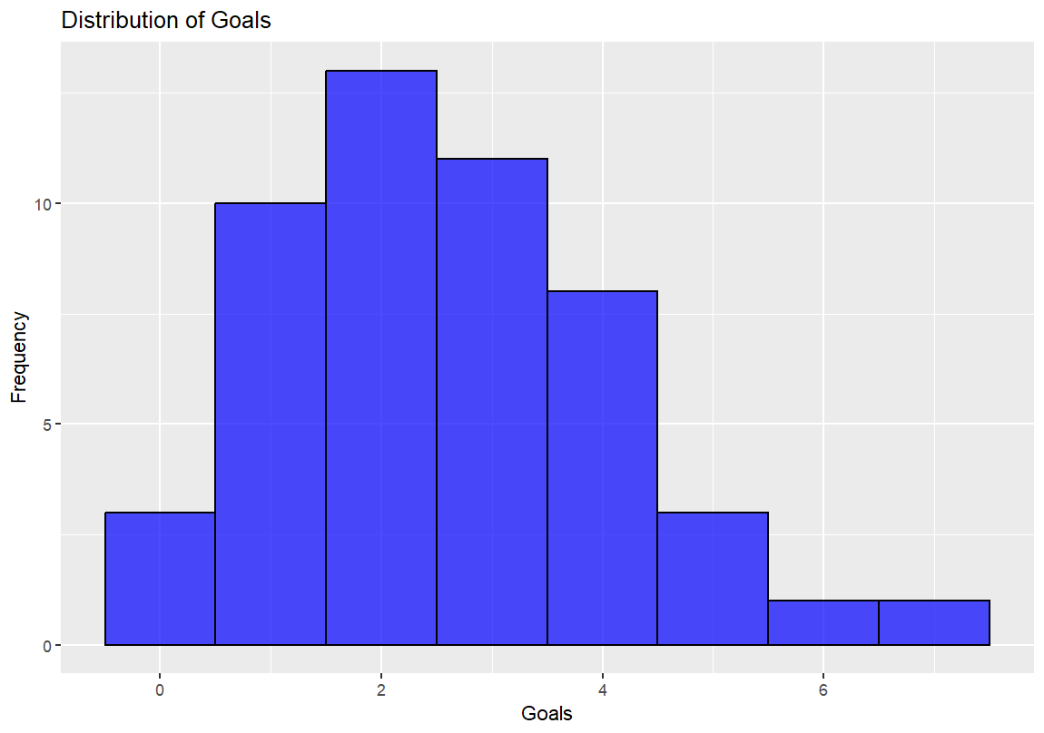

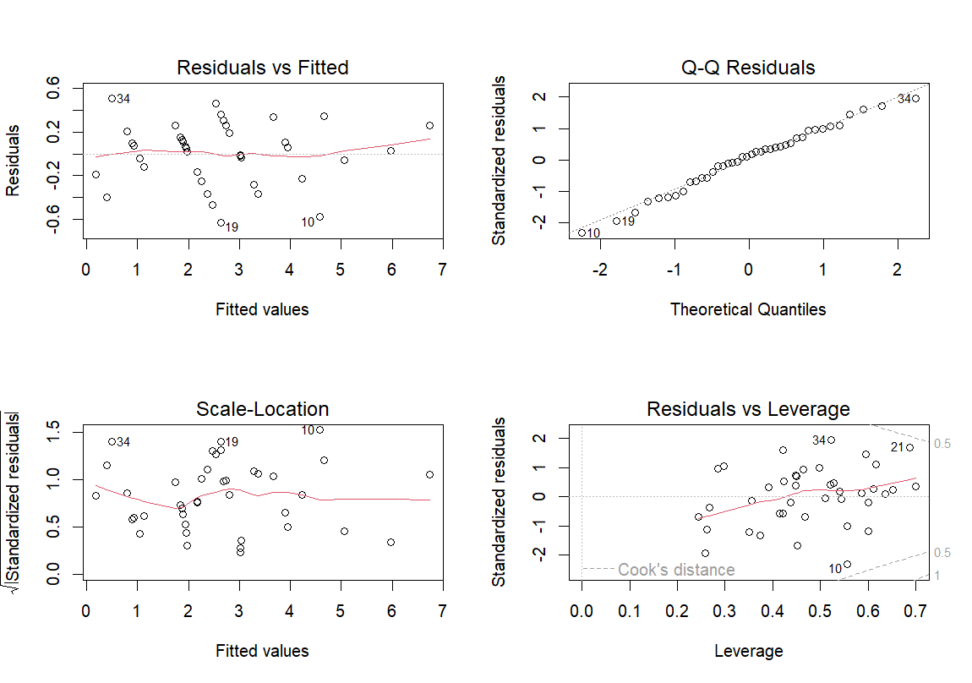

| **Deviance Table for Match-Level Regression** | | | | | | |
| --- | --- | --- | --- | --- | --- | --- |
| **Variable** | **Df** | **Sum Sq** | **Mean Sq** | **F Value** | **Pr(>F)** | **Significance** |
| Big Chances | 1 | 0.155 | 0.155 | 1.0955 | 0.3071 |  |
| Attempts on target | 1 | 47.281 | 47.281 | 333.6408 | 2.28e-14 | *** |
| Attempts off target | 1 | 0.201 | 0.201 | 1.4197 | 0.2467 |  |
| Crosses completed | 1 | 0.072 | 0.072 | 0.5060 | 0.4846 |  |
| Dribbling | 1 | 0.088 | 0.088 | 0.6240 | 0.4383 |  |
| Passes completed | 1 | 0.085 | 0.085 | 0.6026 | 0.4462 |  |
| Passes accuracy | 1 | 1.851 | 1.851 | 13.0582 | 0.0016 | ** |
| Delivery into penalty area | 1 | 0.883 | 0.883 | 6.2321 | 0.0209 | * |
| Corners | 1 | 0.562 | 0.562 | 3.9625 | 0.0596 | . |
| Attempts on direct free kick | 1 | 0.001 | 0.001 | 0.0063 | 0.9375 |  |
| Tackles won | 1 | 0.079 | 0.079 | 0.5579 | 0.4634 |  |
| Recovered balls | 1 | 0.090 | 0.090 | 0.6335 | 0.4349 |  |
| Clearances successful | 1 | 1.809 | 1.809 | 12.7673 | 0.0017 | ** |
| Saves | 1 | 31.027 | 31.027 | 218.9476 | 1.39e-12 | *** |
| Blocks | 1 | 0.101 | 0.101 | 0.7109 | 0.4086 |  |
| Fouls committed | 1 | 0.052 | 0.052 | 0.3695 | 0.5498 |  |
| Tackles performed gaining the ball | 1 | 0.002 | 0.002 | 0.0118 | 0.9146 |  |
| Crosses attempted | 1 | 0.060 | 0.060 | 0.4222 | 0.5228 |  |
| Residuals | 21 | 2.976 | 0.142 |  |  |  |

Signif. codes: 0 ‘***’ 0.001 ‘**’ 0.01 ‘*’ 0.05 ‘.’ 0.1 ‘ ’ 1

**(Table 1)**

| **Deviance Table for Team-Level Regression** | | | | | | |
| --- | --- | --- | --- | --- | --- | --- |
| **Variable** | **Df** | **Sum Sq** | **Mean Sq** | **F Value** | **Pr(>F)** | **Significance** |
| Big Chances | 1 | 107.052 | 107.052 | 161.6680 | 5.350e-05 | *** |
| Attempts on target | 1 | 138.882 | 138.882 | 209.7382 | 2.833e-05 | *** |
| Attempts off target | 1 | 2.623 | 2.623 | 3.9605 | 0.10324 |  |
| Crosses completed | 1 | 8.302 | 8.302 | 12.5376 | 0.01655 | * |
| Dribbling | 1 | 5.400 | 5.400 | 8.1549 | 0.03559 | * |
| Passes completed | 1 | 0.655 | 0.655 | 0.9888 | 0.36570 |  |
| Passes accuracy | 1 | 7.018 | 7.018 | 10.5981 | 0.02256 | * |
| Delivery into penalty area | 1 | 3.413 | 3.413 | 5.1538 | 0.07242 | . |
| Corners | 1 | 0.561 | 0.561 | 0.8474 | 0.39953 |  |
| Attempts on direct free kick | 1 | 0.517 | 0.517 | 0.7803 | 0.41750 |  |
| Tackles won | 1 | 0.157 | 0.157 | 0.2368 | 0.64708 |  |
| Recovered balls | 1 | 0.099 | 0.099 | 0.1497 | 0.71473 |  |
| Clearances successful | 1 | 0.027 | 0.027 | 0.0409 | 0.84768 |  |
| Saves | 1 | 0.000 | 0.000 | 0.0000 | 0.99533 |  |
| Blocks | 1 | 0.708 | 0.708 | 1.0697 | 0.34842 |  |
| Fouls committed | 1 | 0.075 | 0.075 | 0.1132 | 0.75018 |  |
| Tackles performed gaining the ball | 1 | 1.166 | 1.166 | 1.7615 | 0.24181 |  |
| Crosses attempted | 1 | 3.660 | 3.660 | 5.5275 | 0.06547 | . |
| Residuals | 5 | 3.311 | 0.662 |  |  |  |

Signif. codes: 0 ‘***’ 0.001 ‘**’ 0.01 ‘*’ 0.05 ‘.’ 0.1 ‘ ’ 1

**(Table 2)**