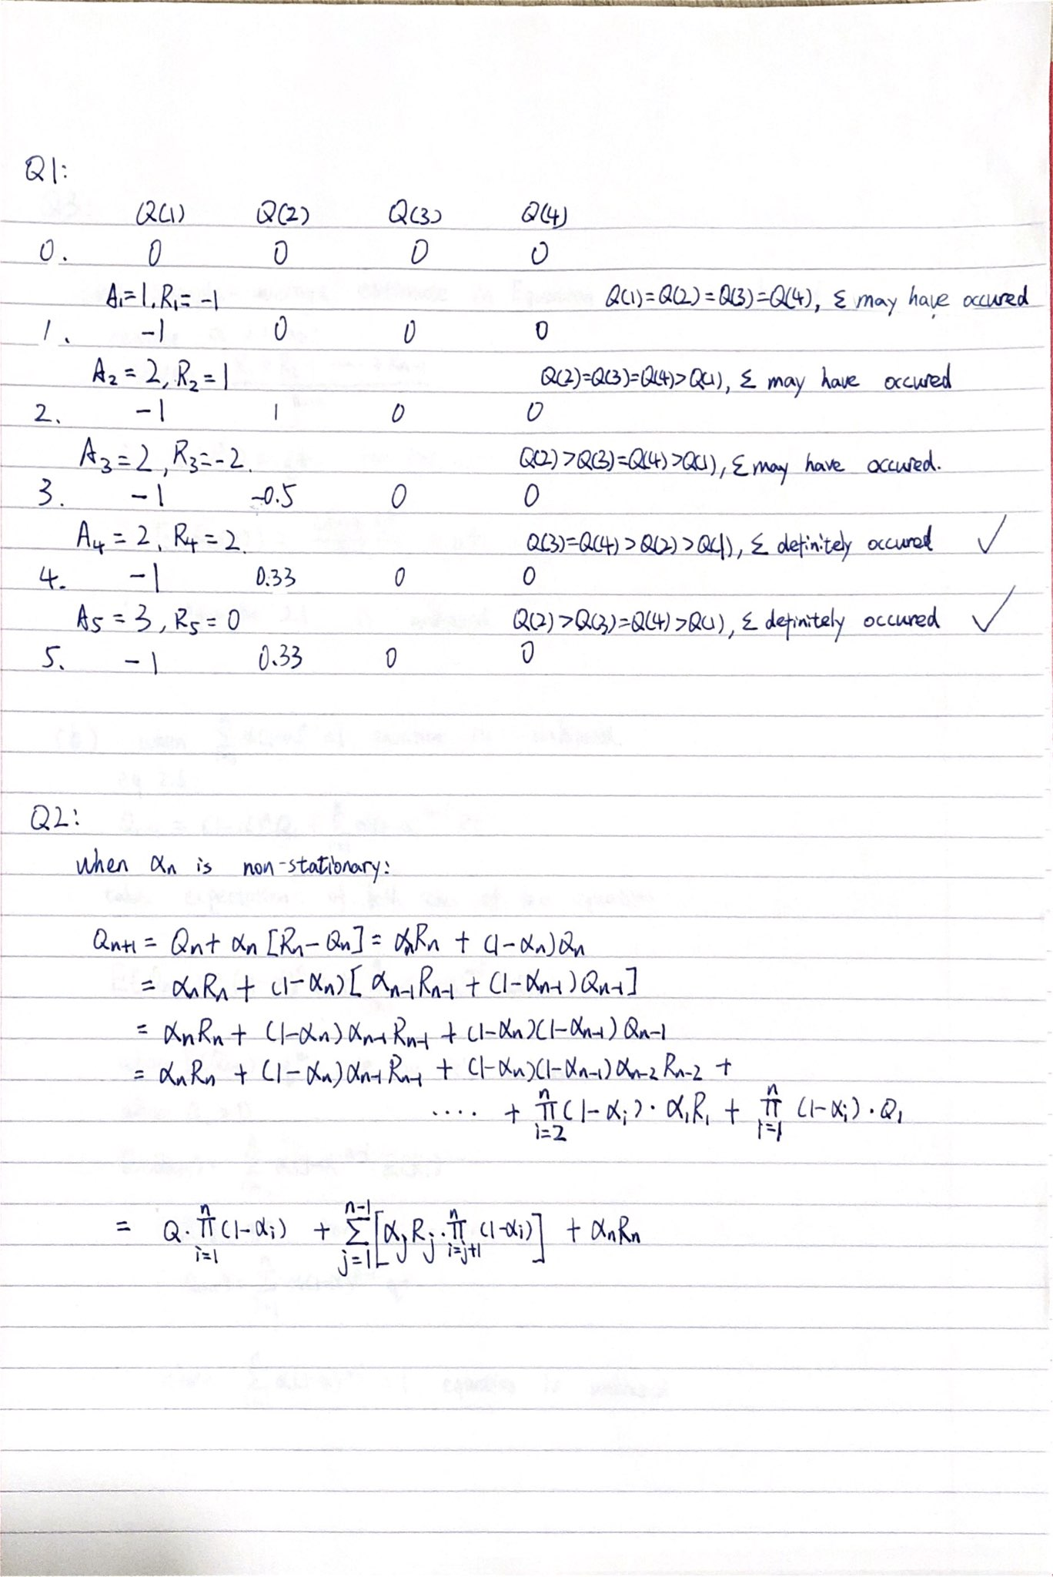
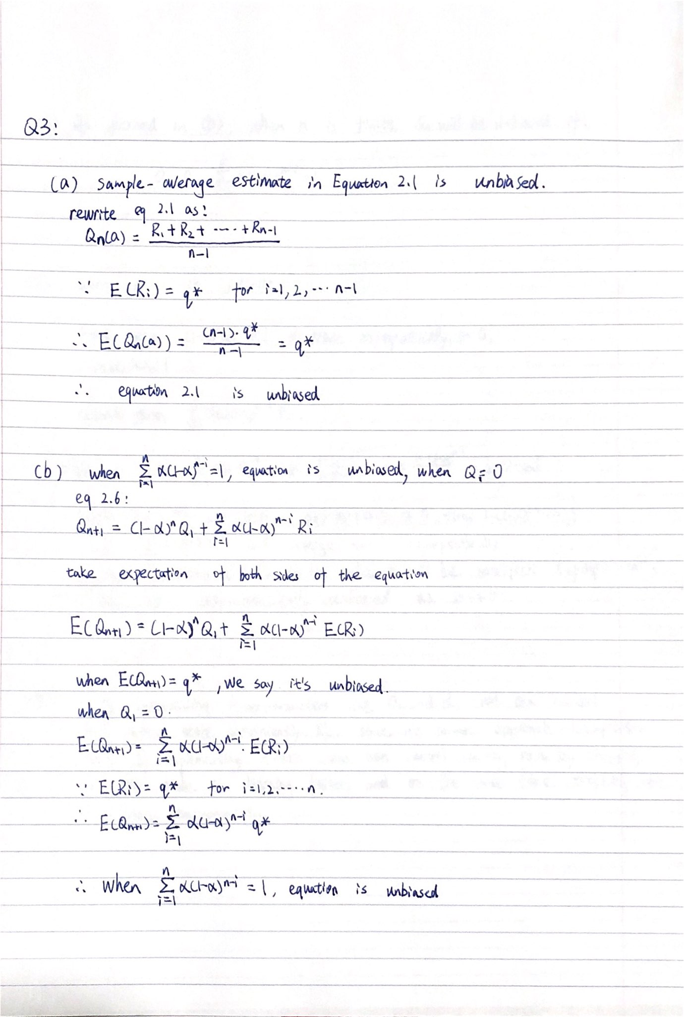
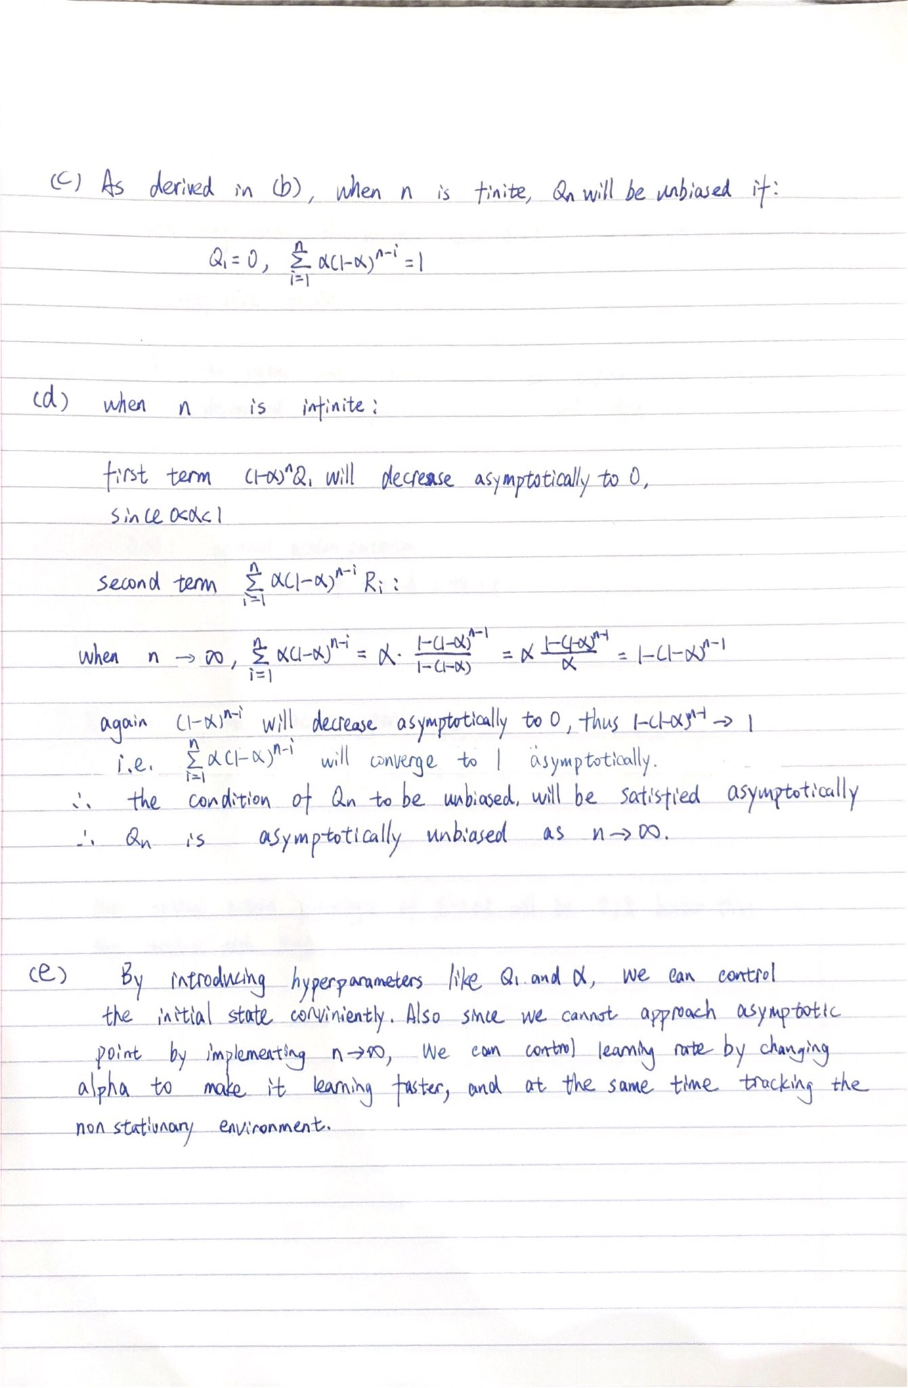

Q4: (All levers are chosen 10000 times in total)
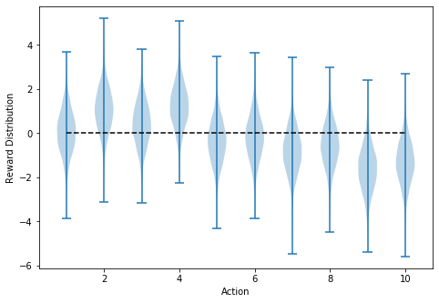

Q5:
Q6: (Medium setting)
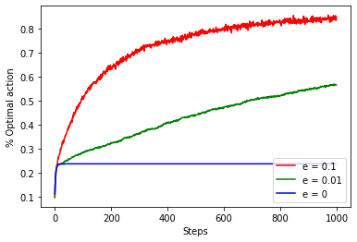
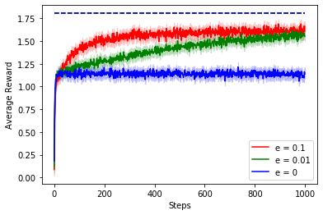


% Optimal action and Average reward graph for e-Greedy method with different e value
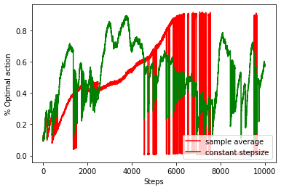
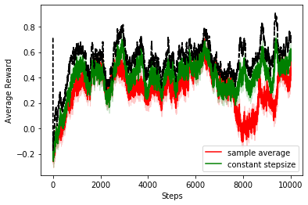
Q7: (Large setting)

comparison between sample average and constant stepsize method

We can see that in general constant stepsize method performs better than constant stepsize method, both in average reward and percentage of optimal action, and sample average method is more vulnerable in non-stationary case. For example, the red curve deviated a lot around 8000tth step while the green curve still tracks it well. This may probably because of sample average method won’t ‘forget’ anything.
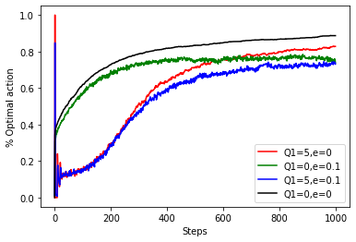
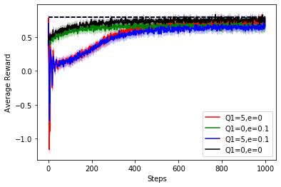
Q8: (Both medium setting)

% Optimal action and Average reward graph for Optimistic Initial Value method

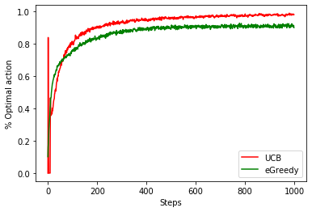
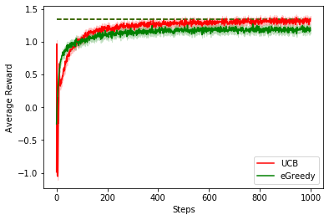

% Optimal action and Average reward graph for UCB method


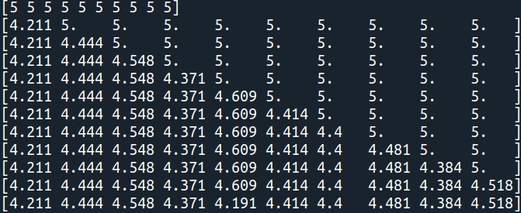

First 11 iteration of updating Q value using Optimistic Initial Value
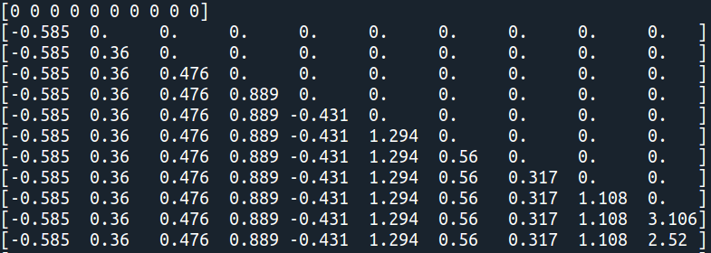

First 11 iteration of updating Q value using UCB
Q9: (Medium setting)
I implemented Gradient Bandit method and managed to reproduce the Figure 2.5 from the book. All the parameters are the same as the book: every initial Q value shifted up by 4, and 4 curves drew regarding alpha = 0.1 or 0.4, with or without baseline.
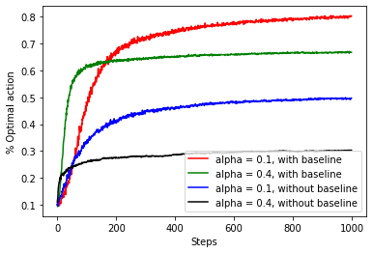
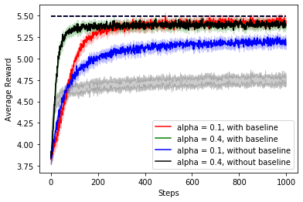
The result looks like this:

% Optimal action and Average reward graph for Gradient Bandit Method
(the black curve in average reward graph was misdirect on the green line, and it should be within the gray shade originally )

I found that gradient bandit algorithm with baseline performs significantly better than the ones without baseline, and the baseline could be easily calculated incrementally, without spending too much memory space.

