pp=1

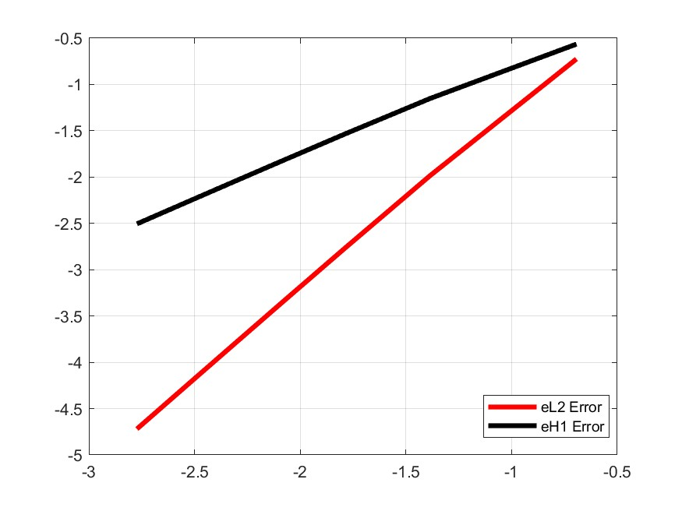

Slope：eH2=1.9302 eL1=0.9409

pp=2

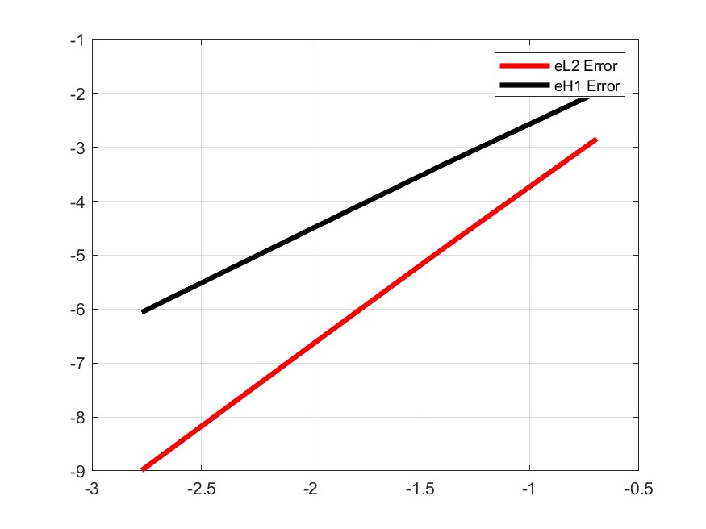

Slope：eH2=2.9615 eL1=1.9635

pp=3

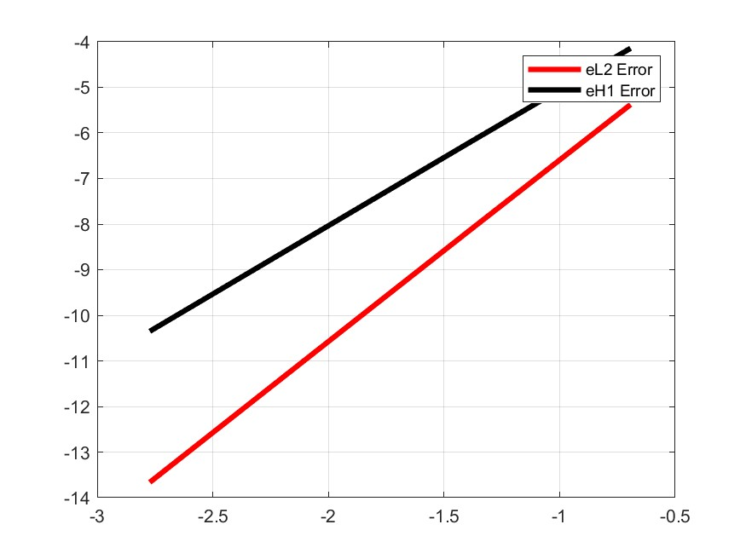

Slope：eH2=3.9868 eL1=2.9871

(e) n_el = 1, 2时单元刚度矩阵奇异，n_el = 3, 4, 5 , 6 时矩阵非奇异  
m=1，k= $\overline{K}$ =4， -2m+k+ $\overline{K}$ =4，  
the 3 x 3 Gauss rule is needed.

(d)

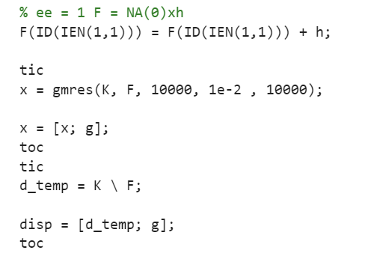

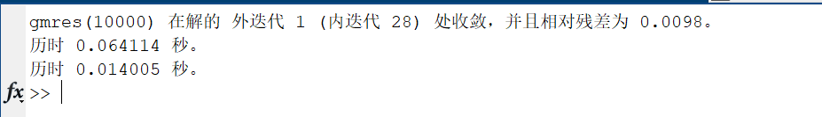

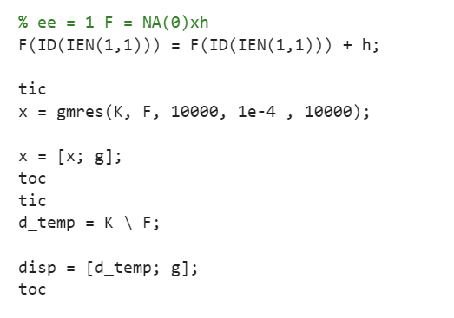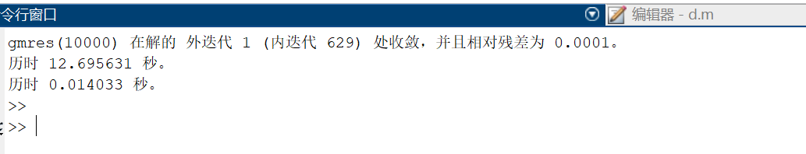

精度翻倍使得计算量急剧加大