1. Work Breakdown Structure
The Work Breakdown Structure divides the project into eight manageable work packages. It covers both the academic research and the implementation evidence required for the final capstone submission.
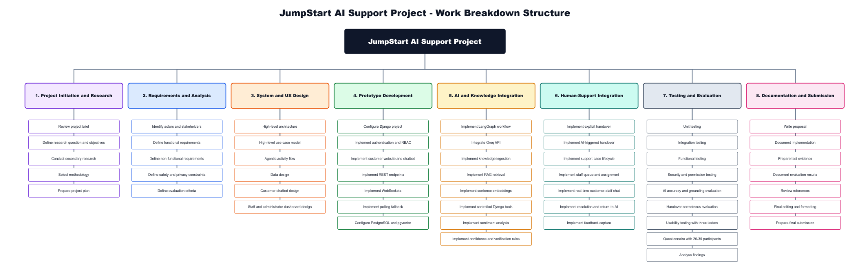
Figure 1. JumpStart AI Support Project - Work Breakdown Structure
WBS explanation
Work packages 1 and 2 establish the academic and requirements foundation by reviewing the brief, defining the research question, selecting the methodology, identifying actors and specifying functional, non-functional, safety and privacy requirements.
Work package 3 produces the architecture, use-case model, data design and interface plans. Work package 4 creates the Django prototype, authentication, customer interface, APIs, WebSockets, polling fallback and PostgreSQL/pgvector environment.
Work packages 5 and 6 implement the AI and human-support capabilities. These include LangGraph, Groq, knowledge ingestion, RAG, embeddings, sentiment, controlled tools, confidence rules, explicit and AI-triggered handover, queue management, staff chat, resolution, return to AI and feedback capture.
Work packages 7 and 8 provide evidence and completion activities: functional, integration, security, accuracy, grounding, handover and usability tests; questionnaire analysis; implementation documentation; evaluation; reference checking; final formatting and submission. The WBS demonstrates that documentation and evaluation are continuous project outputs rather than tasks left until the final day.

2. Project Schedule
The proposal is submitted on 26 June 2026. Development begins on 29 June 2026 and is organised into four main weeks, followed by a three-day closeout period ending with final submission on 29 July 2026. The schedule deliberately places core architecture and data work before AI integration, and completes the human-support path before final evaluation.
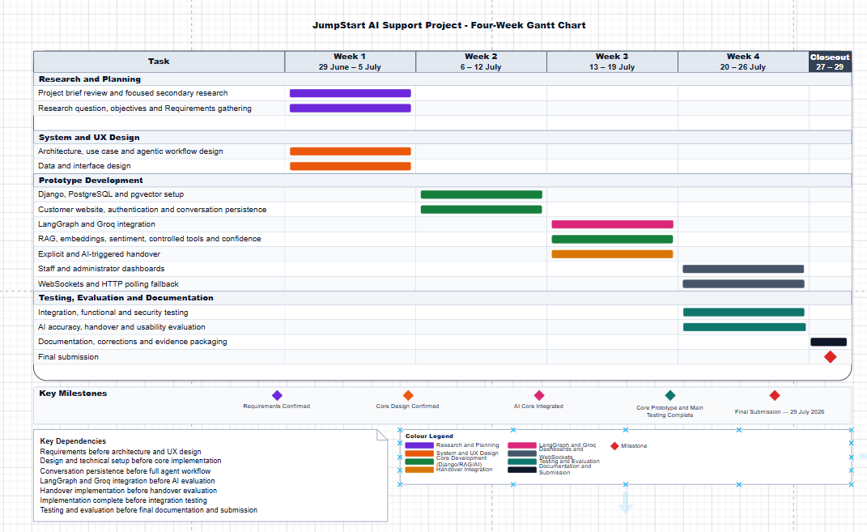
Figure 2. JumpStart AI Support Project - Four-Week Gantt Chart
Gantt chart explanation
Week 1 (29 June-5 July) confirms requirements, and produces architecture, use-case, agentic workflow, data and interface designs. This creates the baseline required before implementation begins.
Week 2 (6-12 July) establishes Django, PostgreSQL, pgvector, authentication, the retail website and conversation persistence. These foundations are dependencies for the AI workflow and for later staff communication.
Week 3 (13-19 July) integrates LangGraph and Groq, RAG, embeddings, sentiment, approved tools, confidence logic and both handover routes. The milestone is a connected core prototype that can answer, clarify, verify and escalate.
Week 4 (20-26 July) completes staff and administrator dashboards, WebSockets, polling fallback, integration testing, security testing, answer-quality evaluation, handover evaluation and the three-participant usability exercise. The closeout period (27-29 July) is reserved for final documentation, corrections, evidence packaging and submission. The milestone and dependency notes show that testing must be completed before the final report is closed.

3. Expected Deliverables
- A completed research proposal and focused literature review.
- A locally running JumpStart retail website with registration, login and an authenticated customer-support chatbot.
- A single-agent LangGraph workflow using the Understand, Plan and Act, Verify and Route stages.
- RAG over approved JumpStart knowledge stored in PostgreSQL with pgvector.
- Local sentence embeddings, local sentiment analysis and deterministic confidence bands.
- Controlled Django tools for products, variants, mock orders, accounts, support cases and feedback.
- Validated explicit handover and separate AI-triggered handover.
- A support staff dashboard with waiting, active and resolved views, manual first acceptance, direct chat, return to AI and resolution.
- An administrator dashboard for users, permissions, knowledge approval, monitoring, errors and feedback review.
- Functional, integration, permission, security, RAG, routing, handover and usability evidence.
- Questionnaire results from approximately 20-30 participants and exploratory usability evidence from three participants.
- Screenshots, logs, test results, database backup or fixtures and a short recorded demonstration.
- A final report, evaluation and presentation materials.

4. Hardware and Software Requirements

4.1 Hardware
Hardware | Purpose and suitability
Windows 11 laptop | Primary development, local hosting, testing and demonstration environment.
NVIDIA GeForce GTX 1660 Ti with 6 GB VRAM | Suitable for compact local sentiment and embedding inference; the main LLM is hosted by Groq.
Internet connection | Required for Groq API, source control and academic-source access.
Local storage | Stores the project, PostgreSQL data, knowledge documents, backups, screenshots and evidence.
Additional browser/device where available | Allows simultaneous demonstration of customer, support staff and administrator views.

4.2 Software
Software or service | Role in the project
Visual Studio Code and Python | Development environment and programming language.
Django and Django REST Framework | Web application, authentication, permissions, APIs and controlled business logic.
PostgreSQL and pgvector | Relational data, conversation state, support cases, feedback, knowledge chunks and vector search.
LangGraph and LangChain integrations | Single-agent stateful workflow and connection to retrieval/tools/model services.
Groq API; initial configurable model openai/gpt-oss-20b | External language understanding and customer-friendly response drafting; availability rechecked before testing.
Hugging Face and Sentence Transformers | Compact local sentiment model and local embedding model.
Django Channels and WebSockets | Primary real-time customer-staff messaging and queue updates.
Tailwind CSS, HTMX, Alpine.js and JavaScript | Responsive and interactive browser interfaces.
Git and GitHub | Version control, backup and change history.
Postman | API and endpoint testing.
Draw.io | Creation and maintenance of the four selected proposal diagrams.
Microsoft Word and PowerPoint | Proposal/report formatting and final presentation.

5. Project Limitations and Future Enhancements

5.1 Limitations
Limitation | Effect on interpretation | Planned mitigation
Small questionnaire and three-person usability sample | Findings cannot be generalised to all retail customers. | Describe the study as exploratory and combine user evidence with technical testing.
Four-week implementation period | Complex features may compete for development time. | Freeze the core scope, use mock integrations and prioritise the complete AI-to-human workflow.
Local-only prototype | No evidence of public-cloud scalability or production availability. | Demonstrate reliably on local hardware and report cloud deployment as future work.
External Groq dependency | Model availability, limits or identifiers may change. | Keep the model configurable and recheck availability before testing and demonstration.
RAG retrieval errors | Weak or outdated evidence may produce an unsuitable answer. | Use approval, source metadata, relevance tests, verification, refusal and handover.
Sentiment and confidence misclassification | A case may escalate unnecessarily or fail to escalate. | Use multiple measurable signals, test thresholds and never use sentiment alone.
Simulated retail operations | The prototype does not prove real payment, refund, courier or inventory integration. | Label mock data clearly and avoid production claims.
English-only text interface | The prototype is less accessible to multilingual users and does not support attachments. | Record multilingual support and secure attachments as future enhancements.

5.2 Future Enhancements
- Public cloud deployment with production monitoring, secure secrets management and a managed database.
- Multilingual customer support and language-aware knowledge retrieval.
- Secure file and image attachments in customer-staff conversations.
- Automatic staff assignment using availability, skill, urgency and workload while retaining manual override.
- Real inventory, courier, payment, refund and loyalty integrations after security and organizational approval.
- A larger usability sample, longitudinal evaluation and comparison with an existing support process.
- Model and embedding comparison, improved retrieval reranking and more advanced structured knowledge.
- A multi-agent architecture only after the single-agent workflow has been validated and the additional coordination cost is justified.

