Overall System Architecture
Figure 1 presents the complete high-level architecture selected for the proposal. It shows the separation between browser interfaces, deterministic application control, the single-agent workflow, AI and knowledge services, human-support services, the data layer and the external Groq inference service.
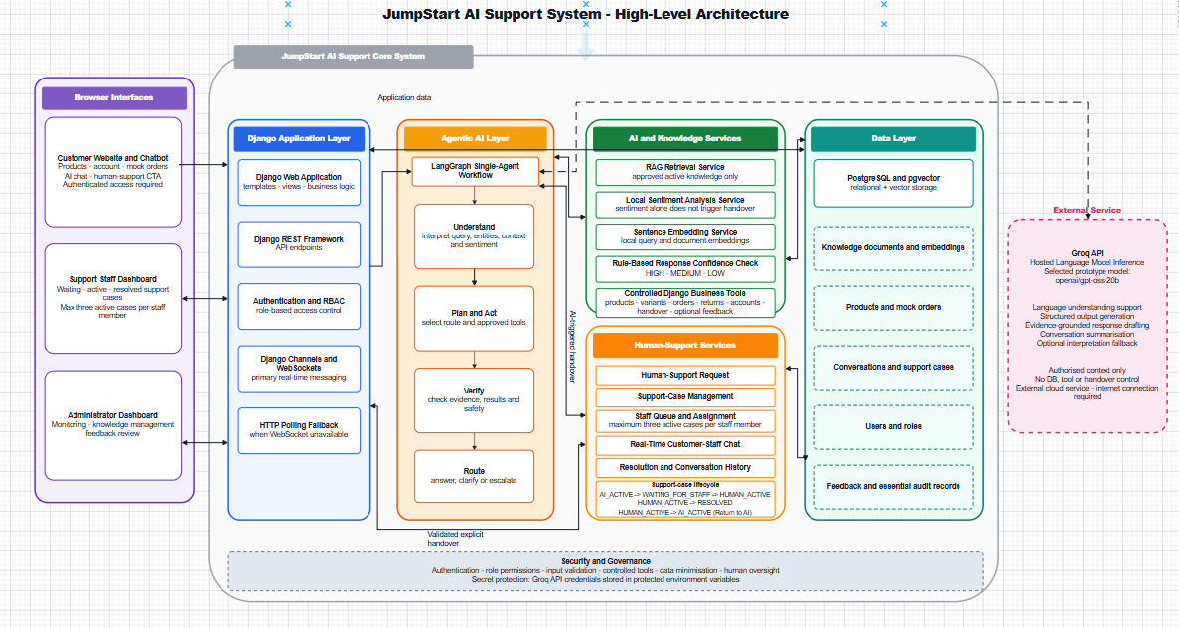
Figure 1. JumpStart AI Support System - High-Level Architecture
Architecture explanation
The left side contains three browser interfaces: the customer website and chatbot, the support staff dashboard and the administrator dashboard. All application requests pass through the Django application layer, which is responsible for authentication, role-based access control, API endpoints and real-time WebSocket communication. HTTP polling every two to three seconds is retained only as a fallback when WebSockets are unavailable.
The agentic AI layer contains one LangGraph workflow with four conceptual stages: Understand, Plan and Act, Verify, and Route. The workflow may use the approved RAG retriever, a controlled Django business tool, or both. The external Groq service provides language understanding and response drafting only from authorized context; it has no direct database, business-tool or handover control.
Two independent human-handover paths are represented. A validated explicit handover travels directly from the Django application to Human-Support Services when the customer selects the CTA or clearly asks for a person. An AI-triggered handover travels from the LangGraph workflow when deterministic routing identifies low confidence, repeated failure, a sensitive issue or an appropriate tool failure. The AI pauses while a conversation is waiting for staff or actively handled by staff.
PostgreSQL and pgvector hold users, products, mock orders, conversations, support cases, feedback, audit records, knowledge documents and vector embeddings. Security and governance form a foundation across the system through authentication, minimum data collection, controlled tools, input/output validation, human oversight and protected API credentials.

2. High-Level Use-Case Model
Figure 2 defines the main actors and the capabilities available to each role. The proposal intentionally uses three operational roles - customer, support staff and administrator - while treating a visitor as a pre-authentication actor.
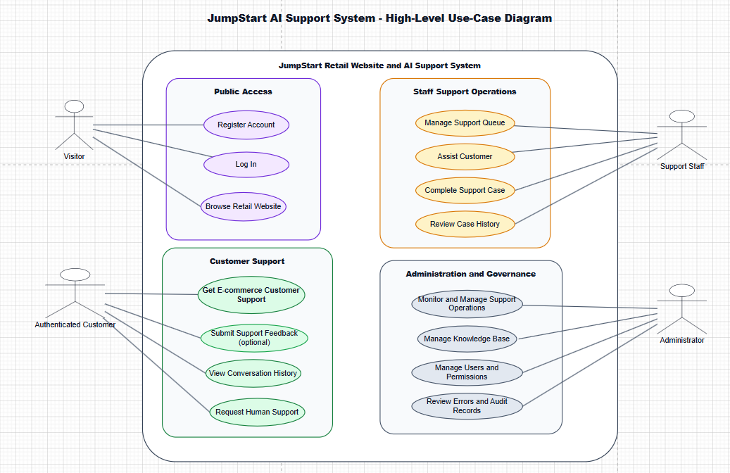
Figure 2. JumpStart AI Support System - High-Level Use-Case Diagram

Use-case explanation
A visitor can browse the retail website, register an account and log in. The visitor cannot open the support chatbot because conversation history, mock order tools and human-support cases require an authenticated identity.
An authenticated customer can request e-commerce support, view conversation history, request a human member of staff and submit optional feedback after resolution. The broad support use case includes product and policy questions, mock order enquiries, return guidance, account help, clarification and safe escalation.
Support staff manage the waiting queue, accept a case, assist the customer through real-time chat, complete the case and review resolved history. Assignment is manual and atomic: only the first valid acceptance succeeds, and each staff member may manage a maximum of three active cases.
Administrators monitor support operations, manage the approved knowledge base, manage users and permissions, and review essential errors and audit records. Supervisor-like permissions may be granted to selected staff for workload review and reassignment, but the proposal does not create a separate supervisor actor or dashboard.

3. Front-End Technologies and User Experience
The front end will use Django templates, Tailwind CSS, HTMX, Alpine.js and JavaScript. This combination supports a responsive interface without the additional complexity of a separate single-page application. Tailwind CSS will provide consistent spacing, contrast and responsive layouts; HTMX will update partial page content; Alpine.js will manage small interactive states; and JavaScript will handle WebSocket events, sound alerts, typing indicators and fallback behaviour.
The customer chat will follow a familiar messenger pattern with message bubbles, timestamps, sender labels, conversation status, a fixed input area and a visible Talk to Human Staff control. The interface must clearly distinguish AI messages from staff messages. The support dashboard will provide waiting, active and resolved views, while the administrator dashboard will prioritise monitoring, knowledge approval and feedback review.

3.1 Wire Frames of Jump Start Retail
(a). Home Page
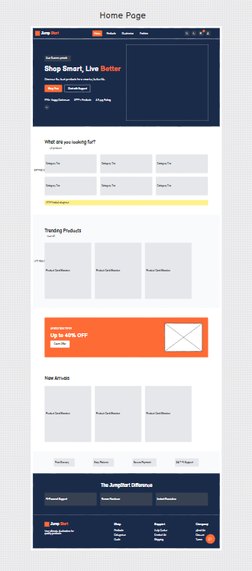
(b). Product List Page
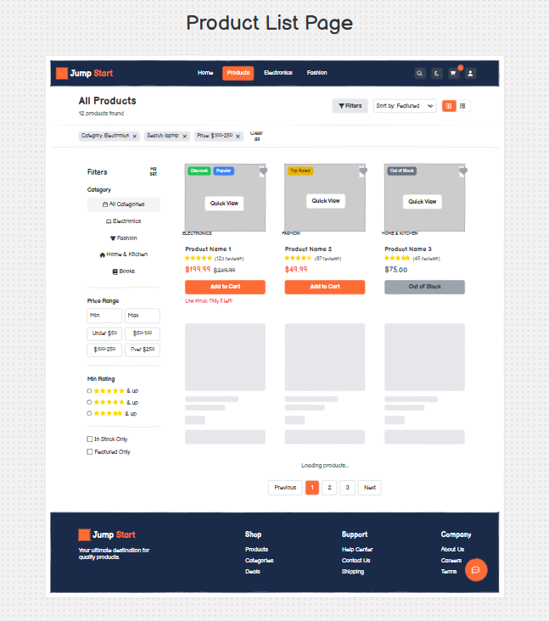
(c). Product Details Modal
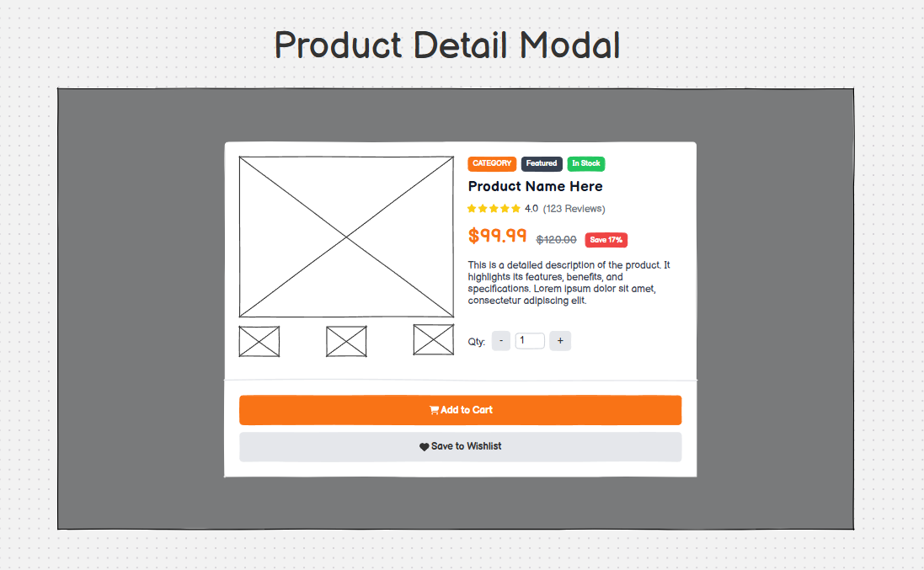
(d). Shopping Cart Drawer
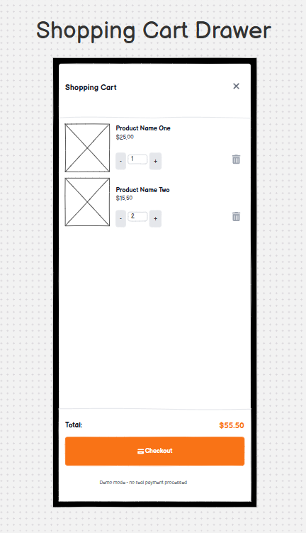
(e). SignIn Modal
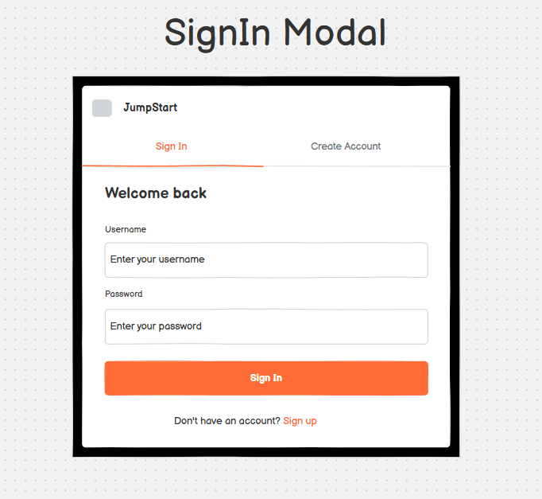
(f). Register Modal
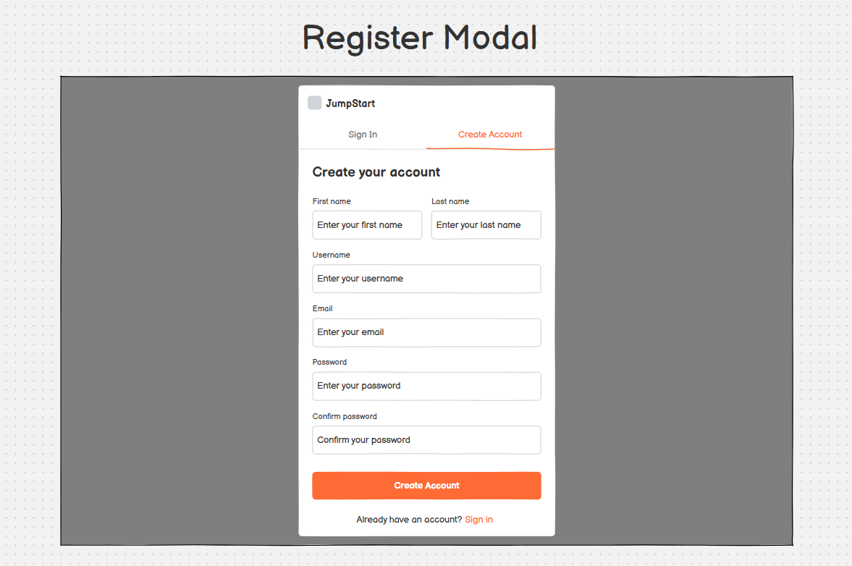
(g). Customer Dashboard Page
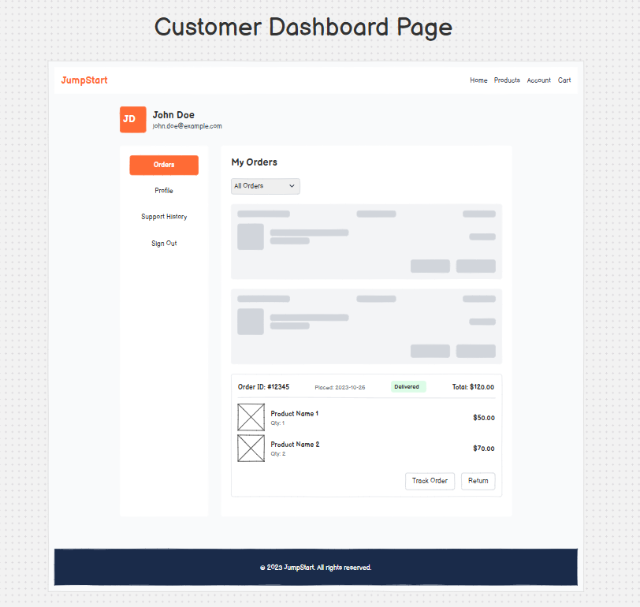
(h). Chat UI Page
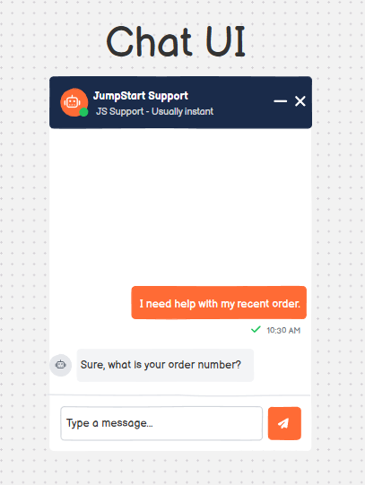
(i). Staff Dashboard Page
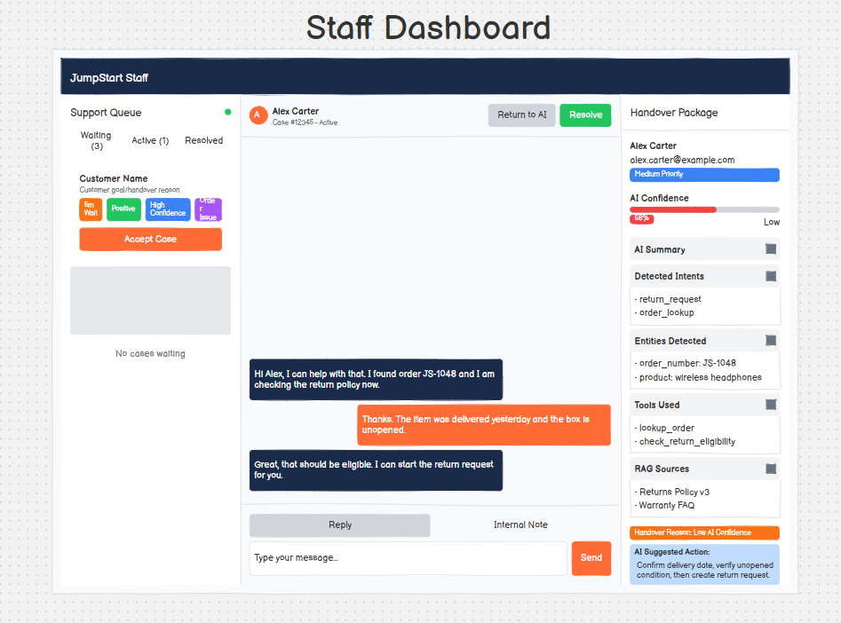
(j). Admin Dashboard Page
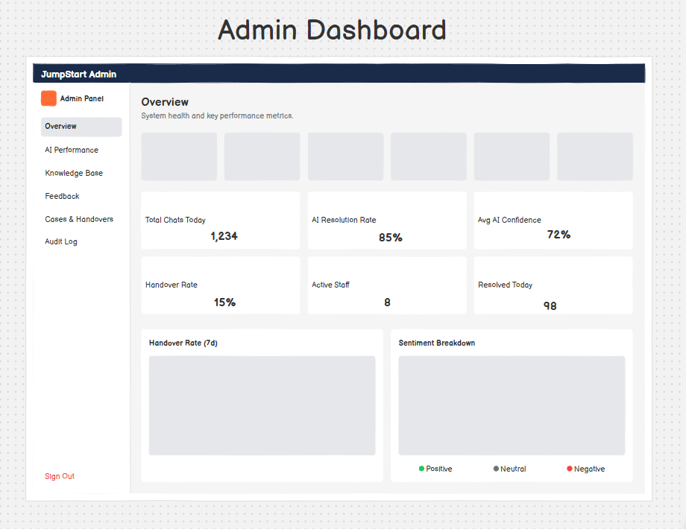
(k). Knowledge Base Page
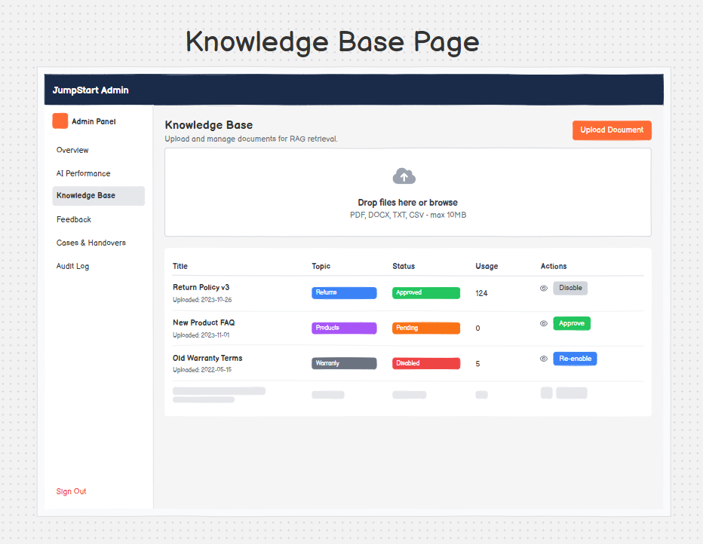

4. Back-End and API Technologies
Django will provide the main application framework, authentication, permissions, business rules and server-rendered interfaces. Django REST Framework will expose controlled endpoints where asynchronous or structured client interaction is useful. Sensitive actions will be validated in Django rather than delegated to the language model. The backend will also enforce ownership checks so that customers can access only their own conversations, mock orders and feedback.

5. Single-Agent Agentic Workflow
The workflow will be implemented with LangGraph and LangChain integrations. A conversation state record will persist the current status, interpreted intent, required information, clarification count, selected evidence, tool result, sentiment result, confidence band and handover reason. The persistent service states are AI_ACTIVE, WAITING_FOR_STAFF, HUMAN_ACTIVE and RESOLVED.
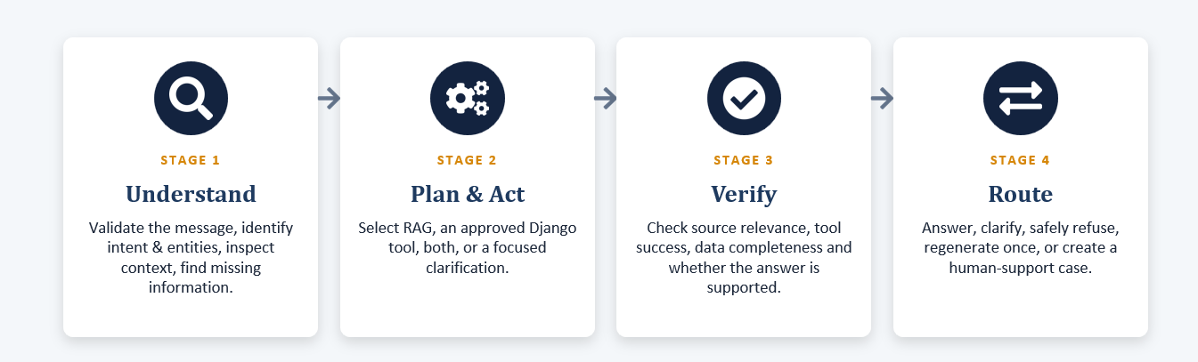
Figure 3. JumpStart AI Support System – Agentic Workflow Diagram
The workflow will permit no more than two clarification attempts and one response-regeneration attempt. A regenerated response must be verified again. These limits prevent an endless automated loop and make the transition to human support predictable.

6. RAG and Knowledge-Base Design
Administrators will be able to add, update, disable, approve and reject knowledge. Supported import formats are PDF, DOCX, TXT and CSV. Uploaded content will pass through validation, extraction and preview before approval. Only approved information will be cleaned, chunked, assigned metadata, embedded locally and stored in PostgreSQL with pgvector.
The exact Sentence Transformers model, vector dimension, chunk size, overlap, top-k value, distance metric and relevance threshold will be selected through realistic retail-support tests. This is preferable to fixing arbitrary values in the proposal. Source metadata and document status will be retained so that answers can be traced and outdated material can be disabled.
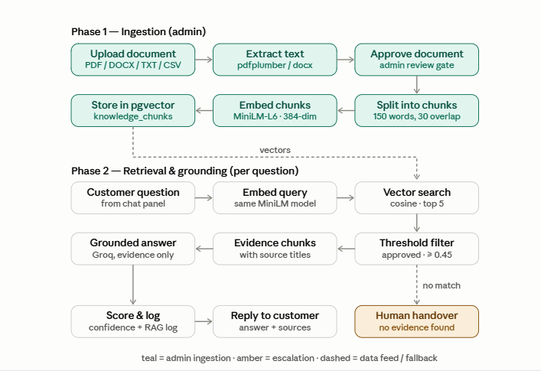
Figure 4. JumpStart AI Support System – RAG workflow Diagram

7. Sentiment, Confidence and Human Handover
A compact local Hugging Face model will provide primary sentiment analysis. Text preparation will validate input and normalise Unicode and whitespace while preserving punctuation, emojis and meaningful wording. The main language-model service is Groq, while sentiment and embeddings remain local.
Sentiment alone will not create a handover. Strong negative sentiment will contribute only when another condition is present, such as low answer confidence, repeated failure, issue sensitivity or tool failure. Answer confidence will use deterministic HIGH, MEDIUM and LOW bands based on retrieval relevance, source support, tool success, data completeness and verification results rather than a language model's self-reported certainty.
Handover route | Trigger and behaviour
Validated explicit handover | A typed request or visible CTA is validated by Django and creates a support case immediately without RAG or Groq processing.
AI-triggered handover | LangGraph routes the case when measurable evidence shows low confidence, repeated failure, a sensitive issue or an appropriate tool failure.
Waiting and active states | AI output pauses in WAITING_FOR_STAFF and HUMAN_ACTIVE. The same conversation and context are preserved for staff.
Return to AI | A staff member may use a separate action to move HUMAN_ACTIVE back to AI_ACTIVE without resolving the conversation.

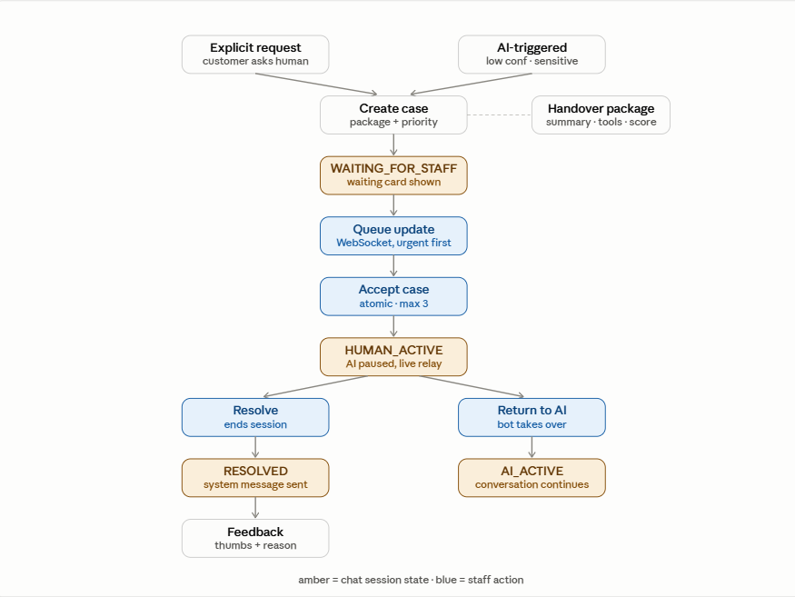
Figure 5. JumpStart AI Support System – Human Handover flow Diagram

8. Staff Dashboard and Real-Time Chat
Urgent waiting cases will appear at the top of the support queue and create visual and sound notifications for available staff. A staff member will select Accept Case, and an atomic database update will ensure that only the first valid acceptance succeeds. After acceptance, the status update will remove or update the notification for other staff in real time. Each staff member may hold a maximum of three active cases.
Django Channels and WebSockets will be the primary transport for customer-staff messages, queue updates, typing states and case status changes. HTTP polling every two to three seconds will be available as a fallback. Staff can resolve a case or return it to AI. Resolution preserves the messages in the customer history and staff Resolved/History view, and it makes optional feedback available to the customer.

9. Administrator Monitoring and Customer Feedback
The administrator dashboard will provide proportionate oversight rather than invasive surveillance. It will allow authorized users to review conversation histories, detected intent, sentiment, confidence bands, retrieved sources, controlled tool actions, handover reasons, staff replies, errors and feedback. Negative feedback can be linked to the relevant conversation so that administrators can determine whether the issue came from knowledge, AI routing, a tool or human handling.
Feedback will be optional and displayed after resolution. The basic mechanism will use thumbs up or thumbs down. A negative response may include an optional reason and short comment. The system will automatically identify whether the support path was AI_ONLY, AI_AND_HUMAN or HUMAN_ONLY, enabling simple comparison without asking the customer to classify the interaction.

10. Database and pgvector Design
PostgreSQL will provide both relational application storage and vector storage through pgvector. Core relational areas will include users and roles, customer profiles, products and variants, mock orders and order items, chat sessions, messages, support cases, staff assignments, feedback, knowledge documents, knowledge chunks, agent actions and essential error/audit records. Foreign keys and transaction boundaries will protect consistency, especially during first-accept case assignment and conversation-state changes.
Vector embeddings will be associated with approved knowledge chunks rather than stored as an unrelated index. Each chunk will retain its source document, metadata, approval status and update information. This design supports retrieval while allowing an administrator to disable a document and prevent its chunks from being used.

11. Flow Chart of Jump Start Retail
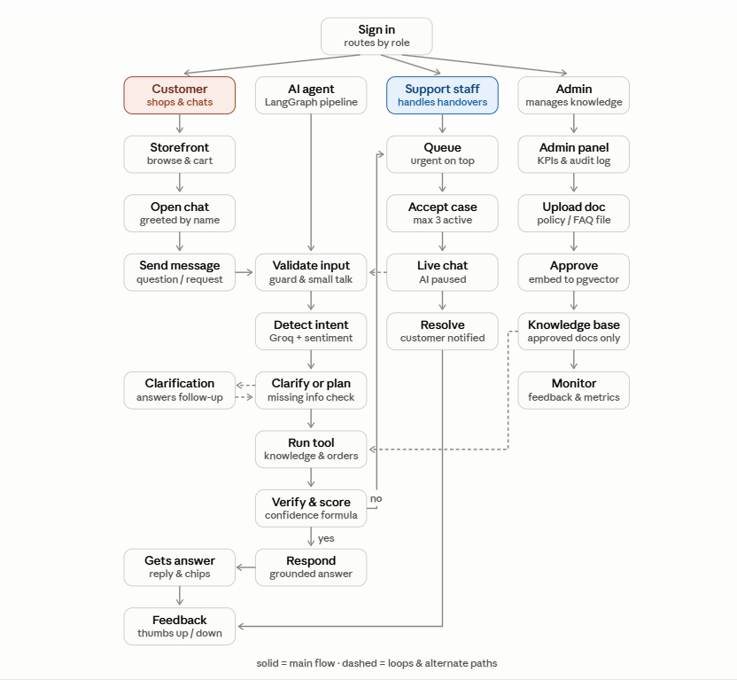

12. Chatbot Flow of Jump Start Retail
