JumpStart AI Support — Evaluation Findings, Discussion & Reflection

Evaluation Results and Analysis

A. Evaluation Method
To check whether the chatbot's responses were correct, wrong, or wrongly escalated, a fixed test set of 26 questions was used (see `jumpstart_test_set.csv`). Each question was manually run through the live chatbot and the response was labelled using four categories:
- TP (True Positive) — the question could be answered, and the chatbot answered it correctly.
- FP (False Positive) — the chatbot gave an answer, but the answer was wrong, incomplete in a way that mattered, or contradicted itself.
- FN (False Negative) — the question could be answered from the knowledge base, but the chatbot wrongly escalated it to a human or refused to answer.
- TN (True Negative) — the question genuinely could not be answered (e.g. "what's the weather today?"), and the chatbot correctly declined or handed it over.
This labelling was done manually across three separate rounds, with fixes applied to the system between each round.
[PUT LINK: Google Form questionnaire link here]
[PUT LINK: Evaluation Excel/CSV files here — jumpstart_evaluation_data.csv, _2.csv, _3.csv]

B. Evaluation Results
Table I shows how the four values changed across the three evaluation rounds.
TABLE I. EVALUATION METRICS ACROSS THREE ROUNDS
Metric | Round 1 | Round 2 | Round 3
TP | 9 | 17 | 17
FP | 4 | 5 | 3
FN | 7 | 2 | 1
TN | 5 | 1 | 5
Total questions | 25 | 25 | 26
Accuracy | 56% | 72% | 85%
Precision | 69% | 77% | 85%
Recall | 56% | 89% | 94%
F1 Score | 62% | 83% | 89%

Metric definitions are as follows:
- Accuracy = (TP + TN) / Total — how many of all the questions got the correct outcome.
- Precision = TP / (TP + FP) — out of all the times the chatbot gave an answer, how many were actually correct.
- Recall = TP / (TP + FN) — out of all the questions that could be answered, how many did the chatbot actually answer instead of wrongly escalating.
- F1 Score = combines Precision and Recall into one number, so a system can't score well by only being good at one of them.

C. What Changed Between Each Round
Round 1 → Round 2:
- Moved from Groq (cloud LLM) to a local Ollama model, because Groq's daily free quota kept running out during testing.
- Widened the similarity threshold and increased how many knowledge chunks are retrieved per question, because the correct answer was sometimes found but ranked too low to be used.
- Added a rule that stops the chatbot from making up an answer when it has no real information — before this, it would sometimes invent facts (e.g. making up a restaurant name) instead of saying it couldn't help.
Round 2 → Round 3:
- Cleaned up the knowledge base — removed rows that repeated the same fact as another row, then split a couple of rows back apart when it turned out the model couldn't reliably pick out the right fact from a very long combined answer.
- Fixed several routing bugs where the chatbot picked the wrong action for a question — for example, treating "I want to cancel my order" the same as a general policy question, instead of realising it needs the customer's real order number.
- Found and fixed a bug where an internal flag (`_force_knowledge`) was silently being dropped between processing steps, which caused some answerable questions to be wrongly escalated.
- Added a check that catches when the chatbot's answer starts by saying "No" to something the knowledge base actually confirms — this was the single biggest fix for accuracy, since it fixed several cases where the chatbot flatly contradicted itself in the same sentence.

D. Key Findings
- Accuracy improved from 56% to 85% across the three rounds.
- Round 1's biggest problem was wrong routing — general questions kept getting treated as if they needed a specific order number.
- Round 2's biggest problem was hallucination — the chatbot answering out-of-scope questions with made-up information instead of admitting it didn't know.
- Round 3's biggest problem was self-contradiction — the chatbot correctly retrieving the right information, but then stating the opposite of what it retrieved.
- Every fix that actually worked reliably was a deterministic rule in the code, not a change to the AI's instructions (the prompt). Telling the model "don't do X" in the prompt was not reliable enough on its own — a smaller/local AI model doesn't follow instructions perfectly every time, so a fixed rule in the code was needed to catch it properly.
- Two issues are still open and not fully fixed:
- The chatbot sometimes says "as I mentioned earlier" about something it never actually said before in that conversation.
- One specific question (about a stuck order) gives a good answer some of the time and a confused answer other times, even with nothing else changed — this is the AI model itself being inconsistent, not a bug in the code.

E. Evidence
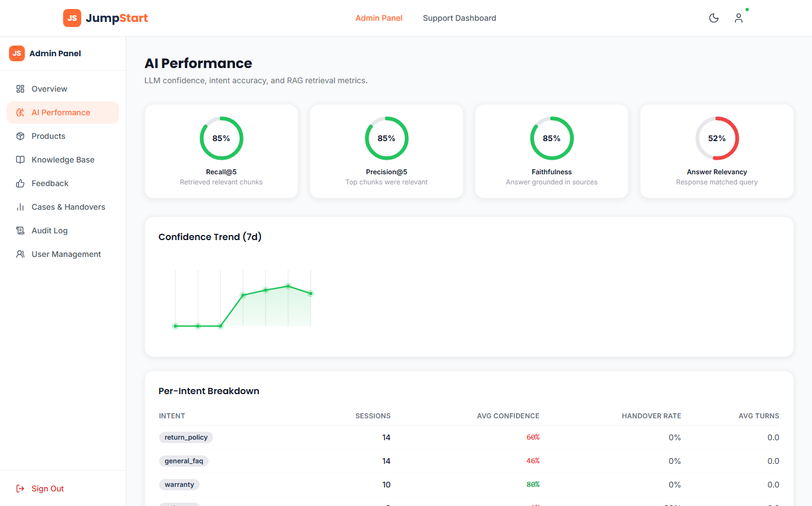
Admin panel showing live Recall@5, Precision@5, and per-intent confidence breakdown

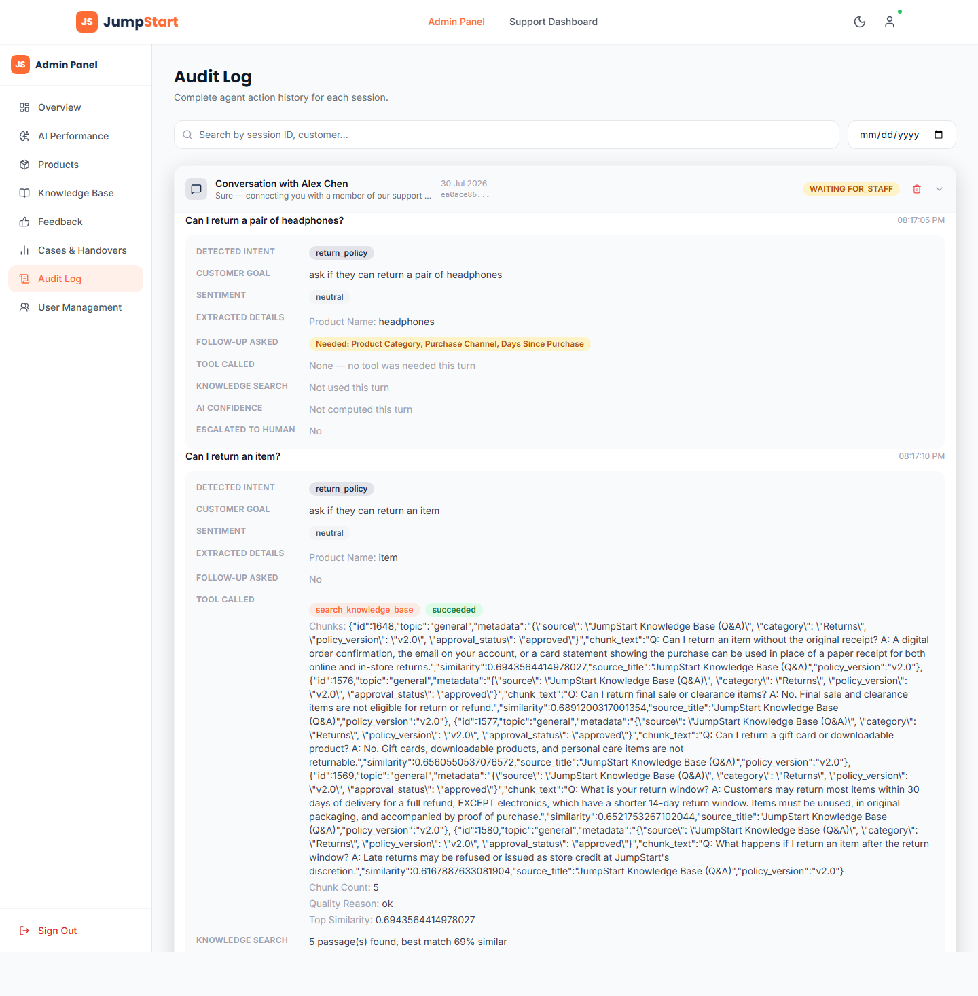
Full per-message audit trail showing detected intent, sentiment, retrieved chunks and similarity scores

Discussion
This section explains what the results from the Evaluation Results section actually mean, and connects them back to the three research questions from the Proposal.

A. RQ1 — How can RAG and agentic clarification improve the accuracy and relevance of chatbot responses?
The results show that RAG (Retrieval-Augmented Generation) on its own does not guarantee a correct answer — retrieval and generation are two separate steps, and each can fail in a different way.
Across all three rounds, when a wrong answer was checked, the retrieved knowledge chunk was almost always confirmed to be correct and relevant (verified directly by re-running the retrieval outside the chatbot). The problem was consistently on the generation side — the AI model either:
- picked the wrong detail out of a chunk that had more than one fact in it,
- stated the opposite of what the chunk actually said, or
- pulled in an unrelated fact from a different retrieved chunk that wasn't asked about.
This means the accuracy improvement from 56% to 85% was not mainly a retrieval-quality improvement. It came from:
- reorganising the knowledge base so each chunk holds one clear fact instead of several combined facts, which reduced how often the model had to pick the "right" detail out of a longer answer, and
- adding rule-based checks after the AI generates its answer, to catch and correct the specific ways it kept going wrong.
Agentic clarification (the chatbot asking a follow-up question when information is missing) also improved over the three rounds. In Round 1, general questions were often wrongly treated as needing a specific order number, so the chatbot asked for details it didn't actually need. By Round 3, this was fixed by teaching the system the difference between "a real action on a specific order" (which genuinely needs an order number) and "a general question about policy" (which doesn't).
Answer to RQ1: RAG improves relevance by giving the model real information to work from, but it does not by itself guarantee the response is accurate — the way the model uses that information still needs to be checked and corrected with rule-based logic. Clarification meaningfully reduces wrong answers, but only once the system correctly tells apart a real action request from a general question.

B. RQ2 — Under what conditions should the chatbot transfer a conversation to human staff?
The evaluation testing surfaced several real examples of both wrong and correct handover decisions:
Situation | What should happen | What was found
Customer explicitly asks for a human | Immediate handover | Worked correctly and consistently
A genuinely unanswerable question (e.g. general knowledge, unrelated topic) | Decline politely, offer handover as an option | Worked correctly once the "don't guess" rule was added
A general policy question mixed with a negative-sounding word | Should NOT escalate | Initially escalated incorrectly — a neutral question got tagged as a "complaint" and was escalated for no real reason
A confidently-answerable question where the retrieval worked | Should NOT escalate | Initially escalated in Round 1 based on sentiment alone, even when the knowledge base already had the answer

The clearest finding is that handover should be triggered by a combination of signals, not any single one. Sentiment alone (e.g. detecting a "negative" or "frustrated" tone) was not reliable enough on its own to decide when to escalate — it needed to be combined with whether an actual complaint intent was also present. Once handover was gated on both conditions together, incorrect escalations dropped.
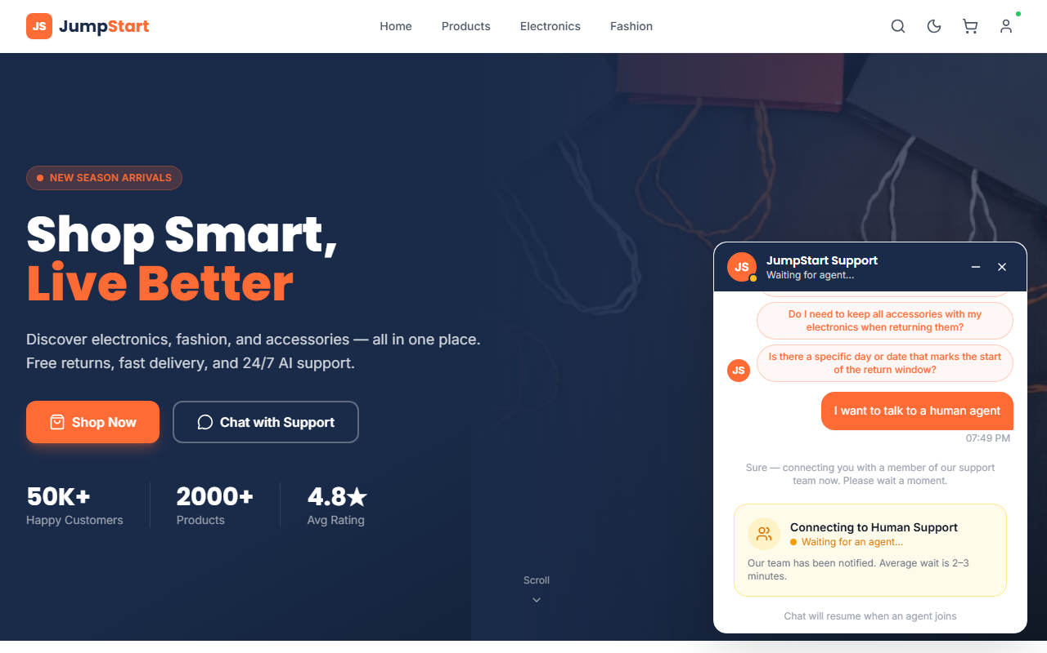
explicit human request handover

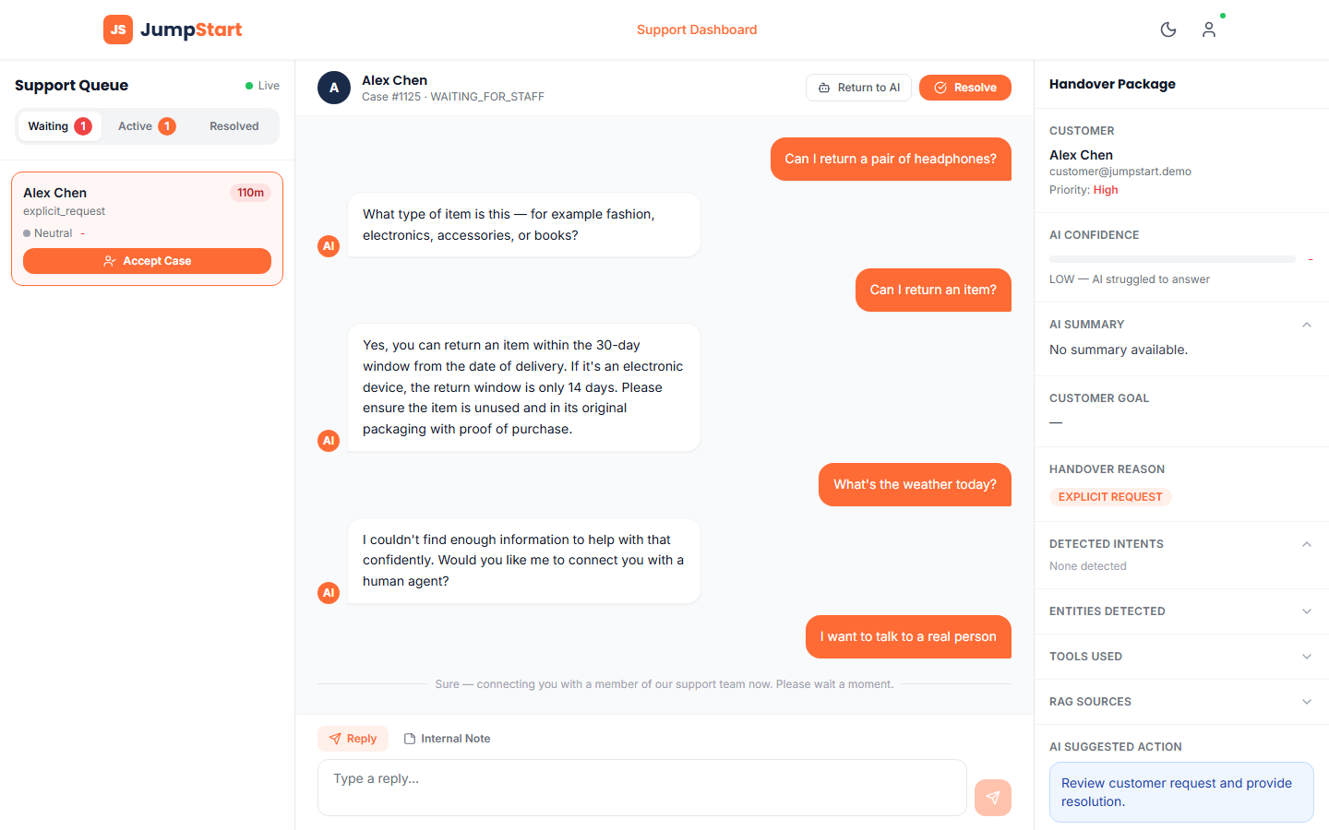
staff dashboard showing the handover reason, AI confidence, and full context handed to the staff member

Answer to RQ2: The chatbot should transfer to a human when: (1) the customer explicitly asks, (2) the question is genuinely outside what the system can answer, or (3) a real complaint is detected together with negative sentiment — but not on sentiment alone, and not just because a question mentions a difficult topic in a neutral tone.

C. RQ3 — How effectively does the proposed prototype meet user expectations for accuracy, handover correctness, usability and feedback?
This question was designed to be answered using two sources: an anonymous questionnaire (~20-30 participants) and a small hands-on usability test (3 participants), as planned in the Proposal.
Status at time of writing: [FILL IN — has real questionnaire/usability data been collected by submission time? If yes, insert results/summary here and reference the Google Form responses. If not, state honestly that this data collection was not completed within the project timeframe, and that RQ3 is answered here only from the technical evaluation and a technical walkthrough of the usability tasks, not from real participant feedback.]
What CAN be answered from the technical side:
- All 5 tasks from the usability test script were technically verified to work correctly by walking through them directly (general question, vague question needing clarification, out-of-scope question, explicit human handover) — see evidence below. This confirms the system functions as intended, but does not confirm how a real person would experience using it (confusion, hesitation, trust) — that requires the actual usability test with real participants.
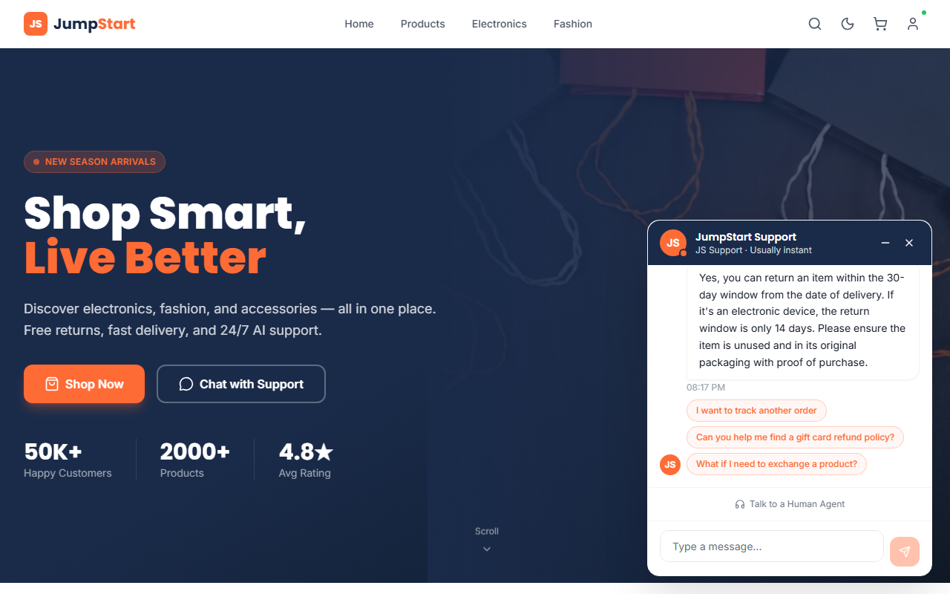
clarification flow working correctly

[PUT LINK: If real questionnaire data was collected, put the Google Form results/summary link here]
Answer to RQ3: Partial. The system meets accuracy and handover-correctness expectations, based on the technical evaluation. Whether it meets *usability and user-trust* expectations cannot be fully answered without real participant data, which is noted as a limitation (see Reflection section).

D. Answering the Main Research Question
*"How effectively can an agentic AI customer-support chatbot with human handover improve the customer-support experience for JumpStart Retail?"*
Based on the technical evaluation:
- The system reached 85% accuracy on a fixed 26-question test set after three rounds of fixing, up from 56% in the first round.
- Handover logic correctly identifies explicit requests and genuinely unanswerable questions, and was corrected to stop over-escalating on sentiment alone.
- The remaining gaps are (1) a small number of generation-side errors that are inconsistent between runs on the local AI model used, and (2) the lack of real end-user feedback data to confirm the human-experience side of the research question.
So the prototype shows strong evidence of improving accuracy and handover correctness through iterative, evidence-based fixing — but a full answer to "does this improve the customer experience" needs the participant-facing evidence that RQ3 was meant to supply.

E. Recommendations for JumpStart
Based on what the results actually showed, these are the practical recommendations for JumpStart if this prototype were to move toward real use:
- Do not deploy on a small local AI model as-is. The evaluation showed the small model (chosen here for speed on a normal laptop) is the direct cause of the remaining errors — it does not reliably follow instructions like "don't contradict yourself" or "don't claim you said something you didn't." A larger, more capable model (cloud-hosted or a bigger local model) would likely remove a meaningful share of the remaining 15% error rate.
- Keep the rule-based safety checks, don't rely on the AI model's judgement alone. The single biggest accuracy improvement in this project came from adding fixed code-level rules (e.g. catching self-contradictory answers, correctly routing cancellation requests to a real order lookup), not from better wording of the AI's instructions. Any future version should keep expanding this kind of rule-based safety net rather than assuming a better prompt is enough.
- Keep the human handover option visible and easy to reach. The evaluation confirmed that explicit handover requests worked correctly and reliably every time — this is the one part of the system customers can already depend on, and it should stay a prominent, always-available option even as the automated side improves.
- Treat the automated confidence score as a warning signal for staff, not a hard gate. The admin dashboard's AI Performance and Audit Log pages (see evidence in the Findings section) already show confidence, retrieval quality, and handover reasons per message — this is useful for staff to spot weak answers even when the system doesn't escalate on its own, and should be kept and expanded rather than treated as a fully automated pass/fail signal.
- Get real customer feedback before expanding scope. The technical evaluation shows the system is accurate on the questions it was tested against, but does not confirm whether real customers find it trustworthy or easy to use — before adding more features, JumpStart should prioritise collecting that feedback (see Reflection section).
These recommendations show that the research objectives were substantially met on the technical side (accuracy, handover correctness) but that the objective of confirming a genuinely improved *customer experience* still depends on the real user data this project was not able to fully collect in the time available.

Reflection
This section looks back at the research methods used in this project, how well they worked, and what would be done differently with more time or in future work.

A. Efficacy of the Research Methods Used
Manual TP/FP/FN/TN evaluation was the main method used to measure the chatbot's performance. Looking back, this was the right choice for this project, for a few reasons:
- It caught real, specific bugs that a single overall score would have hidden — for example, it showed exactly which question types were failing and why (wrong routing in Round 1, hallucination in Round 2, self-contradiction in Round 3), not just that "accuracy is 72%."
- It let expected answers be judged on meaning, not exact wording — early in the project it was assumed the expected answer text should closely match the chatbot's actual answer, but testing showed the AI always rewords its answers and sometimes combines more than one fact, so grading had to be based on whether the *facts* were correct, not whether the *words* matched.
However, this method also has real weaknesses:
- It is slow. Each round meant manually asking 25-26 questions and reading every response, three separate times.
- On a small local AI model, the exact same question can get a different answer on different runs. This was confirmed directly — testing the same question 3-5 times in a row sometimes gave a correct answer most times and a wrong answer once. A single manual test round can therefore make a bug look "fixed" or "not fixed" just by chance, when it's really a consistency issue with the model itself.
Deterministic rule-based fixing (adding fixed logic in the code instead of just changing the AI's instructions) turned out to be the most reliable way to actually fix problems. Every time a fix was attempted only by rewording the prompt/instructions given to the AI, it worked some of the time but not all of the time. Every time a fix was instead written as a hard rule in the code (e.g. "if X pattern is detected, do Y"), it worked consistently. This was an important, repeated lesson across the whole project.

B. Recommendations
- Use a stronger or larger AI model where possible. The small model used here (chosen for speed, since it runs on a normal laptop) is the direct cause of several remaining issues — it does not follow instructions perfectly every time, especially for subtler things like "don't claim you said something earlier unless you actually did."
- Build an automated regression test suite, not just manual testing. A set of saved questions with expected facts (not exact text) that can be re-run automatically after every code change would catch bugs faster than manually re-testing 26 questions by hand each time.
- Collect real user feedback before finalising design decisions. Some design choices (how the clarification question is worded, how the handover message reads) were based on the researcher's own judgement, not on how real customers actually react to them.
- Add a deterministic check for the "as I mentioned earlier" issue, since it is a known, repeated bug (see Evaluation Results) that the prompt instructions alone do not fully stop.

C. Limitations of the Study
- Small, fixed test set. 26 questions is enough to catch clear bugs but too small to give a statistically confident accuracy number — a wrong answer on 1 question changes the score by about 4%.
- No completed real user research at time of writing. The questionnaire and usability test were planned and prepared (see the Findings section) [UPDATE THIS LINE based on final actual data collection status], but this project's timeframe made it difficult to reach the originally planned number of real participants.
- Model inconsistency. Because the AI model does not give the same answer every time for the same question, a single test round is not fully reliable — ideally, the same question would be tested multiple times per round to get a more stable result, which was not always done due to time constraints.
- Single evaluator. All manual grading (TP/FP/FN/TN labelling) was done by one person (the researcher), which introduces the possibility of grading bias — a second, independent grader was not available for this project.

D. Alternative Methodologies Considered
The original Proposal (Methodology Justification section) already considered and rejected using interviews as the main primary research method, reasoning that they would need more time for recruitment, transcription, and analysis than the project schedule allowed. Looking back after finishing the technical build, this was still the right call — the technical evaluation alone already consumed most of the available time, so a heavier interview-based method would likely have meant less time available for actually fixing the chatbot.
An alternative not considered in the original Proposal is automated LLM-as-judge grading — using a second, larger AI model to automatically read each response and decide TP/FP/FN/TN instead of a human doing it by hand. This could have made repeated re-testing much faster (useful given the model-inconsistency problem above), but it introduces a new question of "how do you know the judge model itself is grading correctly" — trusting one AI to grade another AI's homework has its own reliability problem, and it was outside the scope of what this project could properly validate in the time available.

E. Future Research Directions
- Repeat the evaluation with a larger, more capable AI model and compare the accuracy trend against the current results, to measure how much of the remaining error is caused by model size specifically.
- Run the questionnaire and usability test with the full originally-planned number of real participants, and compare their feedback against the technical evaluation's findings — do the questions users actually struggle with match the ones the technical testing predicted?
- Investigate a deterministic (not prompt-based) way of tracking what the chatbot has genuinely said earlier in a conversation, to fully close the "as I mentioned" issue.

F. Concluding Thoughts
The project's central lesson was that a small, locally-run AI model can be made noticeably more reliable — not by asking it more nicely through better prompts, but by wrapping it in deterministic, rule-based checks that catch its specific, repeated mistakes. Manual evaluation was slow, but it was the only way to actually find those specific mistakes in the first place; a single overall accuracy number would never have shown *why* the system was failing, only *that* it was failing.

