PROGRAM CODE

tcp_server.c
#include <stdio.h>
#include <stdlib.h>
#include <sys/socket.h>
#include <netinet/in.h>
#include <unistd.h>

#define PORT 8000

void main() {
int server_fd, client_fd;
struct sockaddr_in address;
int addrlen = sizeof(address);
char buff[6];

printf("TCP Server\n");

if((server_fd = socket(AF_INET, SOCK_STREAM, 0)) < 0) {
printf("Socket creation failed!\n");
exit(1);
} else {
printf("Server socket created.\n");
}

address.sin_family = AF_INET;
address.sin_addr.s_addr = INADDR_ANY; //OR inet_addr("172.20.34.12")
address.sin_port = htons(PORT);

if(bind(server_fd, (struct sockaddr*) &address, addrlen) < 0) {
printf("Binding failed!\n");
exit(1);
} else {
printf("Socket binded.\n");
}

if(listen(server_fd, 5) < 0) {
printf("Listening failed!\n");
exit(1);
} else {
printf("Listening.\n");
}

if((client_fd = accept(server_fd, (struct sockaddr*) &address, (socklen_t*) &addrlen)) < 0) {
printf("Accept failed!\n");
exit(1);
} else {
printf("Connection accepted.\n");
}

if(recv(client_fd, buff, 6 * sizeof(char), 0) < 0) {
printf("Receive failed!\n");
exit(1);
} else {
printf("Received message: %s\n", buff);
}

close(server_fd);
close(client_fd);
}

tcp_client.c
#include <stdio.h>
#include <stdlib.h>
#include <sys/socket.h>
#include <arpa/inet.h>
#include <unistd.h>

#define PORT 8000

void main() {
int client_fd;
struct sockaddr_in serv_addr;
char buff[] = "HELLO";

printf("TCP Client\n");

if((client_fd = socket(AF_INET, SOCK_STREAM, 0)) < 0) {
printf("Socket creation failed!\n");
exit(1);
} else {
printf("Client socket created.\n");
}

serv_addr.sin_family = AF_INET;
serv_addr.sin_addr.s_addr = INADDR_ANY; //OR inet_addr("172.20.34.12")
serv_addr.sin_port = htons(PORT);

if(connect(client_fd, (struct sockaddr*) &serv_addr, sizeof(serv_addr)) < 0) {
printf("Connection failed!\n");
exit(1);
} else {
printf("Connected to server.\n");
}

if(send(client_fd, buff, 6 * sizeof(char), 0) < 0) {
printf("Sending failed!\n");
exit(1);
} else {
printf("Message sent: %s\n", buff);
}

close(client_fd);
}

udp_server.c
#include <stdio.h>
#include <stdlib.h>
#include <unistd.h>
#include <sys/socket.h>
#include <netinet/in.h>
#include <string.h>

#define PORT 8000

void main() {
int server_fd;
struct sockaddr_in serv_addr, cli_addr;
char buff[6];

printf("UDP Server\n");

if((server_fd = socket(AF_INET, SOCK_DGRAM, 0)) < 0) {
printf("Socket creation failed!\n");
exit(1);
} else {
printf("Server socket created.\n");
}

serv_addr.sin_family = AF_INET;
serv_addr.sin_addr.s_addr = INADDR_ANY; //OR inet_addr("172.20.34.12")
serv_addr.sin_port = htons(PORT);

if(bind(server_fd, (struct sockaddr*) &serv_addr, sizeof(serv_addr)) < 0) {
printf("Binding failed!\n");
exit(1);
} else {
printf("Socket binded.\n");
}

int len = sizeof(cli_addr);

if(recvfrom(server_fd, (char*) buff, 6 * sizeof(char), 0, (struct sockaddr*) &cli_addr, &len) < 0) {
printf("Receive failed!\n");
exit(1);
} else {
printf("Received message: %s\n", buff);
}

close(server_fd);
}

udp_client.c
#include <stdio.h>
#include <stdlib.h>
#include <sys/socket.h>
#include <arpa/inet.h>
#include <unistd.h>

#define PORT 8000

void main() {
int client_fd;
struct sockaddr_in serv_addr;
char buff[] = "HELLO";

printf("UDP Client\n");

if((client_fd = socket(AF_INET, SOCK_DGRAM, 0)) < 0) {
printf("Socket creation failed!\n");
exit(1);
} else {
printf("Client socket created.\n");
}

serv_addr.sin_family = AF_INET;
serv_addr.sin_addr.s_addr = INADDR_ANY; //OR inet_addr("172.20.34.12")
serv_addr.sin_port = htons(PORT);

if(sendto(client_fd, buff, 6 * sizeof(char), 0, (struct sockaddr*) &serv_addr, sizeof(serv_addr)) < 0) {
printf("Sending failed!\n");
exit(1);
} else {
printf("Message sent: %s\n", buff);
}

close(client_fd);
}

OUTPUT

TCP
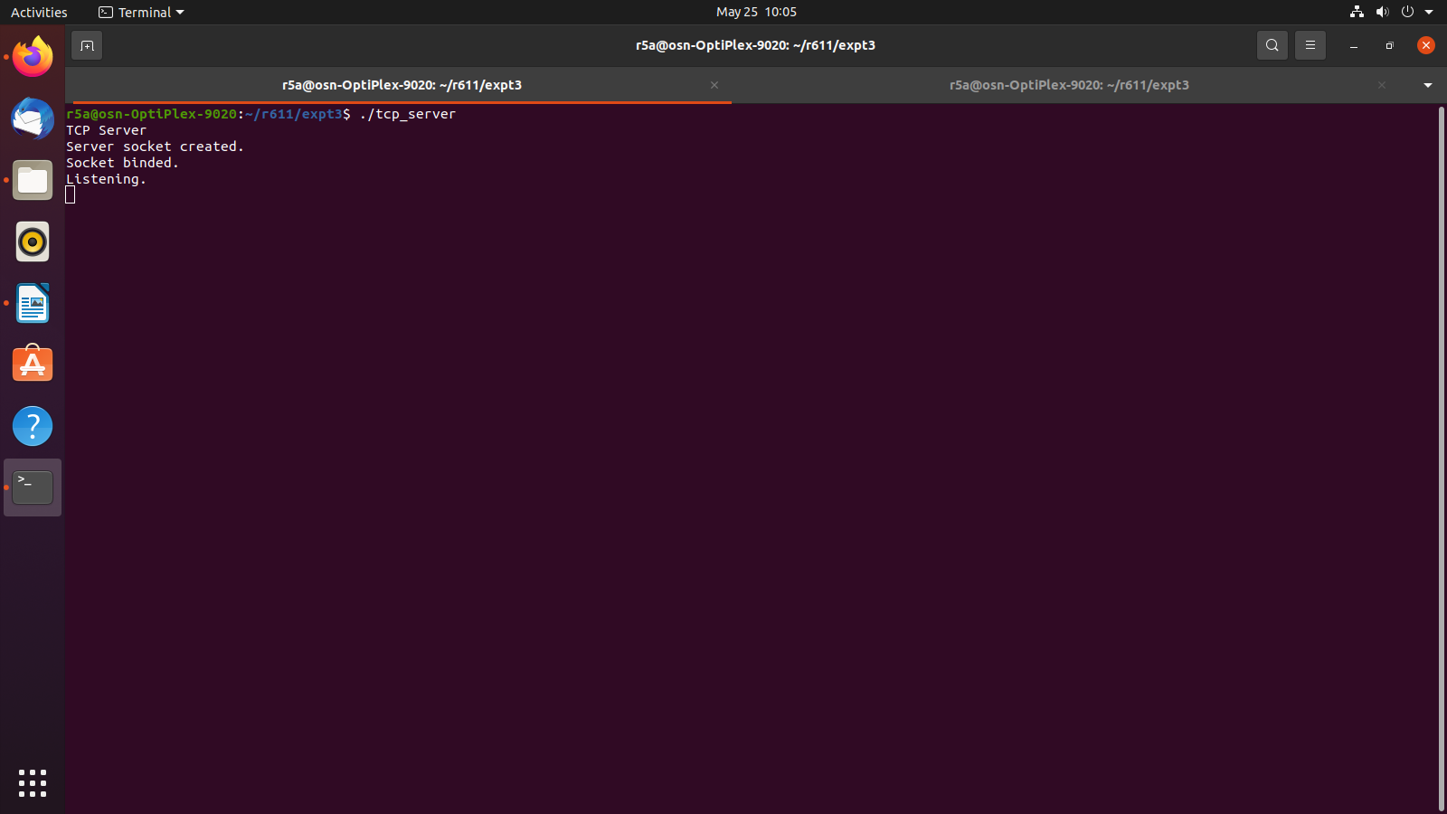
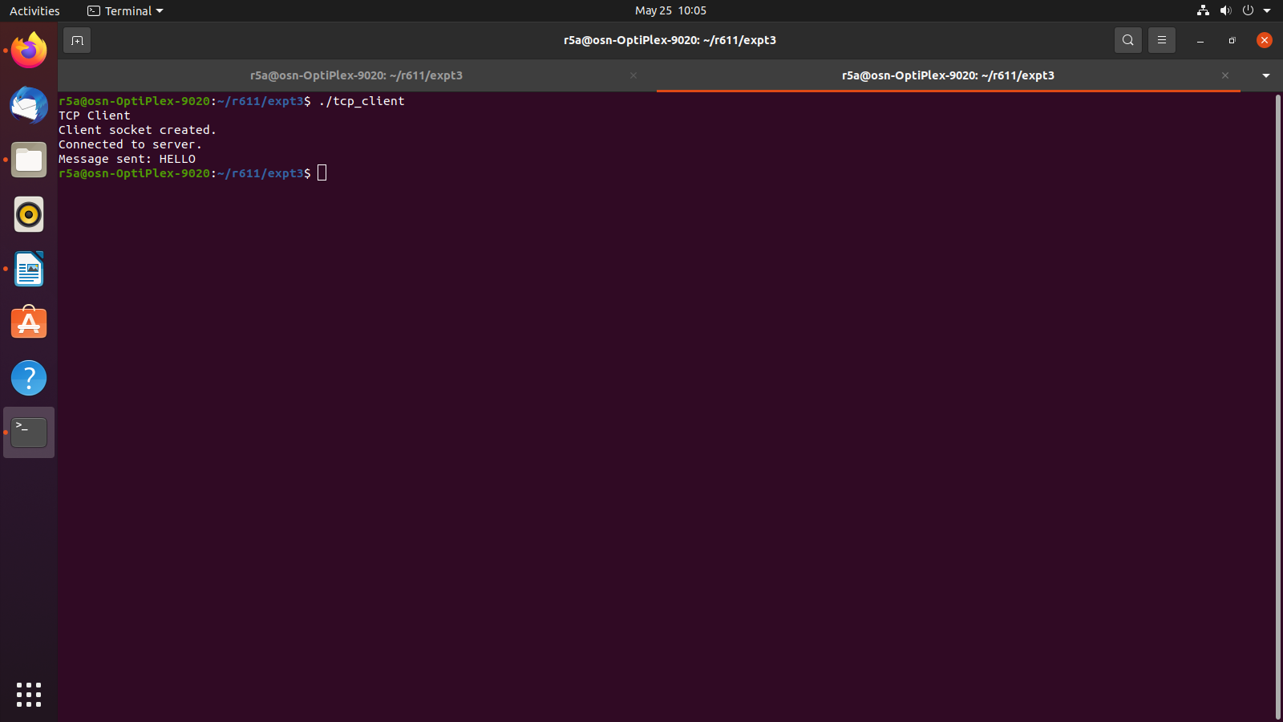
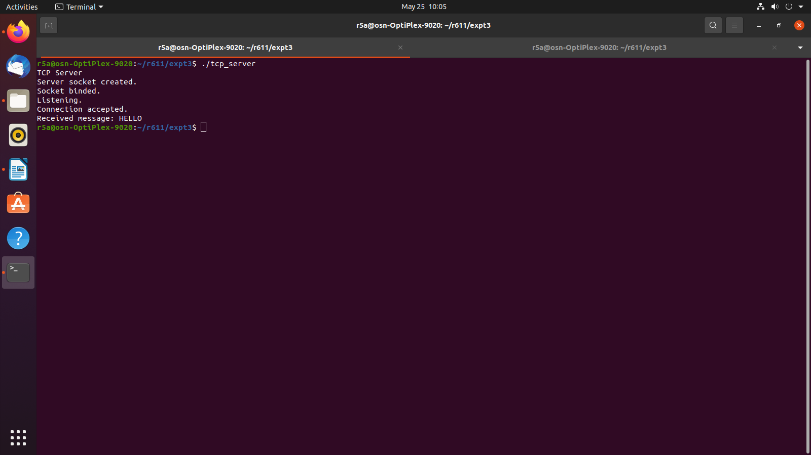

UDP
