PROGRAM CODE

tcp_server.c
#include <stdio.h>
#include <stdlib.h>
#include <sys/socket.h>
#include <arpa/inet.h>
#include <unistd.h>

#define PORT 8000

float findMin(float *buff, int n) {
int min = 0;
for(int i = 0; i < n; i++) {
if (buff[min] > buff[i])
min = i;
}
return buff[min];
}

float findMax(float *buff, int n) {
int max = 0;
for(int i = 0; i < n; i++) {
if (buff[max] < buff[i])
max = i;
}
return buff[max];
}

float findAvg(float *buff, int n) {
float avg = 0;
for(int i = 0; i < n; i++) {
avg += buff[i];
}
avg /= n;
return avg;
}

void main() {
int server_fd, client_fd;
struct sockaddr_in address;
int n, addrlen = sizeof(address);
float *buff, output[3];

printf("TCP Server\n");

if((server_fd = socket(AF_INET, SOCK_STREAM, 0)) < 0) {
printf("Socket creation failed!\n");
exit(1);
} else {
printf("Server socket created.\n");
}

address.sin_family = AF_INET;
address.sin_addr.s_addr = INADDR_ANY;
address.sin_port = htons(PORT);

if(bind(server_fd, (struct sockaddr*) &address, addrlen) < 0) {
printf("Socket binding failed!\n");
exit(1);
} else {
printf("Socket binded.\n");
}

if(listen(server_fd, 5) < 0) {
printf("Listening failed!\n");
exit(1);
} else {
printf("Server listening.\n");
}

if((client_fd = accept(server_fd, (struct sockaddr*) &address, (socklen_t*) &addrlen)) < 0) {
printf("Connection failed!\n");
exit(1);
} else {
printf("Connected to client.\n");
}

if(recv(client_fd, &n, sizeof(int), 0) < 0) {
printf("Receive failed!\n");
exit(1);
} else {
buff = (float*) malloc(n * sizeof(float));

if(recv(client_fd, buff, n * sizeof(float), 0) < 0) {
printf("Receive failed!\n");
exit(1);
} else {
printf("Received data:");
for(int i = 0; i < n; i++) {
printf(" %.1f", buff[i]);
}
printf("\n");
}
}

printf("Calculating min, max and avg.\n");
output[0] = findMin(buff, n);
output[1] = findMax(buff, n);
output[2] = findAvg(buff, n);

if(send(client_fd, output, 3 * sizeof(float), 0) < 0) {
printf("Send failed!\n");
exit(1);
} else {
printf("Result sent to client.\n");
}

close(server_fd);
close(client_fd);
}

tcp_client.c
#include <stdio.h>
#include <stdlib.h>
#include <sys/socket.h>
#include <arpa/inet.h>
#include <unistd.h>

#define PORT 8000

void main() {
int client_fd;
struct sockaddr_in serv_addr;
float *buff, reply[3];
int n;

printf("TCP Client\n");

client_fd = socket(AF_INET, SOCK_STREAM, 0);

if(client_fd < 0) {
printf("Socket creation failed!\n");
exit(1);
} else {
printf("Client socket created.\n");
}

serv_addr.sin_family = AF_INET;
serv_addr.sin_addr.s_addr = INADDR_ANY;
serv_addr.sin_port = htons(PORT);

if(connect(client_fd, (struct sockaddr*) &serv_addr, sizeof(serv_addr)) < 0) {
printf("Connection failed!\n");
exit(1);
} else {
printf("Connection established.\n");
}

printf("Enter size: ");
scanf("%d", &n);

buff = (float*) malloc(n * sizeof(float));

printf("Enter numbers: ");
for(int i = 0; i < n; i++)
scanf("%f", &buff[i]);

if(send(client_fd, &n, sizeof(int), 0) < 0) {
printf("Send failed!\n");
exit(1);
} else {
if(send(client_fd, buff, n * sizeof(float), 0) < 0) {
printf("Send failed!\n");
exit(1);
} else {
printf("Data sent:");
for(int i = 0; i < n; i++) {
printf(" %.1f", buff[i]);
}
printf("\nWaiting for reply.\n");
}
}

if(recv(client_fd, reply, 3 * sizeof(float), 0) < 0) {
printf("Receive failed!\n");
exit(1);
} else {
printf("Result received:\n");
printf("Min: %.1f\n", reply[0]);
printf("Max: %.1f\n", reply[1]);
printf("Avg: %.1f\n", reply[2]);
}

close(client_fd);
}

udp_server.c
#include <stdio.h>
#include <stdlib.h>
#include <sys/socket.h>
#include <arpa/inet.h>
#include <unistd.h>

#define PORT 8000

float findMin(float *buff, int n) {
int min = 0;
for(int i = 0; i < n; i++) {
if (buff[min] > buff[i])
min = i;
}
return buff[min];
}

float findMax(float *buff, int n) {
int max = 0;
for(int i = 0; i < n; i++) {
if (buff[max] < buff[i])
max = i;
}
return buff[max];
}

float findAvg(float *buff, int n) {
float avg = 0;
for(int i = 0; i < n; i++) {
avg += buff[i];
}
avg /= n;
return avg;
}

void main() {
int server_fd, client_fd;
struct sockaddr_in address, cli_addr;
int n, addrlen = sizeof(address);
float *buff, output[3];

printf("TCP Server\n");

if((server_fd = socket(AF_INET, SOCK_DGRAM, 0)) < 0) {
printf("Socket creation failed!\n");
exit(1);
} else {
printf("Server socket created.\n");
}

address.sin_family = AF_INET;
address.sin_addr.s_addr = INADDR_ANY;
address.sin_port = htons(PORT);

if(bind(server_fd, (struct sockaddr*) &address, addrlen) < 0) {
printf("Socket binding failed!\n");
exit(1);
} else {
printf("Socket binded.\n");
}

int len = sizeof(cli_addr);

if(recvfrom(server_fd, &n, sizeof(int), 0, (struct sockaddr*) &cli_addr, &len) < 0) {
printf("Receive failed!\n");
exit(1);
} else {
buff = (float*) malloc(n * sizeof(float));

if(recvfrom(server_fd, buff, n * sizeof(float), 0, (struct sockaddr*) &cli_addr, &len) < 0) {
printf("Receive failed!\n");
exit(1);
} else {
printf("Received data:");
for(int i = 0; i < n; i++) {
printf(" %.1f", buff[i]);
}
printf("\n");
}
}

printf("Calculating min, max and avg.\n");
output[0] = findMin(buff, n);
output[1] = findMax(buff, n);
output[2] = findAvg(buff, n);

if(sendto(server_fd, output, 3 * sizeof(float), 0, (struct sockaddr*) &cli_addr, len) < 0) {
printf("Send failed!\n");
exit(1);
} else {
printf("Result sent to client.\n");
}

close(server_fd);
close(client_fd);
}

udp_client.c
#include <stdio.h>
#include <stdlib.h>
#include <sys/socket.h>
#include <arpa/inet.h>
#include <unistd.h>

#define PORT 8000

void main() {
int client_fd;
struct sockaddr_in serv_addr;
float *buff, reply[3];
int n;

printf("TCP Client\n");

client_fd = socket(AF_INET, SOCK_DGRAM, 0);

if(client_fd < 0) {
printf("Socket creation failed!\n");
exit(1);
} else {
printf("Client socket created.\n");
}

serv_addr.sin_family = AF_INET;
serv_addr.sin_addr.s_addr = INADDR_ANY;
serv_addr.sin_port = htons(PORT);

printf("Enter size: ");
scanf("%d", &n);

buff = (float*) malloc(n * sizeof(float));

printf("Enter numbers: ");
for(int i = 0; i < n; i++)
scanf("%f", &buff[i]);

int len = sizeof(serv_addr);

if(sendto(client_fd, &n, sizeof(int), 0, (struct sockaddr*) &serv_addr, len) < 0) {
printf("Send failed!\n");
exit(1);
} else {
if(sendto(client_fd, buff, n * sizeof(float), 0, (struct sockaddr*) &serv_addr, len) < 0) {
printf("Send failed!\n");
exit(1);
} else {
printf("Data sent:");
for(int i = 0; i < n; i++) {
printf(" %.1f", buff[i]);
}
printf("\nWaiting for reply.\n");
}
}

if(recvfrom(client_fd, reply, 3 * sizeof(float), 0, (struct sockaddr*) &serv_addr, &len) < 0) {
printf("Receive failed!\n");
exit(1);
} else {
printf("Result received:\n");
printf("Min: %.1f\n", reply[0]);
printf("Max: %.1f\n", reply[1]);
printf("Avg: %.1f\n", reply[2]);
}

close(client_fd);
}
OUTPUT

TCP
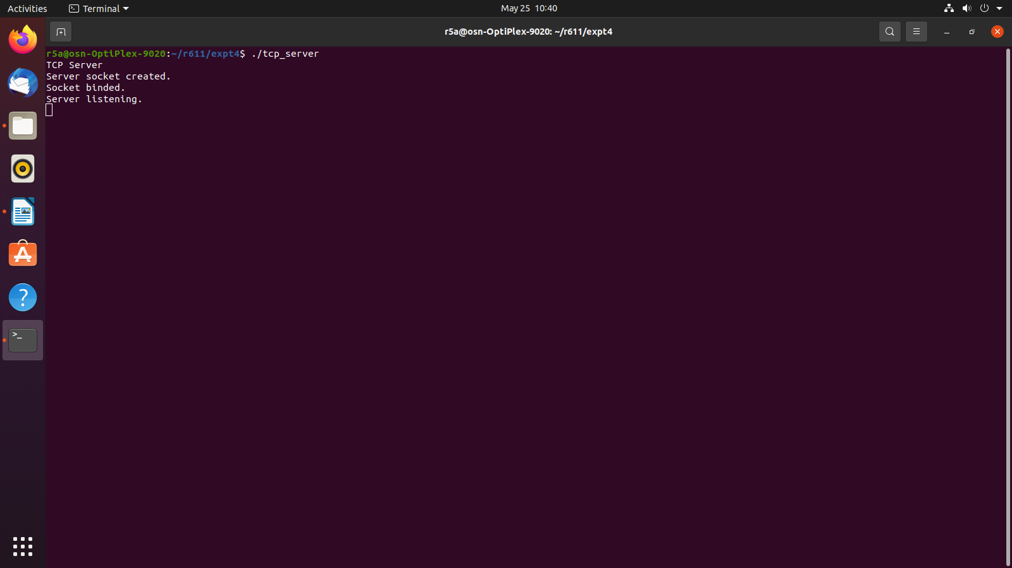
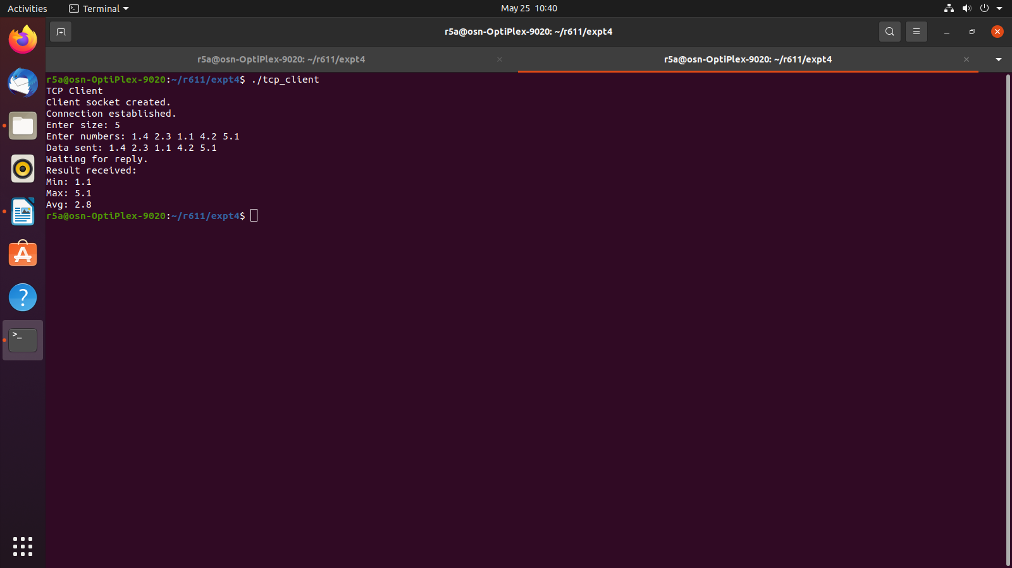
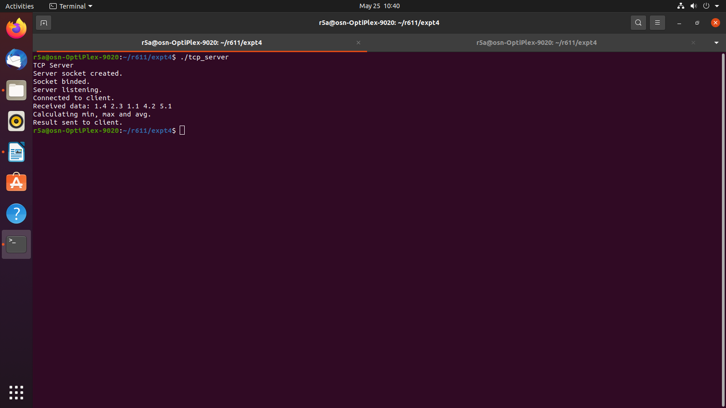

UDP
