PROGRAM CODE

server.c
#include <stdio.h>
#include <stdlib.h>
#include <sys/socket.h>
#include <arpa/inet.h>
#include <unistd.h>
#include <string.h>
#include <math.h>

#define PORT 8000
#define C1PORT 8001
#define C2PORT 8002

void main() {
int server_fd, client_fd1, client_fd2;
struct sockaddr_in address, cli_addr1, cli_addr2;
int opt, addrlen = sizeof(address);
float num;

printf("Enter 1 (TCP) or 2 (UDP): ");
scanf("%d", &opt);

if(opt == 1)
printf("TCP Server\n");
else if(opt == 2)
printf("UDP Server\n");
else {
printf("Invalid input!\n");
exit(1);
}

if(opt == 1) {
if((server_fd = socket(AF_INET, SOCK_STREAM, 0)) < 0) {
printf("Socket creation failed!\n");
exit(1);
} else {
printf("Server socket created.\n");
}
} else {
if((server_fd = socket(AF_INET, SOCK_DGRAM, 0)) < 0) {
printf("Socket creation failed!\n");
exit(1);
} else {
printf("Server socket created.\n");
}
}

address.sin_family = AF_INET;
address.sin_addr.s_addr = INADDR_ANY;
address.sin_port = htons(PORT);

if(bind(server_fd, (struct sockaddr*) &address, addrlen) < 0) {
printf("Socket binding failed!\n");
exit(1);
} else {
printf("Socket binded.\n");
}

if(opt == 1) {
if(listen(server_fd, 5) < 0) {
printf("Listening failed!\n");
exit(1);
} else {
printf("Server listening.\n");
}

if((client_fd1 = accept(server_fd, (struct sockaddr*) &address, (socklen_t*) &addrlen)) < 0) {
printf("Connection failed!\n");
exit(1);
} else {
printf("Connected to client 1.\n");
}

if((client_fd2 = accept(server_fd, (struct sockaddr*) &address, (socklen_t*) &addrlen)) < 0) {
printf("Connection failed!\n");
exit(1);
} else {
printf("Connected to client 2.\n");
}

if(recv(client_fd1, &num, sizeof(float), 0) < 0) {
printf("Receive failed!\n");
exit(1);
} else {
printf("Received float value from client 1: %.2f\n", num);
}

float res = pow(num, 1.5);

if(send(client_fd2, &res, sizeof(float), 0) < 0) {
printf("Send failed!\n");
exit(1);
} else {
printf("%.2f^1.5 = %.4f sent to client 2.\n", num, res);
}
} else {
int len1 = sizeof(cli_addr1);
int len2 = sizeof(cli_addr1);

cli_addr1.sin_port = htons(C1PORT);
cli_addr2.sin_port = htons(C2PORT);

if(recvfrom(server_fd, &num, sizeof(float), 0, (struct sockaddr*) &cli_addr1, &len1) < 0) {
printf("Receive failed!\n");
exit(1);
} else {
printf("Received float value from client 1: %.2f\n", num);
}

float res = pow(num, 1.5);

if(sendto(server_fd, &res, sizeof(float), 0, (struct sockaddr*) &cli_addr2, len2) < 0) {
printf("Send failed!\n");
exit(1);
} else {
printf("%.2f^1.5 = %.4f sent to client 2.\n", num, res);
}
}

close(server_fd);
close(client_fd1);
close(client_fd2);
}

client1.c
#include <stdio.h>
#include <stdlib.h>
#include <sys/socket.h>
#include <arpa/inet.h>
#include <unistd.h>
#include <string.h>

#define PORT 8000

void main() {
int client_fd;
struct sockaddr_in serv_addr;
float num;
int opt;

printf("Enter 1 (TCP) or 2 (UDP): ");
scanf("%d", &opt);

if(opt == 1)
printf("TCP Client\n");
else if(opt == 2)
printf("UDP Client\n");
else {
printf("Invalid input!\n");
exit(1);
}

if(opt == 1) {
if((client_fd = socket(AF_INET, SOCK_STREAM, 0)) < 0) {
printf("Socket creation failed!\n");
exit(1);
} else {
printf("Client socket created.\n");
}
} else {
if((client_fd = socket(AF_INET, SOCK_DGRAM, 0)) < 0) {
printf("Socket creation failed!\n");
exit(1);
} else {
printf("Client socket created.\n");
}
}

serv_addr.sin_family = AF_INET;
serv_addr.sin_addr.s_addr = INADDR_ANY;
serv_addr.sin_port = htons(PORT);

if(opt == 1) {
if(connect(client_fd, (struct sockaddr*) &serv_addr, sizeof(serv_addr)) < 0) {
printf("Connection failed!\n");
exit(1);
} else {
printf("Connection established.\n");
}
}

printf("Enter float value: ");
scanf("%f", &num);

if(opt == 1) {
if(send(client_fd, &num, sizeof(float), 0) < 0) {
printf("Send failed!\n");
exit(1);
} else {
printf("Float value sent: %.2f\n", num);
}
} else {
if(sendto(client_fd, &num, sizeof(float), 0, (struct sockaddr*) &serv_addr, sizeof(serv_addr)) < 0) {
printf("Send failed!\n");
exit(1);
} else {
printf("Float value sent: %.2f\n", num);
}
}

close(client_fd);
}

client2.c
#include <stdio.h>
#include <stdlib.h>
#include <sys/socket.h>
#include <arpa/inet.h>
#include <unistd.h>
#include <string.h>

#define PORT 8000
#define PORT2 8002

void main() {
int client_fd;
struct sockaddr_in serv_addr;
struct sockaddr_in cli_addr;
float num;
int opt, len = sizeof(serv_addr);

printf("Enter 1 (TCP) or 2 (UDP): ");
scanf("%d", &opt);

if(opt == 1)
printf("TCP Client\n");
else if(opt == 2)
printf("UDP Client\n");
else {
printf("Invalid input!\n");
exit(1);
}

if(opt == 1) {
if((client_fd = socket(AF_INET, SOCK_STREAM, 0)) < 0) {
printf("Socket creation failed!\n");
exit(1);
} else {
printf("Client socket created.\n");
}
} else {
if((client_fd = socket(AF_INET, SOCK_DGRAM, 0)) < 0) {
printf("Socket creation failed!\n");
exit(1);
} else {
printf("Client socket created.\n");
}
}

serv_addr.sin_family = AF_INET;
serv_addr.sin_addr.s_addr = INADDR_ANY;
serv_addr.sin_port = htons(PORT);

cli_addr.sin_family = AF_INET;
cli_addr.sin_addr.s_addr = INADDR_ANY;
cli_addr.sin_port = htons(PORT2);

if(opt == 1) {
if(connect(client_fd, (struct sockaddr*) &serv_addr, len) < 0) {
printf("Connection failed!\n");
exit(1);
} else {
printf("Connection established.\n");
}
}

if(opt == 1) {
if(recv(client_fd, &num, sizeof(float), 0) < 0) {
printf("Receive failed!\n");
exit(1);
} else {
printf("Result received: %.4f\n", num);
}
} else {
if(bind(client_fd, (struct sockaddr*) &cli_addr, sizeof(cli_addr)) < 0) {
printf("Socket binding failed!\n");
exit(1);
} else {
printf("Socket binded.\n");
}

if(recvfrom(client_fd, &num, sizeof(float), 0, (struct sockaddr*) &serv_addr, &len) < 0) {
printf("Receive failed!\n");
exit(1);
} else {
printf("Result received: %.4f\n", num);
}
}

close(client_fd);
}
OUTPUT

TCP
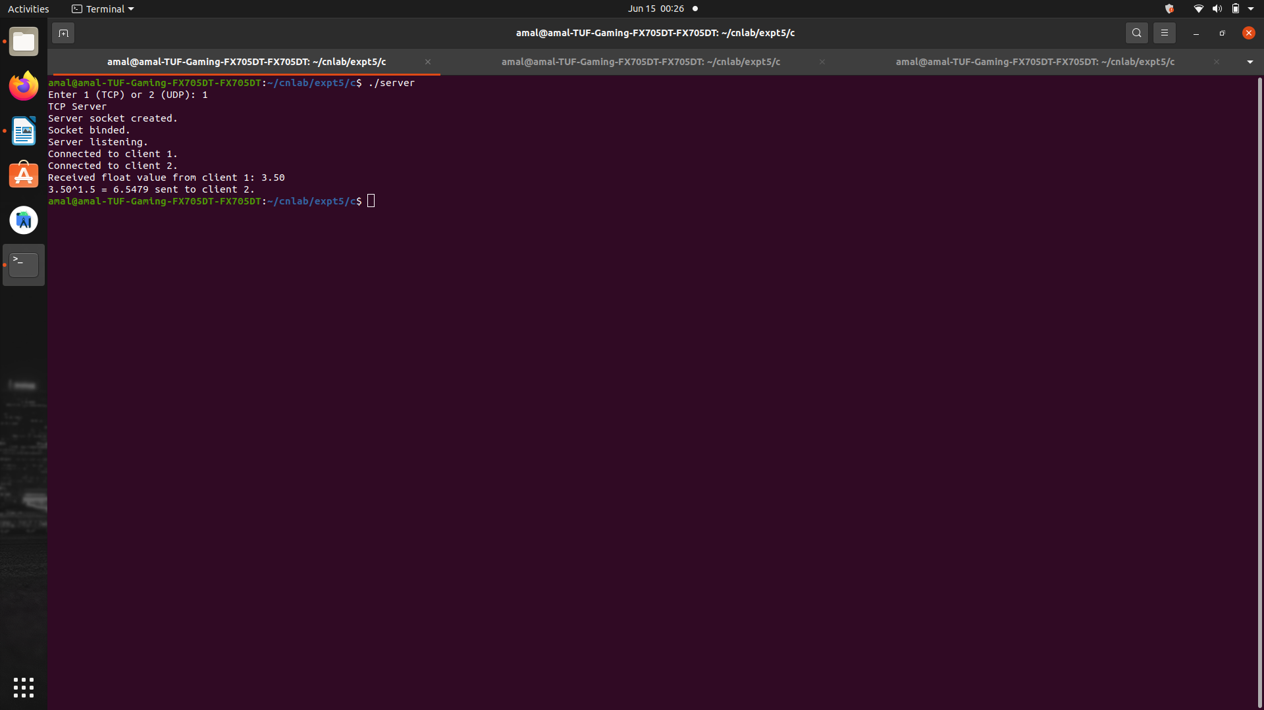
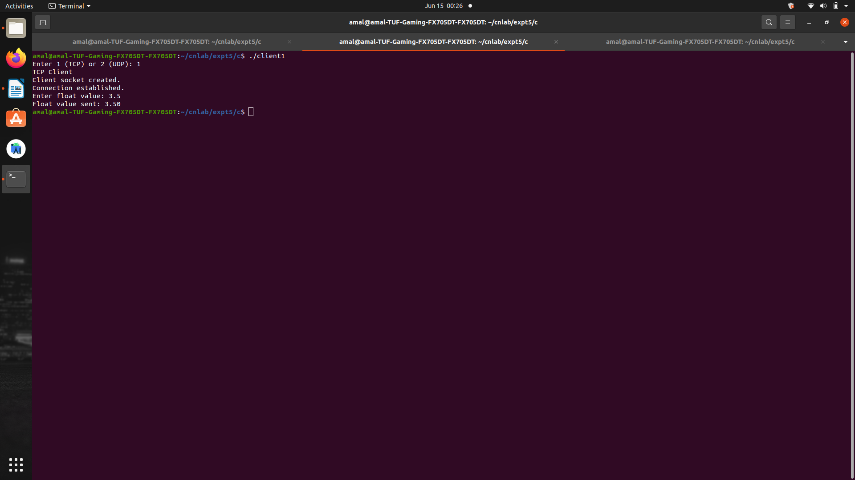
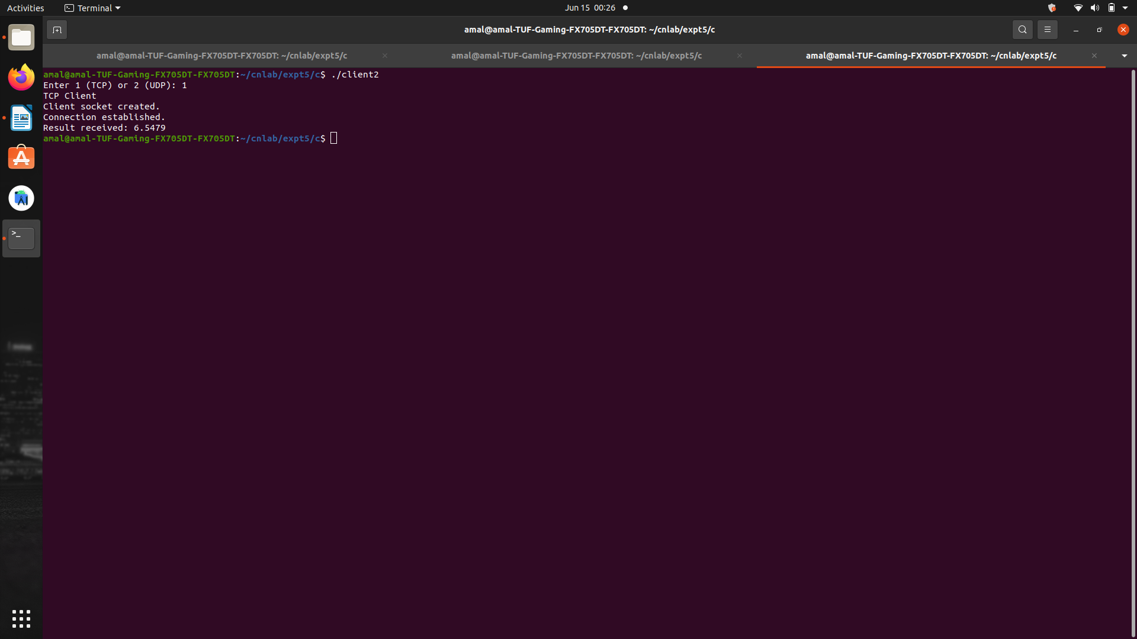

UDP
