PROGRAM CODE

server.c
#include <stdio.h>
#include <stdlib.h>
#include <sys/socket.h>
#include <arpa/inet.h>
#include <unistd.h>
#include <string.h>

#define PORT 8000
#define PORT1 8001

char* reverse(char* str) {
char* temp = strdup(str);
int n = strlen(temp);

for(int i = 0; i < n / 2; i++) {
char t = temp[i];
temp[i] = temp[n - i - 1];
temp[n - i - 1] = t;
}

return temp;
}

void main() {
int server_fd, client_fd1, client_fd2;
struct sockaddr_in address, cli_addr;
int opt, addrlen = sizeof(address);
char* str;

printf("Enter 1 (TCP) or 2 (UDP): ");
scanf("%d", &opt);

if(opt == 1)
printf("TCP Server\n");
else if(opt == 2)
printf("UDP Server\n");
else {
printf("Invalid input!\n");
exit(1);
}

if(opt == 1) {
if((server_fd = socket(AF_INET, SOCK_STREAM, 0)) < 0) {
printf("Socket creation failed!\n");
exit(1);
} else {
printf("Server socket created.\n");
}
} else {
if((server_fd = socket(AF_INET, SOCK_DGRAM, 0)) < 0) {
printf("Socket creation failed!\n");
exit(1);
} else {
printf("Server socket created.\n");
}
}

address.sin_family = AF_INET;
address.sin_addr.s_addr = INADDR_ANY;
address.sin_port = htons(PORT);

if(bind(server_fd, (struct sockaddr*) &address, addrlen) < 0) {
printf("Socket binding failed!\n");
exit(1);
} else {
printf("Socket binded.\n");
}

if(opt == 1) {
if(listen(server_fd, 5) < 0) {
printf("Listening failed!\n");
exit(1);
} else {
printf("Server listening.\n");
}

if((client_fd1 = accept(server_fd, (struct sockaddr*) &address, (socklen_t*) &addrlen)) < 0) {
printf("Connection failed!\n");
exit(1);
} else {
printf("Connected to client 1.\n");
}

if((client_fd2 = accept(server_fd, (struct sockaddr*) &address, (socklen_t*) &addrlen)) < 0) {
printf("Connection failed!\n");
exit(1);
} else {
printf("Connected to client 2.\n");
}

str = (char*) malloc(20 * sizeof(char));

if(recv(client_fd1, str, 20 * sizeof(char), 0) < 0) {
printf("Receive failed!\n");
exit(1);
} else {
printf("Received string from client 1: %s\n", str);
}

str = reverse(str);

if(send(client_fd2, str, (strlen(str) + 1) * sizeof(char), 0) < 0) {
printf("Send failed!\n");
exit(1);
} else {
printf("Reversed string sent to client 2.\n");
}
} else {
int len = sizeof(address);
int len1 = sizeof(cli_addr);

cli_addr.sin_port = htons(PORT1);

str = (char*) malloc(20 * sizeof(char));

if(recvfrom(server_fd, str, 20 * sizeof(char), 0, (struct sockaddr*) &address, &len) < 0) {
printf("Receive failed!\n");
exit(1);
} else {
printf("Received string from client 1: %s\n", str);
}

str = reverse(str);

if(sendto(server_fd, str, 20 * sizeof(char), 0, (struct sockaddr*) &cli_addr, len1) < 0) {
printf("Send failed!\n");
exit(1);
} else {
printf("Reversed string sent to client 2.\n");
}
}

close(server_fd);
close(client_fd1);
close(client_fd2);
}

client1.c
#include <stdio.h>
#include <stdlib.h>
#include <sys/socket.h>
#include <arpa/inet.h>
#include <unistd.h>
#include <string.h>

#define PORT 8000

void main() {
int client_fd;
struct sockaddr_in serv_addr;
char* str;
int opt;

printf("Enter 1 (TCP) or 2 (UDP): ");
scanf("%d", &opt);

if(opt == 1)
printf("TCP Client\n");
else if(opt == 2)
printf("UDP Client\n");
else {
printf("Invalid input!\n");
exit(1);
}

if(opt == 1) {
if((client_fd = socket(AF_INET, SOCK_STREAM, 0)) < 0) {
printf("Socket creation failed!\n");
exit(1);
} else {
printf("Client socket created.\n");
}
} else {
if((client_fd = socket(AF_INET, SOCK_DGRAM, 0)) < 0) {
printf("Socket creation failed!\n");
exit(1);
} else {
printf("Client socket created.\n");
}
}

serv_addr.sin_family = AF_INET;
serv_addr.sin_addr.s_addr = INADDR_ANY;
serv_addr.sin_port = htons(PORT);

if(opt == 1) {
if(connect(client_fd, (struct sockaddr*) &serv_addr, sizeof(serv_addr)) < 0) {
printf("Connection failed!\n");
exit(1);
} else {
printf("Connection established.\n");
}
}

str = (char*) malloc(20 * sizeof(char));

printf("Enter string: ");
scanf("%s", str);

if(opt == 1) {
if(send(client_fd, str, 20 * sizeof(char), 0) < 0) {
printf("Send failed!\n");
exit(1);
} else {
printf("String sent: %s\n", str);
}
} else {
if(sendto(client_fd, str, 20 * sizeof(char), 0, (struct sockaddr*) &serv_addr, sizeof(serv_addr)) < 0) {
printf("Send failed!\n");
exit(1);
} else {
printf("String sent: %s\n", str);
}
}

close(client_fd);
}

client2.c
#include <stdio.h>
#include <stdlib.h>
#include <sys/socket.h>
#include <arpa/inet.h>
#include <unistd.h>
#include <string.h>

#define PORT 8000
#define PORT1 8001

void main() {
int client_fd;
struct sockaddr_in serv_addr;
struct sockaddr_in cli_addr;
char* str;
int opt, len = sizeof(serv_addr);

printf("Enter 1 (TCP) or 2 (UDP): ");
scanf("%d", &opt);

if(opt == 1)
printf("TCP Client\n");
else if(opt == 2)
printf("UDP Client\n");
else {
printf("Invalid input!\n");
exit(1);
}

if(opt == 1) {
if((client_fd = socket(AF_INET, SOCK_STREAM, 0)) < 0) {
printf("Socket creation failed!\n");
exit(1);
} else {
printf("Client socket created.\n");
}
} else {
if((client_fd = socket(AF_INET, SOCK_DGRAM, 0)) < 0) {
printf("Socket creation failed!\n");
exit(1);
} else {
printf("Client socket created.\n");
}
}

serv_addr.sin_family = AF_INET;
serv_addr.sin_addr.s_addr = INADDR_ANY;
serv_addr.sin_port = htons(PORT);

cli_addr.sin_family = AF_INET;
cli_addr.sin_addr.s_addr = INADDR_ANY;
cli_addr.sin_port = htons(PORT1);

if(opt == 1) {
if(connect(client_fd, (struct sockaddr*) &serv_addr, len) < 0) {
printf("Connection failed!\n");
exit(1);
} else {
printf("Connection established.\n");
}
}

str = (char*) malloc(20 * sizeof(char));

if(opt == 1) {
if(recv(client_fd, str, 20 * sizeof(char), 0) < 0) {
printf("Receive failed!\n");
exit(1);
} else {
printf("Reversed string received: %s\n", str);
}
} else {
if(bind(client_fd, (struct sockaddr*) &cli_addr, sizeof(cli_addr)) < 0) {
printf("Socket binding failed!\n");
exit(1);
} else {
printf("Socket binded.\n");
}

if(recvfrom(client_fd, str, 20 * sizeof(char), 0, (struct sockaddr*) &cli_addr, &len) < 0) {
printf("Receive failed!\n");
exit(1);
} else {
printf("Reversed string received: %s\n", str);
}
}

close(client_fd);
}

OUTPUT

TCP
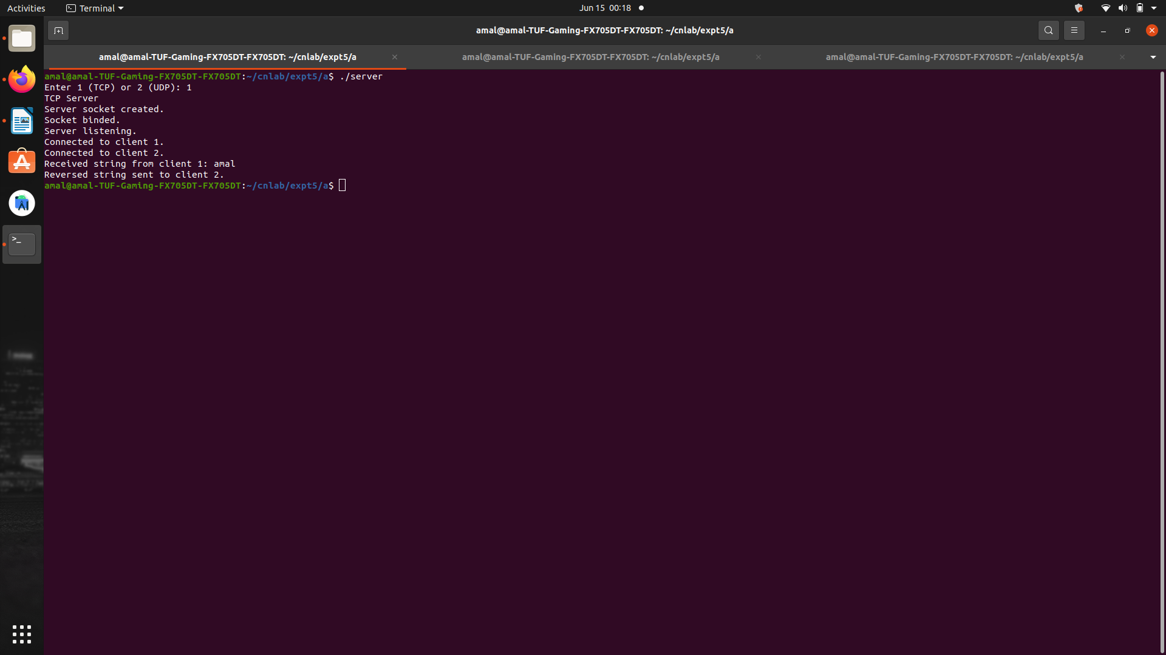
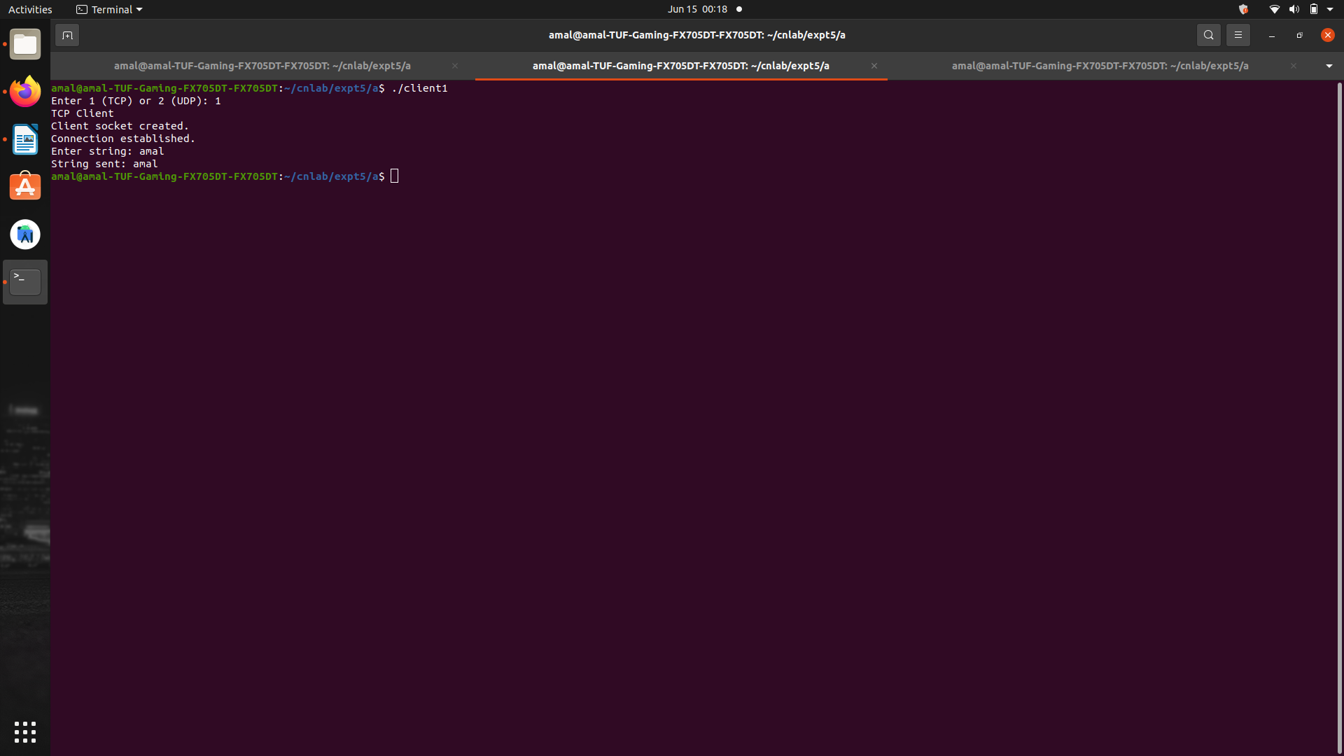
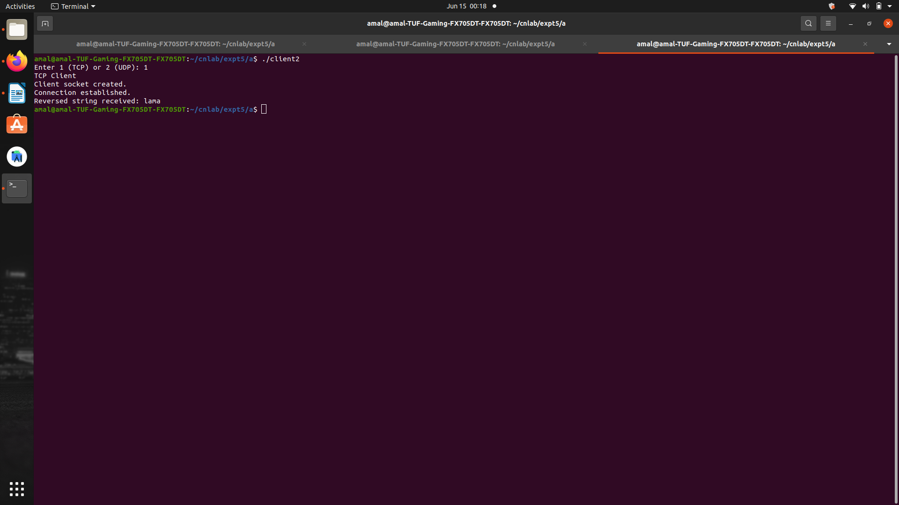

UDP
