<creative title to be inserted>

1.Introduction 2
1.1 Scope 2
1.2 Abbreviations 3
2. Design Overview 3
2.1. Design Interfaces 4
2.2. Design Features 4
3. Configuration 4
4. Limitations 4

1.Introduction

1.1 Scope
This document describes the functionality and specifications of the <catchy title> device

1.2 Abbreviations
DUT | Device Under Test
APB | Advanced Peripheral BUS
ALU | Arithmetic and Logic Unit
IRQ | Interrupt Request

2. Design Overview

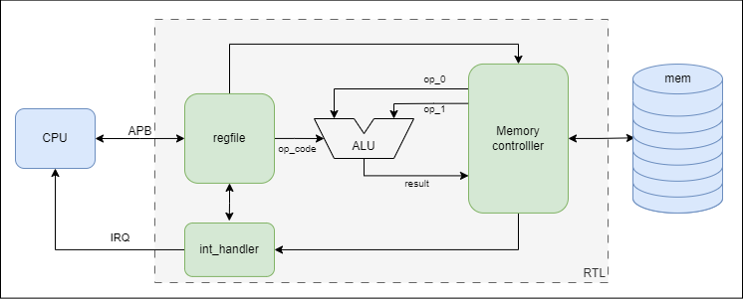
Figure 1. <title> Block diagram and interfaces
<overview and working condition description>

2.1. Design Interfaces

2.2. Register fields

2.3. Design Features
<what it can do>

3. Configuration
<how to use it>

4. Limitations
- Device does not support the fly reconfigurations
- Device supports only a limited number of operations
- Device takes longer to do complex operations such as division

