Zachary Norton

CS-330 Final Project Reflection

Southern New Hampshire University

August 8th 2024

Development Choices

The objects rendered in this scene were chosen as they represent a wide spectrum of different challenges and techniques needed to create them while still being manageable to achieve. To elaborate, we have relatively simple objects such as the cutting board and tea box which require only manipulation of a basic mesh, slightly more complicated objects such as the avocados, which although are composed of two meshes combined, largely use the same techniques, and objects made out of three or more meshes such as the bottle, knife, protein container and glass which require more precise positioning and manipulation of meshes in order to convincingly recreate them. The saute pan was left out of the final scene as its construction would not have demonstrated any further techniques that had not been used elsewhere. The selection of items was also meant to demonstrate use of various types of materials. Rather than selecting exclusively metal objects, here we have objects made from metal, plastic, glass, granite, and organic material, which also added to the challenges of their interaction with lighting. For example, the plastic needed to be transparent and have a high degree of specular reflection while the avocados had just the opposite properties. As for other development considerations, the resolution of the textures used made note of the size of the object they were to be used on in order to conserve resources. This is to say that the texture used on the avocados is of much lower resolution than the one used for the counter surface. In a similar vein, the polygon count in the image was also limited to prioritize the smooth running of the 3D environment. Images of the original scene are attached below.

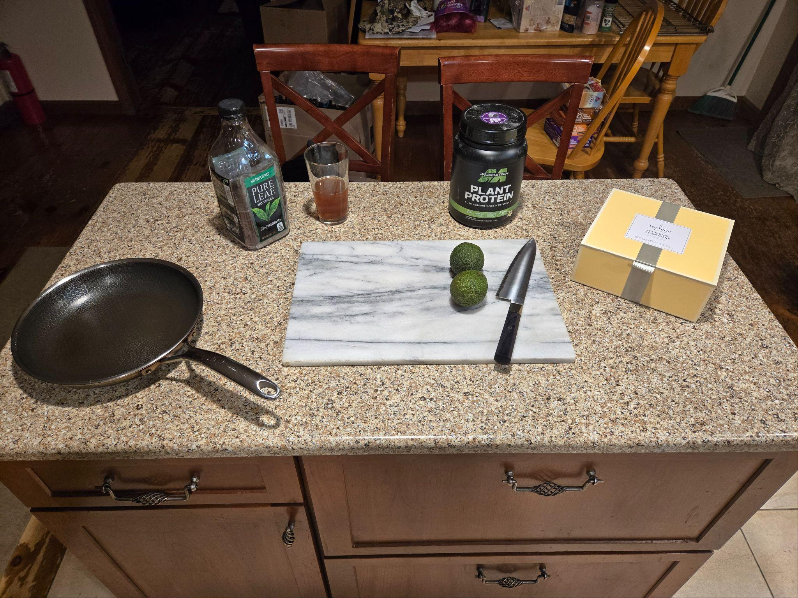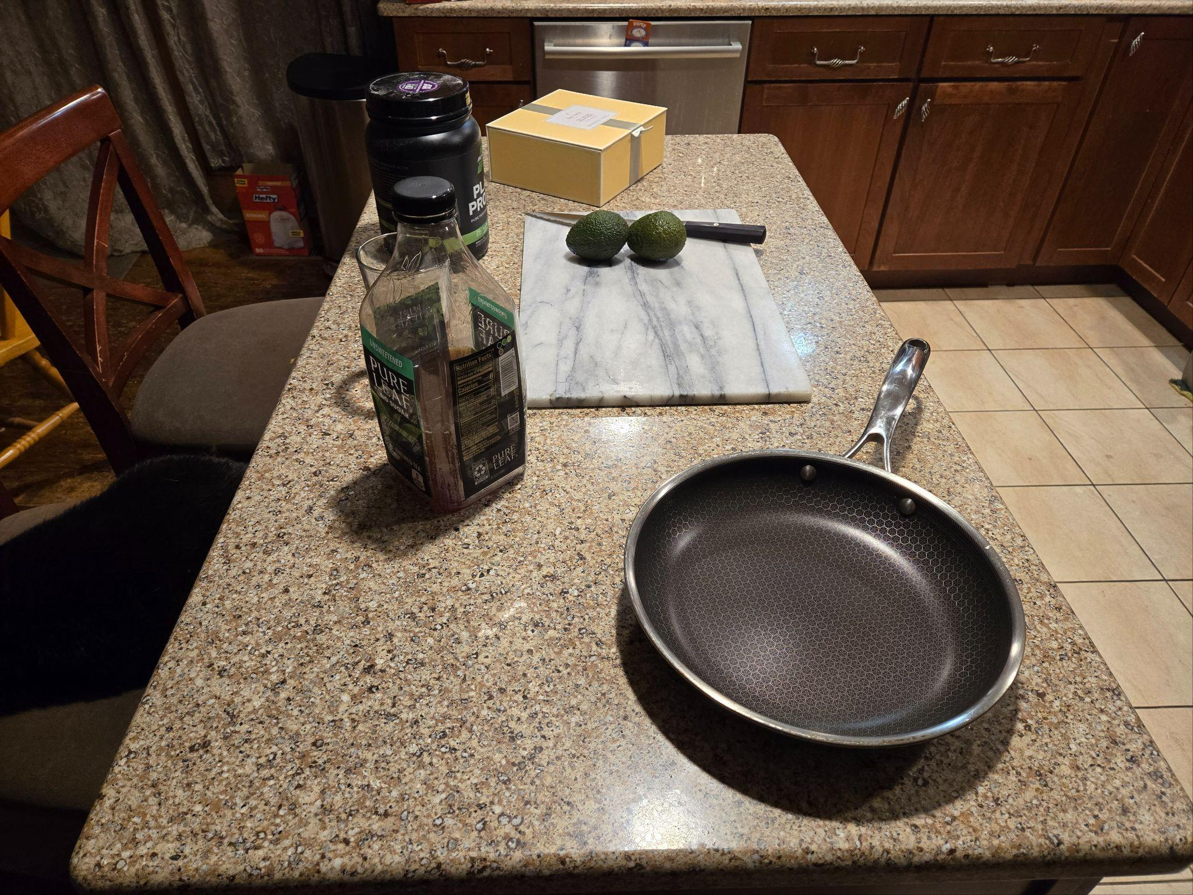

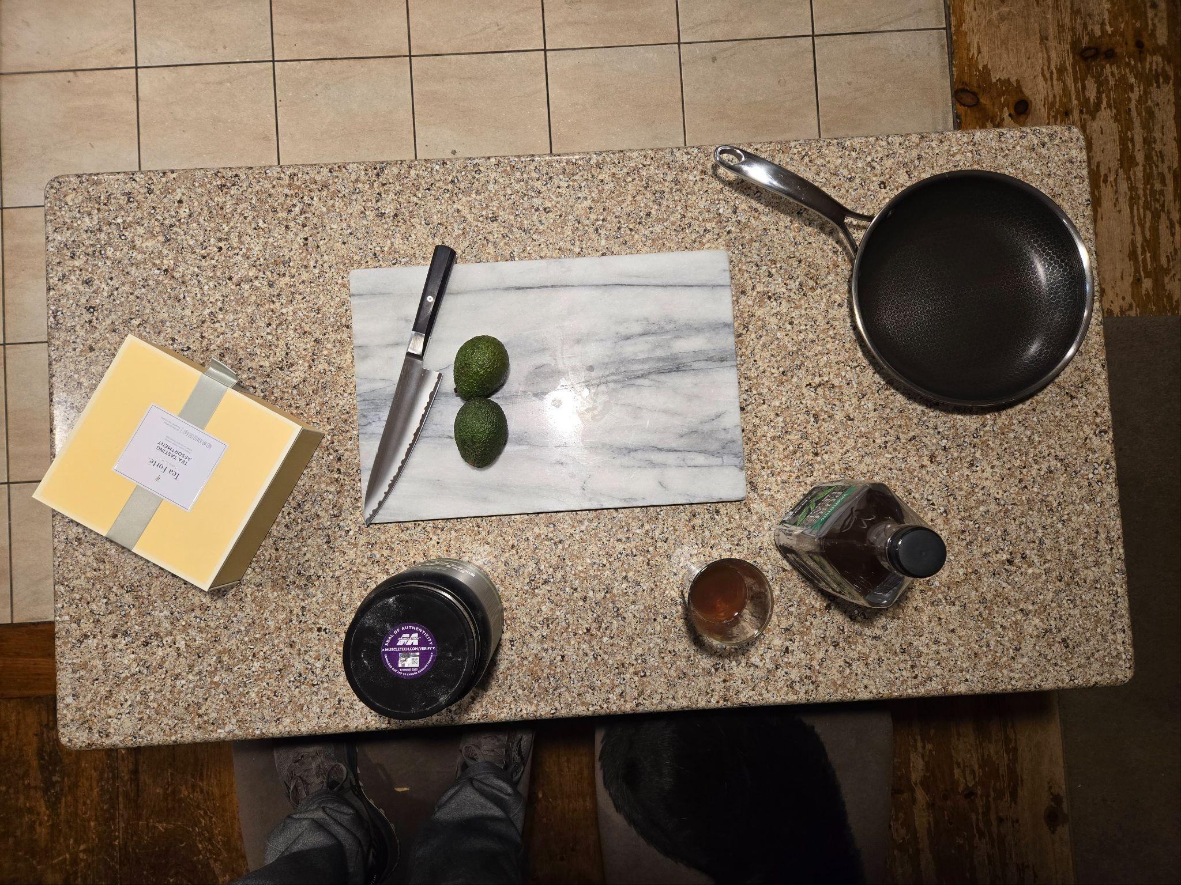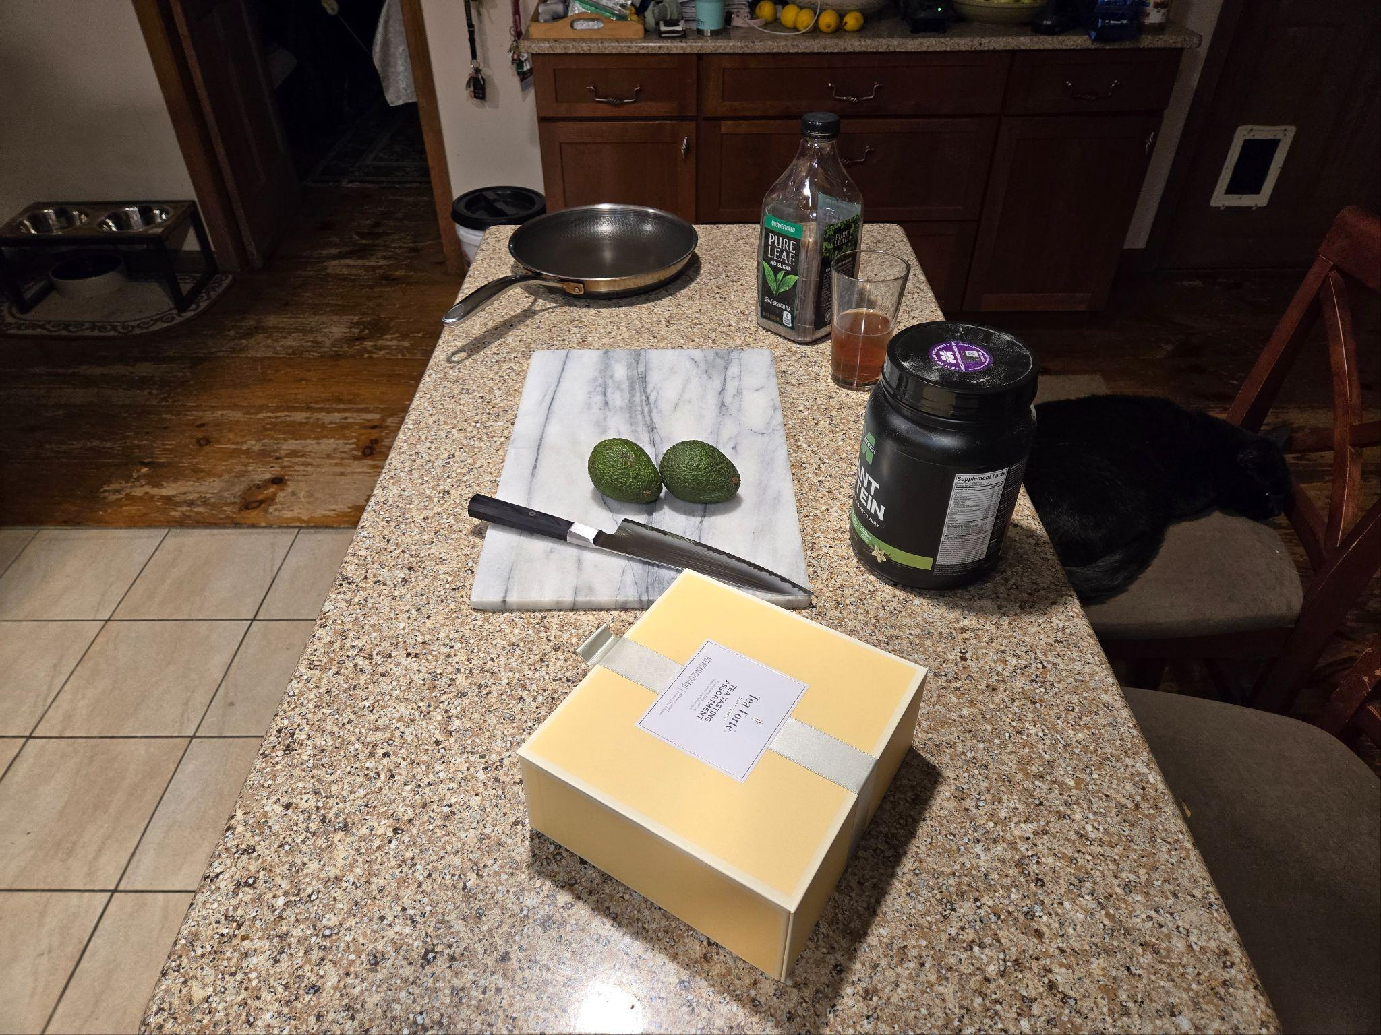

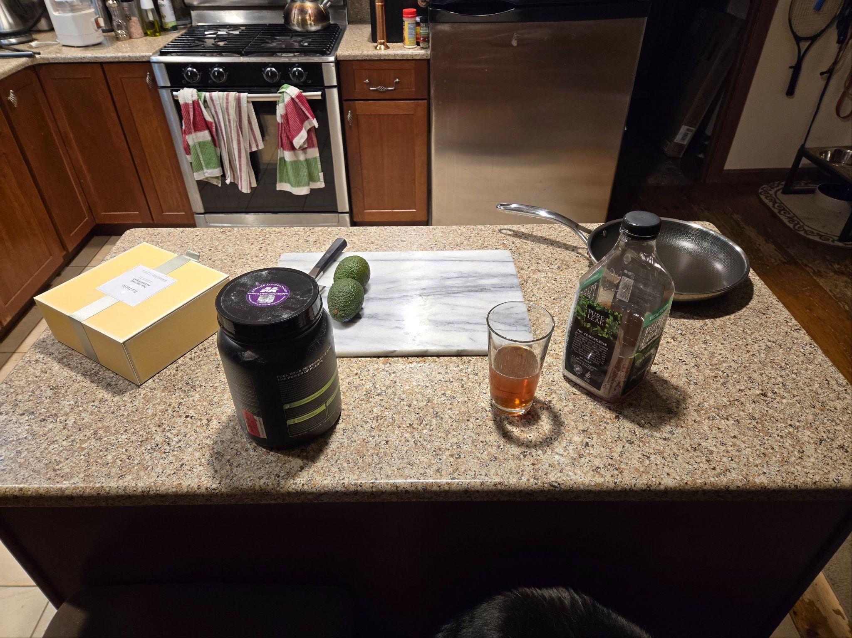

Navigation

The navigation in this scene is fairly straightforward, and behaves much like a user would expect. The ‘W’ and ‘S’ keys have been bound to move the camera in relation to the scene, forward and backwards, respectively. The ‘A’ and ‘D’ keys will move the camera left and right. Though vertical movement is approached in a much greater variety of ways than the previous four motions in 3D space, for ease of access and proximity to the other keys in use, ‘Q’ and ‘E’ are used to raise and lower the camera. Also as one might surmise, the mouse is the other peripheral used to manipulate the camera, bestowing the user the ability to look or turn the camera in the direction the mouse moves. In addition, the scroll wheel has been bound with a callback function to accommodate changes in sensitivity to movement speed for more detailed maneuvering around the scene. The user can also navigate the scene through four preconfigured views, reasonably bound to keys ‘1’ through ‘4’, giving both orthographic and perspective views to quickly view the scene.

Custom Functions

Among the custom functions in this program we have the previously mentioned scrolling function which gives control over movement speed. This feature is implemented through the ‘scroll_callback’ callback function. As long as a program has declared the function in the appropriate header, and is using the GLFW library, the function can be used in similar programs and the maximum and minimum movement speeds are easily adjusted.