**Assignment Report**

EGBE 443Image Processing in Medicine

1. **Develop program to read an image and Convert RGB to gray scale image**

I required OpenCV library or cv2 module to read an image and convert to gray scale by use cv2.imread function. This function required 2 variable such as filename and mode. I select mode 0 to convert RGB to gray scale image

1. **Create function for computing histogram and cumulative histogram**

def calculateHistogram(img):

    list_img = []

    intensity = [0 for i in range(max_intensity)]

    for row,index in enumerate(img):

        list_img = np.concatenate((list_img,index))

    for i in list_img:

        intensity[int(i)] +=1

    return intensity

I developed calculateHistogram function to calculate histogram manually. To use this function, I have to pass 1 parameter that is img: 2D arrays that return from cv2.imread mode 0 then I concatenate the index, pixels value, from img into list_img and calculate how many in each pixel value that have been counted

def calculateCumulativeHistogram(intensity):

    cumulative = [0 for i in range(max_intensity)]

    for i in range(max_intensity):

        if(i == 0):

            cumulative[i] = intensity[i]

        else:

            cumulative[i] = (intensity[i] + cumulative[i-1])

    return cumulative

In calculateCumulativeHistogram function

1. **Demonstrate your developed functions with at least two images** **and from the images and their histograms explain in formation that you gain from them**

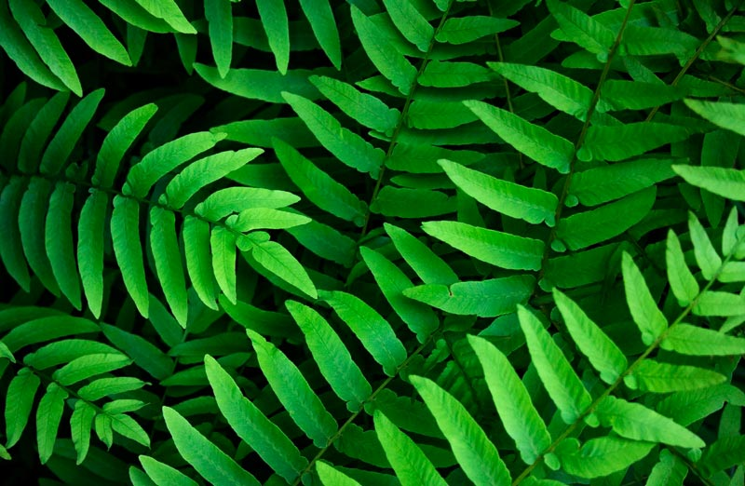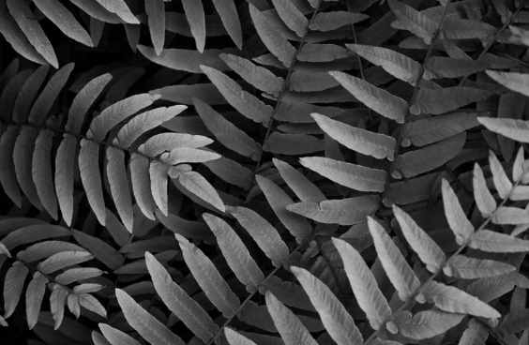

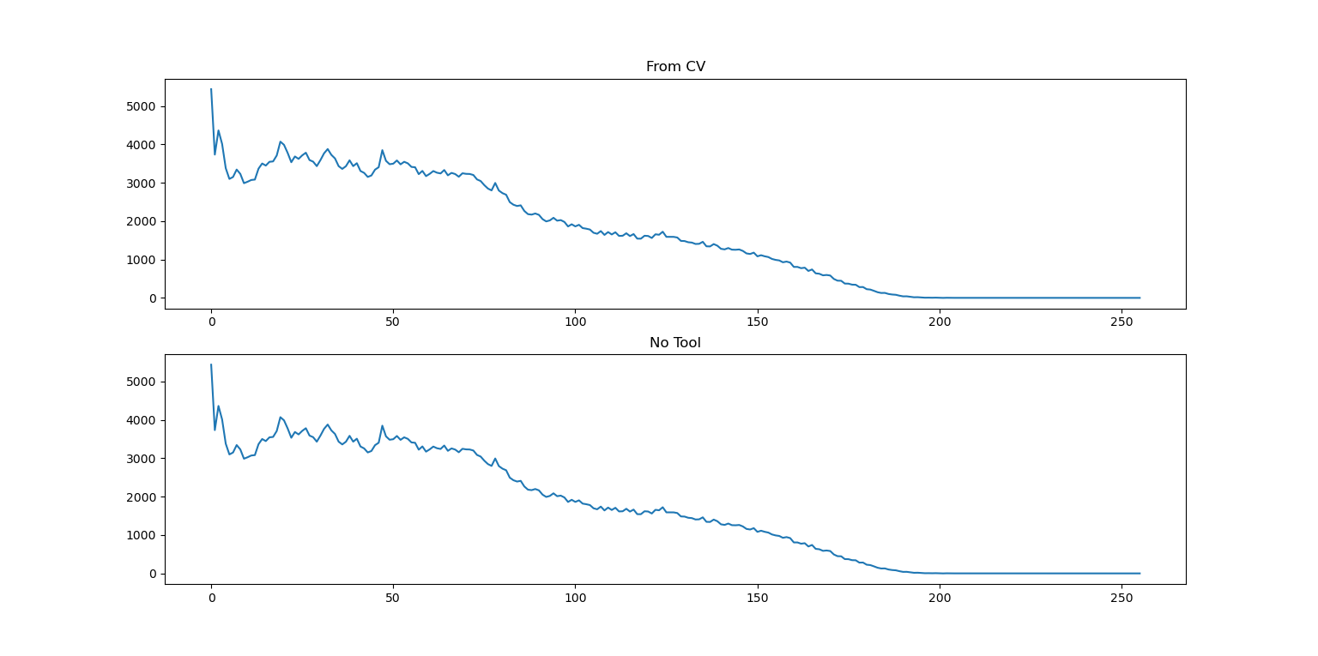 **Fig. 1** Image 1(24-bit depth, RGB) **Fig. 2** Image 1 Converse to Gray scale by OpenCV

**Fig. 3** Compare histogram that use tool and my developed function of Image 1

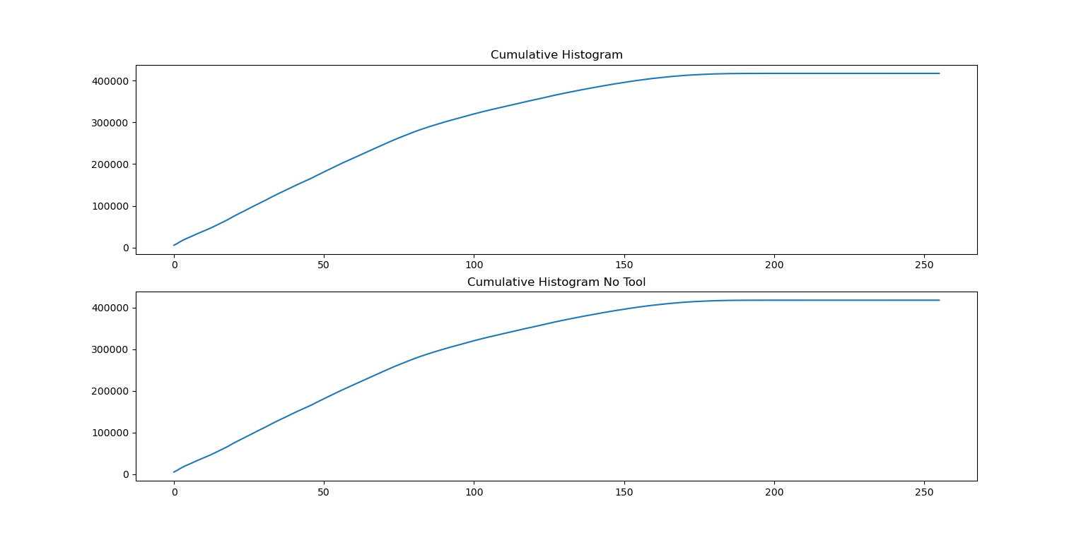

**Fig. 4** Compare cumulative histogram that use tool and my developed function of Image 1

From the histogram, I gained that Image 1 has

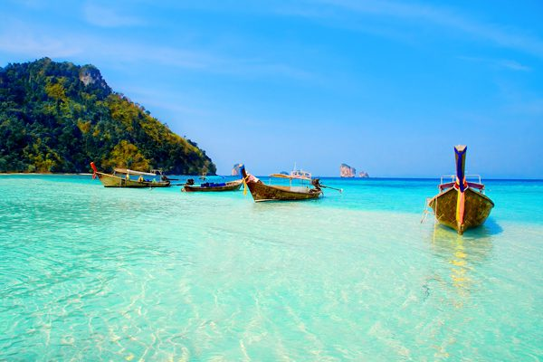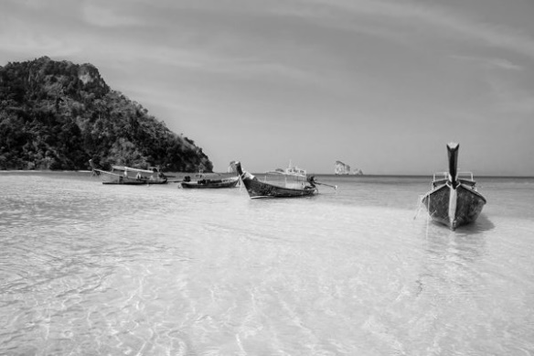

**Fig. 5** Image 2(24-bit depth, RGB) **Fig. 6** Image 2 Converse to Gray scale by OpenCV

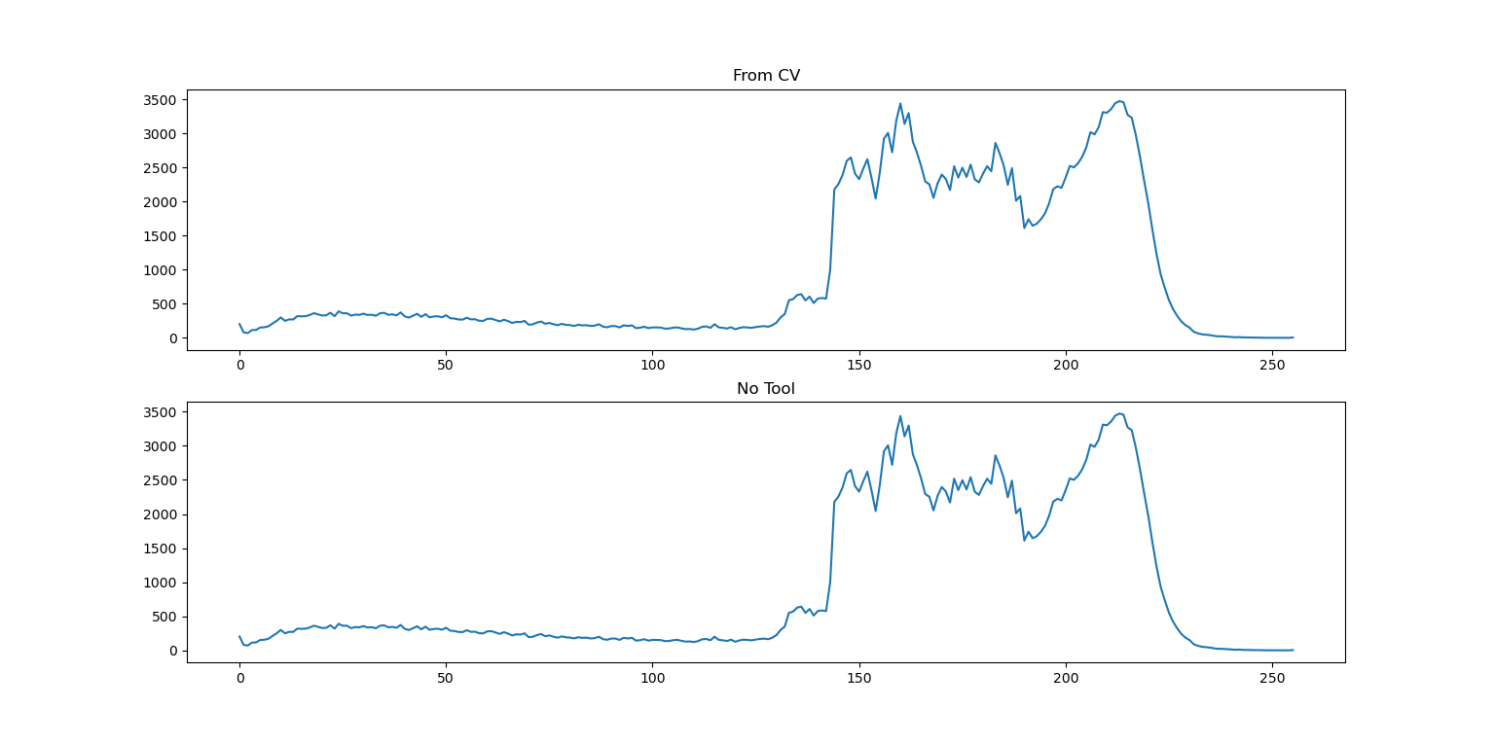

**Fig. 7** Compare histogram that use tool and my developed function of Image 2

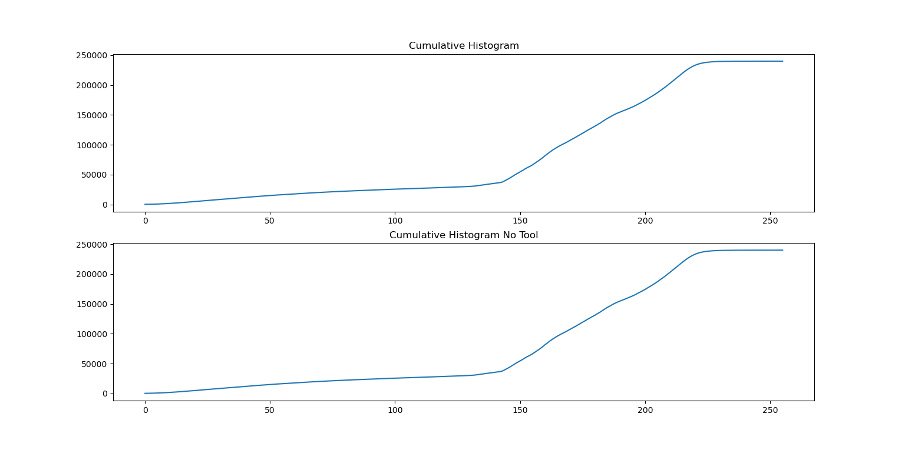**Fig. 8** Compare cumulative histogram that use tool and my developed function of Image 2

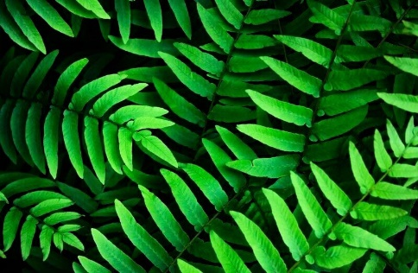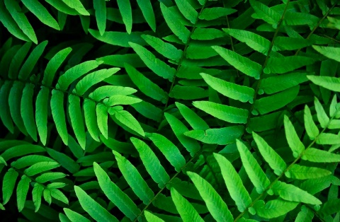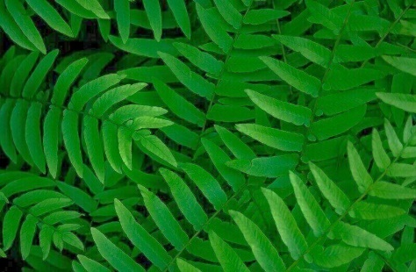

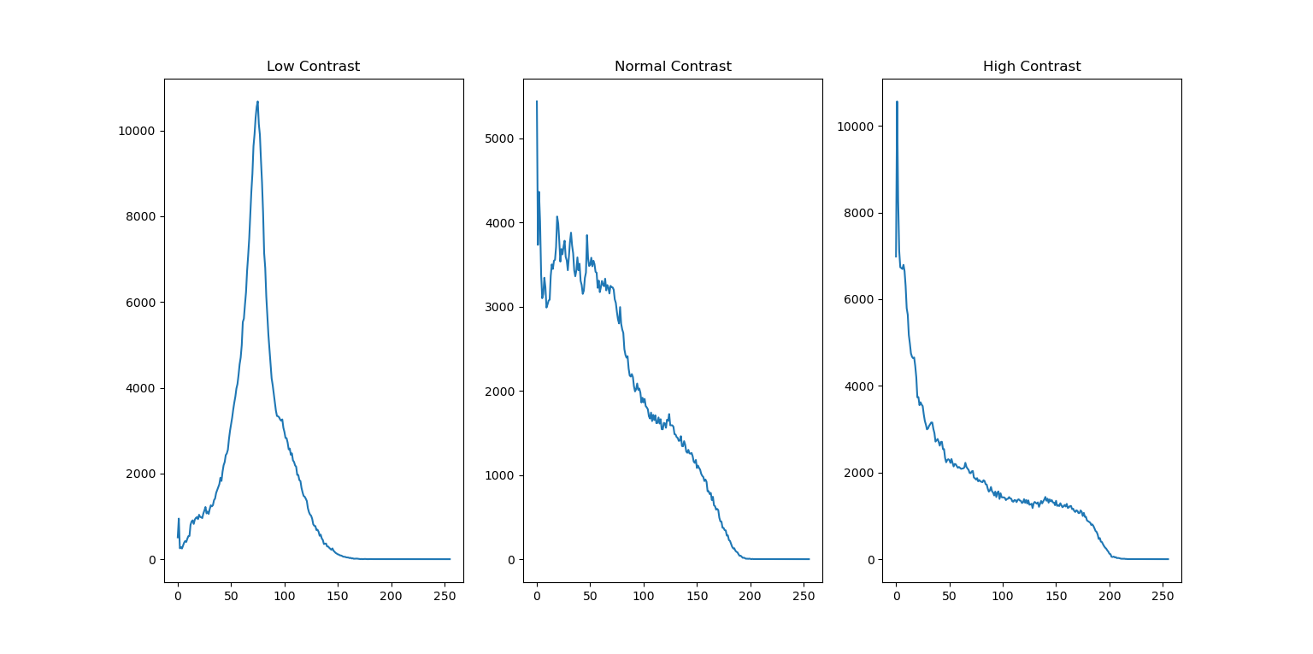 **Fig. 9** Low Contrast  **Fig. 10** Normal Contrast **Fig. 11** High Contrast

**Fig. 12** Compare histogram from difference contrast (Low contrast, Normal contrast and High contrast)

From the above Figure. I found that the low contrast image has lowest range of intensity. The high contrast image has highest range of intensity.