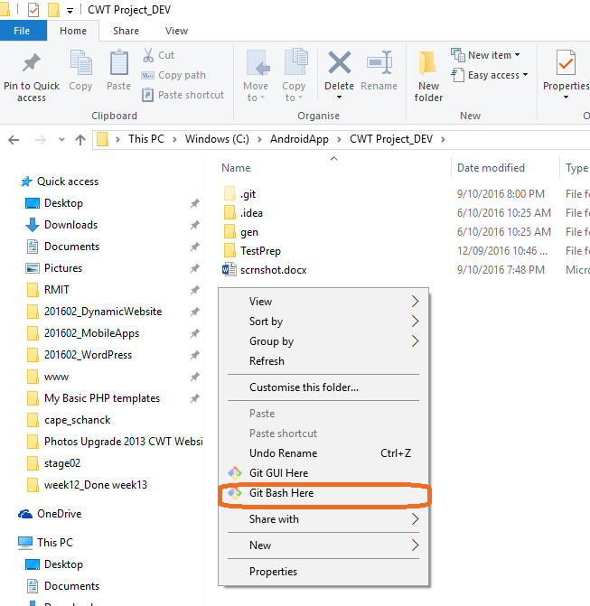

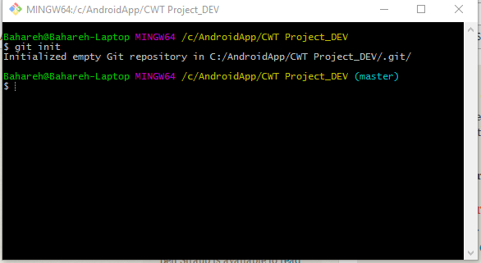

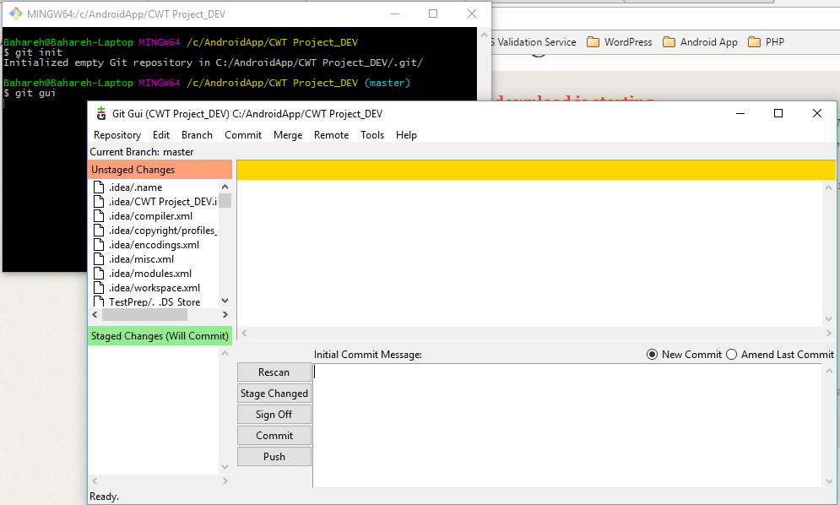

Unstaged Changes:

Working directory. Changes that you are working on now.

To bring all the project in staged for the first time you are running git:

Run command “git add .” or you can click on the icons in gui.

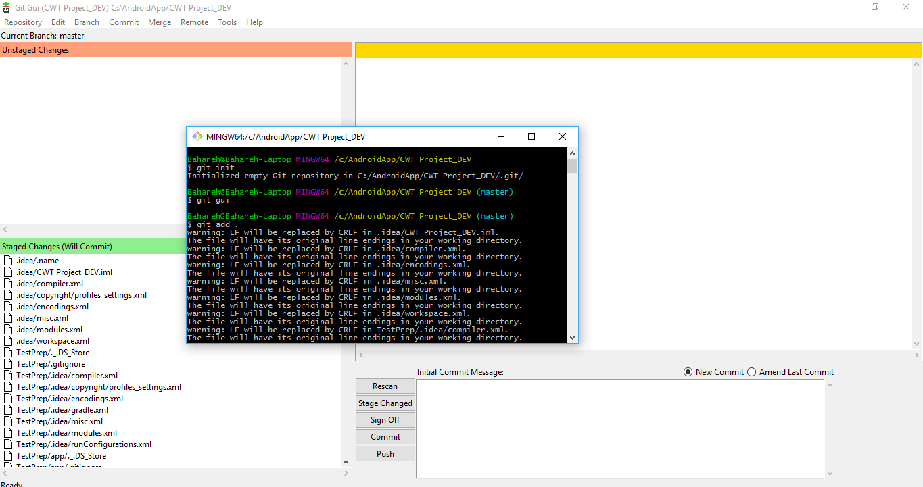

Command “git status” will show what has been staged and ready to commit.

Setting global: 