***Assaingment#9***

***Addition***

***Html***

*<!DOCTYPE html>*

*<html lang="en">*

*<head>*

*<meta charset="UTF-8">*

*<meta name="viewport" content="width=device-width, initial-scale=1.0">*

*<title>Document</title>*

*<link rel="stylesheet" href="calculator.css">*

*<script src="calculator.js"></script>*

*</head>*

*<body>*

*<div id="calculator">*

*<h1>Calculator</h1>*

*<div class="input selection">*

*<input id="num1"type="number" placeholder="First Number">*

*<br><br>*

*<input id="num2"type="number" placeholder="Second Number">*

*</div>*

*<br><br>*

*<div class="button">*

*<button onclick="add()">+</button>*

*<button onclick="subtract()">-</button>*

*<button onclick="multiply()">x</button> <button onclick="devide()">÷</button></div> </div> </body> </html>*

***css***

body{

    display: flex;

    flex-direction: column;

    justify-content: center;

    align-items: center;

    background-image: url(https://tse2.mm.bing.net/th?id=OIP.ObgoHVI81V-tVlqMNrusCAHaEK&pid=Api&P=0&h=220);

}

#calculator{

    justify-content: center;

    align-items: center;

    color: blue;

    background-image: url(https://tse4.mm.bing.net/th?id=OIP.JlLJlfv2_ZMANzZoalmUiwAAAA&pid=Api&P=0&h=220);

}

.button{

    color: white;

    display: flex;

    flex-direction: row;

    justify-content: space-evenly;

   background-color: blue;

   background-image: url(https://tse1.mm.bing.net/th?id=OIP.9UvvJd3aBD1VQkr-vNDMgAHaEK&pid=Api&P=0&h=220);

}

.result{

    display: flex;

    flex-direction: column;

    justify-content: center;

    background-image: url(https://encrypted-tbn0.gstatic.com/images?q=tbn:ANd9GcRoP5eqEAi8B3QjR31ei8bJgTAwhFofHZq9mg&s);

}

.inputselection{

    display: flex;

    flex-direction: row;

justify-content: center;

}

.button:hover{

    color: white;

    background-color: black;

    display: flex;

    flex-direction: row;

    justify-content: center;

}

*<div class="result">*

*<h2>Result: <span id="result">0</span></h2>*

*</div>*

*</div>*

*</body>*

*</html>*

***JAVASCRIPT***

function add(){

    const num1 = document.getElementById("num1").value;

    const num2 = document.getElementById("num1").value;

    document.getElementById("result").innerHTML = Number(num1) + Number(num2)

    }

    function subtract(){

        const num1 = document.getElementById("num1").value;

        const num2 = document.getElementById("num1").value;

        document.getElementById("result").innerHTML = Number(num1) - Number(num2)

    }

    function multiply(){

        const num1 = document.getElementById("num1").value;

        const num2 = document.getElementById("num1").value;

        document.getElementById("result").innerHTML = Number(num1) * Number(num2)

    }

    function devide(){

        const num1 = document.getElementById("num1").value;

        const num2 = document.getElementById("num1").value;

        document.getElementById("result").innerHTML = Number(num1) / Number(num2)

    }

***ADDITION***

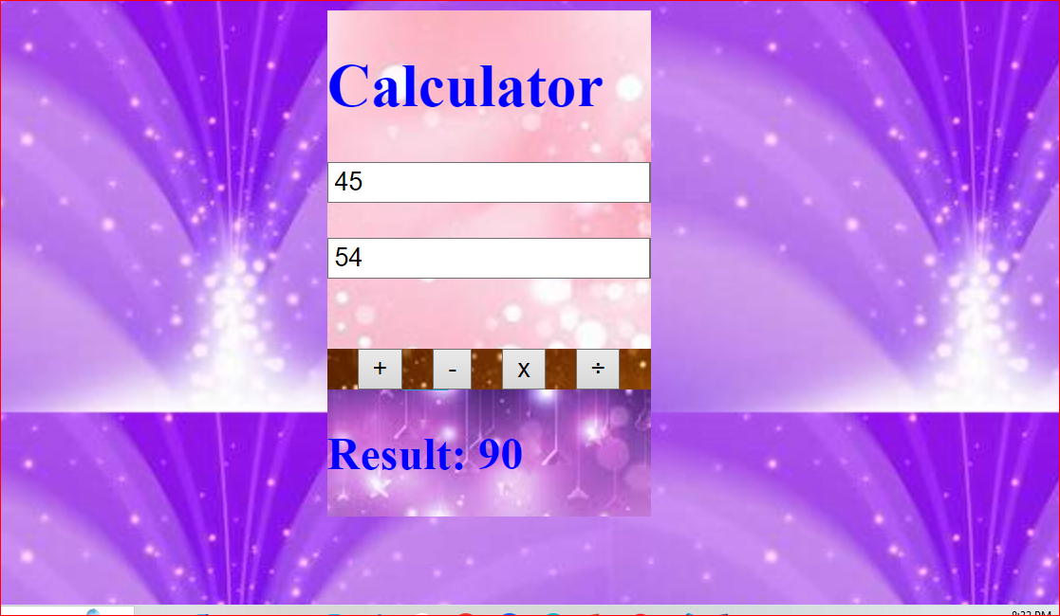

***SUBTRACT***

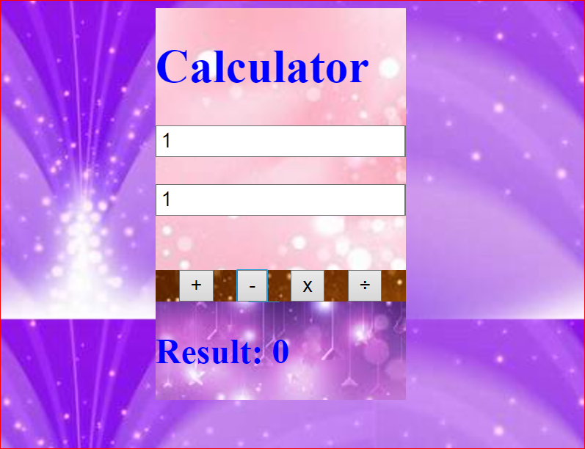

***multiplty***

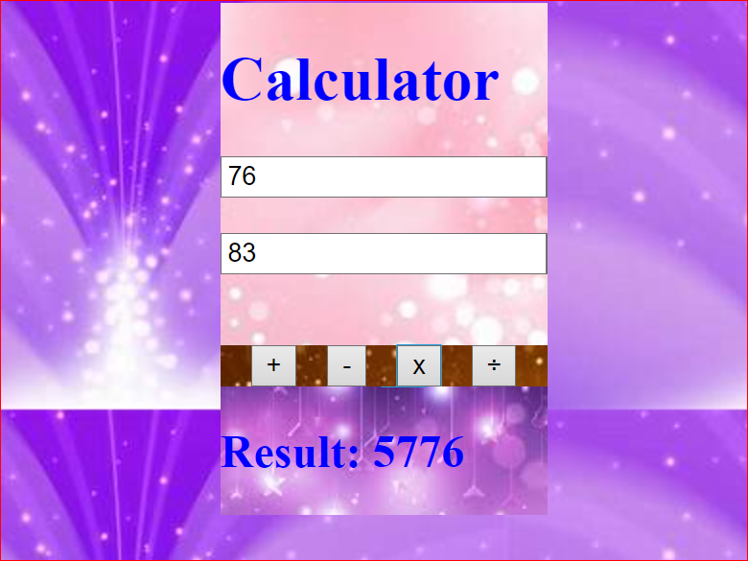

***devide***

