USB & PS/2 keyboard sync status test

- 同时连接USB和PS/2键盘
- Connect USB & PS/2 keyboard at the same time
- 进入FreeDOS系统，分别点击PS/2键盘与USB键盘的Num_Lock键，检查Num_Lock状态灯是否同步
- Pressing Num Lock key of PS/2 and USB keyboard under FreeDOS mode.
- Check Num Lock LED are turn on sync status
- 在DOS系统下将Num_Lock/Caps_Lock/Scroll Lock指示灯分别点亮，按Power键关机，检查指示灯灯是否关闭
- Pressing Num_Lock/Caps_Lock/Scroll Lock in Dos mode and check LED status is turn on separately.
- Press power button to shutdown system and check LED is off.
- 系统关机后，移除USB键盘，开机进入FreeDOS系统.连接USB键盘/鼠标，检查USB键盘/鼠标是否有效
- Shutdown system at first then Remove USB keyboard
- Boot to FreeDos and connect USB KB/MS in FreeDOS mode .
- Check the USB KB/MS is work normally
- 分别点击PS/2键盘与USB键盘的Num_Lock键，检查Num_Lock状态灯是否同步
- Repeat step 2
- 在DOS系统下将Num_Lock/Caps_Lock/Scroll Lock指示灯分别点亮，按Power键关机，检查指示灯灯是否关闭
- Repeat step 3
Keyboard LED status test

- 本项目需要在XP和Windows7操作系统下分别测试
- This item need to test on both XP and Win 7 OS
- 同时连接PS/2及USB键盘
- Connect USB & PS/2 keyboard at the same time
- 进入DOS系统，将Num_Lock/Caps_Lock/Scroll Lock指示灯分别点亮
- Pressing Num_Lock/Caps_Lock/Scroll Lock in Dos mode and check LED status is turn on separately.
- 按Power键关机，检查指示灯是否关闭
- Press power button to shutdown system and check LED is off.
- 进入BIOS设置界面，调整ACPI Suspend Type项目为S1
- Change ACPI Suspend Mode to S1 in Bios Setup Menu
- Exit and save
- 进入操作系统，将Num_Lock/Caps_Lock/Scroll Lock指示灯分别点亮
- Boot to Win7/ XP
- Press Num_Lock/Caps_Lock/Scroll Lock and check LED is on.
- 使系统进入S1待机状态，检查指示灯是否关闭
- Let system enter S1 state.
- Check LED is off.
- 1分钟后唤醒系统，检查指示灯是否恢复待机前的点亮状态
- Resume system after 1 min
- Check LED is same as last status
- 进入BIOS设置界面，调整ACPI Suspend Type项目为S3
- 进入操作系统，将Num_Lock/Caps_Lock/Scroll Lock指示灯分别点亮
- 使系统进入S3待机状态，检查指示灯是否关闭
- 1分钟后唤醒系统，检查指示灯是否恢复待机前的点亮状态
- 使系统进入S4休眠状态，检查指示灯是否关闭
- 1分钟后唤醒系统，检查指示灯是否恢复待机前的点亮状态
- Let system into ACPI each state (S3/S4) and check LED is off
- Repeat step 9~12
- 在操作系统下关机，检查指示灯是否关闭
- Shutdown system by Start Menu.
- Check LED is off.
Keyboard hotkey test
Only define SOP for “Power” hotkey, other function hotkey need ODM to provide test plan.

- 连接带有 “Power”功能键的PS/2键盘
- Connect PS/2 keyboard with “Power” hotkey.
- 开机进入操作系统，打开控制面板中的电源选项项目，调整Power键的作用为休眠
- Go to "Start" -> "Control panel" -> "Power Options" -> “Choose what the power button does”
- Power Button action set as " Hibernate"
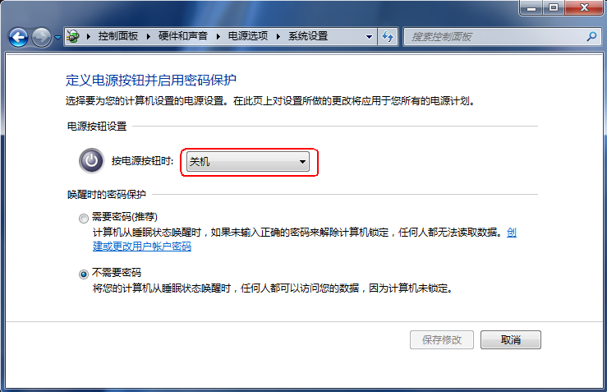
- 确定设定后，按键盘上的Power键，检查是否进入休眠，系统进入S4状态后，按键盘上的Power键，检查是否能够开机（同时检验其他按键是否都无效），是否能够从S4状态恢复到S0状态
- Let system enter S4 state and resume from S4 by “Power” hotkey.
(Check all key are invalid to resume system)
- 打开控制面板中的电源选项项目，调整Power键的作用为睡眠
- 按键盘上的Power键，检查是否能够进入S3待机状态，进入S3状态后，按键盘上的Power键（同时检验其他键是否都无效），检查是否能够唤醒，进入操作系统后是否正常。
- Power Button action set as " Sleep"
- Let system enter S3 state and resume from S3 by “Power” hotkey.
(Check all key are invalid to resume system)
- 在系统中选择关机，关机后不要移除AC电源线，按键盘上的Power键，检查是否能够开机（同时检验其他键是否都无效）
- Don’t remove the AC power cord when shutdown system by Start Menu.
- Check system can power on by “Power” hotkey.
(Check all key are invalid to power on system)
- 进入FreeDOS操作系统，按主机Power键关机，按键盘上的Power键，检查是否能够正常开机（同时检验其他键是否都无效）
- Boot to FreeDOS and shutdown system by pressing Power Button.
- Check system can power on by “Power” hotkey.
(Check all key are invalid to power on system)

