Microsoft - OEM Activation 3.0 Pilot

Microsoft is in the process of developing a new digital form of the current Certificate of Authority (COA) sticker currently in use throughout the OEM PC channel.  This new feature, OEM Activation 3.0 (OA3.0), enables an injection of a unique, SKU-specific, 5x5 product key into an ACPI table within the PC’s BIOS/Firmware.  This feature will ultimately allow for electronic OS licensing and product activation by our mutual customers.  Microsoft is asking our OEM Activation partners to assist us with a pilot that will be used to ensure OA3.0 can be successfully implemented into the BIOS/Firmware and tested with existing PC BIOS/Firmware versions.

The Windows team would like to kick off the pilot by testing of our OA3.0 toolset on OEM machines.  The pilot involves the creation\modification of a new ACPI table specific to OA3.0 (MSDM), along with an associated BIOS Flash utility to support the injection of the 5x5 product key.  Attached is a sample BIOS MSDM table (OA30-MSDM.bin) that includes headers and a 5x5 payload to leverage in your development and test work. Microsoft would like to obtain a minimum of 2 PC’s across segments (consumer and commercial) and form factors (Desktop and Notebook or Netbook or Laptop) to ensure sufficient testing. Microsoft is also requesting a full Windows based and or Windows PE based BIOS/Firmware flash utility that will write the contents of the new ACPI table content (DM.BIN) as defined below.

We would appreciate working directly with your respective onsite systems engineers to ensure cooperation and progress occurs in a timely and efficient manner.  This pilot will also require access to specific BIOS engineers and engineering teams to ensure success.  Below are specific details and requirements of this Pilot.

**Pilot Requirements:**

1. 2 PC’s (Desktop and or Notebook/Netbook/Laptop) – Prefer one commercial/enterprise based system and one consumer system if possible
2. PC’s contain either a shipping Legacy BIOS, Hybrid UEFI Firmware w/ csm, and or Native UEFI Firmware
3. A BIOS/Firmware Flash Utility that supports flashing the BIOS via the full Operating System (Vista/WS08/Win7) and or Windows PE (per PC Make/Model).  This BIOS/Firmware flash utility will be used to flash the BIOS/Firmware of the PC’s provided in #2 above with the correct contents of the new ACPI table as defined below in item #4.  Please be sure to provide a utility that has corresponding documentation on usage (cmd line and or help file/doc)
4. Ensure that the supplied BIOS/Firmware utility can inject a new ACPI table (OA30-MSDM.bin) as defined below into the BIOS/UEFI Firmware of the supplied PCs. Specifically, the BIOS utility must populate the header of the new ACPI table appropriately as specified below, and inject the attached (DM.BIN) file as the payload of this new ACPI table:

For this pilot, the ACPI header of the MSDM table should be populated as follows:

* SDT header signature = MSDM
* Length = 85 or 0x55
* OEMID = ***<Your current OEMID used with OA 2.x>***
* OEMTableID = ***<Your OEMTableID currently used for OA2.x>***
* Creator ID = TEST

The BIOS injection utility must be tested with the attached (DM.BIN) file format payload for the ACPI table.

A sample completed ACPI table is provided below. The BIN format payload starts from the 37th byte to the end. This payload will eventually be generated by a Microsoft tool and provided as input to your BIOS injection utility.

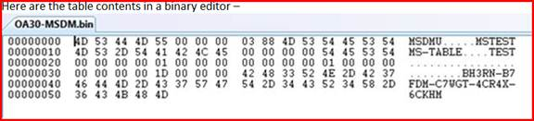

***Note:****You will need to use Visual Studio to open the bin file contained within this package.  The BIN file contains all settings required for the new ACPI MS-TABLE.  This table will need to be “updated” using the Windows BIOS Flash Utility + the Bin file provided for sample.*

|  |  |  |  |  |
| --- | --- | --- | --- | --- |
| **Field** | **Byte Length** | **Byte Offset (Decimal position)** | **Description** | **Corresponding to the sample** |
| Signature | 4 | 0 | MSDM | MSDM |
| Length | 4 | 4 | 0x55 | 0x55 |
| Revision | 1 | 8 | 0x03 | 0x03 |
| Checksum | 1 | 9 | Checksum of the entire table | 0x88 |
| OEMID | 6 | 10 | A string that is consistent with OEMID in other ACPI RSDTs/XSDTs ***<Your current OEMID used with OA 2.x>*** | MSTEST |
| OEM Table ID | 8 | 16 | A string that is consistent with OEMTableID in other ACPI RSDTs/XSDTs ***<Your OEMTableID currently used for OA2.x>*** | MS-TABLE |
| OEM Revision | 4 | 24 | 0x0 | 0x0 |
| Creator ID | 4 | 28 | Vendor ID of the utility that created the table | TEST |
| Creator Revision | 4 | 32 | Revision of the utility that created the table | 0x0 |
| MSDM Version | 4 | 36 | 0x1 | 0x1 |
| MSDM Reserved | 4 | 40 | 0x0 | 0x0 |
| MSDM Data Type | 4 | 44 | 0x1 | 0x1 |
| MSDM Data Reserved | 4 | 48 | 0x0 | 0x0 |
| MSDM Data Length | 4 | 52 | 0x1D | 0x1D |
| MSDM Data | 29 | 56 | 5x5 Product Key, including “-“ | BH3RN-B7FDM-C7WGT-4CR4X-6CKHM |

The following diagram shows OEMID and OEMTableID in relation to RSDT/XSDT

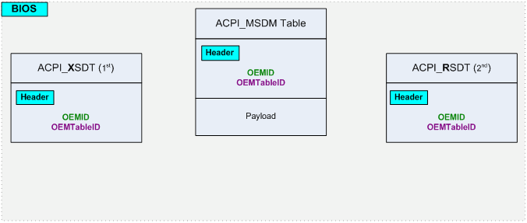

Note:

1. The signature “MSDM” may change due to our name change
2. OEM Injection tool should ideally allow us to customize the OEMID and OEMTableID fields

Additional constraints on the ACPI MSDM Table:

1. **OEMID** field in ACPI header for MSDM table must have same value as **OEMID** field in ACPI header for RSDT/XSDT table.
2. **OEMTableID** field in ACPI header for MSDM table must have same value as **OEMTableID** field in ACPI header for RSDT/XSDT table.

Note: The constraints specify RSDT/XSDT because according to ACPI specifications only one of RSDT table or XSDT table can be present on a system. For example, on a system with RSDT table the values of **OEM ID** and **OEM Table ID** fields in MSDM table will be compared with RSDT table values for these fields.

**Pilot Details:**

Microsoft will be testing a new tool that will output a binary file for consumption by your BIOS injection utility. This binary file will contain the 5x5 product key. The BIOS flash utility provided by you will then be used to inject the contents of the BIN file into the BIOS in the new table specified earlier (standard ACPI format).

This initial pilot will last for approx. 2 months long and will require the use of the PC’s during that timeframe.  Microsoft also asks that the onsite Systems Engineers be available to provide assistance and or additional BIOS flashing assistance throughout this pilot timeline via conference calls or in person meetings. Ultimately, Microsoft will run a second pilot that will provide the OEM the ability to test the OA3.0 tools directly along with your BIOS flashing tools and backend systems to ensure a successful feature launch with the next version of Windows, more on that as we progress through this initial pilot.

Microsoft appreciates your willingness to assist and develop this new digital form of licensing and product activation, and we look forward to working with you throughout the development cycle to ensure a successful launch.