**BIOS Requirement Supplements**

*for*

**China DT Commercial Projects**



**Acer Incorporated**

**8F, No. 88, Hsin Tai Wu Rd., Sec. 1,**

**Hsichih, Taipei County 221**

**Taiwan, R.O.C.**

|  |  |
| --- | --- |
| Document Type: | Specification Requirements |
| Department: | Platform Technology BU |
| Document Version: | V1.8 |
| Release Date: | 08/24/2017 |

This document contains proprietary technical information, which is the property of the Acer Incorporated and shall not be disclosed to others in whole or in part, reproduced, copied, or used as the basis for design, manufacturing, or sale of apparatus without written permission of Acer Incorporated.**Revision History**

| Rev. # | Date | Explanation of Change | Author |
| --- | --- | --- | --- |
| 0.8 | 02/18/2016 | 1. First release | David Chien |
| 0.9 | 02/19/2016 | 1. Modified chapter 5 SMBIOS requirements 2. Modified chapter 6 BIOS Setup requirements 3. Modified chapter 7 BIOS Copyright requirements | David Chien |
| 1.0 | 02/22/2016 | 1. Renamed to official version | David Chien |
| 1.1 | 04/20/2016 | 1. Added section 8.3 DB Key for 一键通 Software | David Chien |
| 1.2 | 07/14/2016 | 1. Updated Founder brand logo file(Section 3.1) 2. Modified BIOS Hotkey Requirements(Section 4.2) 3. Modified SMBIOS type 1, Family string definition for Microsoft MDA(Section 5.2) | David Chien |
| 1.3 | 08/05/2016 | 1. Modified BIOS version control(Chapter 2) for 证券 PC | David Chien |
| 1.4 | 09/01/2016 | 1. Reserved 4 customized SKU IDs for Soft Guard BIOS(Section 8.2) | David Chien |
| 1.5 | 10/14/2016 | 1. Added requirements for Soft Guard BIOS(Section 8.2) | David Chien |
| 1.6 | 01/09/2017 | 1. ABCT feature is not required, removed ABCT Data Version from Main page of BIOS Setup utility(Section 6.4) | David Chien |
| 1.7 | 03/23/2017 | 1. Chassis opened warning is not required, set default to be disabled and hid related items(Section 6.2) | David Chien |
| 1.8 | 08/24/2017 | 1. Updated requirements for Soft Guard BIOS(Section 8.2) | David Chien |

TABLE OF CONTENTS

SCOPE 4

1. Industry Specifications and Features 5

1.1 Industry Specification Requirements 5

1.2 Feature Requirements 5

2. BIOS Version Control 6

3. OEM Logo 7

3.1 Logo for Acer brand and Founder brand 7

3.2 Logo for Tax PC 7

4. BIOS Hotkey Requirements 8

4.1 Hotkeys for BIOS POST 8

4.2 Hotkeys for BIOS Setup 8

4.3 Hotkeys for Intel Platform 8

5. SMBIOS Requirements 9

5.1 Type 0: BIOS Information 9

5.2 Type 1: System Information 9

5.3 Type 2: Base Board Information 9

5.4 Type 3: System Enclosure or Chassis 9

6. BIOS Setup Requirements 10

6.1 Copyright String 10

6.2 Default Settings 10

6.3 Term for TPM Module 10

6.4 ABCT Data Version Information 11

7. BIOS Copyright Requirements 12

7.1 Copyright String on BIOS Setup Utility 12

7.2 BIOS Owner String during POST 13

7.3 EFI Vendor on EFI Shell 14

8. Special Requirements 15

8.1 证券 PC BIOS 15

8.2 Soft Guard BIOS 15

8.3 DB Key for 一键通 Software 16

# SCOPE

The document lists the BIOS requirements in support of developing Acer Desktop projects for Acer Inc. It covers the BIOS requirements and the project dependent requirements for new launch projects. The ODM suppliers should provide enough information for review and confirmation for all BIOS requirements specification with Acer.

# 1. Industry Specifications and Features

## 1.1 Industry Specification Requirements

| Industry Specification Requirements | Comment |
| --- | --- |
| TCM support   * Compliant with China Trusted Cryptography Module (TCM) Specification * Security architecture based on ZTEIC 8bit Security controller family | Required for China DT commercial projects  Refer to TCM specification “国家密码管理局 2007年12月” |

## 1.2 Feature Requirements

| Feature Requirements | Comment |
| --- | --- |
| Founder software protection card support (Refer to “PCGUARD BIOS VERSION SPEC.ZIP”) & “(制作日期2011.07.17)FZNB_2.10版本 Sig.zip” | Required for China DT commercial projects |
| Boot ROM requirement (Refer to “bootROM_Founder.bmp”) | Required for China DT commercial projects |



# 2. BIOS Version Control

The ODM suppliers should follow the rules below to release BIOS with proper version control.

* For China DT commercial projects, change BIOS version format to be “Main version + Special function + CTO number”  
  Main version: Same as Acer normal BIOS format like “E01”, “D01” or “R01-A0”  
  Special version: “R” for BIOS with hard disk guard solution, “T” for Tax PC and “Q” for 证券 PC  
  CTO number: from 001 to 999  
  For example,  
  R01-A0: Normal BIOS for Windows/Linux/FreeDOS  
  R01-A0R: BIOS with hard disk guard solution  
  R01-A0T: BIOS for Tax PC  
  R01-A0Q: BIOS for 证券 PC  
  R01-A0R-001: BIOS with hard disk guard solution and CTO defined  
  R01-A0-001: BIOS with CTO defined  
  Note: If the system BIOS includes special function(either hard disk guard, Tax PC or证券 PC), its ROM ID should be different from normal BIOS.
* Computer Hardware ID-10 differentiated between Normal BIOS and Customized/Service BIOSTo have different Computer Hardware ID-10 for customized or service BIOS, the system BIOS needs to append identification characters to SMBIOS Type 1 Family string. For customized BIOS, append “(C)” and for service BIOS, append “(S)”.  
  For example, SMBIOS Type 1 Family string would be “Founder Desktop (C)” for customized BIOS and would be “Founder Desktop (S)” for service BIOS.  
  Note: Because CHID-10 mechanism is case sensitive, please take care of correct information in SMBIOS. For example, “Founder” is correct string for manufacturer but “FOUNDER” or “founder”.

# OEM Logo

## 3.1 Logo for Acer brand and Founder brand



## 3.2 Logo for Tax PC



# 4. BIOS Hotkey Requirements

## 4.1 Hotkeys for BIOS POST

|  |  |  |  |  |  |
| --- | --- | --- | --- | --- | --- |
| Switch Logo to Text Mode | Continue POST after Error | Enter BIOS Setup | Display Boot Menu | Boot from LAN | Recover OS |
| Esc | F1 | Del | F12 | F9 | Not Support |

## 4.2 Hotkeys for BIOS Setup

|  |  |  |  |  |  |
| --- | --- | --- | --- | --- | --- |
| Load Acer-defined Defaults | Save and Exit BIOS Setup | Load User-defined Defaults | Save as User-defined | Show/Hide Memory and HDD Test items | Show/Hide OneBIOS SKU ID |
| F9 | F10 | F7 | F8 | Ctrl + D | Ctrl + D |

## 4.3 Hotkeys for Intel Platform

|  |
| --- |
| MEBx |
| Ctrl + P |

# 5. SMBIOS Requirements

## 5.1 Type 0: BIOS Information

|  |  |  |  |
| --- | --- | --- | --- |
| Offset | Name | Value | Description |
| 04h | Vendor | STRING | “Acer” for Acer brand  “Founder” for Founder brand  The BIOS vendor should be the same as system manufacturer |

## 5.2 Type 1: System Information

|  |  |  |  |
| --- | --- | --- | --- |
| Offset | Name | Value | Description |
| 04h | Manufacturer | STRING | “Acer” for Acer brand  “Founder” for Founder brand |
| 1Ah | Family | STRING | Refer to Acer SMBIOS Spec v2.2 or later for the details |

## 5.3 Type 2: Base Board Information

|  |  |  |  |
| --- | --- | --- | --- |
| Offset | Name | Value | Description |
| 04h | Manufacturer | STRING | “Acer” for Acer brand  “Founder” for Founder brand |

## 5.4 Type 3: System Enclosure or Chassis

|  |  |  |  |
| --- | --- | --- | --- |
| Offset | Name | Value | Description |
| 04h | Manufacturer | STRING | “Acer” for Acer brand  “Founder” for Founder brand |

# 6. BIOS Setup Requirements

## 6.1 Copyright String

* Keep BIOS vendor copyright string at the bottom of BIOS Setup utility

|  |  |  |  |  |  |  |
| --- | --- | --- | --- | --- | --- | --- |
| BIOS Setup Utility | | | | | | |
| Main | Advanced | Power | Authentication | Security | Boot Options | Exit |
|  | ►CPU and Chipset Configuration |  |  |  |  | Save & Exit Setup |
|  | ►Integrated Peripherals |  |  |  |  | Discard Changes and Exit Setup |
|  | ►Integrated Peripherals |  |  |  |  | Save Changes |
|  | ►Processor Configuration |  |  |  |  | Discard Changes |
|  | ►DRAM Configuration |  |  |  |  | Load Default Settings |
|  | ►Bus Configuration |  |  |  |  | Save as User Default Settings |
|  |  |  |  |  |  | Load User Default Settings |
|  |  |  |  |  |  |  |
|  |  |  |  |  |  |  |
| Version x.xx.xxxx. Copyright (C) 2017 American Megatrends, Inc. | | | | | | |

## 6.2 Default Settings

* Remove TPM Device Selection item from Security page because China DT Commercial projects do not support firmware TPM

|  |  |
| --- | --- |
| Security | Options |
| ~~TPM Device Selection~~ | ~~dTPM/PTT dTPM/fTPM~~ |

* Set Chassis Opened Warning default to be disabled and hide related items for China DT commercial projects

|  |  |
| --- | --- |
| Security | Options |
| ~~Chassis Opened Warning~~ | Disabled/Enabled/Clear |
| ~~Chassis Opened~~ | ~~Yes/No~~ |

## 6.3 Term for TPM Module

* Change the term “TPM” to “TCM”

|  |  |
| --- | --- |
| Security | Options |
| TCM Support | Disabled/Enabled |
| TCM State | Disabled/Enabled |
| TCM Operation | None/Clear |
| Current TCM Status |  |
| TCM Enabled Status | Disabled |
| TCM Active Status | Deactivated |
| TCM Owner Status | UnOwned |

## 6.4 ABCT Data Version Information

* China DT Commercial projects do not support ABCT feature, remove ABCT Data Version information from Main page of BIOS Setup utility

|  |  |
| --- | --- |
| Main | Options |
| ~~ABCT Data Version~~ | ~~XXXXXXXXh~~ |

# 7. BIOS Copyright Requirements

## 7.1 Copyright String on BIOS Setup Utility

* Keep BIOS vendor copyright string at the bottom of BIOS Setup utility

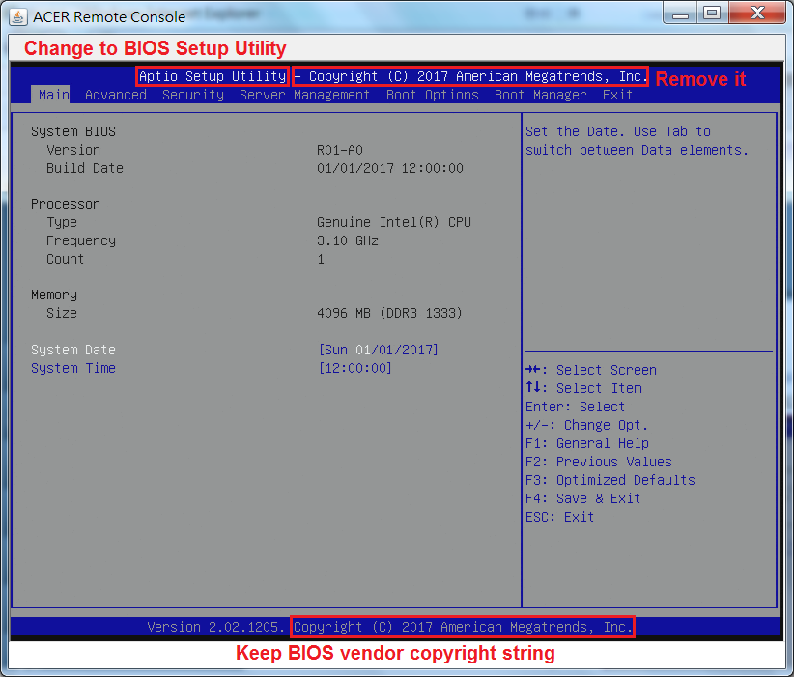

## 7.2 BIOS Owner String during POST

* Display BIOS owner string as follows  
  “This BIOS is exclusively for Acer only” for Acer brand or  
  “This BIOS is exclusively for Founder only” for Founder brand  
  Note: Acer copyright string “Copyright (C) 2002-2017, Acer Inc.” is not required to be displayed

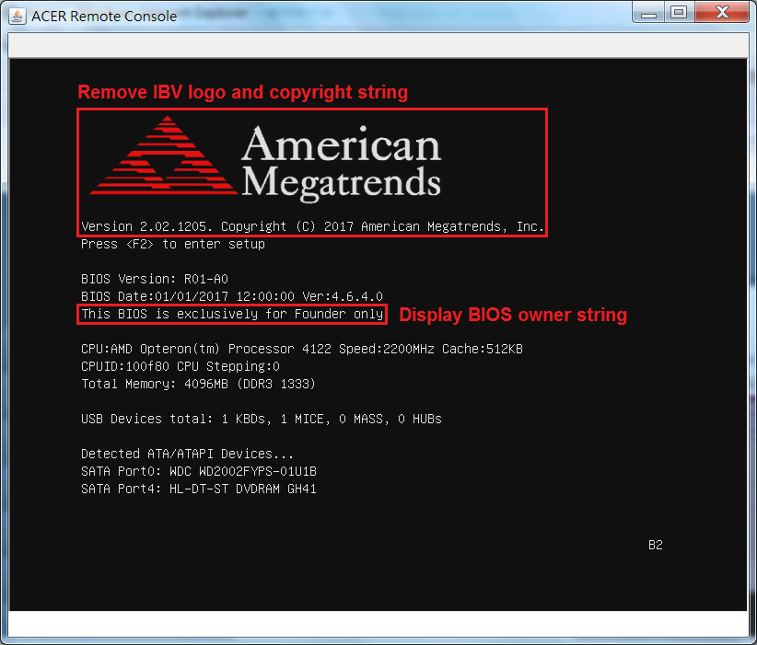

## 7.3 EFI Vendor on EFI Shell

* Keep BIOS vendor name as EFI vendor

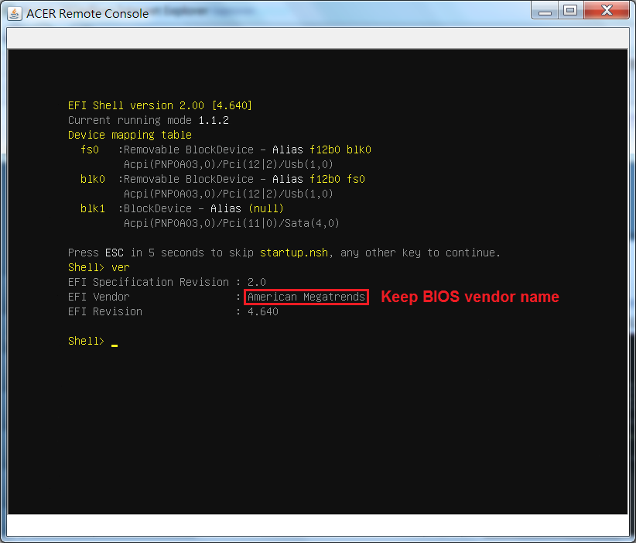

# 8. Special Requirements

## 8.1 证券 PC BIOS

* Display onboard LAN MAC address on the Main page of BIOS Setup Utility

|  |  |
| --- | --- |
| Main | Options |
| **System BIOS** |  |
| Version | R01-A0Q |
| Build Date | MM/DD/YYYY |
| OneBIOS SKU ID | XXXXh |
| **EC Firmware** |  |
| Version | 1.00 |
| Build Date | MM/DD/YYYY |
| **Processor** |  |
| Intel series / AMD series |  |
| Core Frequency | X.XX GHz |
| **Memory** |  |
| Size | XXXX MB |
| Product Name |  |
| System Serial Number | 22 characters minimum |
| Base Board Serial Number | 22 characters minimum |
| Asset Tag Number | 22 characters minimum |
| Onboard LAN MAC Address | XX-XX-XX-XX-XX-XX |
| System Language | English/Spanish/SC/TC/... |
| System Date | WEK MM/DD/YYYY |
| System Time | HH:MM:SS |

## 8.2 Soft Guard BIOS

* Set onboard LAN option ROM default to be enabled, always and only load onboard LAN EFI driver regardless of CSM or Boot Filter setting
* To support PXE boot function in legacy mode, the UEFI PXE boot devices are required to be listed in Boot Menu when Boot Filter setting is legacy mode

|  |  |
| --- | --- |
| Integrated Peripherals | Options |
| Onboard LAN Option ROM | Disabled/Enabled |
| Option ROM Protocol | IPv4/IPv6 |

* Reserved 4 customized SKU IDs that change Secure Boot to be disabled



|  |  |  |  |  |  |  |  |  |  |
| --- | --- | --- | --- | --- | --- | --- | --- | --- | --- |
| SKU ID | Binary File | MSDM | SLIC | SATA Mode | Secure Boot | CSM | Boot Filter | Boot Menu | OS Type |
| F004h | WINAGPAH.F04 | O | X | AHCI | Disabled | Never | UEFI | Enabled | Win 10 |
| F008h | WINAGPRD.F08 | O | X | RAID | Disabled | Never | UEFI | Enabled | Win 10 |
| F00Ah | WAPRGPAH.F0A | O | O | AHCI | Disabled | Never | UEFI | Enabled | Win 10 Pro |
| F00Bh | WAPRGPRD.F0B | O | O | RAID | Disabled | Never | UEFI | Enabled | Win 10 Pro |

* To support 三茗软保卡(CCM) software, use DMI tool to write an OEM string “SAMING” into Type 11
* For BIOS R01-xxR(华锐软保卡 support), BIOS always returns “Function not support” for WMI function call “Set BIOS Option/Set CSM & Secure Boot Default Value”
* For normal BIOS R01-xx, if OEM string “SAMING” exists in SMBIOS Type 11, BIOS should return “Function not support” for WMI function call “Set BIOS Option/Set CSM & Secure Boot Default Value”, else BIOS follows WMI function call to change CSM and Secure Boot settings.

## 8.3 DB Key for 一键通 Software

* Add Lumos DB Key into BIOS to support secure boot feature with 一键通 Software

