**Acer BIOS HDD-Unlock Procedure**

|  |  |
| --- | --- |
| Revision: | 0.1 |
| Create Date: | Jul. 9th, 2015 |
| Author: | Jovi Liu |

## History

|  |  |  |  |
| --- | --- | --- | --- |
| Revision | Author | Date | Changes |
| 0.1 | Jovi Liu | 2015/07/09 | Initial draft |
|  |  |  |  |
|  |  |  |  |

## Introduction

Users are able to set HDD User Password in Acer BIOS setup menu for security concern, the contents of HDD cannot be accessed without correct password.

Once HDD User Password is set, user is able to try to enter HDD User Password up to a maximum of three times during POST. After three attempts failed, HDD locked by incorrect password, system will pop up a prompt window with “Unlock HDD Token”, which needs to be provided for Acer CSD to unlock HDD for user.

This document describes the standard operating procedure for CSD to help user remove HDD User Password, in case user forgets the password which was installed on system.

## Standard Operating Procedure

1. User would set HDD User Password in Security page:

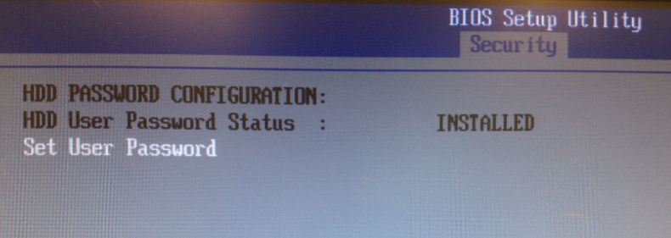

1. System will pop up a window to ask user to enter HDD User Password during POST if password is installed:

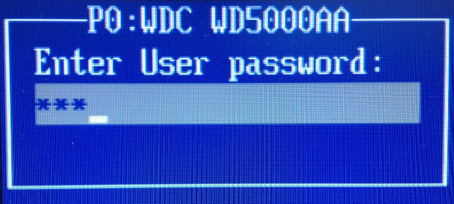

1. System stops to boot if HDD User Password is invalid:

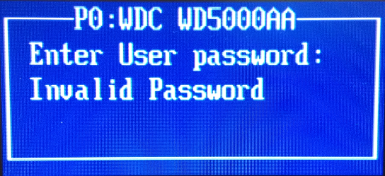

1. After three failed attempts, user will get a message with “Unlock HDD Token”:

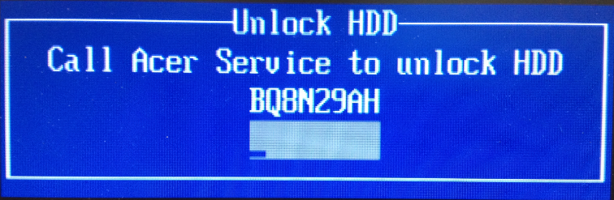

1. There’s a JAVA tool named “AcerUnlockHdd.jar” which is designed for CSD to unlock HDD (remove HDD User Password), in case user forgets their HDD User Password installed on the system.

unzip pwd: acer

1. Left click “AcerUnlockHdd.jar” twice to open the application under OS, CSD has to input Access code: **acerDtCSD** before executing the application:

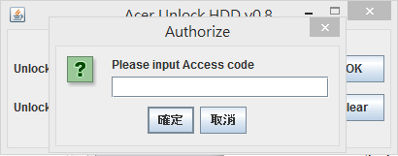

1. Once you pass the authorization, will get a prompt message to ask you to input “Unlock HDD Token”:

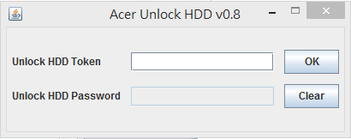

1. In this case, please refer to step 4, “Unlock HDD Token” is “BQ8N29AH”.
2. The application will auto-generate “Unlock HDD Password”:

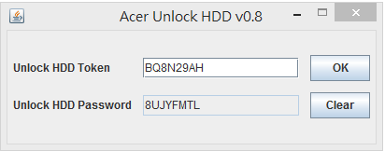

1. CSD can provide the “Unlock HDD Password” for user to unlock HDD (remove HDD User Password):

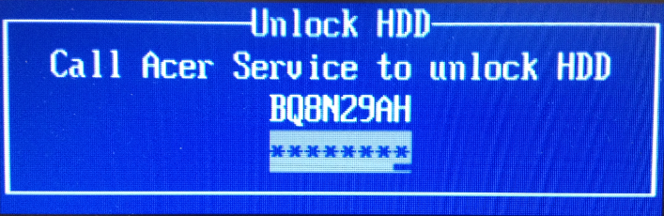

1. Then system will reboot and clean HDD User Password.