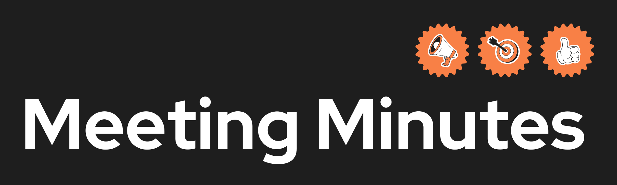
Date and Time | 23/01/2026  1:50 PM
Project Name | Study Buddy
Meeting Goal | - Agree code of conduct  - Agree group name  - Choose project
Facilitator | N/A
Note taker | Lan
Attendees | Ali, Nilay, Lan, Maywon
Roundtable Updates (each group member to contribute) | N/A
Discussion points | .Gorup members/group nam  .Code of conduct  .Github repository
Actions (list tasks and assign a group member) | .Group + group name decided (all)  .Code of conduct discussed and created (all)  .Potential project choice discussed (all)

