AI And Web-Based Interactive College Enquiry Chatbot

# Rohan Parkar

*Computer Engineering*

*A. P. Shah Institute of Technology*

Thane, India [parkarrohan45@gmail.com](mailto:parkarrohan45@gmail.com)

# Jitesh Nambiar

*Computer Engineering*

*A. P. Shah Institute of Technology*

Thane, India [jitujitesh394@gmail.com](mailto:jitujitesh394@gmail.com)

# Yash Payare

*Computer Engineering*

*A. P. Shah Institute of Technology*

Thane, India [yashpayare27@gmail.com](mailto:yashpayare27@gmail.com)

# Prof. Jaya Gupta

*Computer Engineering*

*A. P. Shah Institute of Technology*

Thane, India [jdgupta@apsit.edu.in](mailto:jdgupta@apsit.edu.in)

# Keyur Mithari

*Computer Engineering*

*A. P. Shah Institute of Technology*

Thane, India [mitharike](mailto:mitharikeyur246@gmail.com)[yur246@gmail.com](mailto:yur246@gmail.com)

***Abstract*—AI and web-based interactive College Enquiry Chat- bot is a straightforward web application that aims to supply knowledge regarding college. The chatbot created here may be a web-based application that uses tongue Processing Libraries and AI terminology to possess conversations with humans. “Eliza” and “Cleverbot” are several online applications that are created within the past. The College Enquiry Chatbot will engage in friendly conversations, respond to the course and college information, provide a link to the tutorial calendar, and answer frequently asked questions, among other things. This project is specialized in creating a chatbot to be employed by students to urge their queries responded to easily from the college website. A chatbot may be a program that may do real conversations with textual and/or auditory methods. Using AI, chatbots can simulate human conversations. Humans respond to others depending on their mood and emotions. Whereas chatbots are bound by some rules, resulting in them treating a customer most politely and perfectly. Students can ask questions to the chatbot at any time of the day and get a reply very quickly. At any time of day, chatbots can have simultaneous conversations with thousands of people. A chatbot can work 24x7 without getting tired. It is subjected to minimal errors thus increasing productivity.**

2021 13th International Conference on Electronics, Computers and Artificial Intelligence (ECAI) | 978-1-6654-2534-6/21/$31.00 ©2021 IEEE | DOI: 10.1109/ECAI52376.2021.9515065

***Index Terms*—Artificial Intelligence, Machine Learning, Chat- bot, Natural Language, GUI.**

1. Introduction

Usually, we tend to pay our time interacting with distinct chatterboxes on the web, largely targeted at such functions or just entertainment. Chatbots extract relevant entities by analysing and defining the intent of the user’s request. The college inquiry chatbot project is meaning to use natural lan- guage processing to answer the user’s queries. It is extremely beneficial to users because it helps them to ask questions in their native tongue and receive the requested answers quickly. The project takes the user’s queries in question- based format and processes them to produce the requested response as a message. It avoids the time-consuming approach of visiting colleges and collecting relevant information to meet the requirements [6]. As students, we require many sorts of

data regarding our college and university during our course. Traditionally we have a person’s representative who answers all the doubts and questions of the scholars. This process is tedious and repetitive. It can reduce the efficiency of a person’s representative. Instead, a chatbot can serve this purpose well. Artificial intelligence (AI) relates to the simulation of human intellect in instruments that are programmed to conceive like humans and imitate their actions. The term may also be applied to any machine that displays characteristics related to a person’s mind like learning and problem-solving. AI may be a method of making a machine, a computer-controlled robot, or computer software think intelligently. Chatbots make use of machine learning to accomplish AI helping them to understand the user query and provide an appropriate response [5]. The chatbot developed here is a web-based application that converses with humans using Natural Language Processing Libraries and Machine Learning [3]. Since the curriculum of the college keeps on changing, there has to be a database that can be altered and updated. To serve this purpose a website is created in HTML and PHP to update the database from time to time. To improve efficiency and accountability for college students, the bot uses essential data given by the institute themselves. It reduces the paperwork, manpower for a person. For the User, there is no need to visit the college personally to inquiry about the college-related information. This technique aids the scholars to be updated with college-related activities [7]. This technique is developed aiming at reducing the time for the student, parents, and the faculty at the institution.

1. Literature Review
2. *AI and Web-Based Human-Like Interactive University Chatbot (UNIBOT)*

The paper titled ”AI and Web-Based Human-Like Interac- tive University Chatbot (UNIBOT),” 2019 [1] was published by N. P. Patel, D. R. Parikh, D. A. Patel and R. R. Patel

Often students have to visit the college to get information about the admission process or activities taking place in college etc. They have to travel to the college every time to collect the information making this process tedious and time- consuming. So to surmount this issue Chatbot was developed. This helps you have a conversation with the user in an interactive manner. The main advantage is that it reduces your time for traveling and can be accessed anywhere and anytime. The Chatbot proposed in this paper has been developed by the PHP language and uses the concept of Artificial intelligence and Machine learning [3]. The Graphical interface for this chatbot is close to that of a messaging app.

Drawbacks: The Unibot developed in the paper is unable to comprehend the twisted queries asked by the user correctly as it uses SQL queries to fetch the answers. As a result, Artificial Intelligence will be the greatest alternative for comprehending user questions and selecting the most relevant solution.

1. *Chatbot for University Related FAQs*

The paper titled ”Chatbot for University Related FAQs”, (2017) [2] was published by B. R. Ranoliya, N. Raghuwanshi and S. Singh

Chatbots are the virtual assistant developed using Artificial intelligence and can be similar to human conversation. It can be used for various purposes like entertainment, education, healthcare, etc. Chatbots have been beneficial in many sectors like for eg. in the Business sector the customer service cost can be reduced immensely and can also handle lots of users at a time [2]. For this, we need to increase the efficiency of the chatbot and this has been accomplished in the following paper. They have developed a chatbot that gives you the exact answer based on the query. This Chatbot has been developed using Artificial Intelligence Markup language and Latent Semantic Analysis [5]. Basic greetings are answered using the AIML whereas the other questions are answered using the LSA. This chatbot can be used by any student to get the answers to the University related FAQs.

Drawbacks: NLP can be used to preprocess the data so that the model can use meaningful data for training and provide an accurate answer to the users’ query.

1. *Recommending Moodle Resources Using Chatbots*

The article named ”Recommending Moodle Resources Us- ing Chatbots”,(2019) [3] was published by Kamal Souali, Othmane Rahmaoui, Mohammed Ouzzif, Ismail El Haddioui. In a conventional homeroom, at whatever point a student needs assistance or then again looks for extra data, he should consistently reach that teacher for an added explanation or either request his kindred acquaintances or associates. This test has pushed teachers and analysts to execute novel plans to assist students with improving their learning furthermore, their insight. New arrangements are utilizing Artificial Knowledge (AI) procedures like Machine Learning (ML) furthermore, Natural Language Processing (NLP). Utilizing one of the PHP put-together accessible systems concerning the web, Their chatbot could be coordinated within Moodle’s foundation each

as a custom menu thing or essentially a gadget in an HTML block.

Drawbacks: Using a JSON file for a dataset is more efficient since it reduces response time. JSON file stores the data in an array, which makes the transfer of data much easier.

1. *NLP Chatbot for Discharge Summaries*

”NLP chatbot for Discharge Summaries”, (2019) [4] was published by Harsh Lal, Priyanshu Lal.

In modern times, there continues a growing concern in im- proving the utility of application interfaces. The robot interface is high-tech automation that combines various fields, including computational approaches that promote collaboration among clients and machines utilizing natural language. Improving the quality of treatment and support provided by the healthcare sector is one of the most significant priorities of healthcare. There is an increasing need for health care accessibility, which requires the advancement of wellness technologies with Human-Computer Interaction (HCI) architecture in mind. The use of HCI will benefit each patient and healthcare provider. We present a Natural Language Processing technology [12] that uses subject representation and word grafting to build a chatbot that can answer patients’ questions dependent on their discharge summary and the information representation gained from a corpus of various discharge summaries.

Drawbacks: User-friendly GUI and FAQ system can make it much easier for the user to interact with the chatbot.

1. Proposed System

We created an integrated chatbot for college-related en- quiries in this work, and the workflow of the proposed system as seen in Fig.1. A dataset is created using tags, questions, and responses accordingly. The dataset is then separated into x train and y train, where x train is the inputs that are processed using NLP and y train are all the tags in the dataset. The hyper-parameters are then defined and the Feedforward neural network model. The model is trained on x train and y train. Once the model is trained, it is saved and ready to answer user queries. In all cases, user discussion begins with greetings or general questions. NLP is used to process user requests first, and this operation is split into four sections.

* Tokenization is used to divide the sentence into words.
* Using porter stemmer, these words are clipped to their source words.
* The punctuation marks are removed.
* A bag of words is formed.

This processed data is then fed into a trained feedforward neural network model. Then it predicts the most appropriate tag. The model checks if the prediction is above 75% and if so, it finds the predicted tag in the dataset, and the user is then given an answer related to that tag. When the prediction is below 75% the bot gives a link to a google form where the user can give feedback of the question whose answer was not found. This paper introduces a chatbot for educational services, where users (students or parents) may ask ques- tions about college enrollment, college information, and other

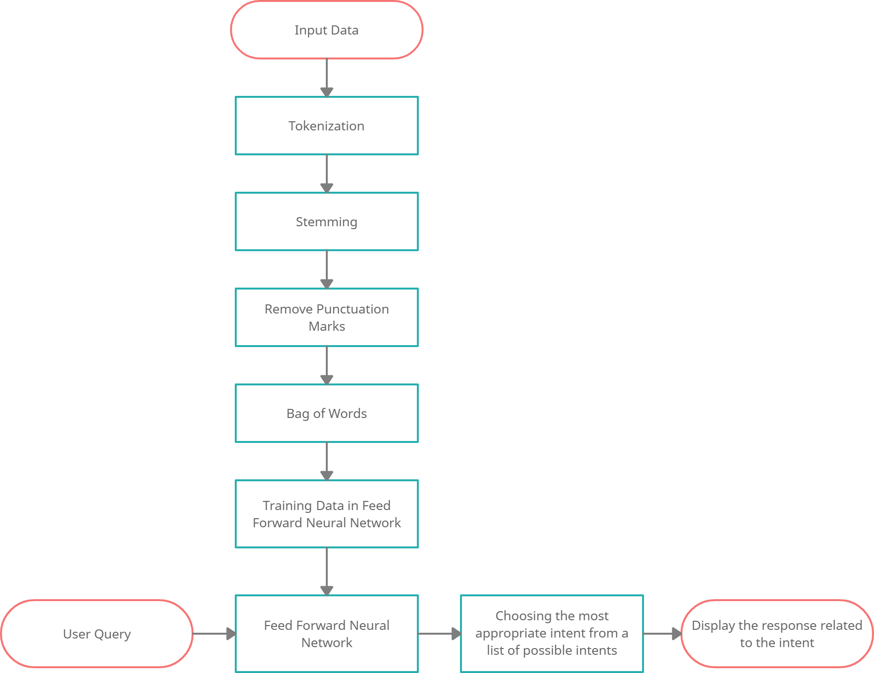

Fig. 1. Workflow Diagram

academic-related topics [7][8]. As previously the chatbots were based on SQL queries it was tough to get accurate responses when the questions were twisted. The use of AI helps the understand the human language and give correct responses even if the questions are twisted. This approach helps to create more interactive conversations with the chatbot as the chatbot is first trained on the data and then deployed to give responses to the users.

1. Design of ApsitBot

The ApsitBot i.e., A.P. Shah Chatbot, is Displayed in Fig.2. The graphical user interface (GUI) is important in chatbots because it improves the user experience. The chatbot’s front end is then created using HTML, CSS, and jQuery. Flask- SocketIO is used to get a response from the back end and display the messages to the user.

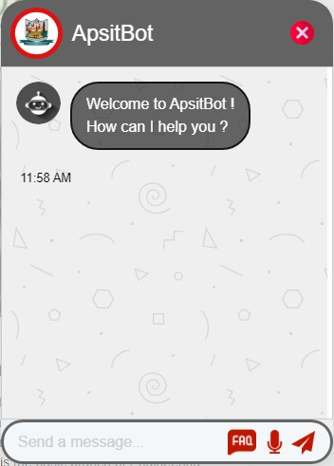

Fig. 2. Design of Bot

1. Implementation Process
   1. Algorithm

The project is based on Natural Language Processing (NLP) [4][12], which enables human-machine communication without the need for humans to speak Java or any other programming language and process data from user inputs that are written or spoken. In NLP there are various steps such as:

* Tokenization: In tokenization, the sentences are broken down into small units called tokens. Tokens may be words, characters, or subwords in this case. The format- ting is done based on spaces [11].
* Stemming: In stemming morphological variants of a root/base word are produced. Stemming algorithms or stemmers are terms used to describe stemming systems. Tokenized words are given as input to the stemmers [11].
* Bag of Words: The text is pre-processed using the bag of words model into the bag of words, which keeps track of the total number of times the most commonly used words appear. A table can be used to visualize this model, which contains the number of terms that correspond to each word.
  1. Feedforward Neural Network

The chatbot uses Feedforward Neural Network for predict- ing the responses. Once the Natural Language Processing is performed on the patterns, X variable is created which has all the training dataset which is fed to the feedforward neural network model and it predicts the Y variable that is tagged. The dataset has around 204 unique words as the input and 54 tags as the output. The hyper-parameters like learning rate are set to 0.00017, the batch size is 8 and the number of epochs is 1000. Our feedforward neural network has one input layer and two hidden layers. Each layer has an activation function between them except the last layer as it has Softmax at the end. Once the training is complete the model is saved in a file named ‘data.pth’. The training loss is calculated after each iteration and the final loss is calculated at the end, which is around 0.0002. This trained model is then used to predict the appropriate tags when the user asks a question to the chatbot. The working of the feedforward neural network is shown in Fig.3.

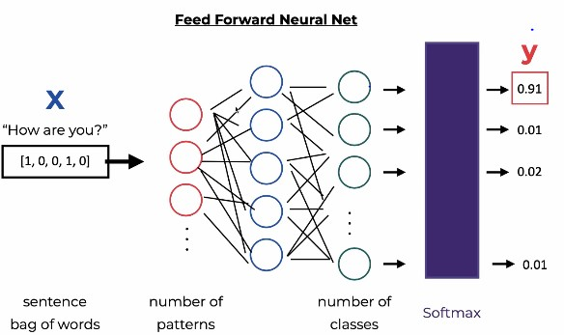

Fig. 3. Working of Feedforward Neural Network

* 1. Dataset

The chatbot’s storage is in the .json format. JavaScript Object Notation (JSON) is a text-oriented format that is widely

used which uses JavaScript syntax. It stores and transmits data objects made up of attribute-value pairs and array data types using human-readable text. The .json file contains the intents i.e., the goal the user has in mind when typing in a question or query to the chatbot application [10]. Every intent has a tag name saved in a variable named tag (for example greeting, committees, location, contact, etc.). Also, concerning every tag, there are several queries a user can ask under the heading patterns. There are different patterns in which a user can ask a single query. All these patterns are included in this pattern’s variable. The responses to these queries are stored in the responses variable. The database is created to study the college website and analysing what queries a user can ask and what responses he or she will expect. Also, google forms have been used to collect data for the database. Fig.4 shows two intents which are greetings and time. Here the questions in the pattern variable are input for the neural network model and tags are the output.

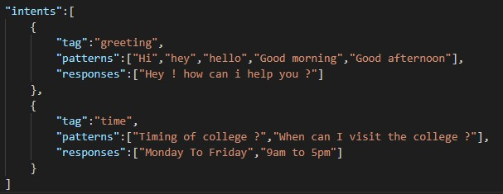

Fig. 4. Dataset

1. Results

The ApsitBot uses NLP to process the user query and then this processed query is used by the neural network model to predict the response. The feedforward neural network model was trained with 54 intents with a learning rate of 0.00017. The number of epochs was set to 1000 and after 10 successful iterations, the final loss of the trained model was found to be 0.0002. Training loss was calculated after each iteration and it is plotted using a graph in Fig.5.The plotted graph shows that the training loss is decreased to the point of stability. This indicated that this is an optimal fit.

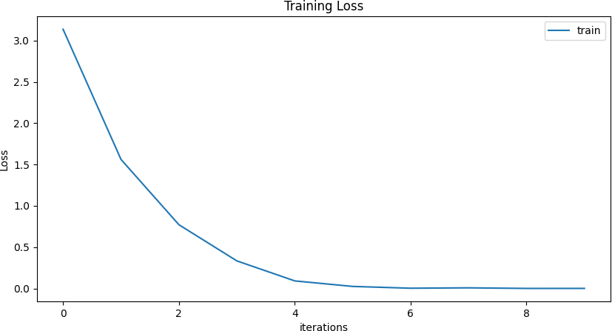

Fig. 5. Training loss

Most of the chatbots which work on SQL queries [1][11] are unable to find a response when the questions are asked differently. As ApsitBot uses NLP and AI to find a response, the bot can find the response easily even if the questions are twisted. Fig.6 shows how the chatbot responds with the right answer even if the question was asked differently.

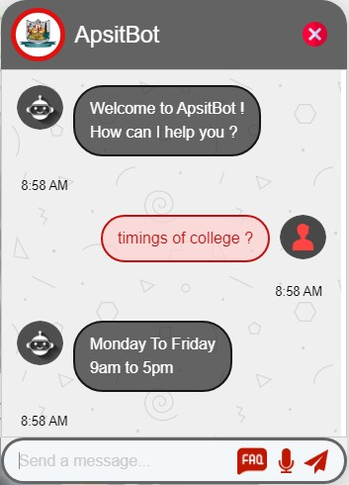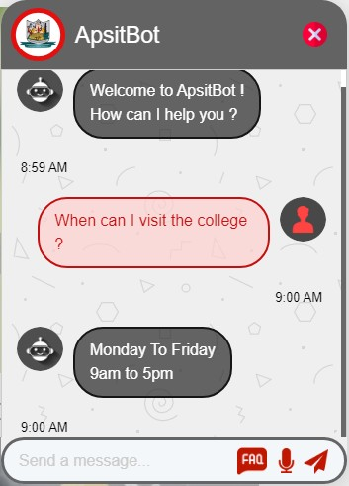

Fig. 6. Screenshots of chatbot

The FAQ system as seen in Fig.7 helps the users to ask a predefined question without any need of framing a new one. These predefined questions are easily identified by the model and it gives accurate answers. This FAQ system helps in increasing the overall performance of the chatbot [2].

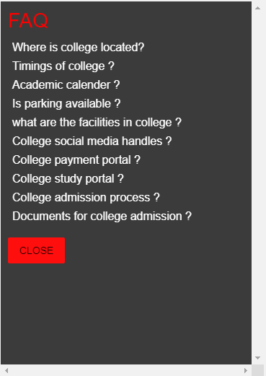

Fig. 7. FAQ system of chatbot

1. Conclusion

A chatbot is a piece of software that automates the process of answering questions. Chatbots are artificially intelligent programs that live online in chat rooms or on social media sites and are constantly evolving. The most critical role of a chatbot is to analyze and classify the intent of the user’s request in retrieving appropriate entities. The consumer receives an appropriate answer after the evaluation is complete. Chatbots

are a more sophisticated way to ensure that consumers get the quick help they need without having to wait. Bots are accessible at any time to engage consumers and provide instant responses to their most frequently asked questions.

ApsitBot is a steppingstone technology developed with Natural Language Processing and Artificial Intelligence. It is a web-based application that uses Natural Language Processing Libraries and Machine Learning to have conversations with humans [9]. Even if not being familiar with the college website, the user can ask their queries to the bot and get desired answers. The result can be shown in the form of images and card format or text format. The query will be answered based on the questions that were posed, the language model that was developed, and the response media that was created. To ask any questions, the user can use the speech recognition functionality [5]. While typing questions, the chatbot offers suggestions that assist the user to ask the right questions and getting an accurate response to their queries. The bot has a FAQ button that allows users to ask the bot a commonly asked question with just one click.

The development of this chatbot addresses the issues that may arise when collecting information. This application can be relied on by students with considerable ease and without difficulties. As a result, the chatbot assists students in staying informed about college-related events and aims to save time for students, parents, and faculty at the institution.

References

1. N. P. Patel, D. R. Parikh, D. A. Patel and R. R. Patel, ”AI and Web- Based Human-Like Interactive University Chatbot (UNIBOT),” 2019 3rd International conference on Electronics, Communication and Aerospace Technology (ICECA), Coimbatore, India, 2019.
2. B. R. Ranoliya, N. Raghuwanshi and S. Singh, ”Chatbot for University Related FAQs”, 2017 International Conference on Advances in Computing Communications and Informatics (ICACCI), 2017.
3. Souali, K., Rahmaoui, O., Ouzzif, M.,—&. El Haddioui, I. (2019). ”Recommending Moodle Resources Using Chatbots”, 2019 15th Interna- tional Conference on Signal-Image Technology & Internet-Based Systems (SITIS).
4. Lal, H., & Lal, P. (2019). NLP chatbot for Discharge Summaries. 2019 2nd International Conference on Intelligent Communication and Computational Techniques (ICCT).
5. Fernando A. Mikic Fonte, Mart´ın Llamas Nistal, Juan C. Burguillo Rial and Manuel Caeiro Rodr´ıguez, ”NLAST: A natural language assistant for students” in , Vigo, Spain:Department of Telematics Engineering, University of Vigo.
6. Amey Tiwari, Rahul Talekar and S.M. Patil, ”College Information Chat Bot System”, International Journal of Engineering Research and General Science, 2017.
7. Balbir Singh Bani and Ajay Pratap Singh, ”College Enquiry Chatbot Using A.L.I.C.E”, International Journal of New Technology and Research, 2017.
8. Mondal, A., Dey, M., Das, D., Nagpal, S., & Garda, K. (2018). Chatbot: An automated conversation system for the educational domain. 2018 Inter- national Joint Symposium on Artificial Intelligence and Natural Language Processing (iSAI-NLP).
9. H. K. K., A. K. Palakurthi, V. Putnala and A. Kumar K., ”Smart College Chatbot using ML and Python,” 2020 International Conference on Sys- tem, Computation, Automation and Networking” (ICSCAN), Pondicherry, India, 2020.
10. Chun Ho, C., Lee, H. L., Lo, W. K., & Lui, K. F. A. (2018). ”Developing a Chatbot for College Student Programme Advisement”, 2018 International Symposium on Educational Technology (ISET).
11. Prof.K. Bala, Mukesh Kumar, Sayali Hulawale and SahiI Pandita, ”Chat- Bot For College Management System Using A.I”, International Research Journal of Engineering and Technology (IRJET), vol. 04, no. 11, pp. 2030- 2033, Nov 2017.
12. Guruswami Hiremath, Aishwarya Hajare, Priyanka Bhosale, Rasika Nanaware and K. S. Wagh, ”Chatbot for education system”, Interna- tional Journal of Advance Research Ideas and Innovations in Technology (IJARIIT), vol. 4, no. 3, pp. 37-43, 2018.