Name: Chea Senghak

ID: e20211624

Group: I3 GIC A

**Assignment07-web**

TP07-01

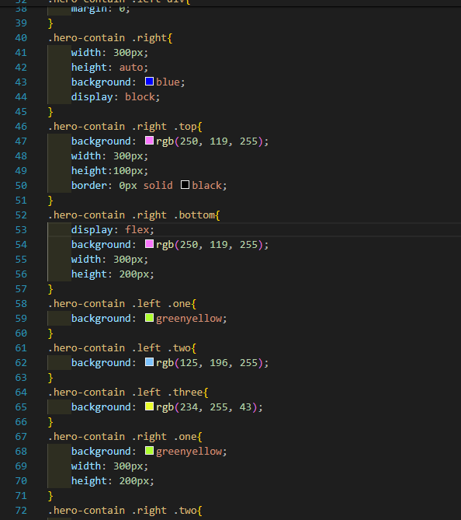 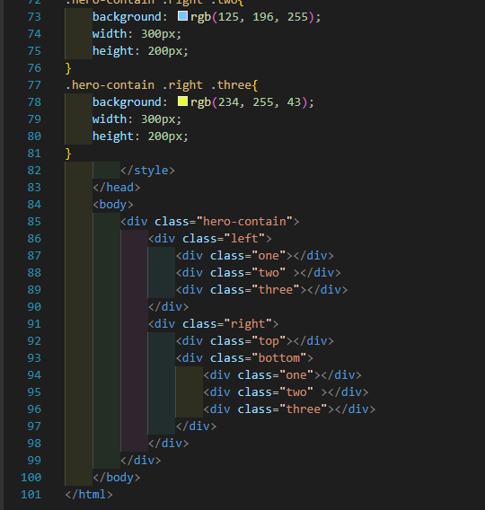

TP07-02 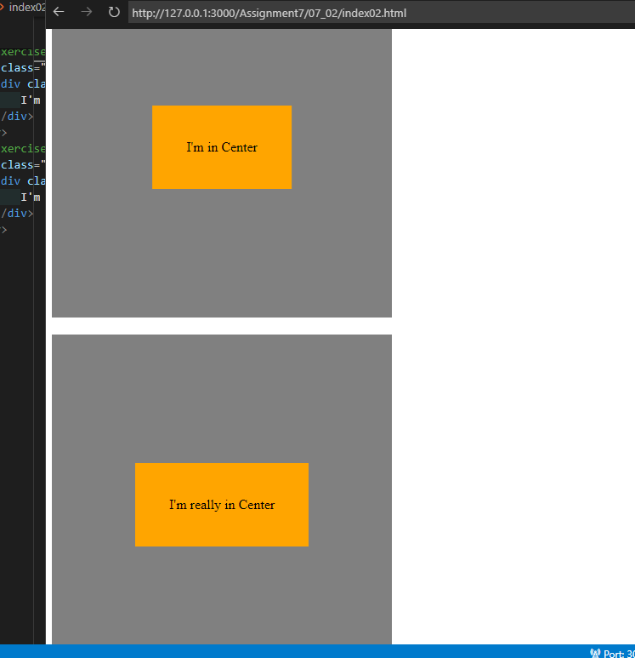 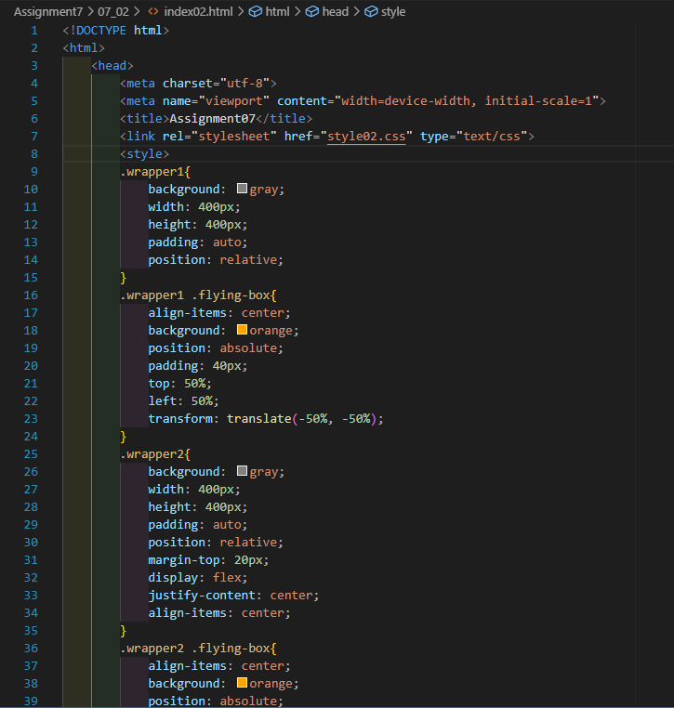 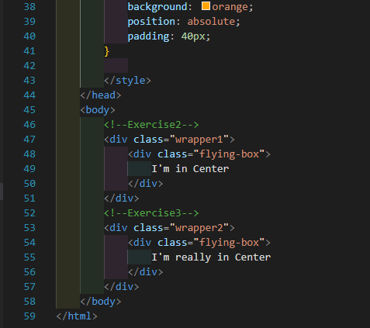

TP07-03

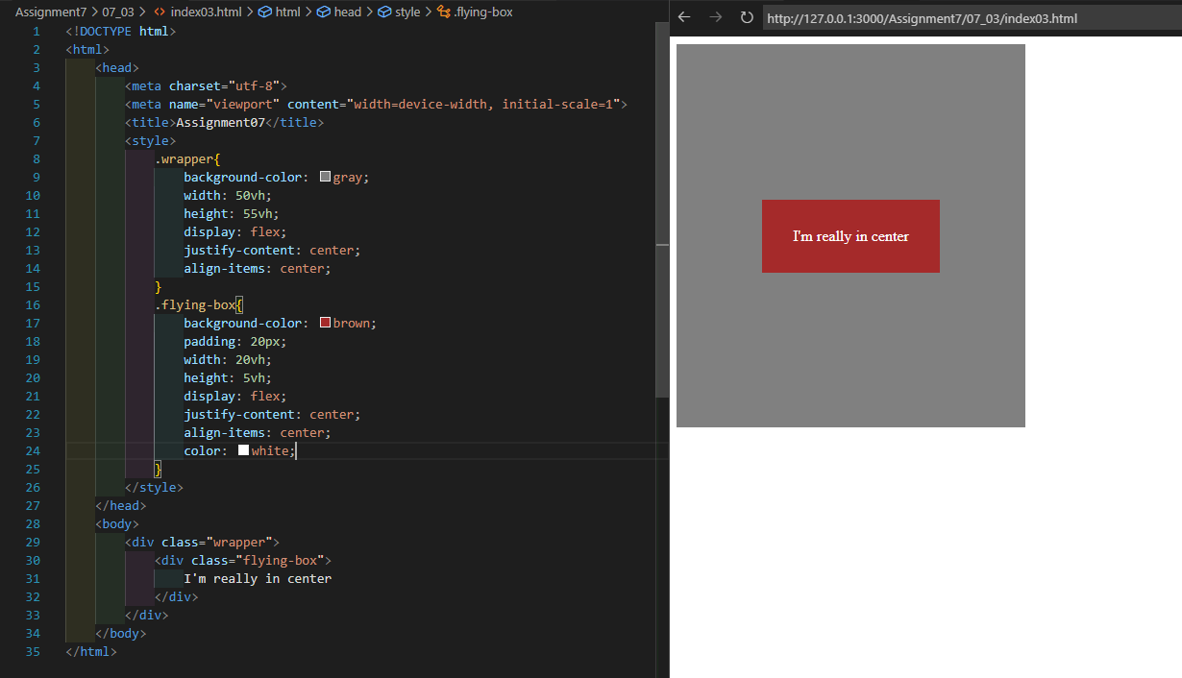

TP07-04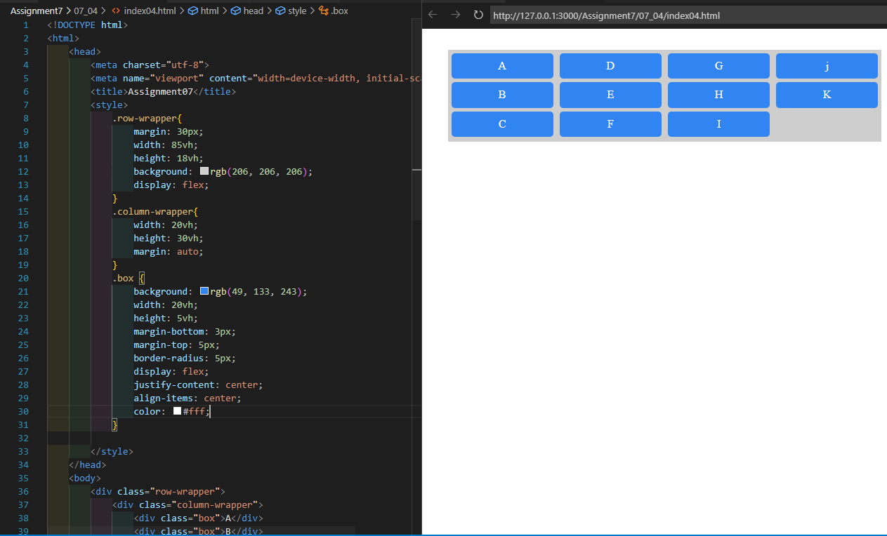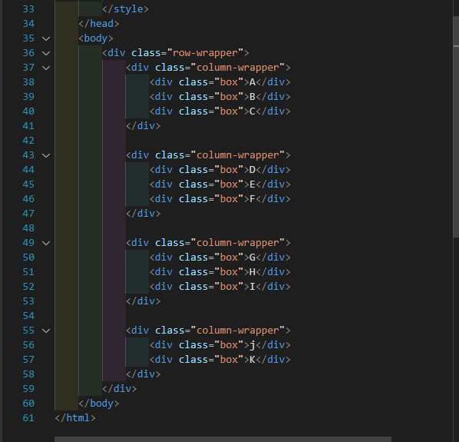

TP07-05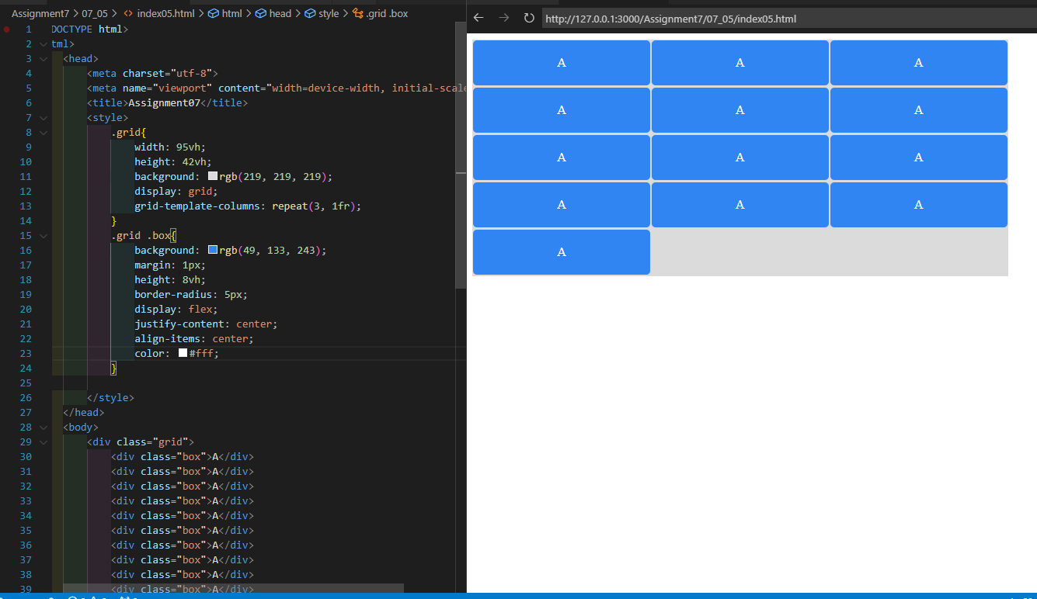

TP07-06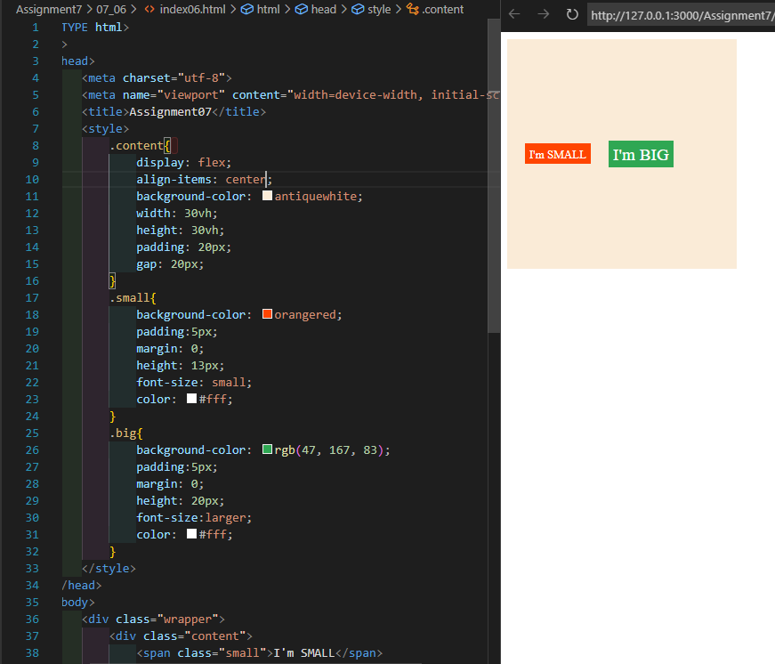

TP07-07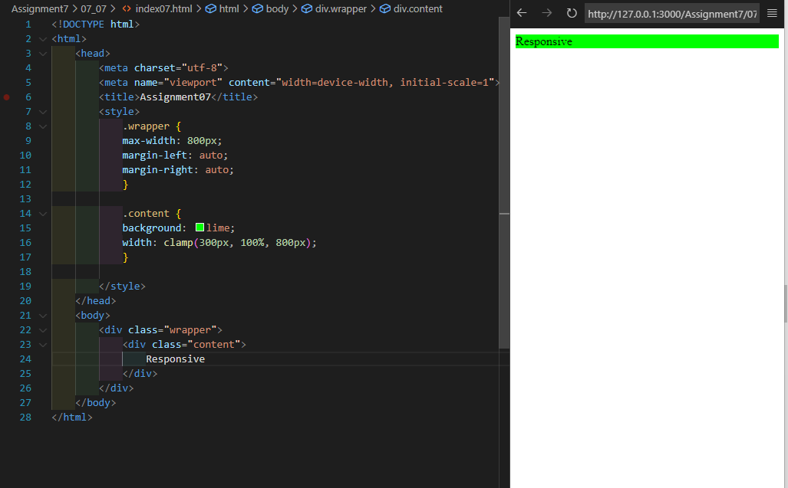

TP07-08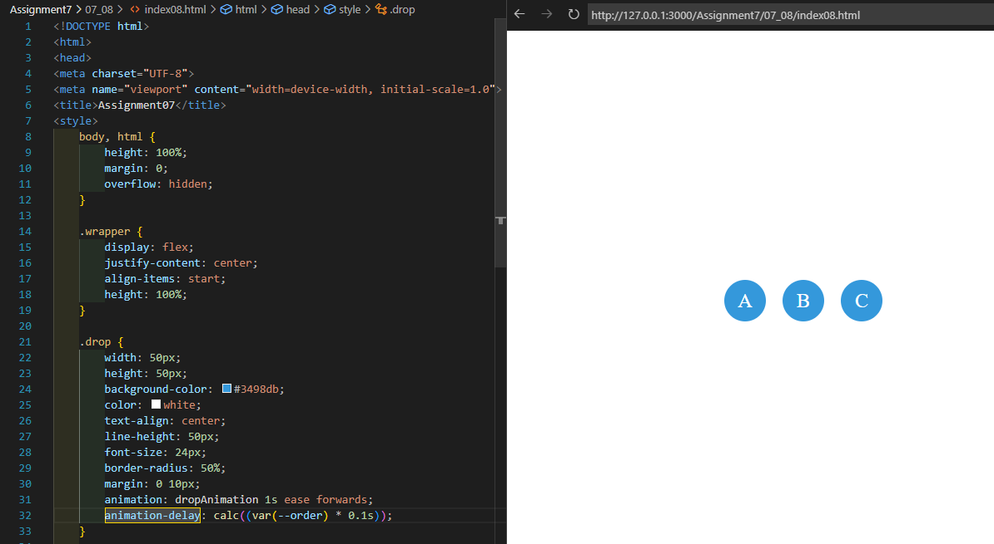

TP07-10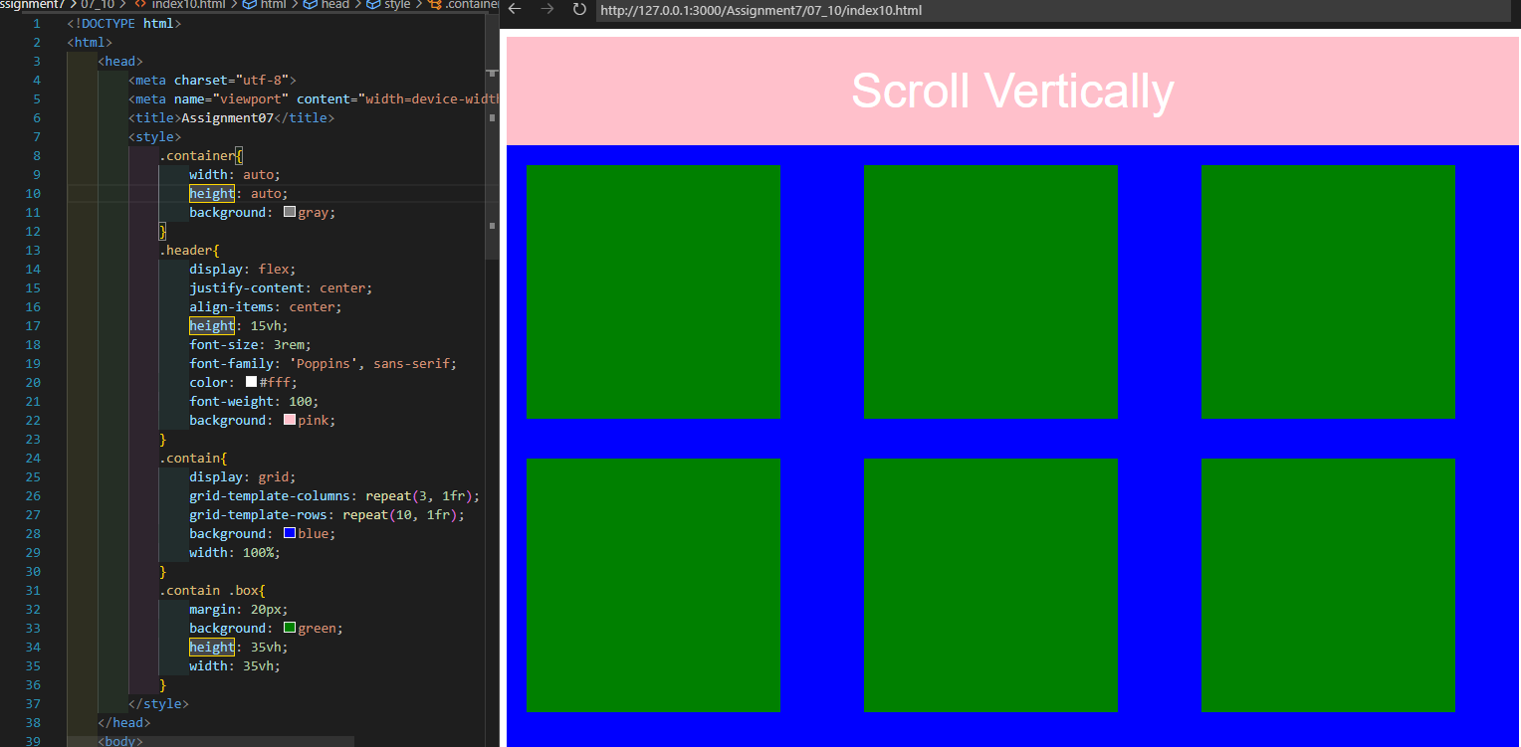

TP07-11

