Name: Chea Senghak

ID: e20211624

**Assignment04-web**

TP04-02

TP04-03

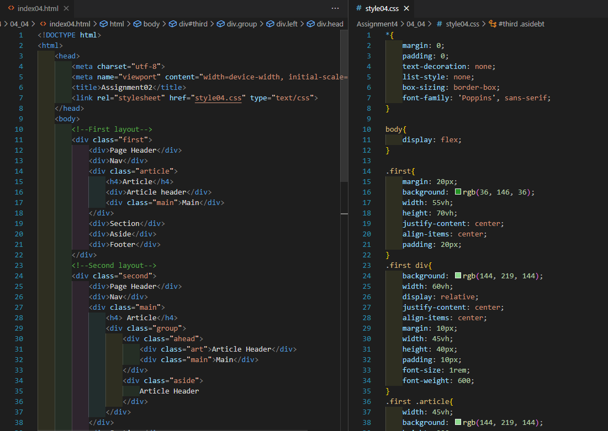

TP04-05

