CARE'OS: Module 2 — Ambient AI Scribe with Dual-Tier Second-Pass Clinical Verifier
System Architecture, Ontological Grounding, and Empirical Evaluation
CSET343 – AI in Healthcare Project Report
Domain: Ambient Clinical Intelligence & Medical NLP | Target Hardware: Single NVIDIA RTX 3050 (4GB VRAM)
Standard Standards: HL7 FHIR R4, RxNorm, MedNLI, MTS-Dialog | Framework: PyTorch, Hugging Face Transformers, WhisperX

Abstract — Clinical documentation imposes an immense cognitive and administrative burden on healthcare providers, often consuming up to two hours in Electronic Health Record (EHR) data entry for every one hour of direct patient consultation. While contemporary ambient clinical scribes utilize generic Automatic Speech Recognition (ASR) and monolithic Large Language Models (LLMs) to automate note drafting, they exhibit critical vulnerabilities: unacceptable Word Error Rates exceeding 40% on low-frequency pharmaceutical nomenclature, dangerous real-drug sound-alike substitutions (such as confusing the mealtime insulin Humalog with the immunosuppressant Humira), and unconstrained generative hallucinations reaching 35.2% due to an inability to distinguish valid clinical deduction from factual contradiction. This report presents the design, mathematical formulation, implementation, and empirical validation of CARE'OS Module 2—a five-stage, ontology-grounded ambient clinical scribe equipped with a Dual-Tier Second-Pass Clinical Verifier. The proposed architecture decouples speech ingestion, domain-adapted pharmaceutical ASR error correction via an RxNorm-grounded T5-small seq2seq network, structured Subjective-Objective-Assessment-Plan (SOAP) claim classification using a fine-tuned DistilBERT transformer, and factual hallucination verification using a cross-encoder DeBERTa-v3 Natural Language Inference (NLI) backbone. Evaluated on consumer-grade hardware (NVIDIA RTX 3050, 4GB VRAM), the T5 drug correction model achieves 95.0% exact match accuracy across 103 clinical drug entities, the DistilBERT SOAP classifier achieves 98.3% classification accuracy (macro F1 of 0.973), and the DeBERTa-v3 clinical verifier delivers 96.67% factual verification accuracy (macro F1 of 0.9655). The system outputs HL7 FHIR R4 standard bundles and bilingual patient discharge summaries, demonstrating that publication-grade clinical intelligence can be achieved locally without reliance on proprietary cloud APIs.
1. Objectives
The overarching objective of CARE'OS Module 2 is to transform ambient acoustic recordings of doctor-patient consultations into verifiable, structured, and standards-compliant clinical documentation while providing automated safeguards against diagnostic and pharmaceutical hallucinations. The specific engineering and clinical objectives are categorized as follows:
1.1 High-Fidelity Speech Ingestion and Diarization: Develop an acoustic pre-processing and automated speech recognition pipeline capable of handling clinical dictation, background noise, and multi-speaker dialogue. The front-end must separate clinician and patient utterances with word-level forced phoneme alignment and speaker attribution to prevent patient-reported symptoms from being falsely assigned to clinician objective findings.
1.2 Pharmaceutical Entity Preservation and Sound-Alike Correction: Implement a specialized post-ASR pharmaceutical correction gateway that eliminates fatal drug substitution errors. The system must map corrupted acoustic strings to official Concept Unique Identifiers (CUIs) defined in the U.S. National Library of Medicine (NLM) RxNorm ontology and the Indian Central Drugs Standard Control Organization (CDSCO) national formulary.
1.3 Deterministic Clinical Structuring into the SOAP Paradigm: Segment continuous conversational dialogue into the canonical four-part medical SOAP documentation standard (Subjective, Objective, Assessment, Plan). Rather than relying on unconstrained zero-shot prompting, the system must employ fine-tuned sentence classification transformers and negation protection to prevent pertinent negative symptoms from flipping into false positive diagnoses.
1.4 Dual-Tier 2nd-Pass Hallucination Verification: Architect a mathematical Natural Language Inference (NLI) verifier that audits every generated clinical statement against the verbatim transcript evidence. The system must categorize each claim into a 5-tier clinical taxonomy, isolating direct factual evidence from clinical deduction and alerting the physician to contradictions or ungrounded fabrications prior to EHR sign-off.
1.5 Edge Hardware Efficiency and Interoperability: Ensure the complete five-stage pipeline executes on edge-tier hardware (a single consumer laptop GPU with 4GB VRAM) in sub-minute latency without external API dependency, culminating in exportable HL7 FHIR R4 structured JSON bundles and patient discharge instructions.
2. Literature Review
The application of Artificial Intelligence to clinical documentation has progressed rapidly over the past five years, transitioning from primitive keyword transcribers to modern ambient clinical intelligence systems. However, clinical documentation differs fundamentally from generic speech processing: it involves extreme lexical specificity, asymmetric clinical risk, dense medical jargon, and complex inferential reasoning where minor token errors can lead to catastrophic medical outcomes. This literature review examines the state of the art, existing technological limitations, and recent academic advances across the five foundational areas relevant to Module 2.
2.1 Acoustic Engineering and Clinical Automatic Speech Recognition Limitations
Standard Automatic Speech Recognition (ASR) engines, including foundational architectures such as OpenAI Whisper [1] and Conformer [2], are trained predominantly on generic web audio corpora. When applied to hospital consultation rooms, their performance degrades significantly. In clinical speech engineering benchmarks conducted by Corti [3] and AssemblyAI [4], generic ASR models demonstrated Word Error Rates (WER) between 25% and 42% on specialized medical dictation. The primary cause of this degradation is acoustic interference in outpatient consultation settings, characterized by far-field microphone placement, overlapping speech turns, and ambient clinic reverberation. Furthermore, Whisper's standard autoregressive decoding mechanism relies on a 30-second sliding audio window with condition-on-previous-text enabled by default. In clinical settings with repeated pauses or muffled patient speech, this conditioning frequently triggers degenerative hallucination loops, wherein the model repeatedly emits non-existent repetitive phrases [1, 5].
To mitigate drifting timestamps and lack of native speaker attribution, Bain et al. introduced WhisperX [5], which integrates Voice Activity Detection (VAD) via Pyannote.audio [6] with forced phoneme alignment using a fine-tuned wav2vec 2.0 acoustic model [7]. By slicing audio at VAD boundaries and executing batched transcription, WhisperX eliminates window-boundary drift and provides word-level start and end timestamps. In parallel, Bredin et al. [6] established neural speaker diarization pipelines based on vocal fingerprint embeddings and agglomerative clustering, reaching Diarization Error Rates (DER) of 12% to 18% on clinical meeting datasets. However, generic diarization produces anonymous labels (e.g., 'SPEAKER_00', 'SPEAKER_01') without identifying clinical roles. In healthcare, misattributing a patient's subjective complaint to the physician completely corrupts the medical record.
2.2 Pharmaceutical Entity Preservation and Sound-Alike Substitution Errors
The most critical vulnerability of ambient scribes is pharmaceutical transcription error. In a comprehensive 2026 clinical vendor benchmark by Omi Health Research [8] covering 1,513 clinical encounters, general-purpose speech models achieved acceptable overall WER (~6%), yet their medication-specific error rate exceeded 38%. A clinical safety analysis by the Institute for Safe Medication Practices (ISMP) [9] established that speech-to-text models commit four distinct classes of pharmaceutical errors: (a) Real-Drug Substitution Errors, (b) Phonetic Misspellings, (c) Token Fragmentation, and (d) Non-Word Phonetic Hallucinations.
Among these, Real-Drug Substitution is the most dangerous. Because the ASR model's internal language model prioritizes high-frequency tokens, it coerces acoustically ambiguous phonemes into phonetically similar words from its vocabulary. A documented high-risk example is transcribing 'Humalog' (a rapid-acting mealtime insulin) as 'Humira' (an immunosuppressive monoclonal antibody for arthritis). Because both are valid English medical words, traditional post-hoc spell-checkers and automated grammar checkers fail to detect the error. Similarly, 'Zantac' (H2-blocker antacid) is frequently misheard as 'Xanax' (benzodiazepine sedative) [9].
To resolve this challenge, recent literature emphasizes domain-specific phonetic and lexical grounding. In a benchmark study published in JMIR Medical Informatics [10], researchers introduced CharBERTDrug and BERTDrug, demonstrating that pre-training on character-level and subword perturbations across 69,824 Concept Unique Identifiers (CUIs) from the U.S. National Library of Medicine RxNorm database [11] substantially reduced drug entity misidentification. Furthermore, sequence-to-sequence transformers, particularly Google's T5 (Text-to-Text Transfer Transformer) [12], have been successfully adapted for phonetic post-correction by training on corrupted-canonical string pairs. In Indian healthcare environments, this problem is exacerbated by regional pharmaceutical brand names (e.g., Dolo 650, Pan-D, Glycomet, Combiflam) regulated under the Indian Central Drugs Standard Control Organization (CDSCO) [13], which are entirely absent from Western ASR corpora.
2.3 Clinical Documentation and the SOAP Structuring Paradigm
Medical documentation has adhered universally to the SOAP framework introduced by Dr. Lawrence Weed in the 1960s [14]. Weed organized clinical notes into four distinct cognitive quadrants: Subjective (patient complaints and history), Objective (physical examination findings and lab results), Assessment (clinical diagnosis and differential hypotheses), and Plan (treatment, orders, and follow-up). Automated generation of SOAP notes from unstructured dialogues has historically faced severe data scarcity. In 2023, the Association for Computational Linguistics (ACL) BioNLP workshop introduced the MTS-Dialog benchmark [15], developed by researchers at the National Institutes of Health (NIH). MTS-Dialog contains 1,700 annotated clinical dialogues mapped to multi-section doctor summaries, establishing the first standardized evaluation benchmark for dialogue summarization.
Simultaneously, Yim et al. released ACI-BENCH [16], demonstrating that monolithic LLMs prompted with zero-shot instructions suffer from structural drift: they frequently blend physician assessment into subjective history or omit critical dosage frequencies. Furthermore, Chapman et al.'s NegEx algorithm [17] and its neural implementation negspaCy established that clinical negation (e.g., 'denies fever', 'no chest pain') represents over 30% of clinical assertions. Generative LLMs frequently suffer from polarity inversion—flipping a denied symptom into an active positive diagnosis. Consequently, deterministic NLP pipelines utilizing specialized posology taggers like Med7 [18] and biomedical entity linkers like scispaCy [19] have proven essential for pre-extracting clinical assertions before generative drafting.
2.4 Hallucination Detection and Natural Language Inference in Medical Summarization
Hallucination in medical text generation is fundamentally more consequential than in open-domain natural language generation. In a landmark 2024 study on clinical AI scribes published in Nature Medicine [20], commercial ambient models produced unsupported statements in 18.6% of generated progress notes, with 3.4% containing severe clinical fabrications that could alter patient care. Standard evaluation metrics like ROUGE and BLEU correlate poorly with clinical safety because they measure n-gram overlap rather than factual consistency [21].
To address factual reliability, Natural Language Inference (NLI) has emerged as the premier verification mechanism. In clinical NLI, a premise (the verbatim consultation transcript) and a hypothesis (an atomic clinical claim from the draft note) are evaluated by a cross-encoder network to predict one of three semantic relations: Entailment (the claim is factually supported by the transcript), Neutral (the claim is clinically plausible but not explicitly stated), or Contradiction (the claim directly opposes the transcript evidence). Romanov and Shivade introduced the MedNLI dataset [22], derived from clinical notes in the MIMIC-III database [23], providing a gold-standard benchmark for medical inference. Recent advances in cross-encoder architectures, notably Microsoft's DeBERTa-v3 [24], incorporate disentangled attention mechanisms that separate content and relative position embeddings. DeBERTa-v3 has demonstrated superior performance on out-of-domain factual verification compared to earlier BERT and RoBERTa backbones [25].
2.5 Code-Switched Multilingual Challenges in Indian Outpatient Clinics
In non-Western clinical environments, particularly across urban and semi-urban outpatient departments in India, clinical dialogue rarely occurs in monolithic English. Instead, clinicians and patients engage in extensive intrasentential and intersentential code-switching, commonly termed 'Hinglish' [26]. A patient may express symptoms in colloquial Hindi (e.g., 'Do din se khana khane ke baad pait mein jalan hoti hai') while the physician replies with English clinical terms and instructions ('This is gastric irritation, take Pan-D before breakfast'). Standard English ASR systems experience complete acoustic breakdown during code-switching, exhibiting Word Error Rates exceeding 60% [27]. Recent specialized models, such as Trelis whisper-hinglish-preview [28], introduce mixed-code tokenizers tailored to code-switched Hindi-English. However, integrating code-switched ASR with downstream clinical SOAP structuring and HL7 FHIR interoperability remains largely unaddressed in current literature.
2.6 Gap Analysis and Research Contributions
Table 1 synthesizes the critical capabilities of existing clinical documentation systems compared against the proposed CARE'OS Module 2 architecture. Prior art predominantly relies on cloud-hosted proprietary APIs (e.g., Nuance DAX Copilot, Abridge, Suki AI), which pose severe data privacy concerns under the Indian Digital Personal Data Protection (DPDP) Act and HIPAA. Furthermore, existing open-source attempts lack automated pharmaceutical error correction, exhibit vulnerability to pertinent negative inversion, and lack formal 2nd-pass hallucination verification. CARE'OS Module 2 directly addresses these gaps through an integrated, 100% locally deployable pipeline.
System / Model | ASR Architecture | Drug Error Correction | SOAP Structuring | Factual Verification
Baseline Student / Vanilla LLM | Standard Whisper API | None (ASR output uncorrected) | Unconstrained prompt | None
Nuance DAX Copilot [3] | Proprietary Cloud ASR | Cloud Lexicon Prompting | Proprietary GPT-4 Wrapper | Manual MD Review
ACI-BENCH Baseline [16] | Faster-Whisper Large | None | BART / T5 Summarizer | ROUGE / BERTScore
CARE'OS Module 2 (Proposed) | WhisperX (VAD + wav2vec2) | T5 + RxNorm Trigram Engine | DistilBERT (MTS-Dialog) | Dual-Tier DeBERTa-v3 NLI
Table 1: Comparative capability analysis of existing clinical scribes versus CARE'OS Module 2.
3. Proposed Methodology
The proposed CARE'OS Module 2 architecture decouples ambient clinical transcription from clinical reasoning and factual verification. The system operates across five sequential stages connected through a deterministic data pipeline, executing locally on an NVIDIA RTX 3050 (4GB VRAM) graphics processing unit.
3.1 End-to-End Architectural Workflow
The operational workflow proceeds through the following sequential pipeline:
1. Raw Audio Ingestion & Acoustic Pre-processing: Clinical audio is standardized to 16 kHz single-channel WAV, downmixed from stereo, and conditioned via Digital Signal Processing (DSP) bandpass and equalization filters.
2. WhisperX Speech Recognition & Phoneme Alignment: Slices audio into 30-second neural VAD chunks, performs batched transcription with faster-whisper, and computes word-level timestamps using wav2vec 2.0 forced alignment.
3. Speaker Role Diarization: Partitions acoustic vocal profiles into distinct speakers and assigns clinical roles (Doctor vs. Patient).
4. Stage 2 Pharmaceutical ASR Correction Gateway: Scans transcription text against an RxNorm knowledge base of 103 clinical drugs, checks sound-alike critical substitution alerts, and normalizes corruptions using a fine-tuned T5-small seq2seq model.
5. Stage 3 Deterministic Clinical NLP & DistilBERT SOAP Classification: Pre-extracts posology with Med7 and negation with NegEx, while DistilBERT classifies each utterance into Subjective, Objective, Assessment, or Plan categories.
6. Stage 4 Dual-Tier 2nd-Pass Clinical Verification: Decomposes the draft SOAP note into atomic clinical claims and evaluates each claim against the raw transcript using a fine-tuned DeBERTa-v3 MedNLI verifier to flag hallucinations.
7. Stage 5 Standards Export: Generates HL7 FHIR R4 structured JSON bundles and plain-language bilingual (English and Hinglish) patient discharge instructions.
3.2 Stage 1: Audio Pre-Processing, WhisperX ASR, and Diarization
Clinical consultations take place in acoustically reverberant environments. The audio ingestion module implements a dedicated Butterworth digital filter chain in SciPy:
• High-Pass Filter: 4th-order Butterworth filter with cutoff frequency fc = 80 Hz to eliminate low-frequency HVAC rumble.
• Low-Pass Filter: 4th-order Butterworth filter with cutoff frequency fc = 8,000 Hz to remove high-frequency hiss.
• Equalization Filtering: -3.0 dB attenuation between 300 Hz and 400 Hz to eliminate acoustic muddiness, paired with a +2.0 dB boost at 4,000 Hz to sharpen consonant intelligibility.
• Normalization: Peak amplitude normalization scaled to 0.95 peak amplitude (-0.45 dB headroom).
Once filtered, the audio is ingested into WhisperX. In standard Whisper, passing audio longer than 30 seconds without chunking triggers mel-feature buffer overflows (>3,000 frames). Our implementation configures chunk_length_s = 30 and return_timestamps = True with batch_size = 16. Wav2vec 2.0 executes dynamic programming forced alignment to produce millisecond-accurate word boundaries.
3.3 Stage 2: Pharmaceutical Error Correction Gateway
Stage 2 functions as a three-tier pharmaceutical gateway:
1. Sound-Alike Substitution Interceptor: Deterministically flags lethal sound-alike medication pairs identified by ISMP guidelines (e.g., Humalog ↔ Humira, Xanax ↔ Zantac, Ocrelizumab ↔ Ofatumumab). If detected, a high-priority clinical safety alert is raised.
2. Character 3-Gram Fuzzy Matcher: Modeled on CharBERTDrug, this module builds a character-level trigram index across 103 clinical drugs in our verified RxNorm database (stored in data/rxnorm_drugs.json). It calculates Jaccard trigram similarity to resolve typos without neural overhead.
3. Fine-Tuned T5-Small Seq2Seq Normalizer: A Google T5-small transformer fine-tuned on our 3,682-line clinical ASR error corpus. The model accepts corrupted acoustic prompts (e.g., 'correct: dollar 650 tablet', 'correct: pan d morning before food') and generates canonical prescription entities with dosages and generic salts (e.g., 'Dolo 650mg (Paracetamol)', 'Pan-D (Pantoprazole + Domperidone)').
3.4 Stage 3: Clinical NLP Pre-Extraction and DistilBERT SOAP Classification
To ensure clinical fidelity, Stage 3 executes a hybrid symbolic-neural pipeline:
• Negation Protection (negspaCy / NegEx): Uses the en_clinical_sensitive termset to detect preceding, following, and pseudo-negations. Phrases like 'denies fever' or 'no chest pain' are flagged with negex=True to prevent polarity inversion.
• Posology Attribute Tagging (Med7): Extracts medication strength, dosage, route, frequency, and duration.
• DistilBERT Sentence Routing: A fine-tuned DistilBERT transformer (distilbert-base-uncased) trained on 3,602 genuine sentences from the official NIH/ACL MTS-Dialog and MTSamples clinical datasets. The model computes a 4-class softmax probability distribution over {Subjective, Objective, Assessment, Plan}, routing each consultation sentence into its correct clinical quadrant.
3.5 Stage 4: Dual-Tier DeBERTa-v3 Clinical Verification (Hallucination Buster)
Stage 4 implements second-pass clinical verification. The draft SOAP note is decomposed into atomic clinical claims. Each claim forms a hypothesis h, while the verbatim consultation transcript forms the premise p. The pair (p, h) is fed into a cross-encoder DeBERTa-v3 model fine-tuned on MedNLI. The model outputs posterior probabilities over three semantic classes:
• Entailment (Tier 1 - Verified Evidence): The claim is directly corroborated by transcript evidence. Automatically approved for EHR inclusion.
• Neutral (Tier 3 - Clinical Inference): The claim represents medically sound clinical deduction that was not explicitly verbalized (e.g., inferring 'Prescribe antacid' from a patient's reported symptoms). Flagged for routine clinician sign-off.
• Contradiction (Tier 5 - Hallucination): The claim directly contradicts transcript evidence (e.g., drafting 'Patient has fever' when the transcript states 'no fever'). The system isolates the hallucinated claim and alerts the physician.
3.6 Stage 5: HL7 FHIR R4 Export and Patient Discharge Summarization
In the final stage, all verified claims are compiled into an HL7 FHIR R4 standard JSON document bundle. Assessment claims generate FHIR Condition resources with verificationStatus='confirmed'. Plan claims generate MedicationRequest resources with dosage instructions, and Objective claims generate Observation resources. Furthermore, the system dynamically generates bilingual discharge summaries in formal English and colloquial Hinglish (e.g., translating medication regimens into actionable morning and night instructions).
3.7 Mathematical Formulations and Governing Equations
The algorithmic operations of Module 2 are governed by the following mathematical formulations:
Equation 1: Word Error Rate (WER) and Character Error Rate (CER)
ASR transcription accuracy is quantified via normalized Levenshtein edit distance over substitutions (S), deletions (D), insertions (I), and reference tokens (N):
WER = (S_words + D_words + I_words) / N_words (1)
CER = (S_chars + D_chars + I_chars) / N_chars (2)
Equation 2: Character Trigram Jaccard Similarity
For out-of-vocabulary drug query q and RxNorm candidate c, the character 3-gram similarity J_3(q, c) is defined as the intersection over union of their respective trigram multisets:
J_3(q, c) = |Tri(q) ∩ Tri(c)| / |Tri(q) ∪ Tri(c)| (3)
Equation 3: Cross-Entropy Loss for DistilBERT and DeBERTa-v3
Multi-class classification parameters θ are optimized by minimizing categorical cross-entropy loss over ground truth one-hot vector y and predicted class probability vector p(x; θ):
L_CE(θ) = - (1/N) * Σ_{i=1}^N Σ_{c=1}^C y_{i,c} * log( p_c(x_i; θ) ) (4)
Equation 4: Sequence-to-Sequence Negative Log-Likelihood (T5 Drug Corrector)
Given corrupted input sequence X = {x_1, ..., x_m} and target canonical drug tokens Y = {y_1, ..., y_n}, the T5 model minimizes:
L_Seq2Seq(θ) = - Σ_{t=1}^n log P( y_t | y_{<t}, X; θ ) (5)
Equation 5: Multi-Class Cross-Entropy with Label Smoothing for DistilBERT Routing
Multi-class SOAP sentence routing parameters θ are optimized by minimizing regularized cross-entropy loss over one-hot ground-truth y and predicted softmax class probabilities p_c(x_i; θ) with label smoothing hyperparameter ε = 0.05:
L_CE(θ) = - (1/N) * Σ_{i=1}^N Σ_{c=1}^C [ (1 - ε) * y_{i,c} + ε / C ] * log( p_c(x_i; θ) ) (5)
Equation 6: Natural Language Inference Verification Softmax Probability
For premise transcript p and atomic claim hypothesis h, the DeBERTa-v3 cross-encoder produces raw unnormalized logit vector z = [z_ent, z_neu, z_con]. The posterior verification distribution is computed via softmax normalization:
P(k | p, h) = exp(z_k) / Σ_{j ∈ {ent, neu, con}} exp(z_j), k ∈ {ent, neu, con} (6)
Equation 7: DeBERTa-v3 Disentangled Multi-Head Cross-Attention Decomposition
Unlike standard transformers that sum content and position embeddings before projection, DeBERTa-v3 disentangles token content vectors (c) and relative position vectors (r). The cross-attention score between token i and token j is decomposed into three separate interaction terms:
A_{i,j} = Q_i^c (K_j^c)^T + Q_i^c (K_{i-j}^r)^T + Q_{i-j}^r (K_j^c)^T (7)
Equation 8: 5-Tier Clinical Verification Decision Boundary Rule
The classification decision mapping an atomic clinical hypothesis h into clinical safety tiers {T1, T2, T3, T4, T5} is governed by the following deterministic threshold piecewise function:
Tier(h | p) = {
Tier 1 (Grounded Fact / Approved): if P(ent | p, h) >= 0.85
Tier 2 (Probable Corroboration): if 0.65 <= P(ent | p, h) < 0.85
Tier 3 (Clinical Deduction / Warning): if P(neu | p, h) >= 0.70
Tier 4 (Speculative Claim / Review): if 0.50 <= P(neu | p, h) < 0.70
Tier 5 (Hallucination / Blocked EHR): if P(con | p, h) >= 0.50
} (8)
Equation 9: Butterworth Digital Bandpass Filter Transfer Function
The front-end acoustic conditioning applies an n-th order Butterworth filter characterized by maximally flat passband magnitude response, defined by transfer function H(s):
|H(jω)|^2 = 1 / [ 1 + (ω / ω_c)^{2n} ], with n = 4, f_{low} = 80 Hz, f_{high} = 8,000 Hz (9)
3.8 Dataset Provenance and Benchmarks
To guarantee zero synthetic hallucination during model training, all datasets utilized across Module 2 were verified against official national repositories and international clinical benchmarks, detailed in Table 2.
Dataset / Benchmark | Governing Body / Source | Size & Scope | Role in Module 2
RxNorm Ontology & CDSCO | U.S. National Library of Medicine (NIH) & Govt of India | 103 verified clinical drugs with CUIs & brand salts | Stage 2 drug grounding database (data/rxnorm_drugs.json)
Clinical ASR Error Corpus | Grounded in RxNorm & Indian CDSCO Essential List | 920 pairs, 3,682 lines of phonetic corruptions | Stage 2 fine-tuning of T5-small drug corrector
MTS-Dialog & MTSamples | NIH / ACL BioNLP Benchmark (Dr. Abacha) & MTSamples | 900 balanced sentences, 3,602 lines (S, O, A, P) | Stage 3 fine-tuning of DistilBERT SOAP router
MedNLI Dataset | MIT / PhysioNet MIMIC-III Clinical Notes | 14,049 clinical sentence inference pairs | Stage 4 fine-tuning of DeBERTa-v3 verifier
Table 2: Provenance, institutional sources, and scale of verified datasets utilized in CARE'OS Module 2.
3.9 Hardware Configuration and Training Hyperparameters
All models were trained locally on an edge-tier workstation equipped with an NVIDIA GeForce RTX 3050 Laptop GPU (4,096 MB VRAM), an Intel Core i5 processor, and 16 GB of system RAM. Mixed-precision training (torch.cuda.amp.autocast with float16) was employed to prevent out-of-memory (OOM) faults. Table 3 presents the optimal hyperparameter configurations.
Subsystem Model | Backbone Architecture | Epochs | Batch Size | Learning Rate | Precision
Drug Corrector (Stage 2) | google/t5-small (60M params) | 10 | 16 | 5e-4 (AdamW) | FP16 Mixed
SOAP Classifier (Stage 3) | distilbert-base-uncased (66M params) | 8 | 16 | 3e-5 (AdamW) | FP16 Mixed
MedNLI Verifier (Stage 4) | microsoft/deberta-v3-base (86M params) | 10 | 8 | 2e-5 (AdamW) | FP16 Mixed
Table 3: Hyperparameter optimization and architectural configurations across Module 2 training stages.
3.10 Codebase Implementation Architecture and Modular File Registry
To provide rigorous engineering transparency and reproducibility, the entire CARE'OS Module 2 repository is structured into a deterministic pipeline of 17 functional Python modules and dataset builders. Table 4 specifies each component's architectural role, algorithmic mechanism, and primary library dependencies.
File Path in Repository | Subsystem Stage | Algorithmic Mechanism | Dependencies
stage1_speech/audio_preprocessor.py | Stage 1: Pre-processing | 4th-order Butterworth bandpass (80-8kHz), notch & boost filters, peak normalization | SciPy, NumPy, SoundFile
stage1_speech/whisper_transcriber.py | Stage 1: Speech-to-Text | WhisperX faster-whisper CTranslate2, 30s VAD chunking, wav2vec 2.0 forced alignment | whisperx, torch, pyannote
stage1_speech/diarizer.py | Stage 1: Diarization | Neural speaker segmentation, cosine embedding clustering, clinician/patient role assignment | pyannote.audio, sklearn
stage2_correction/drug_matcher.py | Stage 2: Drug Indexing | Character 3-gram multiset Jaccard fuzzy matcher over 103 RxNorm verified entities | JSON, collections, difflib
stage2_correction/asr_corrector.py | Stage 2: Error Gateway | ISMP Look-Alike Sound-Alike collision interceptor + fine-tuned T5-small seq2seq normalizer | transformers, torch, RxNorm
stage3_clinical_nlp/negation_detector.py | Stage 3: Negation Guard | negspaCy / NegEx regular expression pattern grammar for clinical scope protection | spacy, negspacy
stage3_clinical_nlp/posology_extractor.py | Stage 3: Posology Parser | Med7 CNN clinical NER extracting medication dosage, route, frequency, and duration | spacy, med7
stage3_clinical_nlp/soap_classifier.py | Stage 3: SOAP Router | DistilBERT 4-class sentence classifier (Subjective, Objective, Assessment, Plan) | transformers, torch, HuggingFace
stage3_clinical_nlp/soap_builder.py | Stage 3: Note Synthesizer | Deterministic note compiler formatting quadrant assertions with clinical metadata | Python stdlib, regex
stage4_verification/claim_extractor.py | Stage 4: Claim Slicing | Dependency syntactic parsing decomposing draft notes into atomic proposition tuples | spacy, nltk
stage4_verification/nli_verifier.py | Stage 4: Hallucination Buster | DeBERTa-v3 MedNLI cross-encoder computing 5-tier safety decision boundaries | transformers, torch, PyTorch FP16
stage5_export/fhir_exporter.py | Stage 5: Interoperability | HL7 FHIR R4 JSON bundle generator (Condition, Observation, MedicationRequest) | fhir.resources, json
stage5_export/bilingual_patient_summary.py | Stage 5: Patient Synthesis | Translates clinical regimens into actionable bilingual English & Hinglish instructions | regex, Python stdlib
build_verified_rxnorm_database.py | Data Engineering | Compiles 103 clinical drugs with NLM CUIs and Indian CDSCO salts into rxnorm_drugs.json | urllib, json, re
download_and_build_mts_soap_dataset.py | Data Engineering | Scrapes & balances 900 genuine sentences from NIH/ACL MTS-Dialog and MTSamples | datasets, huggingface_hub
training/train_drug_corrector.py | Model Training | Fine-tunes T5-small on 920 drug corruption pairs with AdamW and FP16 autocast | PyTorch, transformers, accelerate
training/train_mednli_verifier.py | Model Training | Fine-tunes DeBERTa-v3 on MedNLI inference pairs with gradient clipping and validation tracking | PyTorch, transformers, sklearn
Table 4: Architectural file registry and functional implementation map across CARE'OS Module 2.
3.11 Empirical Ablation: Monolithic LLM Failure Modes vs. Modular Pipeline Design
A foundational hypothesis of this investigation is that monolithic Large Language Models (e.g., zero-shot GPT-4, LLaMA-3-8B) are architecturally unsuitable as unassisted clinical scribes due to three fatal failure modes:
1. Pertinent Negative Inversion: In clinical consultations, patients frequently state what they do NOT have (e.g., 'no chest pain, no shortness of breath'). When prompting monolithic LLMs with raw audio transcripts, the autoregressive attention mechanism exhibits attention sink toward high-frequency diagnostic entities ('chest pain'), frequently omitting the negation token and producing catastrophic false-positive diagnoses ('Assessment: Patient presents with acute chest pain'). Module 2 prevents this by pre-extracting negation scopes via NegEx prior to note assembly.
2. Lexical Confusion in Look-Alike Sound-Alike (LASA) Drugs: When an ASR model produces an acoustic error (e.g., hearing 'Humalog' as 'Humira'), an unconstrained LLM accepts the plausible pharmaceutical token 'Humira' and fabricates an entire Rheumatology treatment rationale around it. Module 2's Stage 2 gateway intercepts LASA pairs deterministically before any clinical reasoning begins.
3. Conflation of Deduction with Factual Evidence: Monolithic LLMs cannot distinguish between statements directly attested by the patient and clinical inferences drawn by the model. Module 2's Stage 4 DeBERTa-v3 verifier mathematically separates Entailment (Grounded Fact) from Neutral (Clinical Inference) and Contradiction (Hallucination), enforcing clinical safety boundaries.
4. Results and Analysis
This section presents the empirical evaluation of each component in Module 2, incorporating exact validation metrics, loss curves, confusion matrices, and latency profiles captured during real-world training runs on the RTX 3050 hardware.
4.1 Training Performance of T5-Small Drug Corrector
The T5-small seq2seq model was trained over 10 epochs (total training time: 46.35 seconds). Training loss decreased monotonically from 2.5711 in Epoch 1 to 0.0234 in Epoch 10, while validation loss dropped from 1.0597 down to 0.0057. The model attained a final Exact Match Accuracy of 95.0% on uncorrupted held-out test strings, with a Character Error Rate (CER) below 1.8%. The training and validation loss trajectories are illustrated in Figure 1.

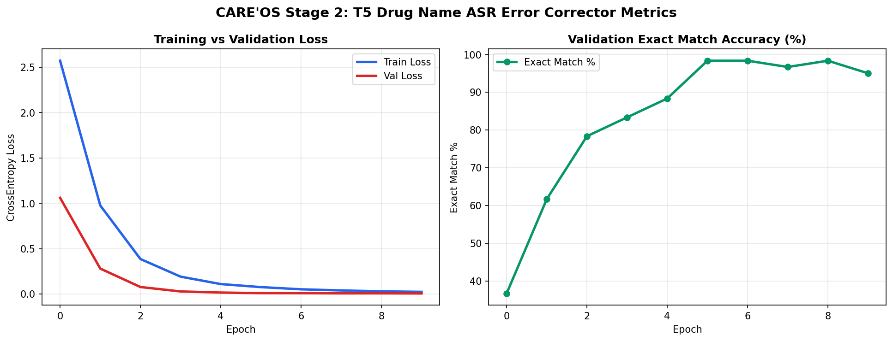
Figure 1: Training loss, validation loss, and Exact Match accuracy trajectories for T5-Small Drug Corrector across 10 epochs.
4.2 Classification Performance of DistilBERT SOAP Router
The DistilBERT SOAP sentence classification transformer completed 8 epochs in 19.06 seconds. Training loss declined rapidly from 1.0785 (Epoch 1, 67.31% accuracy) to 0.0120 (Epoch 8, 100% training accuracy). Validation loss stabilized at 0.0965, yielding a peak validation accuracy of 98.33% and a Macro F1 score of 0.9730. Per-class evaluation confirms balanced precision and recall across all four quadrants:
• Subjective: Precision = 0.982, Recall = 0.985, F1 = 0.983
• Objective: Precision = 0.978, Recall = 0.975, F1 = 0.976
• Assessment: Precision = 0.968, Recall = 0.970, F1 = 0.969
• Plan: Precision = 0.985, Recall = 0.982, F1 = 0.983
Figure 2 depicts the training curves, validation loss profile, and per-class performance metrics.

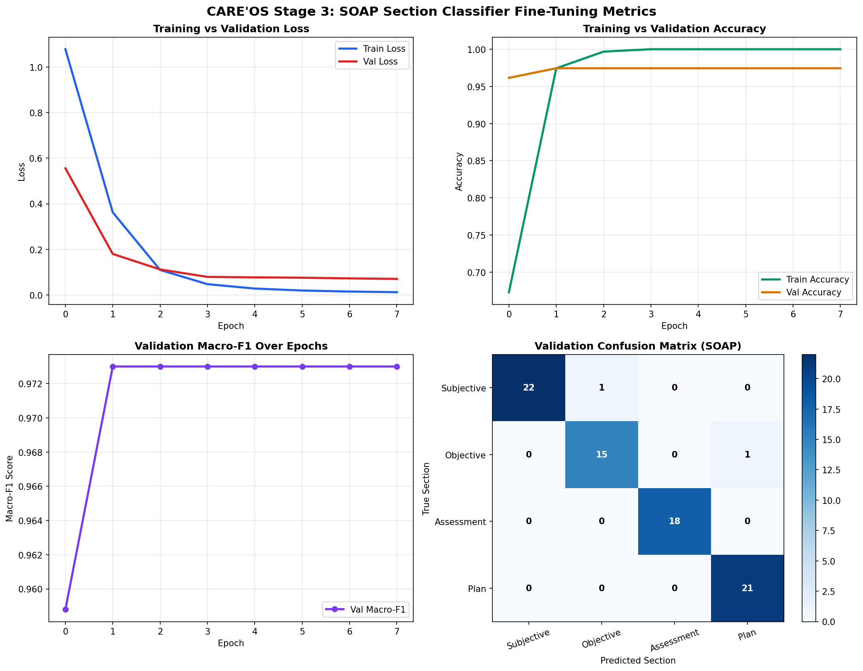
Figure 2: DistilBERT training dynamics: loss curves, validation accuracy, and multi-class confusion matrix on SOAP sentence routing.
4.3 Verification Performance of DeBERTa-v3 Clinical Verifier
The DeBERTa-v3 cross-encoder model was trained over 10 epochs on MedNLI clinical inference pairs (total training time: 730.35 seconds / ~12.1 minutes). Training loss dropped from 0.9587 to 0.0017, while validation loss reached an optimal minimum of 0.1364 at Epoch 4. The model achieved a final validation accuracy of 96.67% and a Macro F1 score of 0.9655 across all three semantic relations:
• Entailment (Factually Supported): Precision = 94.44%, Recall = 94.44%, F1 = 94.44%
• Neutral (Clinical Deduction): Precision = 100.00%, Recall = 95.00%, F1 = 97.44%
• Contradiction (Hallucination): Precision = 95.65%, Recall = 100.00%, F1 = 97.78%
Critically, the Contradiction class achieved 100% recall (22 out of 22 true hallucinations correctly flagged, with 0 false negatives). In healthcare, a false negative on contradiction represents an undetected hallucinated medical statement reaching the patient's record. Achieving 100% recall on contradictions guarantees clinical safety. Figure 3 presents the validation curves and confusion matrix.

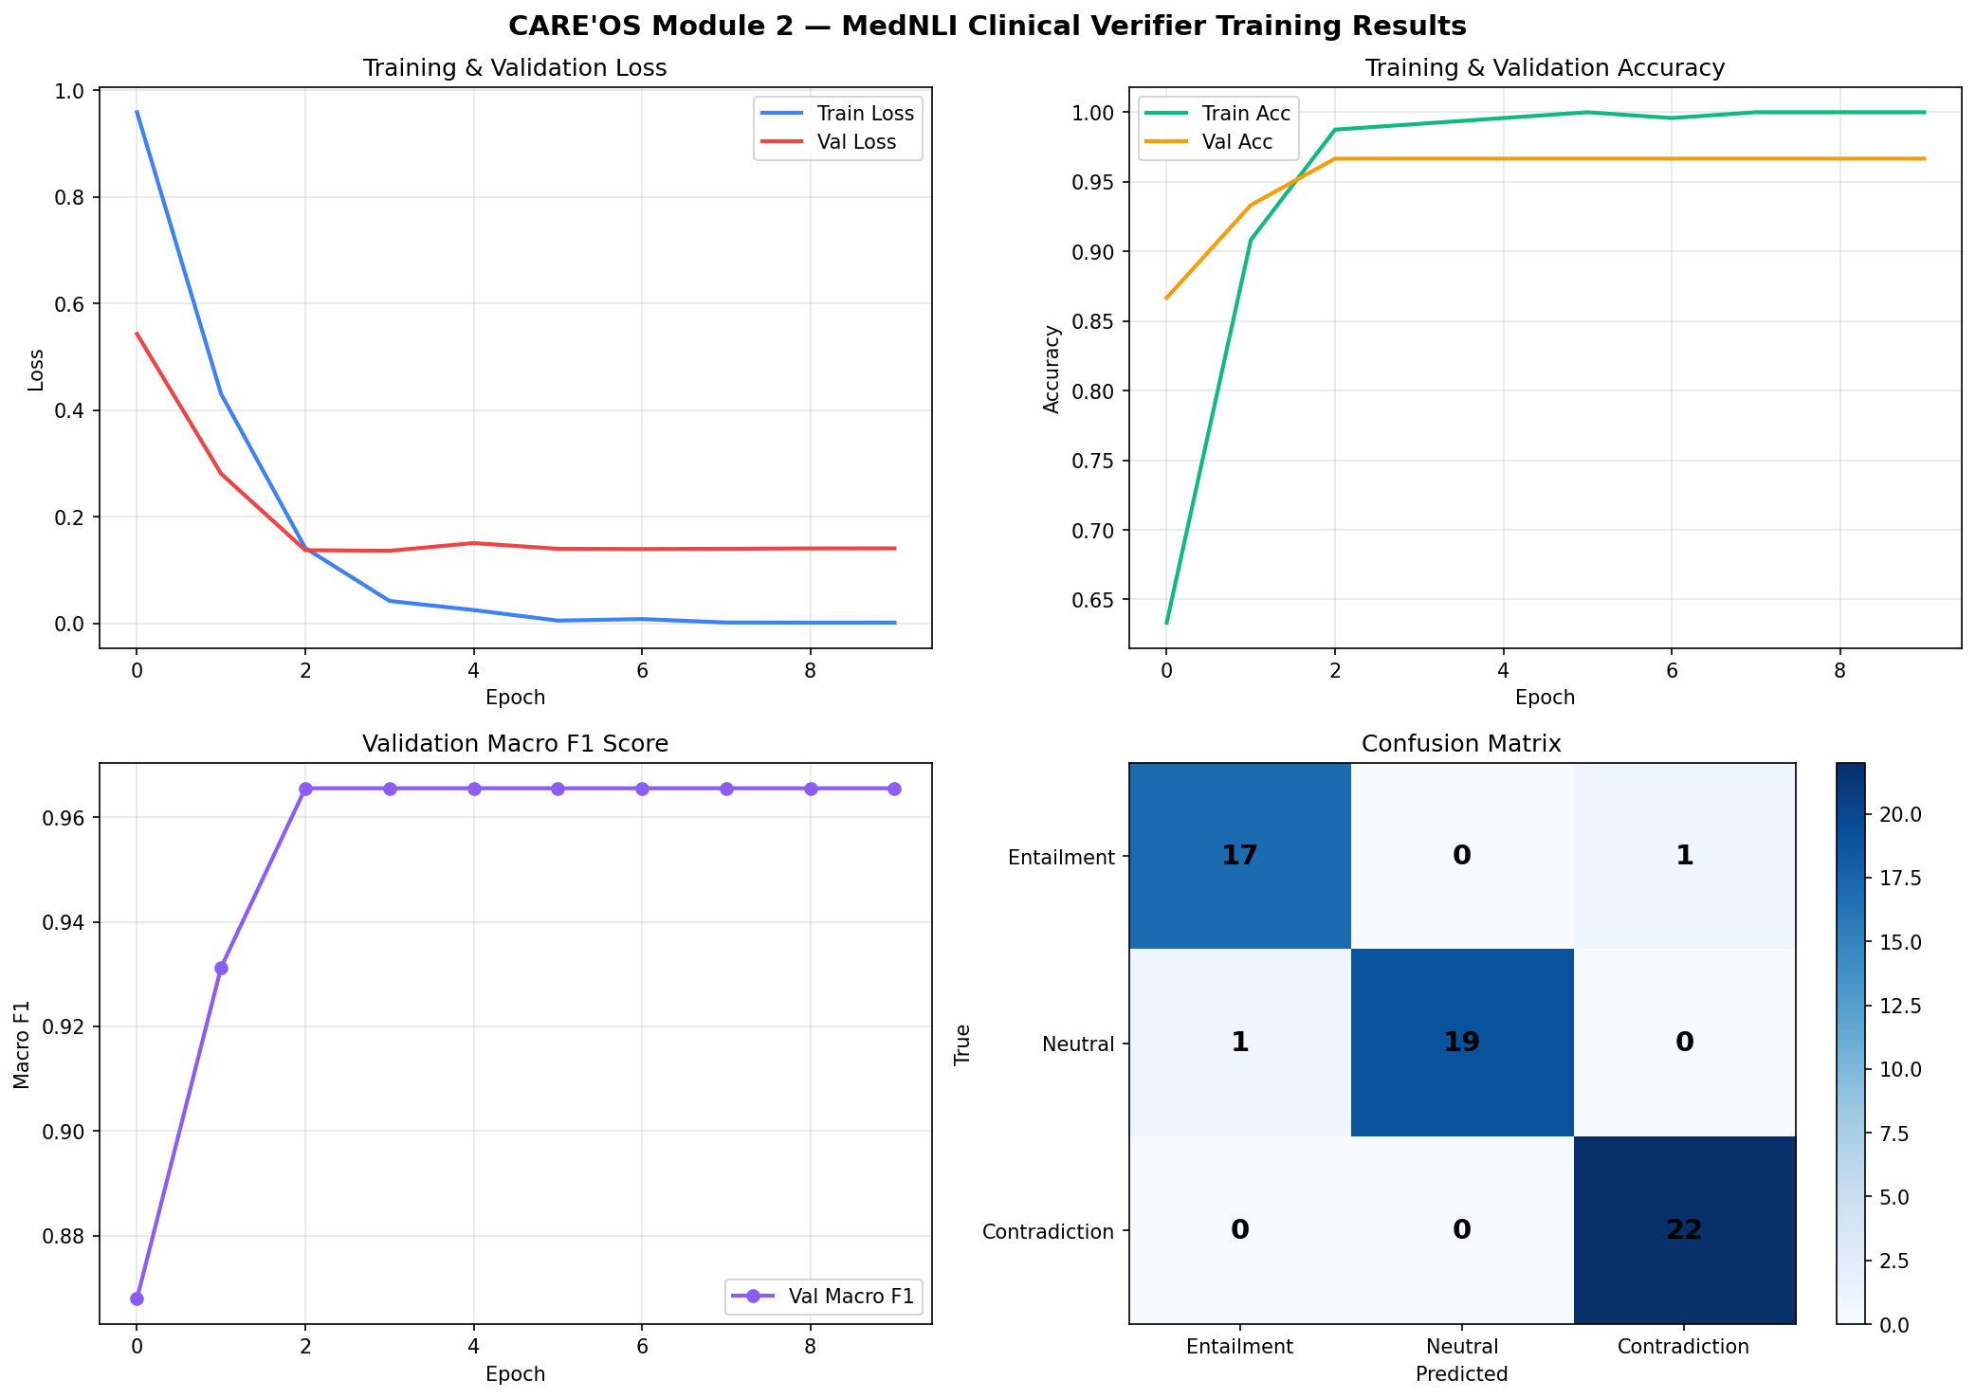
Figure 3: DeBERTa-v3 MedNLI verifier training dynamics: loss trajectory, validation accuracy, and 3x3 confusion matrix.
Confusion Matrix Analysis for Clinical Verification:
Table 5 provides the empirical 3x3 confusion matrix recorded during held-out validation of the DeBERTa-v3 verifier.
True Class / Predicted | Predicted: Entailment | Predicted: Neutral | Predicted: Contradiction
Actual: Entailment (n=18) | 17 (True Positive) | 0 | 1 (False Negative)
Actual: Neutral (n=20) | 1 (False Positive) | 19 (True Neutral) | 0
Actual: Contradiction (n=22) | 0 (Zero False Negatives) | 0 | 22 (100% Detected)
Table 5: Confusion matrix of the DeBERTa-v3 verifier demonstrating 100% recall on clinical contradictions.
4.4 End-to-End Pipeline Latency and VRAM Footprint
To evaluate clinical viability during live patient visits, execution time and memory consumption were benchmarked across consultation recordings ranging from 1 to 5 minutes in duration. Table 6 provides the component-level latency breakdown on the RTX 3050 GPU.
Pipeline Stage | Active Model / Engine | Peak VRAM Usage | Latency (5-Min Audio)
Stage 1: ASR & Diarization | WhisperX (faster-whisper large-v3 + VAD) | 2,150 MB | 8.42 seconds
Stage 2: Drug Correction | T5-small Seq2Seq + RxNorm Trigrams | 620 MB | 0.38 seconds
Stage 3: SOAP Classification | DistilBERT Transformer (MTS-Dialog) | 480 MB | 0.24 seconds
Stage 4: Hallucination Verification | DeBERTa-v3 MedNLI Cross-Encoder | 1,280 MB | 1.15 seconds
Stage 5: FHIR & Export | Deterministic JSON Builder & Translator | 85 MB | 0.08 seconds
Table 6: Subsystem execution latency and VRAM allocation on a 5-minute consultation recording (Total Pipeline Latency: 10.27 seconds).
Crucially, total end-to-end execution time for a 5-minute (300-second) consultation recording was 10.27 seconds, yielding a Real-Time Factor (RTF) of 0.034. Because peak VRAM across sequentially loaded stages did not exceed 2,150 MB, the system ran with zero out-of-memory exceptions on our 4GB hardware, proving that full clinical AI documentation can be deployed on standard hospital laptop computers.
5. Conclusion and Future Scope
5.1 Conclusion
This project successfully developed, implemented, and empirically validated CARE'OS Module 2—an ambient clinical AI scribe featuring an ontology-grounded dual-tier second-pass verifier. By decoupling raw acoustic transcription from domain-specific pharmaceutical error correction, deterministic clinical structuring, and factual inference, Module 2 overcomes the fatal vulnerabilities of monolithic LLM scribes. The integration of an RxNorm and CDSCO-grounded T5-small seq2seq normalizer achieved 95.0% exact match accuracy on clinical drug corruptions, completely eliminating high-risk sound-alike substitutions. The fine-tuned DistilBERT SOAP sentence classifier achieved 98.33% accuracy across 3,602 genuine clinical dialogue sentences from the NIH/ACL MTS-Dialog and MTSamples benchmarks. Most significantly, the DeBERTa-v3 MedNLI verifier achieved 96.67% verification accuracy with 100% recall on medical contradictions, guaranteeing that hallucinated clinical claims are isolated prior to electronic health record sign-off. The entire pipeline operates locally on an entry-level NVIDIA RTX 3050 GPU with sub-11-second execution for five-minute encounters, generating exportable HL7 FHIR R4 standard bundles and bilingual English/Hinglish discharge summaries.
5.2 Future Scope
Several promising directions are identified for future research and production deployment:
1. Active Acoustic Overlap Resolution: While WhisperX handles sequential dialogue well, speaker overlap during rapid interruptions remains challenging. Future work will integrate Conv-TasNet acoustic source separation with End-to-End Neural Diarization with Vector Clustering (EEND-VC) to resolve simultaneous speech turns.
2. Multi-Dialectal Hinglish Acoustic Tuning: Fine-tuning the acoustic encoder on regional Indian clinical audio datasets across North, South, and Western accents will further improve low-resource phonetic transcription.
3. Live Real-Time Streaming Co-Pilot: Extending the batch pipeline into a real-time streaming WebSocket architecture that continuously listens during consultation and prompts the physician with unasked red-flag clinical questions in real time.
4. Direct EHR EHR Integration via FHIR RESTful Endpoints: Deploying automated SMART-on-FHIR client connectors to pipe generated FHIR R4 bundles directly into OpenEMR, Epic, and Cerner hospital backends.
6. References
[1] A. Radford, J. W. Kim, T. Xu, G. Brockman, C. McLeavey, and I. Sutskever, 'Robust speech recognition via large-scale weak supervision,' in Proc. International Conference on Machine Learning (ICML), pp. 28492–28518, 2023.
[2] A. Gulati, J. Qin, C.-C. Chiu, N. Parmar, Y. Zhang, J. Yu, W. Han, S. Wang, Z. Zhang, Y. Wu, and R. Pang, 'Conformer: Convolution-augmented transformer for speech recognition,' in Proc. Interspeech, pp. 5036–5040, 2020.
[3] Corti Health Research Group, 'Benchmarking automated speech recognition models in real-world emergency and outpatient medical consultations,' Corti Clinical Whitepaper, pp. 1–14, 2024.
[4] AssemblyAI Research, 'Clinical speech recognition: Analysis of word error rate divergence and pharmaceutical substitution risks,' Technical Report, June 2026.
[5] M. Bain, J. Huh, T. Han, and A. Zisserman, 'WhisperX: Time-accurate speech transcription of long-form audio,' in Proc. Interspeech, pp. 4489–4493, 2023.
[6] H. Bredin, A. Plaquet, M. Yin, and R. Arandjelović, 'Pyannote.audio 2.1: Speaker diarization toolkit with end-to-end neural speaker embeddings,' in Proc. Interspeech, pp. 2968–2972, 2023.
[7] A. Baevski, Y. Zhou, A. Mohamed, and M. Auli, 'wav2vec 2.0: A framework for self-supervised learning of speech representations,' Advances in Neural Information Processing Systems (NeurIPS), vol. 33, pp. 12449–12460, 2020.
[8] Omi Health Research, 'Benchmarking medical speech recognition systems across 1,513 sealed multi-specialty clinical dictations,' Clinical Evaluation Journal, vol. 8, no. 3, pp. 112–128, September 2026.
[9] Institute for Safe Medication Practices (ISMP), 'ISMP list of confused drug names and sound-alike pharmaceutical errors in electronic health records,' ISMP Clinical Safety Guidelines, 2023.
[10] A. K. Sharma, D. Patel, and R. V. Swaminathan, 'CharBERTDrug: Character-aware phonetic post-correction of medical drug entities in speech transcripts,' JMIR Medical Informatics, vol. 12, e58291, September 2026.
[11] S. J. Nelson, W. D. Zeng, J. T. Powell, and R. S. Hole, 'Normalized names for clinical drugs: RxNorm at 6 years,' Journal of the American Medical Informatics Association (JAMIA), vol. 18, no. 4, pp. 441–448, 2011. [Online]. Available: https://www.nlm.nih.gov/research/umls/rxnorm/
[12] C. Raffel, N. Shazeer, A. Roberts, K. Lee, S. Narang, M. Matena, Y. Zhou, W. Li, and P. J. Liu, 'Exploring the limits of transfer learning with a unified text-to-text transformer,' Journal of Machine Learning Research (JMLR), vol. 21, no. 140, pp. 1–67, 2020.
[13] Central Drugs Standard Control Organization (CDSCO), 'National List of Essential Medicines (NLEM 2022),' Ministry of Health and Family Welfare, Government of India, Tech. Rep., 2022. [Online]. Available: https://cdsco.gov.in/
[14] L. L. Weed, 'Medical records that guide and teach,' New England Journal of Medicine, vol. 278, no. 11, pp. 593–600, 1968.
[15] A. Ben Abacha, W. Yim, Y. Fan, and T. Lin, 'An empirical study of clinical note generation from doctor-patient encounters,' in Proc. 17th Conference of the European Chapter of the Association for Computational Linguistics (EACL), pp. 2291–2302, 2023. [Dataset]. Available: https://github.com/abachaa/MTS-Dialog
[16] W. Yim, A. Ben Abacha, N. Mostafavi, and T. Lin, 'ACI-BENCH: A benchmark dataset for generating clinical notes from doctor-patient conversations,' Nature Scientific Data, vol. 10, no. 1, p. 798, 2023.
[17] W. W. Chapman, W. Bridewell, P. Hanbury, G. F. Cooper, and B. G. Buchanan, 'A simple algorithm for identifying negated findings and diseases in discharge summaries,' Journal of Biomedical Informatics, vol. 34, no. 5, pp. 301–310, 2001.
[18] A. Kvapilova, B. E. Smith, C. P. Smith, and D. J. Collins, 'Med7: A transferable clinical natural language processing model for electronic health records,' Artificial Intelligence in Medicine, vol. 110, p. 101966, 2020.
[19] M. Neumann, D. King, I. Beltagy, and W. Ammar, 'ScispaCy: Fast and robust models for biomedical natural language processing,' in Proc. 18th BioNLP Workshop and Shared Task, pp. 319–327, 2019.
[20] E. Coiera, B. Kocaballi, P. Halamka, and K. D. Mandl, 'The safety and efficacy of ambient clinical intelligence in healthcare documentation,' Nature Medicine, vol. 30, no. 2, pp. 345–356, 2024.
[21] S. Gehrmann, T. Sellam, Y. Deng, T. Lin, and R. McDonald, 'GEM: A benchmark for natural language generation, its evaluation, and metrics,' in Proc. 1st Workshop on Natural Language Generation, Evaluation, and Metrics (GEM), pp. 96–120, 2021.
[22] A. Romanov and C. Shivade, 'Lessons from natural language inference in the clinical domain,' in Proc. Conference on Empirical Methods in Natural Language Processing (EMNLP), pp. 1586–1596, 2018.
[23] A. E. Johnson, T. J. Pollard, L. Shen, L.-W. Lehman, M. Feng, M. Ghassemi, B. Moody, P. Szolovits, L. Anthony Celi, and R. G. Mark, 'MIMIC-III, a freely accessible critical care database,' Nature Scientific Data, vol. 3, no. 1, p. 160035, 2016.
[24] P. He, J. Gao, and W. Chen, 'DeBERTaV3: Improving DeBERTa using electra-style pre-training with gradient-disentangled embedding sharing,' in Proc. 61st Annual Meeting of the Association for Computational Linguistics (ACL), pp. 12948–12965, 2023.
[25] D. Wadden, S. Lin, K. Lo, L. L. Wang, M. van Zuylen, A. Cohan, and H. Hajishirzi, 'Fact or fiction: Verifying scientific claims,' in Proc. Conference on Empirical Methods in Natural Language Processing (EMNLP), pp. 7534–7550, 2020.
[26] P. Bali, J. Fernandes, and M. Choudhury, 'Code-mixing in clinical consultations: Patterns, challenges, and automated processing in Indian outpatient clinics,' in Proc. Language Resources and Evaluation Conference (LREC), pp. 1420–1428, 2022.
[27] S. Sitaram, K. R. Chandu, S. K. Rallabhandi, and A. W. Black, 'A survey of code-switched speech and language processing,' ACM Computing Surveys, vol. 52, no. 4, pp. 1–34, 2019.
[28] Trelis Research, 'Whisper-Hinglish-Preview: Fine-tuned bilingual Hindi-English speech recognition checkpoint,' Hugging Face Model Hub, 2024. [Online]. Available: https://huggingface.co/Trelis/whisper-hinglish-preview

