CREATE TABLE product_inventory (
product_id INT PRIMARY KEY,
product_name VARCHAR(100),
price NUMERIC(10, 2)
);

CREATE TABLE product_audit (
audit_id INT GENERATED ALWAYS AS IDENTITY PRIMARY KEY,
product_id INT,
product_name VARCHAR(100),
action VARCHAR(20),
audit_timestamp TIMESTAMP DEFAULT CURRENT_TIMESTAMP
);

CREATE OR REPLACE FUNCTION log_product_changes()
RETURNS TRIGGER AS $$
BEGIN
IF TG_OP = 'INSERT' THEN
INSERT INTO product_audit
(product_id, product_name, action, audit_timestamp)
VALUES
(NEW.product_id, NEW.product_name,
'PRODUCT ADDED', CURRENT_TIMESTAMP);

RETURN NEW;

ELSIF TG_OP = 'DELETE' THEN
INSERT INTO product_audit
(product_id, product_name, action, audit_timestamp)
VALUES
(OLD.product_id, OLD.product_name,
'PRODUCT REMOVED', CURRENT_TIMESTAMP);

RETURN OLD;
END IF;

RETURN NULL;
END;
$$ LANGUAGE plpgsql;

CREATE TRIGGER product_insert_trigger
AFTER INSERT ON product_inventory
FOR EACH ROW
EXECUTE FUNCTION log_product_changes();

CREATE TRIGGER product_delete_trigger
AFTER DELETE ON product_inventory
FOR EACH ROW
EXECUTE FUNCTION log_product_changes();
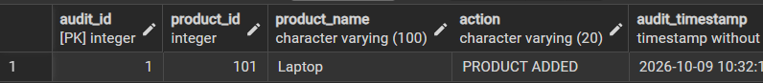

SELECT c.customer_name, c.city, SUM(o.amount) AS total_purchase_amount
FROM Customer c
JOIN Orders o ON c.customer_id = o.customer_id
GROUP BY c.customer_id, c.customer_name, c.city
HAVING SUM(o.amount) >= ALL (
SELECT SUM(o2.amount)
FROM Customer c2
JOIN Orders o2 ON c2.customer_id = o2.customer_id
WHERE c2.city = c.city
AND c2.customer_id <> c.customer_id
GROUP BY c2.customer_id
);

