A Fully Integrated Smart Airport Stakeholders Application

Written by Zina Abohaia ([20194621@ug.buid.ac.ae](mailto:20194621@ug.buid.ac.ae)) and Yousef Mamdouh (20196448@ug.buid.ac.ae)

Problem/Domain

As Internet of Things (IoT) advances, it offers promising solutions to make crowded, public places, such as airports, more efficient, safe, and integrated. The objective of this paper is to combine all available IoT technology to improve the services provided by airports, be it something as small as janitor optimisation, or as crucial as making security checks more efficient. As well as implementing IoT in the management, resource allocation, flights, and runway optimisation, to mention a few. All by using suitable IoT technologies, to finally gather all this information, and using data analytics techniques we integrate them into a smart application that caters to the government, airport management, airline companies, airport employees, and passengers.

HYPOTHESIS

If there is an integrated smart airport solution that caters to stakeholders, smart airports would be more efficient and safer, and stakeholders would be more satisfied.

PROJECT DETAILS

This paper discusses a smart airport solution with an attention to overlooked airport areas and services, such as waiting rooms, paths to gates, security checks, janitor optimisation, runway management, resource allocation, and other common smart airport applications.

From our critical survey, we have noticed that there is a lack of knowledge of IoT by airport personnel, as well as an exclusion of stakeholders. As we highlighted in the survey, papers have found that educating stakeholders on IoT, as well as making it accessible to them, made airports safer, and more efficient and successful.

Therefore, we have decided to design a smart airport model that is fully integrated, and can be accessed using a smartphone application and an internet connection. The papers evaluated prove that this process promises a positive outcome in optimising smart airports and increasing passenger satisfaction. We have conducted a survey to measure the extent of how much people think this would be useful, and we cover the results of the survey in this paper.

Methods

Proposed Smart Airport Architecture

|  |  |  |
| --- | --- | --- |
| System Classification | Proposed System | Technology Used |
| Smart Passenger Services | Automated Check-in | Smartphone application |
| E-gates | Rf-enabled card technology, and biometric scans |
| Luggage Tracking | RFID |
| AI Chatbot for assistance | AI Chatbot |
| Alerts and Recommendations | AI Recommendation system |
| Navigation | Shortest path algorithm, Bluetooth for location |
| Emergency requests | Smartphone Application |
| Smart Assistance for the visually and hearing impaired |
| Smart Baggage Carts (Arrivals) | RFID, Bluetooth, Force Sensor, |
| Smart Check-out | Smartphone Application |
| Smart Food Ordering/Shopping |
| Smart Parking Lots |  |
| Airport Cars Booking |  |
| Condition Monitoring | Air Quality Sensors | Network Bridges (For security reasons) |
| Weather Monitoring |
| Smoke, Fire, Toxicity Sensors |
| Heating System |
| Cooling System (AC) |
| Operational Efficiency | Automated Luggage handling | RFID, Robotic Arms for loading and unloading |
| Smart Lighting System | Smart Application, RFID |
| Smart Water System |
| Janitorial Optimisation |
| Waiting Room Optimisation |
| Asset Tracking |
| Problem Solving Efficiency | Smart Resource Allocation | Smart Application, Cloud |
| Automated resource update |
| Flight schedule organisation |
| Employee Timetable |
| Runway Optimisation |
| Security | AI cybersecurity | AI |
| CCTV Cameras | Smart Application, LoRaWAN |
| Motion, and heat sensors |
| Foreign Object Detection |
| Passenger Risk Assessment |
| Physical Intrusion Detection |
| Body Scanners | Security System within airport, LoRaWan |
| Firewall |
| Threat Hunting |
| Vulnerability Scanners |
| Maintenance and Structural Integrity | Runway Debrie Detection | Bluetooth, Smart Application (to confirm scheduling of maintenance)  Detection using Robots |
| Runway Pavement Management |
| Airport floors and doors management |
| Smart Restroom |
| Solar Panels Dirt Detection |

Some of them the proposed systems are common, so I will only go through the uncommon systems:

* **Smart Baggage Carts**: This proposed system uses both robotics and IoT. It is a cart-looking robot that can put luggage in it and remove it from it to a horizontal surface, such as the back of a car. It uses IoT to find the location of the passenger, to go to them, or to get the location of the car to go to it.
* **Smart Parking Lot**: Passenger, or visitor, can check to see where there are free spaces in the parking, the nearest entry to the airport, the nearest emergency exit, and the parking fare, all from the application. Sensors detect when a car parks, and updates the system. It can also be used to locate cars, and provide navigation from the car to a certain place to the airport or from the airport to the car.
* **Automated Luggage Handling**: A robot, with a robotic arm, moves the luggage to be boarded on an airplane, or boarded off an airplane. Luggage can also be tracked by the passenger.
* **Janitorial Optimisation**: Janitors are alerted to where to go, and that is usually communicated by the smart restroom to move janitors to the most crowded bathrooms at that time.
* **Asset tracking**: using RIFD tags.

Outer Airport Model:

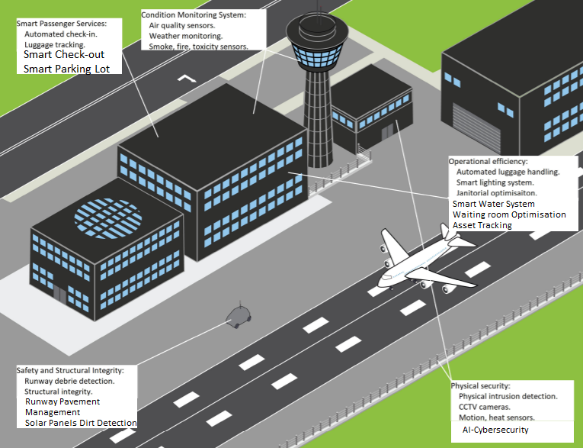

Inner Airport Model:

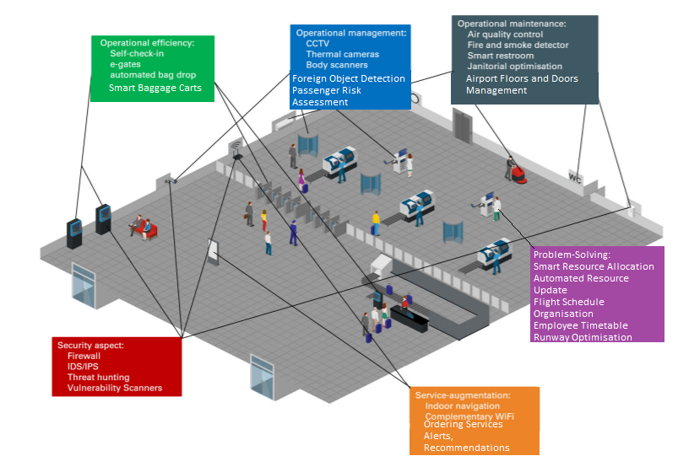

Use Cases: Smartphone Application When the User is a Departing passenger

When the User opens the application, they have access to all the smart services provided by the airport, from checking in to ordering items.

Actors: User, Application

Pre-conditions: User has to have a working internet connection, downloaded the application, and has logged in.

In the condition that the User is traveling from the airport, this is the basic flow of things:

1. User checks in by clicking on the "Check-in" button.

2. User checks airport parking lot to see where it is empty to park.

3. User parks at airport

4. User arrives at the airport.

5. Application welcomes user to the airport.

6. Application asks the user if they would like to talk to the chatbot. ALT

7. User clicks to talk to chatbot. ALT

8. User asks for guidance on what to do next. ALT

9. Chatbot forwards the User to the navigation tab.

10. The User follows the navigation to the e-gate

11. User's ID and biometric information is checked. ALT

12. User checks in luggage.

13. Application alerts user to go to the boarding gate to catch the flight.

14. Application asks user if they would like to follow the navigation to the boarding gate.

15. User accepts to use the navigation.

16. Application guides User to the boarding gate.

17. User checks into boarding gate.

18. User boards flight.

Alternate flows:

1a. User has arrived at airport and has not checked in: Application alerts User to check in.

2a. User doesn’t check parking lot because they will not be arriving to the airport using their private car: Use Case continues from 4.

7a. User doesn’t talk to chatbot: Use Case continues from 11.

8a. User asks for something other than guidance: User question is answered.

8b. User asks for something other than guidance, and it is answered: Chatbot asks user if they want guidance. If User says yes, Use Case continues from 9. If User says no, Use Case continues from 11.

15a. User doesn’t accept to use navigation: Use Case resumes from 17.

17a. User doesn’t check in to boarding gate: Application alerts User to check in.

Exceptions:

11a. User’s ID Card, and Biometric information recorded in the system are NOT identical: User is approached by security personnel. Use Case Ends.

17b. User does not check in to boarding gate, and does not respond to the application’s alerts: User’s location is checked: If user is in airport, they are approached by security personnel, and Use Case Ends. If User is not in the airport, Use Case Ends.

Post conditions: Application thanks User for using the airport, and its services.

Use Cases: Smartphone Application When the User is an Arriving passenger

When the User opens the application, they have access to all the smart services provided by the airport, from checking in to ordering items.

Actors: User, Application

Pre-conditions: User has to have a working internet connection, downloaded the application, and has logged in.

Basic flow in the condition User is arriving to the airport:

1. User gets off the plane.

2. Application prompts user to check out on the application.

3. User checks out on the application.

4. Application asks user if they want to order a smart baggage cart now.

5. User orders smart baggage cart.

6. Smart baggage cart comes to User.

7. Application asks user where to take the luggage.

8. User picks their car that is parked in the airport's parking lot.

9. Application asks user if they want to use navigation to go to the car

10. User accepts to use the navigation.

11. Smart Baggage Cart goes with User to the car.

12. Smart Baggage Cart removes luggage.

13. Application asks user to pay the parking fee.

14. User pays parking fee.

15. User leaves.

Alternate Flows:

8a. User picks Airport Taxi. Use Case continues.

10a - 11a. User doesn’t accept navigation: Smart Baggage Cart goes to Car. Use case continues from 13.

Post conditions: Application thanks User for using the airport, and its services.

Use Case for when User is not a passenger

When the User opens the application, they have access to all the general information about the airport and its flights.

Actors: User, Application

Pre-conditions: User has to have a working internet connection, and downloaded the application.

Basic Flow:

1. User opens application.
2. User chooses Visitor option.
3. Application asks user if they would like to check a status of a certain flight.
4. User enters the number of flight.
5. Application shows flight information.
6. Application asks user if they would like to receive updates on this flight.
7. User accepts.
8. Application provides information on the location of the airport.
9. Application asks user if they would like to be shown the parking lot.
10. User clicks to see parking lot.
11. Application shows user parking lot information, recommending to user where they should park.
12. User arrives at airport parking lot, and parks.
13. Application welcomes user.
14. Application asks user if they would like to use navigation.
15. User accepts.
16. Application guides user to their desired destination.

Alternate Flows:

7a. User doesn’t accept getting updates on flight: Use Case continues from 8.

9a. User doesn’t see parking lot, since they’re not coming with their private car or won’t park: Use Case continues from 13.

Exceptions:

15a. User doesn’t accept navigation. Use Case Ends.

Post conditions: Application thanks User for using the airport, and its services.

Use Cases for Employees

When the User opens the application, they have access to some of the airport’s services, as well as the decisions to accept updates, changes to the flight schedule, and to the runway.

Actors: User, Application

Pre-conditions: User has to have a working internet connection, downloaded the application, and is logged in.

Basic Flow:

1. User checks their monthly timetable.
2. User goes to airport.
3. User parks in employee’s designated parking.
4. Application welcomes employee to airport.
5. User opens their unique barcode on the application.
6. User scans barcode, at security check, and their biometric information is checked.
7. User is updated on any changes.

Alternate Flows:

User is a Janitor: 7a. User gets alerts as part of the janitorial optimisation program.

User is a Manager: 7b. Application asks User to accept or decline changes made to flight schedule, runway organisation, and resource allocation.

User is part of the security personnel: 7c. User is alerted to go to their designated position fo the day, and receive alerts on things to check, or people to approach.

Exceptions:

6a. There is an issue with the barcode: Security Personnel approach Employee. Use Case Ends.

6b. Biometric information is not the same as in the system: Security Personnel approach Employee. Use Case Ends.

Post conditions: Application thanks User for using the airport, its services, and their hard work.

Use Case Model: Passengers (Departing and Arriving)

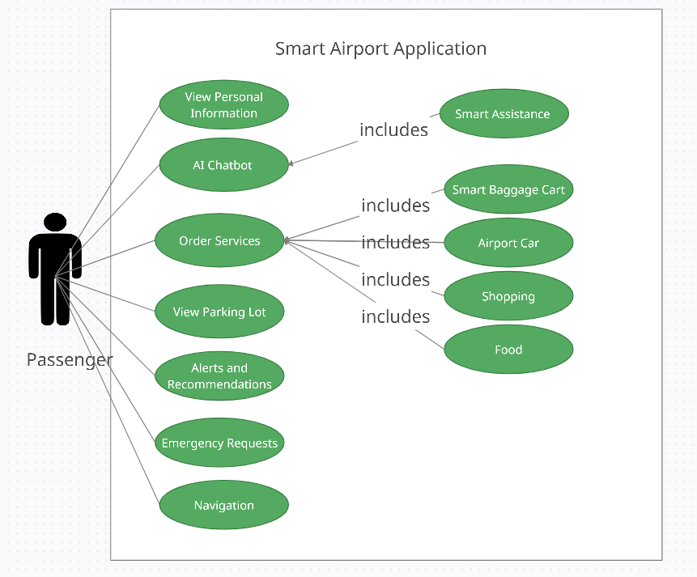

Use Case Model: Employees

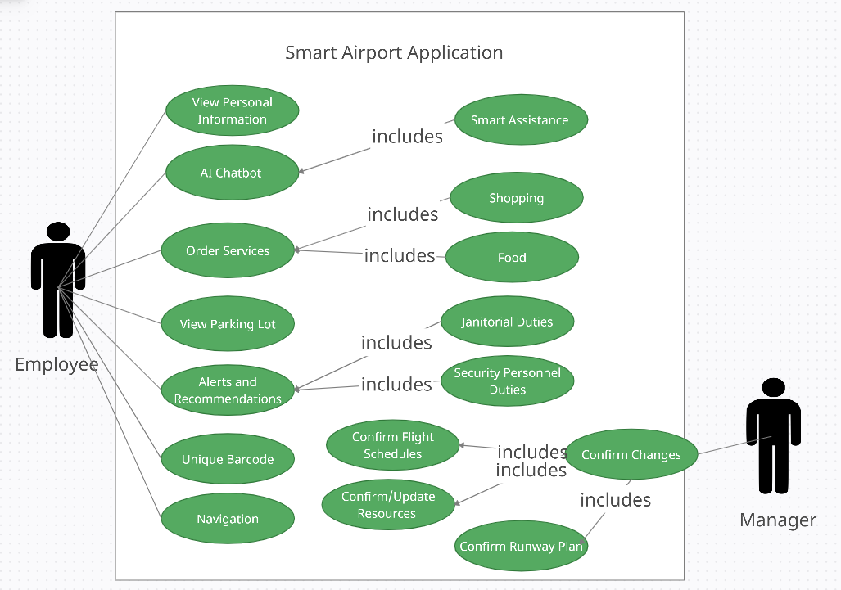

Use Case Model: Visitor

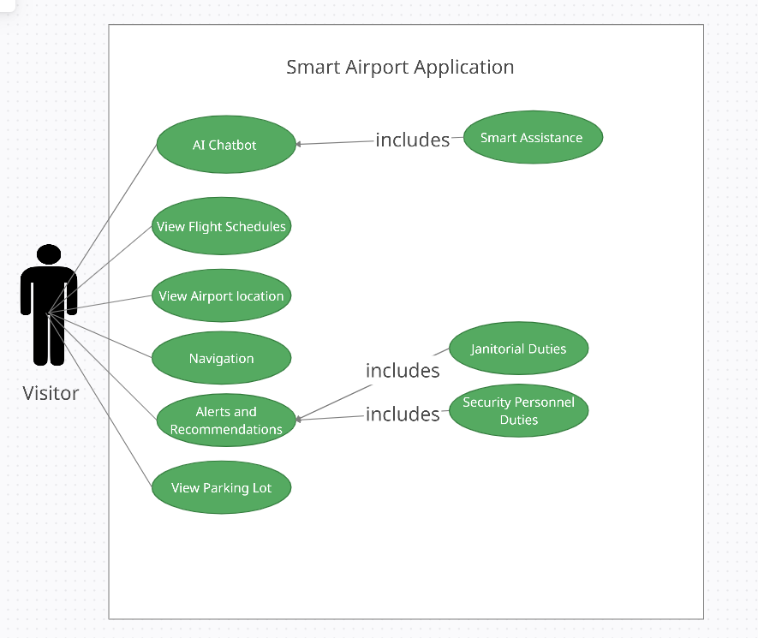

Results

To calculate the results, we have carried out a survey of 10 questions. 9 out of 10 questions received 33 responses, while the last question received 22 responses. In the following images, we will share the results with the questions:

Question 1:

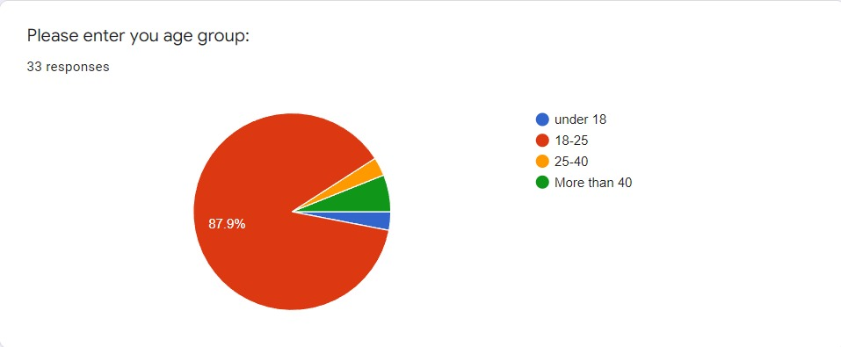

We wanted to see if there was any correlation between age group and answers.

Question 2:

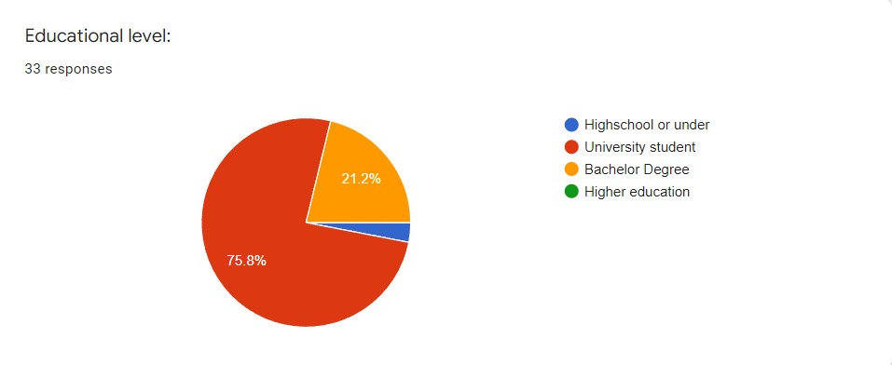

We wanted to see if there was any correlation between educational level.

Question 3:

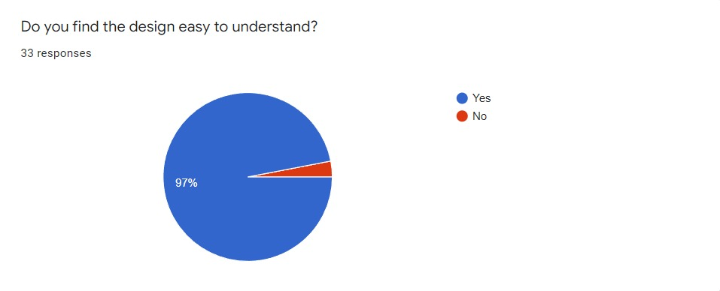

The above question was about the application. It is important to make sure that users would find the design easy to understand to make sure they can use it.

Question 4:

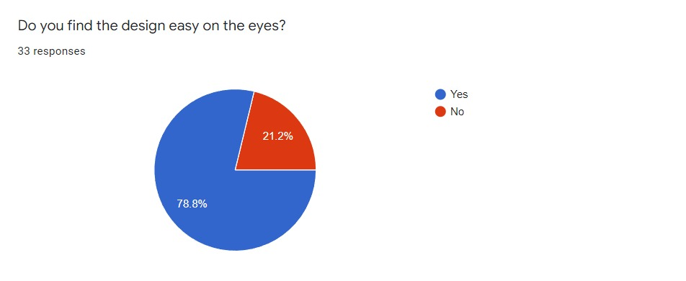

The above question was about the application. It is important to make the design user-friendly and easy on the eyes to give the best user experience.

Question 5:

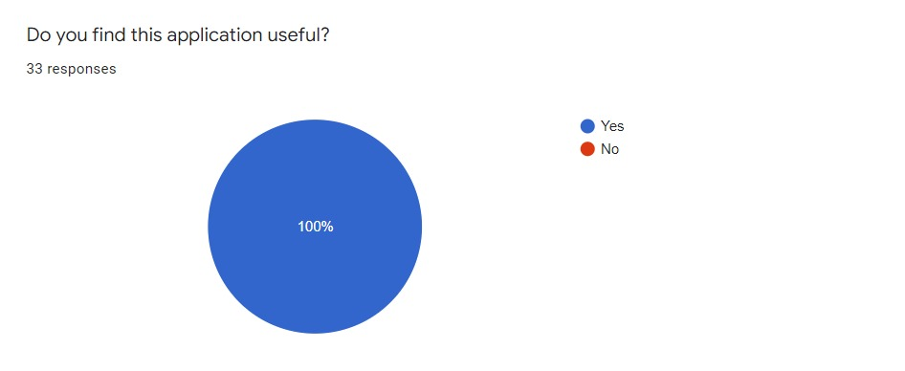

If the application isn’t seen as useful, or has a use, then there would be no point in making it so it was important to make sure that users would find the application useful.

Question 6:

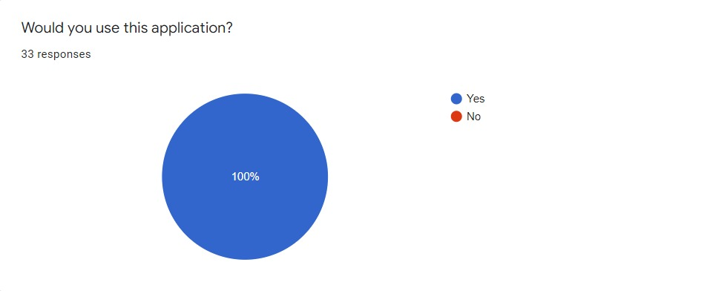

We need to guarantee that users would like to use the application.

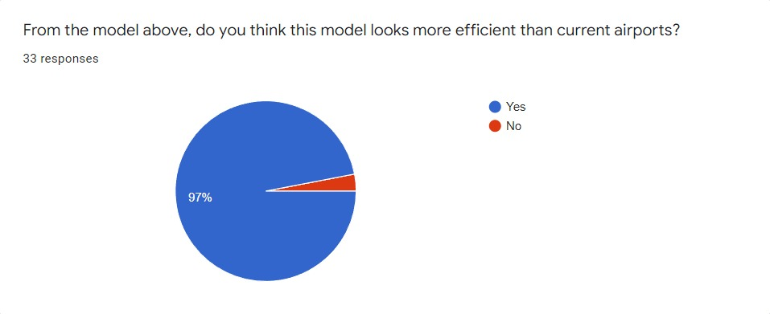

The above question is about the outer airport model.

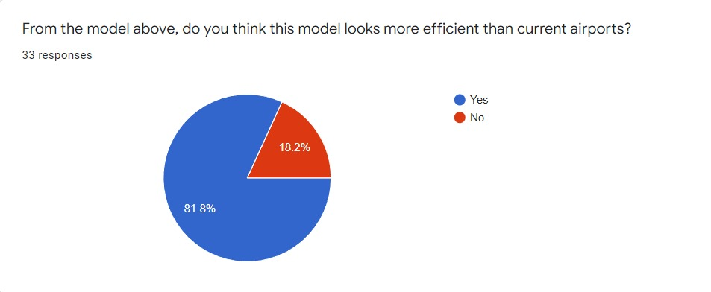

The above question is about the inner airport model.

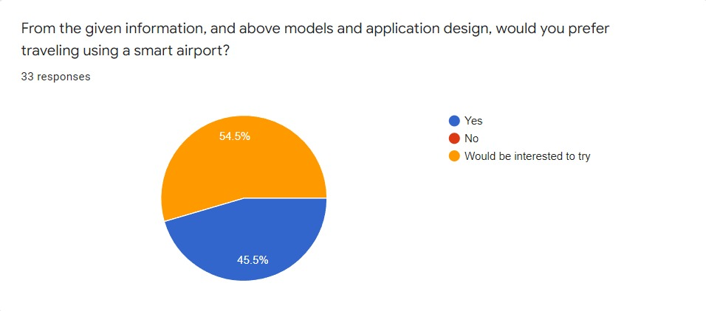

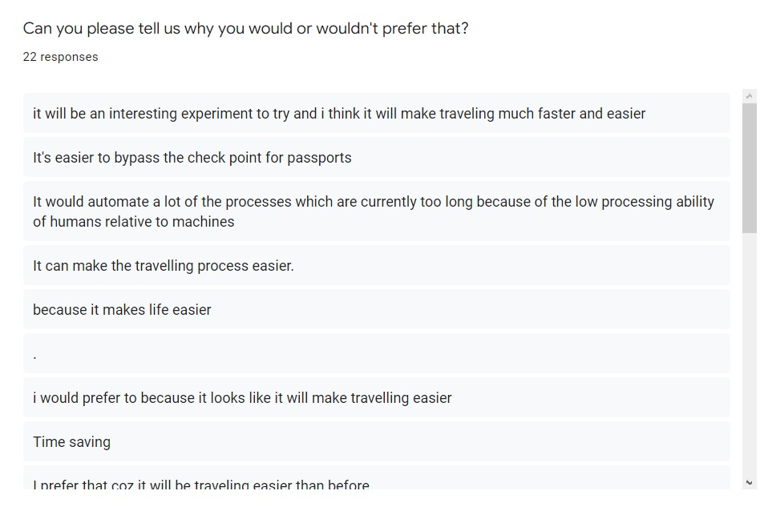

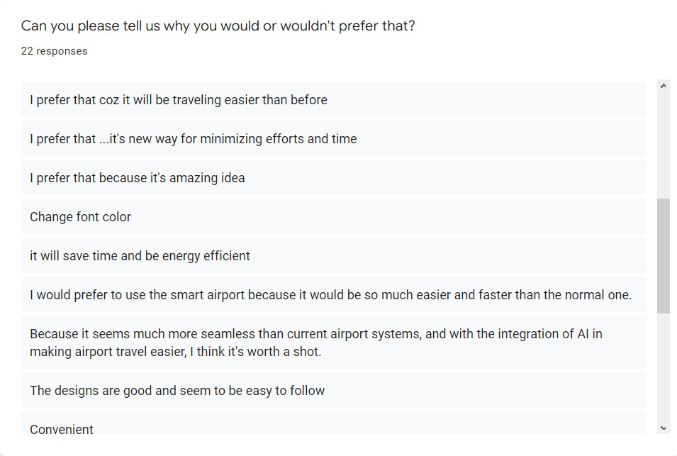

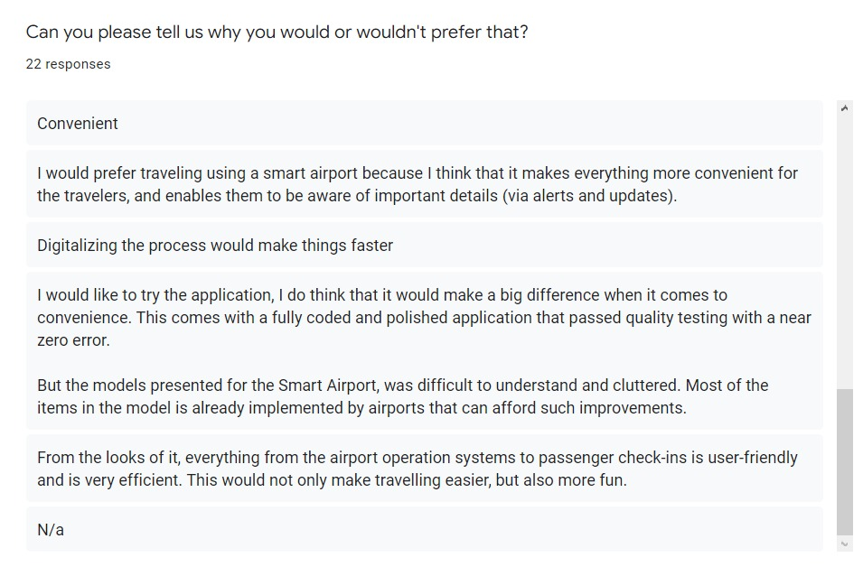

Discussion

From the survey in results, we can see that:

* 97% of users find the design easy to understand
* Around three quarters of the users find the design easy on the eyes
* All Users find the application useful, and said they would use it, despite some of them not finding the design easy on the eyes and one didn’t find it easy to understand
* 97% of users think that the outer airport model looks more efficient than current airports
* 81.8% of users thinks that the inner airport model looks more efficient than current airports
* From the 22 responses received in the last question: 2 were empty, 6 said it would make traveling faster, 8 said it would make traveling easier, 5 said it would make it more efficient, 2 said it would be more convenient, 2 machines and AI, while a couple of users said it was fun or interesting

We have analysed to see if there is any correlation between age group and the answers or if there is a correlation between education level and the answers, and we didn’t find a correlation in either.

Therefore, we can conclude that our project succeeds in creating a model that is easy to use, efficient, and convenient. The level of interest we observed from the survey motivates us to work on this project, and expand it more.

Future Work

We plan to make a functional application, and develop our project further to get it published and help other researchers, and any government planning to build or design a Smart Airport.