A Web-based Car Fault Diagnostic Expert System

Authors:

Zina Abohaia, 20194621@ug.buid.ac.ae

Yousef Mamdouh, 20196448@ug.buid.ac.ae

Sally Blata, 20193300@ug.buid.ac.ae

Abstract

Automotive defects are a major cause of accidents, when they can be easily avoided by diagnosing the fault as soon as possible. We created this expert system to diagnose car faults, to aid both drivers and mechanics. The expert system uses a forward-chaining technique that follows a decision tree, designed by us, using expert knowledge, to reach its diagnosis. We have included the most common causes of defects, some of which can be fixed by drivers temporarily, and others which must be fixed by a mechanic. It is web-based to be accessible to everyone, everywhere, anytime. The web-based car diagnosis expert system successfully reaches the correct diagnosis.

Introduction

In 2021 alone, the global car sales amounted to 66.7 million cars, with 56 million passenger cars. Passenger cars make up the largest portion of car sales, and they have been on the rise, fluctuating in the previous two years due to covid-19 and lockdown (Topic: Automotive industry worldwide, 2022). No one can deny that in some countries cars are seen to be vital for transportation, and in other countries, they are the preferred mode of transport.

As with everything, car have faults, and some of those faults are defects that may result in car accidents, such as steering components, breaks, and wheels that break, windshield wipers that don’t work properly, and much more (Car Accidents Involving Automotive Defects, 2022). Therefore, identifying and diagnosing a car fault as soon as possible is crucial to ensure the safety of passengers, and increase automobile safety generally in the streets.

The most common faults that occur in cars are engine failures, problem with electrical systems, power train, and air bags (Car Problems, Statistics, and Analysis, 2022). These problems cannot be fixed by drivers, and must be taken to an experienced mechanic. There are simpler problems that drivers can fix such as refilling water, or putting the car on the right gear. To provide a guide for drivers, we have decided to make an expert system that diagnosis the car problem, and provides instant guidance to the user of the program on what to do: fix it or go to a mechanic.

Scams by mechanics are very common, partly because car owners have very little information about car diagnosis which makes them more prawn to fall for scams when a mechanic overwhelms them by information and big words. Our system allows the car owner to be more aware of the problem, know what to expect from the mechanic, as well as the budget needed to fix the car.

An expert system uses the knowledge of an expert, and through an interface, it finds out the problem related to its domain, by asking questions, and either uses a forward-chaining or backward-chaining technique to diagnose the problem. We have used a forward-chaining technique to create an expert system that diagnosis car problems. Our expert system is also web-based to be accessible to everyone, and be used anywhere, at any time, with only an internet connection.

This can help both drivers, and mechanics. The former would have more information about the problem and if they can fix it or need the assistance of a mechanic. While the latter, the mechanic, can use the system to diagnose the problem, or to make sure of his own diagnosis.

Literature Review

Car fault diagnosis expert systems have been researched widely, and some systems have even forecasted 100% accuracy (De and Chakraborty, 2019). De and Chakraborty (2019) created a car fault diagnosis expert system using case base (database of related cases), and designed it using a Decision Tree, and the Jaccard Similarity Method. The system takes inputs as queries, and using the previous methods, it finds similar cases and outputs the diagnosis. The system is thoroughly designed, and was tested using a simulation.

Umamaheswaran (2010) proposed a framework for developing an expert system for car fault diagnosis. They have also used the inference technique forward-chaining for their expert system, after designing their system development method, as well as knowledge acquisition and testing. Their process was not much different from the one we used, however, they designed the system in the programming language Prolog, which does not work with the current operating systems, while we have made our expert system web-based to make it accessible.

Mostafa, Ahmad, Mohammed and Obaid (2012) have sought out to implement an expert diagnostic assistance system for car failure and malfunction, to assist mechanics in detecting failures, and in job training. They identified that the issue with previous expert systems was how time consuming they were, and also used the forward-chaining technique and Decision Tree. Their expert system was written in Win-prolog, and there was also a prototype made of it that was tested successfully. No analysis of how much time the system took was included.

Luo and Fang (2020) built a transmission control unit (TCU) diagnostic system, based on AUTOSAR. They took diagnostic systems a step forward by integrating them into the car, which has been a rising trend lately. Car companies are developing IoT expert systems that check every part of a car, and reports back any faults or defects, as well as reminders for any maintenance. This implementation is an important step forward in car fault diagnostic research.

Yang, Chen, Su and Qin (2013) worked in the same direction as Luo and Fang (2020) but focused on hybrid electric cars, and monitored them using On-board Diagnostic System-II (OBD-II) and android-based smartphones. The additional use of android-based smartphones enables drivers, mechanics, and car agencies, to get real-time information of what is happening in cars, and recommendations, that help them to make decisions.

The last paper included in this literature review, is a popular mechanics car diagnostic manual which we used as one of the sources for the knowledge acquisition in our system. It included useful information on what problems were fixable by drivers and which were not.

|  |  |  |  |  |
| --- | --- | --- | --- | --- |
| Paper | Objectives | Findings | Methodology | Future Work |
| De and Chakraborty, 2019 | Research proposed a CBR methodology based Intelligent Car Fault Diagnosis System (CFDS) to help car mechanics in car diagnosis | * Best Case for total time is O(1), and the Worst Case is O(N) * Accuracy would be 100% if the data was updated to the current year | * Case Based Reasoning (CBR) techniques * Decision Tree as a ML technique to store cases * Jaccard similarity method to calculate the similarity between User new query case and stored cases in the CB. | To enhance the cases in CB and update them. |
| Umamaheswaran, 2010 | Research focuses on creating an expert system that focuses on car fault and malfunction diagnosis | * System is useful when “work productivity is improved by decreasing fault diagnosis time and increasing users understanding” | * Creating a Knowledge Based System (KBS). * Database Utilization | Improve the system domain knowledge specifications, and adopt other AI techniques to add more effectiveness to the diagnosis process |
| Mostafa, Ahmad, Mohammed and Obaid, 2012 | Paper explains how to take care of cars, and whether you can fix some problems yourself or not. | * Useful Learning Resources * We can use the data for knowledge acquisition | * Uses Expert Knowledge | No Future Work included |
| Luo and Fang, 2020 | Research develops a Transmission Control Unit (TCU) Diagnostic System based on AUTOSAR | * The diagnostic system fulfils the requirements of the design | * Based on the diagnostic architecture of AUTOSAR | Implement “more specified diagnostic functionality in combination with the vehicle test results” |
| Yang, Chen, Su and Qin, 2013 | Research presents a “remote controller area network bus (LAN-Bus) data monitor and diagnostic system for HEV” | * System was successfully used, it acquired “the running parameters and the location information of HEV and transmit them to the remote web server for monitoring” | * On board diagnostic version-II (OBD-II) and android-based smartphones * Communicated using ELM327 and remote monitoring wirelessly * Bluetooth was used for integration | To develop data analysis and processing on “smartphones with lightweight database SQLite” |
| THE POPULAR MECHANICS CAR CARE DIAGNOSTIC MANUAL, 2017 | Research proposed a “framework for developing an expert system for car fault diagnosis” | * Works accurately on current knowledge base with problems related to the engine of the car | * Rule Based Expert System * Forward-chaining inference technique * Used LPA Prolog language. | To create a version of the framework that is compatible with the latest operating systems and refine errors and rules |

Methodology: Knowledge Acquistion

The research was initially based on car problems we went through or know about. That guided the knowledge acquisition in terms of looking for the most common problems that end up leading to bigger problems. The issue is we do not pay attention to minor faults with the car until it breaks down; More often than not, that’s when the car damage is too big. That cost the car owner much more money which could easily be prevented by looking out for the details.

Knowledge acquisition is the process at the heart of knowledge engineering, and building an expert system. It is how we extract, organise, and use the knowledge needed in the expert system. It generally encompasses observing an expert solving problems, how they come up with solutions to different cases, and developing rules to problems along the way.

Since we did not have access to an actual expert, we used our experience as drivers, knowledge from different research papers, as well as mechanics manuals used to train mechanics. Therefore, most of the information we gathered was from the internet. We targeted the most common problems, and through that uncovered more details that we were able to integrate into our solution. We developed this knowledge to be organized and displayed as a decision tree, and using that decision tree we built our web-based expert system.

Methodology: Decision Tree

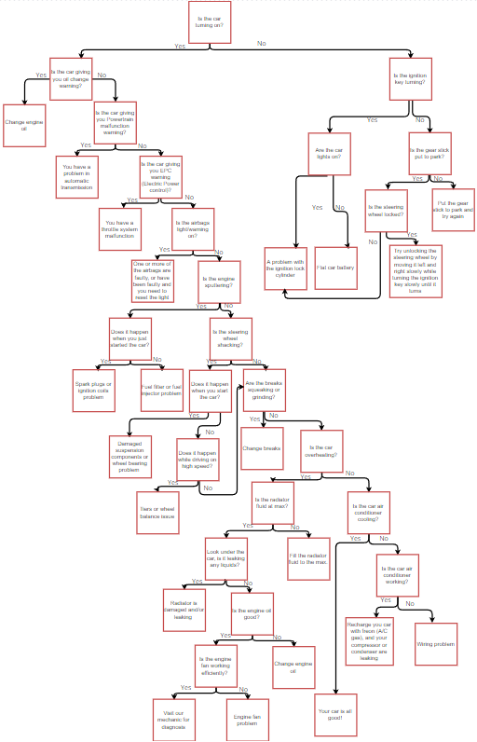

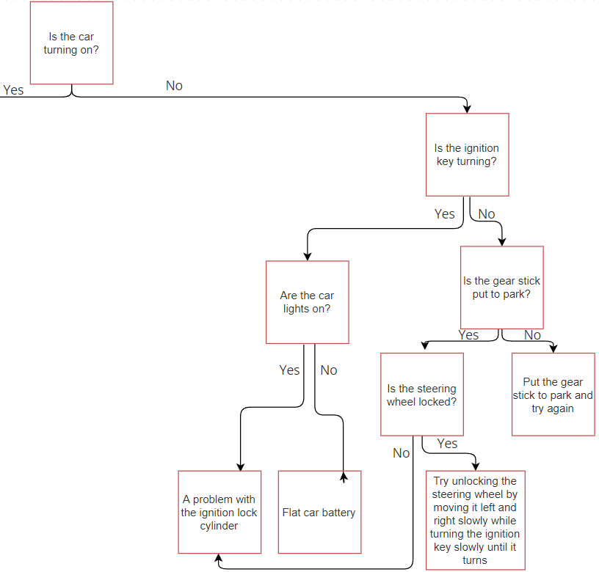

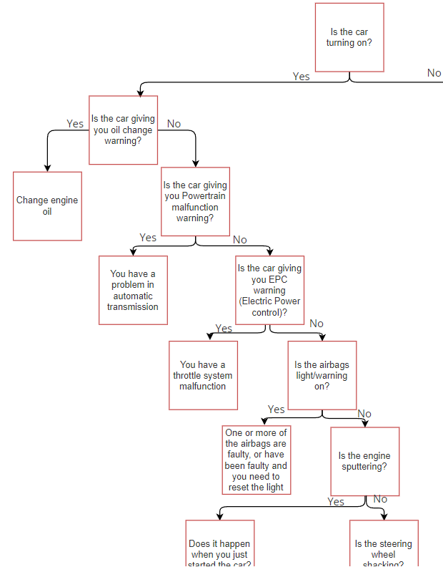

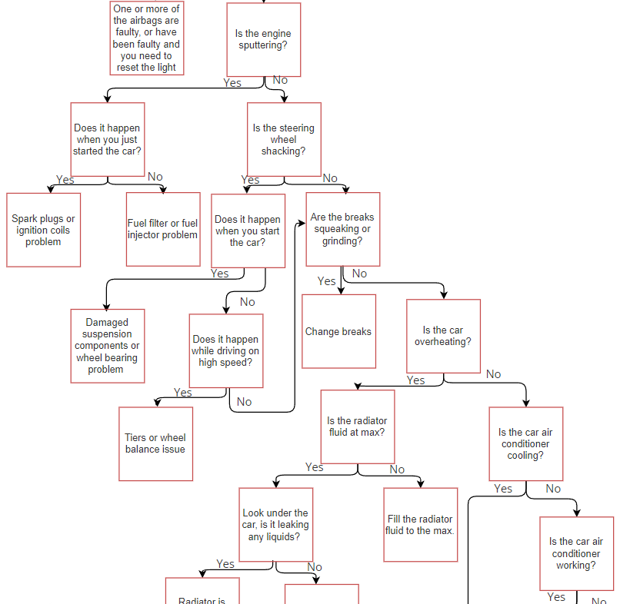

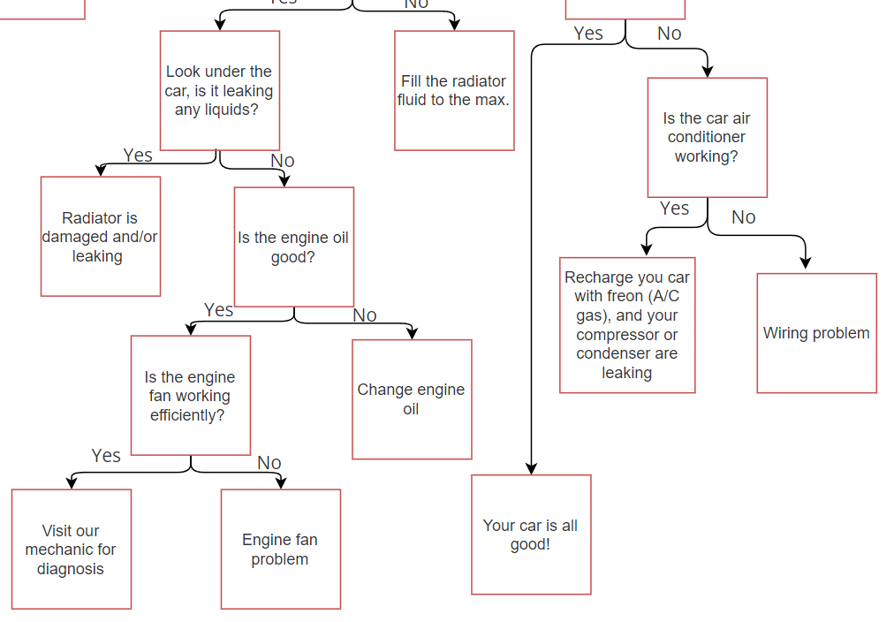

In the following picture, you can see that two answers lead to the same question; however, in decision trees, every node has only one parent. We have only used it in this manner for representation purposes since the decision tree is quite big, and looked very unruly and unclear when we had every path fully drawn out.

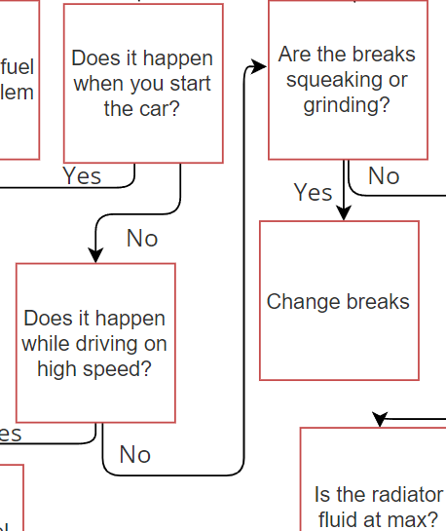

Therefore, they are two separate paths, with similar questions. As you can see in the full decision tree, the sum of questions in all directions is 30 questions.

Testing and Findings

We went through the entire system to make sure every link is working and linked correctly, and that we are not missing any of the branches or leaves of the decision tree, and that every page is used, as well as testing different scenarios multiple times to make sure we get the correct results.

Here are some examples of our working web-based expert system:

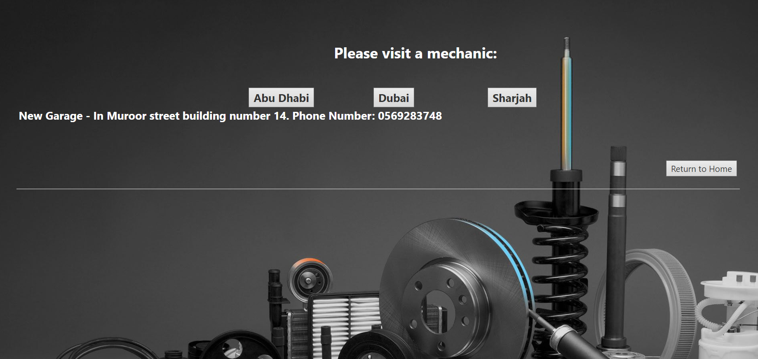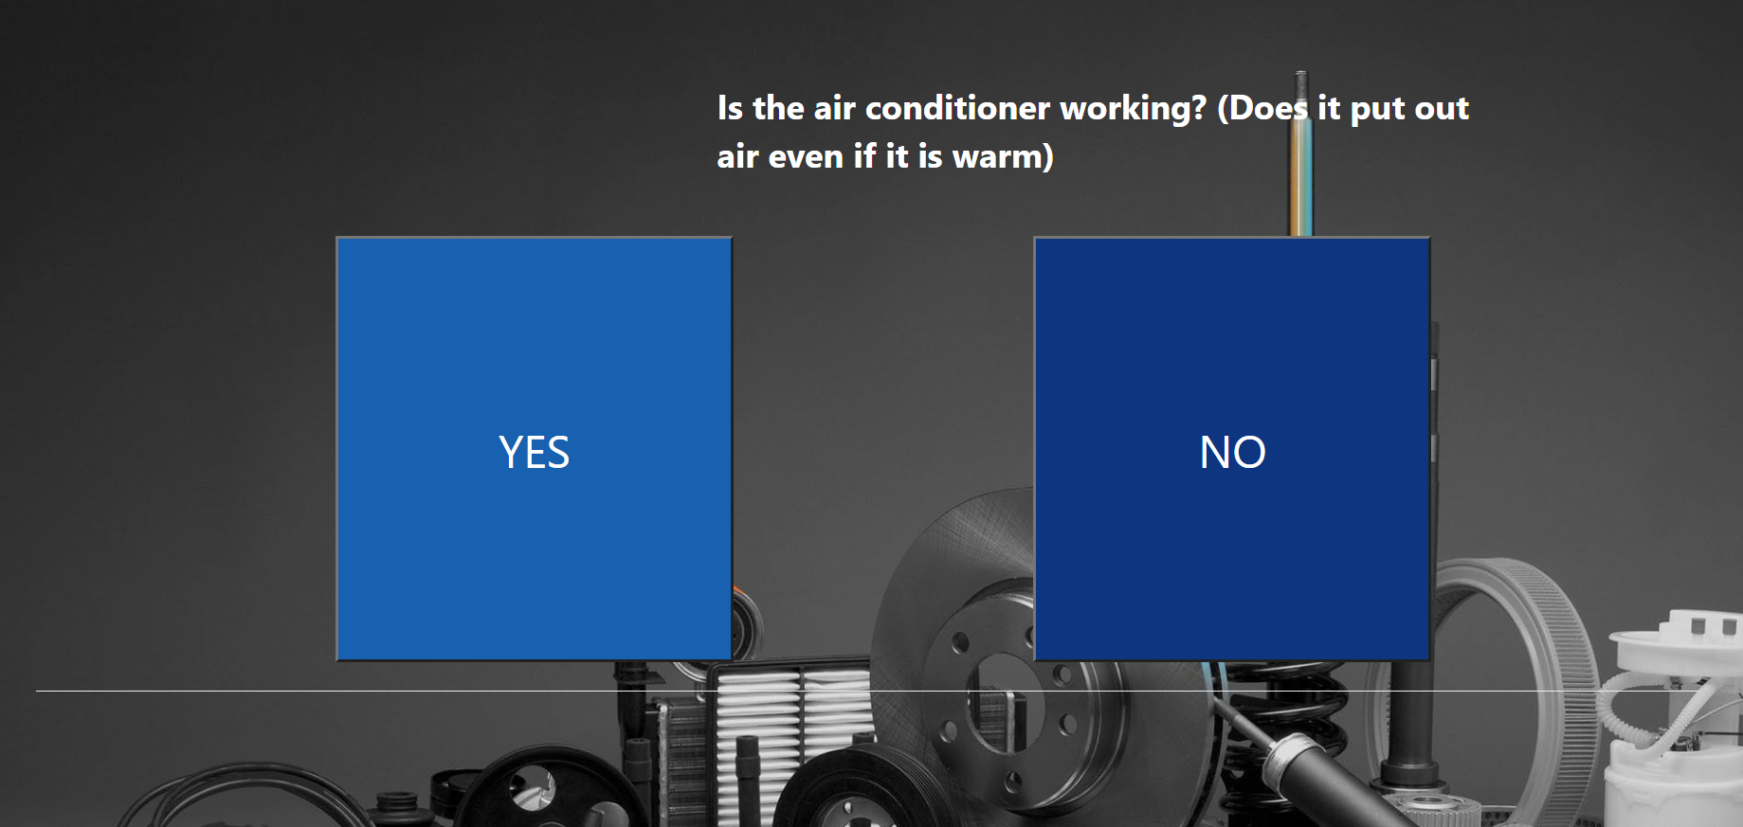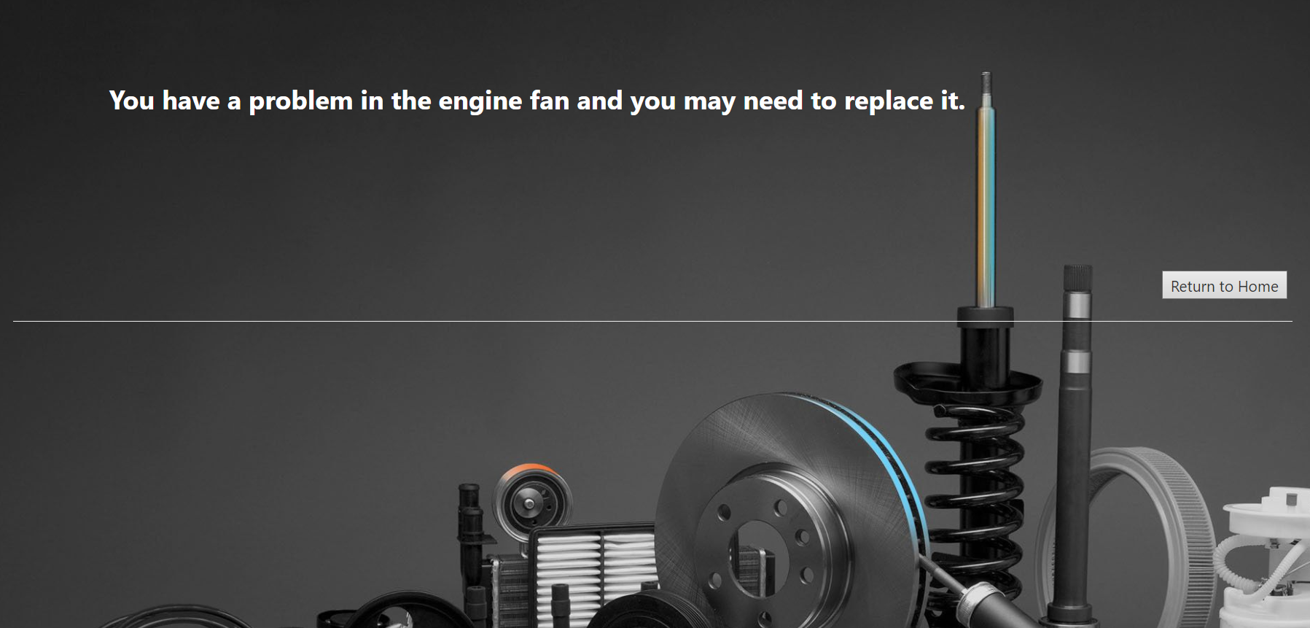

We also found that the Best Case Time complexity for our web-based expert system is O(3), and the general Worst Case Time complexity is O(N). Some questions require the driver or mechanic to do things that may take more time than others, therefore the Worst Case time is general.

Evaluation

Driving a car has become more and more essential, but not everyone has the knowledge to understand the problems with their cars, having a car expert at hand is a very helpful idea for a lot of people, which is why we think this system is quite handy, its relevance, that its free, how clear it is, how many problems it includes, and the details that it provides, knowing what exactly is wrong with your car can save you a lot of time and money.

We have thought of different ways to improve the system, we have tried improving the time complexity of the program but the only way to improve it is to either make it query based, where the worst case time would not be much better, or improve it in the different ways we mention in the future work section.

Discussion and conclusion

Acquiring information through research that is based on previous knowledge of car issues was fundamental. It helped expand the diagnosis process in the decision tree. Finding reliable sources was a bit difficult, given that some diagnoses are made without having all option in mind, and that some of the information is subjective to the car specs, and/or the environment of the car. Once we found middle ground on the most common issues, the rest was easy.

The Research was enlightening in terms of having a better understanding of basic car operational mechanics, pieces, and fault fixing. Information was collected, filtered, fact checked, then arranged in order of operating the car, then the decision tree was planned and created in that order. All group members were cooperative by giving their experience and the knowledge they have about car problems that the majority of people go through, with no idea on how to deal with it.

People always look for products or services that provide comfort, save time, save money and/ or increase their efficiency. Our website provides all four, it allows the user to easily and quickly diagnose fault in their car in the most accurate manner. All the user has to do, is answer a series of “yes” and “no” questions, and the website gives an accurate result on where the fault is and for many cases how to fix it, or at least a temporary solution, as well as advising the users to visit a mechanic. We also give the user the option to visit mechanics that we suggest to them based on their location.

We decided to start with the most common car problems, as well as the standard operating mechanisms, however, the website will expand with time and increase of knowledge about cars, and increase of access to different models, specs and types (electric cars). For users that find our website useful, we are giving the option to subscribe to the website. They will subscribe to an advanced service that includes syncing their car Computers to our program that is based on AI and machine learning. The program provides the subscriber with alerts in the form of notifications. It will predict faults that could occur in the future, therefore allow the car owner to take preventive measures.

Future Work

In the process of developing the website more questions will be added and alternated, in parallel with development of car technologies. As well as:

* Add electric cars diagnosis: People are moving towards minimising their carbon footprint, spreading awareness about the environment and changing their current lifestyle to a greener one. Electric cars are gaining popularity in line with the movements towards a greener earth. Eventually, we will add the option to get a diagnosis for electric cars. The issue for now is that electric car brands are very secretive about the way the cars are engineered. With time, and the spread of electric car brands, and models, information will be easier to obtain.
* Specialize diagnosis to car make, model, and specs: In essence all modern cars operate the same way, however some issues and car fails happen due to environmental factors. Other car brands engineer the cars a little differently. Other details that can affect the decision tree could be things like the car model, since with time new technologies emerge.
* Install a program to subscribers: Website visitors could subscribe to having a program installed on the car computer to predicts car fails, which then the website would send the car owner notification and alerts that allow the car owner to take preventable measures. The program will be based on AI and machine learning technologies that specialize in collecting data from the car performance over all, and specific to each part. That will increase diagnosis accuracy, car efficiency, and car management. Car owners shall benefit from the service by saving money, since no major issues will occur since the car will be in check and well maintained at all times. Aside from that, Car owners will not feel restricted anymore since their cars will not be taken from them for so long, given that they have an immediate accurate diagnosis, all is left for the mechanic to fix the car.

References

Statista. 2022. Topic: Automotive industry worldwide. [online] Available at: <https://www.statista.com/topics/1487/automotive-industry/#dossierContents__outerWrapper> [Accessed 17 February 2022].

Carproblemzoo.com. 2022. Car Problems, Statistics, and Analysis. [online] Available at: <https://www.carproblemzoo.com> [Accessed 17 February 2022].

Kraft & Associates, P.C. 2022. Car Accidents Involving Automotive Defects. [online] Available at: <https://www.kraftlaw.com/car-accidents/causes-car-accidents/car-accidents-involving-automotive-defects/> [Accessed 17 February 2022].

Guru99. 2022. What is Expert System in AI (Artificial Intelligence)? with Example. [online] Available at: <https://www.guru99.com/expert-systems-with-applications.html> [Accessed 17 February 2022].

Red, B., 2022. Red, Black & Blue Color Scheme » Black » SchemeColor.com. [online] Schemecolor.com. Available at: <https://www.schemecolor.com/red-black-blue.php> [Accessed 17 February 2022].

De, S. and Chakraborty, B., 2019. A Novel CBR-Decision Tree Based Intelligent Car Fault Diagnosis System (CFDS). International Journal of Recent Technology and Engineering, 8(2), pp.2180-2193.

Umamaheswaran, S., 2010. Frame Work for Developing an Expert System for Car Fault Diagnosis. i-manager's Journal on Future Engineering and Technology, 5(2), pp.17-24.

Mostafa, S., Ahmad, M., Mohammed, M. and Obaid, O., 2012. Implementing an Expert Diagnostic Assistance System for Car Failure and Malfunction. IJCSI International Journal of Computer Science Issues, [online] 9(2). Available at: <https://www.researchgate.net/publication/224863145_Implementing_an_Expert_Diagnostic_Assistance_System_for_Car_Failure_and_Malfunction> [Accessed 17 February 2022].

Luo, F. and Fang, X., 2020. Development of TCU Diagnostic System in Application Software Based on AUTOSAR. Journal of Physics: Conference Series, 1570(1), p.012028.

Yang, Y., Chen, B., Su, L. and Qin, D., 2013. Research and Development of Hybrid Electric Vehicles CAN-Bus Data Monitor and Diagnostic System through OBD-II and Android-Based Smartphones. Advances in Mechanical Engineering, 5, p.741240.

Popular Mechanics, 2017. THE POPULAR MECHANICS CAR CARE DIAGNOSTIC MANUAL. pp.30-31.

Car Talk. 2022. Top 10 Worst Things Your Mechanic Can Tell You. [online] Available at: <https://www.cartalk.com/content/top-10-worst-things-your-mechanic-can-tell-you> [Accessed 17 February 2022].

Yourmechanic.com. 2022. Top 12 Most Common Car Problems and Issues | YourMechanic Advice. [online] Available at: <https://www.yourmechanic.com/article/top-12-most-common-car-problems-and-issues> [Accessed 17 February 2022].

Lesschwab.com. 2022. Starting Problems? How to Tell If It’s the Battery or Alternator - Les Schwab. [online] Available at: <https://www.lesschwab.com/article/starting-problems-how-to-tell-if-its-the-battery-or-alternator.html#:~:text=If%20your%20vehicle%20won't,battery%20or%20an%20alternator%20problem> [Accessed 17 February 2022].

Engineering.purdue.edu. 2022. Knowledge Acquisition. [online] Available at: <https://engineering.purdue.edu/~engelb/abe565/knowacq.htm> [Accessed 17 February 2022].

Background photo is from depositphotos.com.