**Republic of Algeria Democratic and Popular**

**Ministry of** [**Higher**](http://www.higherlowergame.com/) **Education and Scientific Research**

**University of Sciences and Technology HOUARI**

**BOUMEDIENE**

**[Faculty of Informatic](https://ischool.utoronto.ca/)**



**Report**

**THEME :**

**Information And Communication Technologies And Technologies Related To TIC**

**Presented by :**

**Mr : ZAAF Mohamed [Ishak](https://www.enfant.com/prenoms/garcons/ishak-11597)**

**Supervised by Mr/ R. BOUCHEKIR**

**Academic year 2023/2024**

**TABLE OF CONTENTS**

1. Introduction……………………………………………………………………………………………..1

2. What is TIC……………………………………………………………………………………………...2

2.1 Definition……..……………………………………………………………………………………2

3. Etymology………………………………………………………………………………………….……2

4. Information and communications technology (TIC) vs. Information technology (IT)……….….……...3

5. The technologies included in TIC…………………………………………………………………….…3

5.1- What Is the Internet?............................................................................................................................5

5.2- Key features of the internet………………………………………………………………………..…6

5.3- Types of Internet Services………………………………………………………………………..…..7

5.3.1- Search engine…………………………………………………………………………………..…7

5.3.1.1- Definition……………………………………………………………………………………..7

5.3.1.2- Types Of Search Engines In The Internet World……………………………………….……7

5.3.1.3-Most Popular Search Engines………………………………………………………..………..8

# 5.3.1.3.1- SOME GOOGLE’S PRODUCTS AND SERVICES……………….…………….………9

# 5.3.1.3.2- Microsoft Tools and services………………………………………………………..……..10

6. Avantages of TIC Technologies And Tools………………………………………………….………...11

7. Technological capacity…………………………………………………………………………...…….12

8. Aims & Objective ……………………………………………………………………………….……..12

9. Disadvantages of TIC …………………………………………………………………………….……13

10. Conclusion……………………………………………………………………………………...…..…14

**1- Introduction**

Information technology “evolved in the 1970s. Its basic concept, however, can be traced to the World War II alliance of the military and industry in the development of electronics, computer and information theory. After the 1940s, the military remained the major source of research and development funding for the expansion of automation to replace manpower with machine power.

Information and communication technologies for development refer to the application of information and communication technologies (TIC) towards social, economic, and political development, with a particular emphasis on helping poor and marginalized people and communities. TIC for development is grounded in the notions of “development, growth, progress and globalization and is often interpreted as the use of technology to deliver a greater good.

Information and communication refers to technologies that provide access to information through Telecommunication. It is similar to information Technology but focuses primarily on communication technologies. This includes the internet, wireless network, Cell phone, and other communication medium. For example: people can communicate in real time with others in different countries using technologies such as instant messaging, voice and video conferencing , social networking website like face both allow users from all over the world to remain in contract and communicate on a regular basis. TIC is one of the wonderful gifts of modern science and technology which brought tremendous changes in library and information science. It has opened up a new chapter in library communication and facilitated global access to information crossing the geographical limitations. TIC has a profound effect on the progress and development of human civilization. The tools used in TIC include computer programs, databases, communication networks, analysis and design methods programming languages, artificial intelligence, knowledge bases, etc. TIC has long-standing influence in almost all areas of human activity.

The TIC products are helpful to store, retrieve, manipulate and transmit information electronically. Information and communication technology has revolutionized the concept of libraries. The libraries are also changing their role to meet the demand of users for retrieving desired information which was not possible by the means of traditional libraries. Today TIC is generally understood to encompass both equipment and services that facilitate the electronic capture, processing, display and transmission of information.

**2- What is TIC**:

Information Communication Technology is a common term referring to the technologies used for collecting, storing, editing and communicating information. TIC means the use of computer-based technology and the Internet to make information and communication services available in a wide range of users.

TIC is Hardware and Software that enable society to create, collect, consolidate and communicate information in a multimedia format and for various purposes. The term TIC includes any communication device or application, encompassing, radio, TV, cellular phones, computers and network, hardware and software, satellite systems and so on, as well as the various services and application associated with them. TIC is playing a vital role in the current and future development of society and nation.

TIC has affected all spheres of life and also the library. Information and communication technology is a diverse set of technological tools and resources used to communicate and to create, disseminate, store and manage information. Information and communications technology (TIC) refers to all the technology used to handle telecommunications, broadcast media, intelligent building management systems, audiovisual processing and transmission systems, and network-based control and monitoring functions.

**2.1- Definition:**

According to the Encyclopedia of Computer Science, “**Information Communication Technology** (TIC) is an imprecise term frequently fundamental to broad areas of technologies and associated with the use of computers and communications”.

According to UNESCO “TIC is a scientific, technological and engineering discipline and management techniques used in handling information and application and social, economical and cultural matters”.

**3- Etymology :**

The phrase "**information and communication technologies**" has been used by academic researchers since the 1980s. The abbreviation " TIC " became popular after it was used in a report to the UK government by [Dennis Stevenson](https://en.wikipedia.org/wiki/Dennis_Stevenson,_Baron_Stevenson_of_Coddenham) in 1997, and then in the revised [National Curriculum](https://en.wikipedia.org/wiki/National_Curriculum_(England,_Wales_and_Northern_Ireland)) for England, Wales and Northern Ireland in 2000. However, in 2012, the [Royal Society](https://en.wikipedia.org/wiki/Royal_Society) recommended that the use of the term " TIC " should be discontinued in British schools "as it has attracted too many negative connotations". From 2014, the National Curriculum has used the word  [**computing**](https://en.wikipedia.org/wiki/Computing)*,* which reflects the addition

of [computer programming](https://en.wikipedia.org/wiki/Computer_programming) into the curriculum.

Variations of the phrase have spread worldwide. The United Nations has created a "[United Nations Information and Communication Technologies Task Force](https://en.wikipedia.org/wiki/United_Nations_Information_and_Communication_Technologies_Task_Force)" and an internal "Office of Information and Communications Technology".

**4- Information and communications technology (TIC) vs. Information technology (IT):**

The acronym **(**TIC**)** is sometimes used synonymously with IT. However, **(**TIC**)** is generally used to represent a more comprehensive list of all components related to computer and digital technologies.

IT is more about managing the technologies related to information, and its various technical aspects, including software, hardware, and networking. IT management does not include considerations of telecommunications devices and technologies while **(**TIC**)** does. IT can be considered a subset of **(**TIC**)**.

**5- The technologies included in TIC**

TIC encompasses the internet-enabled sphere and the mobile one powered by wireless networks. It includes antiquated technologies, such as landline telephones, radio and television broadcast -- all of which remain widely used alongside today's cutting-edge TIC pieces, such as artificial intelligence and robotics.

The internet, internet of things, metaverse, virtual reality and social media are also part of TIC, as are cloud computing services, video conferencing and collaboration tools, unified communications systems and mobile communication networks. Emerging, work-in-progress or still-nascent technologies like 5G/6G, Web3, and quantum computing are also in the TIC universe.

Any technology, infrastructure like computers, laptops, printers, scanners, software programs, data projectors, and interactive teaching box, component, or device that enables communications, data sharing, and global connectivity between humans and between humans and machines is included in the umbrella term TIC.

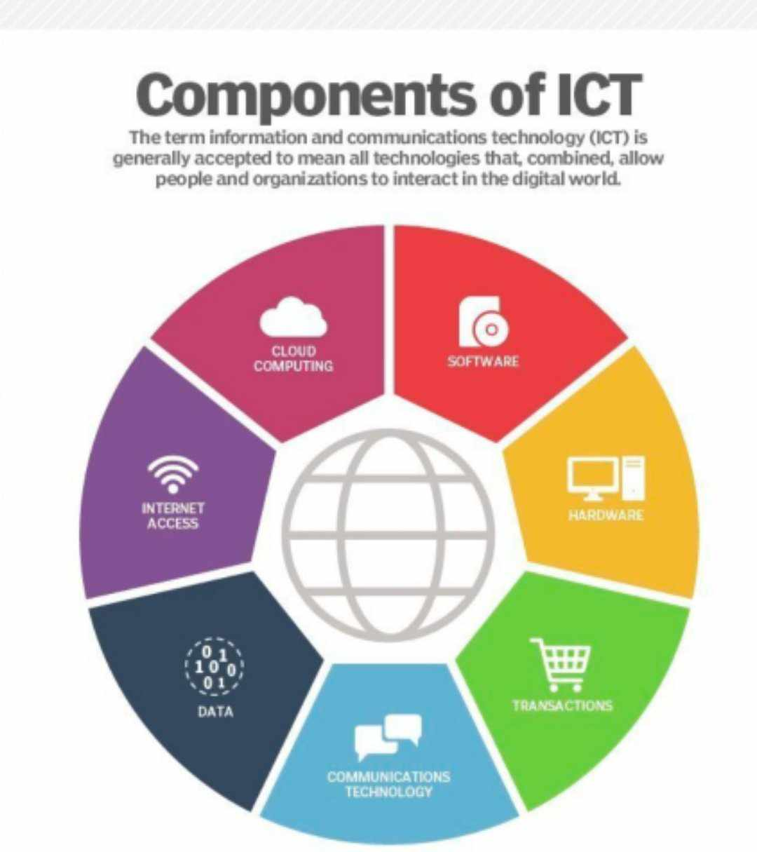

Figure1 : This chart identifies several key categories that are components of information and communications technology.

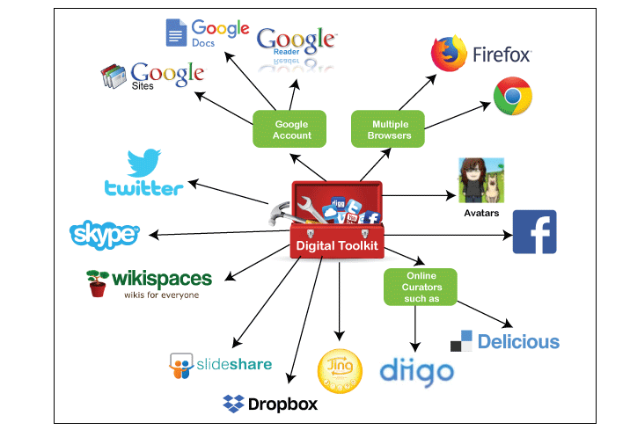

Figure 2 : This figure identifies some **TIC** Tools.

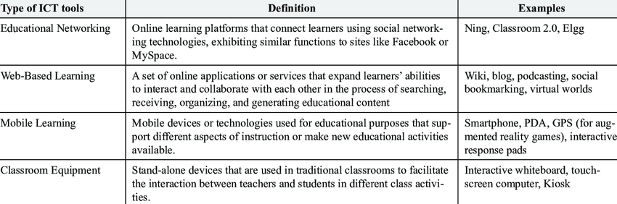

Table 1 : This table identifies some type of ICT Tools.

**5.1- What Is the Internet?**

The internet is a global network of interconnected computers, servers, phones, and smart appliances that communicate with each other using the transmission control protocol (TCP) standard to enable a fast exchange of information and files, along with other types of services.

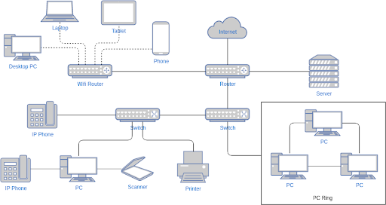

Figure 3 : This figure shows how internet works.

The internet is a global hub of computer networks — a network of connections wherein users at any workstation may, with authorization, receive data from every other system (and often interact with users working on other computers).

Internet infrastructure comprises optical fiber data transmission cables or copper wires, as well as numerous additional networking infrastructures, such as [local area networks (LAN)](https://www.spiceworks.com/tech/networking/articles/what-is-local-area-network/), wide area networks (WAN), metropolitan area networks (MAN), etc. Sometimes wireless services such as 4G and 5G or WiFi necessitate similar physical cable installations for internet access.

Internet Corporation for Assigned Names and Numbers (ICANN) in the United States controls the internet and its associated technologies, such as IP addresses.

**5.2- Key features of the internet**

The internet is a vast, interconnected network of computers and other network-enabled devices, which is:

* **Globally available:** The internet is an international service with universal access. People living in isolated areas of an archipelago or even in the depths of Africa can now access the internet.
* **Easy to use:** The software used to connect to the internet (web browser) is user-friendly and easy to understand. It’s also relatively easy to create.
* **Compatible with other types of media:** The internet provides a high level of engagement with photos and videos, among other media.
* **Affordable:** Internet service development, as well as maintenance costs, are modest.
* **Flexible:** Internet-based communication is highly adaptable. It supports text, audio, and video communication. These services are available at both individual and organizational levels.

**5.3- Types of Internet Services**

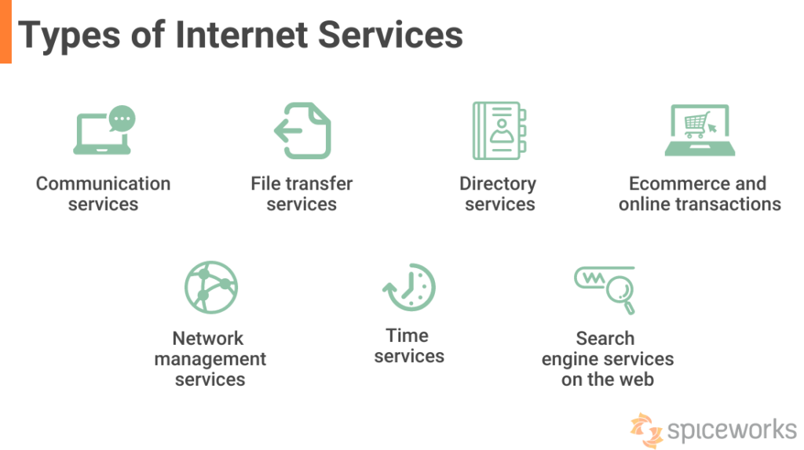

Figure 4 : This figure shows types of Internet Services.

# 5.3.1- Search engine

# 5.3.1.1- Definition:

# A search engine is a software program that helps people find the information they are looking for online using keywords or phrases.

# Search engines are able to return results quickly—even with millions of websites online—by scanning the Internet continuously and indexing every page they find.

# 5.3.1.2- Types Of Search Engines In The Internet World

# There are seven types of search engines: general, vertical, hybrid, metasearch, web search, image search, and video search engines.

# 1. General Search Engines: A general-purpose search engine is a search engine that indexes and ranks web pages based on their content for a wide range of topics. The most popular general-purpose search engines are Google, Yahoo, and Bing.

# 2. Vertical Search Engine: A vertical search engine is a search engine that specializes in a particular type of content. Vertical search engines are often used to find specific types of information, such as images, videos, news, or product reviews. Some popular vertical search engines include Google Images, YouTube, and Amazon.

# 3. Hybrid Search Engine: A hybrid search engine is a search engine that uses more than one search algorithm to find results. This means that the search engine can use different techniques to find the best results for a query.

# The advantage of using a hybrid search engine is that it can find results that other search engines may miss. For example, if one search engine only looks at websites and the other only looks at images, a hybrid search engine can look at both to find the best results.

# Hybrid search engines usually have two parts: a crawler and an indexer. The crawler finds new content, while the indexer keeps track of all the content that has been found. Together, these two parts ensure that the hybrid search engine has the most up-to-date information possible.

# 4. Meta Search Engine: A meta search engine is a search engine that aggregates results from multiple other search engines and presents them to the user in a single list. Metasearch engines are often used to compare results from different general-purpose or vertical search engines. Some popular metasearch engines include Dogpile and MetaCrawler.

# 5. Web Search Engines: Web search engines are the most common type of search engine. They allow users to search for websites by keyword or phrase. The results of a web search are typically a list of websites that match the user’s query.

# 6. Image Search Engines: Image search engines allow users to search for images by keyword or phrase. The results of an image search are typically a list of images that match the user’s query.

# 7. Video Search Engines: Video search engines allow users to search for videos by keyword or phrase. The results of a video search are typically a list of videos that match the user’s query.

# However, it’s essential to remember that not all metasearch engines are created equal, and some may only include results from sources that pay to be included.

# 5.3.1.3-Most Popular Search Engines

# Search engines are the backbone of the Internet, providing users with a way to find the information they need. There are many popular search engines, each with unique algorithms and features. The most popular search engines are Google, Bing, and Yahoo.

# Google is the largest and most popular search engine, handling over 3 billion daily searches. The company uses a complex algorithm called PageRank to determine which websites should rank for each query. Google offers other features beyond traditional web searches, such as Google Maps and Gmail.

# Bing is Microsoft’s search engine, handling around 2.5 billion daily searches. Bing uses a similar algorithm to Google but includes features such as social media integration and video results.

# Yahoo is the third largest search engine, handling around 1 billion daily searches. The company has been working hard to improve its algorithms and catch up to Google and Bing. In addition to web search, Yahoo offers various other services such as news, weather, and sports.

# Many other search engines are available, but these three make up the vast majority of the market.

# 5.3.1.3.1- SOME GOOGLE’S PRODUCTS AND SERVICES

FIGURE 5: Google AdWords

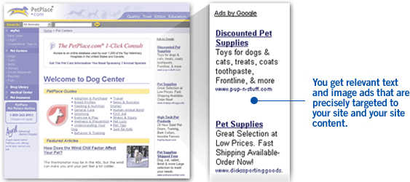

FIGURE 6: GoogleAdSense

## TABLE 2: Other Notable Products and Services by Google

|  |  |
| --- | --- |
| **Product/Service Name** | **Description** |
| Google Earth | Satellite Imagery of geographical locations |
| Google Maps | View driving maps and directions |
| Google Local | Search for local businesses and shops |
| Google News | Search for news stories |
| Google Video | Search for TV programs and video clips |
| Google Desktop Search | Search for offline information stored on computers |
| Google Image Search | Search for images online |
| Google Sketch Up | 3-D model design tool |
| Google Check out | Online payment processing service |
| Google Search Appliance | Enterprise search engine |
| G Mail | Web-based email client |
| G Talk | Internet instant messaging and VoIP |
| Orkut | Online social network community |
| Froogle | Electronic shopper product search |
| Others: Google Page Creator, Google Analytics , Picasa ,Blogger, Google Mobile, Google SMS, Google Finance, Google Groups, Google Scholar, Google Pack, Google Book Search, Google Code, Google Alerts, Google Calendar | |

**5.3.1.3.2**- **Microsoft Tools and services**

Microsoft Office 365 applications provide enterprise solutions that can be adapted for any organization. Popular Microsoft [Office 365](https://www.thinkebiz.net/technology/sharepoint/) applications include Word, Excel, PowerPoint, Outlook, OneNote, Access and Publisher.

Although, there are applications that are useful and often overlooked, such applications are: SharePoint, Exchange Server, Yammer, MyAnalytics, OneDrive, Skype for Business, Microsoft Teams and Power BI. Let’s take a look at some of the over 30 Microsfot Office 365 applications:

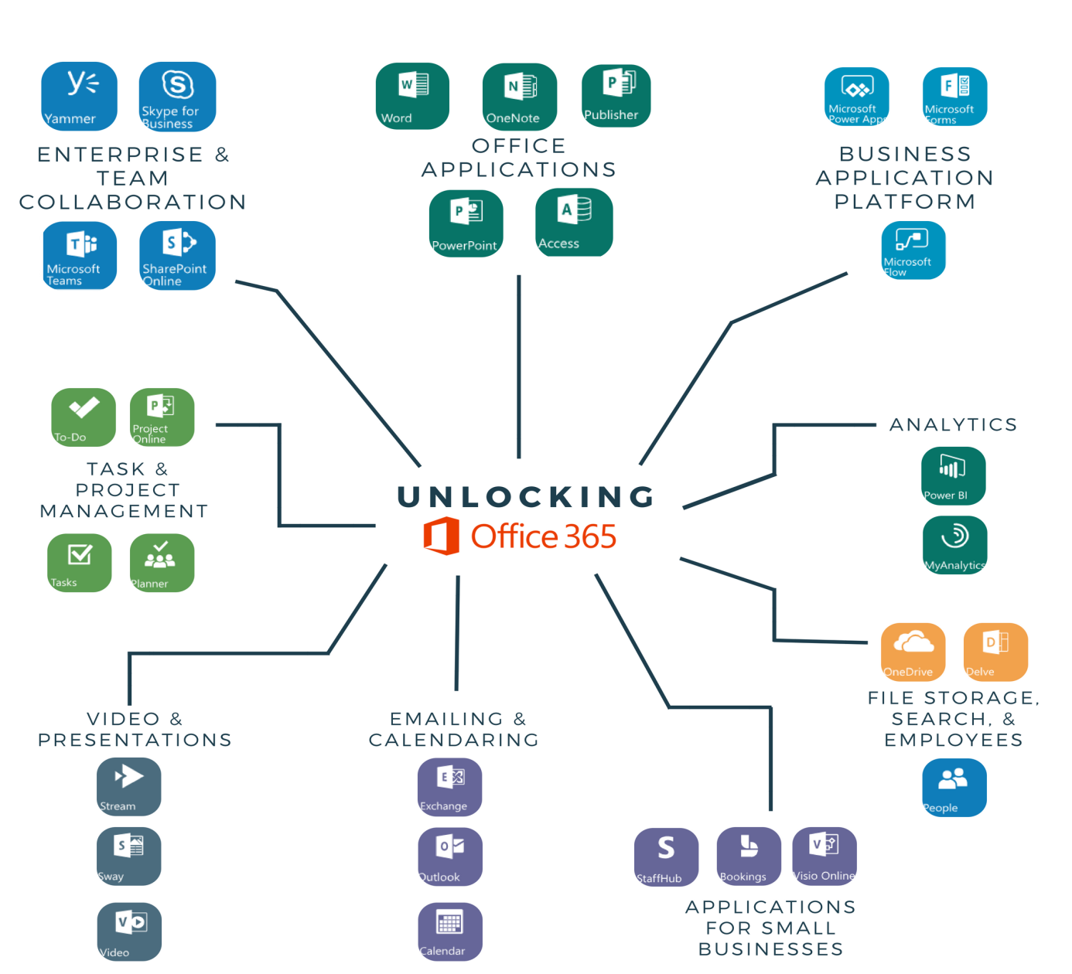

FIGURE 7: Microsoft Tools and products

**6- Avantages of TIC Technologies And Tools**

There are various advantages of TICtechnologies and Tools:

* Cost-efficient
* Provide the facility for easy student management
* Direct classroom teaching
* Improved modes of communication
* Eco-friendly-Eliminate the usage of paper
* Direct classroom teaching
* Minimize cost and saves time
* Improved data and information security
* Web-based LMS tools link teachers, students, researchers, and scholars and education together.
* Teachers are able to teach better with graphics, video and graphics.
* Teachers can create interesting, well-designed and engaging classroom activities.
* Provide better teaching and learning methods
* To spread awareness about the social impact of technological change in education.
* Promoting and improving the digital culture in universities, colleges, and schools.
* Automated solutions to paper-based manual procedures and processes.

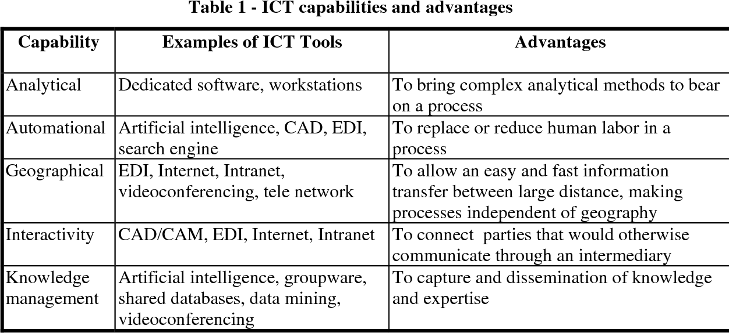

**7- Technological capacity**

The world's technological capacity to store information grew from 2.6 (optimally compressed) [exabytes](https://en.wikipedia.org/wiki/Exabytes) in 1986 to 15.8 in 1993, over 54.5 in 2000, and to 295 (optimally compressed) [exabytes](https://en.wikipedia.org/wiki/Exabytes) in 2007, and some 5 [zetta bytes](https://en.wikipedia.org/wiki/Zettabyte_Era) in 2014. This is the informational equivalent to 1.25 stacks of [CD-ROM](https://en.wikipedia.org/wiki/CD-ROM) from the [earth](https://en.wikipedia.org/wiki/Earth) to the [moon](https://en.wikipedia.org/wiki/Moon) in 2007, and the equivalent of 4,500 stacks of printed books from the [earth](https://en.wikipedia.org/wiki/Earth) to the [sun](https://en.wikipedia.org/wiki/Sun) in 2014. The world's technological capacity to receive information through one-way [broadcast](https://en.wikipedia.org/wiki/Broadcast) networks was 432 [exabytes](https://en.wikipedia.org/wiki/Exabytes) of (optimally compressed) information in 1986, 715 (optimally compressed) [exabytes](https://en.wikipedia.org/wiki/Exabytes) in 1993, 1.2 (optimally compressed) [zettabytes](https://en.wikipedia.org/wiki/Zettabytes) in 2000, and 1.9 [zettabytes](https://en.wikipedia.org/wiki/Zettabytes) in 2007. The world's effective capacity to exchange information through two-way [telecommunication](https://en.wikipedia.org/wiki/Telecommunication) networks was 281 [petabytes](https://en.wikipedia.org/wiki/Petabytes) of (optimally compressed) information in 1986, 471 [petabytes](https://en.wikipedia.org/wiki/Petabytes) in 1993, 2.2 (optimally compressed) [exabytes](https://en.wikipedia.org/wiki/Exabytes) in 2000, 65 (optimally compressed) [exabytes](https://en.wikipedia.org/wiki/Exabytes) in 2007  and some 100 [exabytes](https://en.wikipedia.org/wiki/Exabytes) in 2014. The world's technological capacity to compute information with humanly guided general-purpose computers grew from 3.0 × 10^8 MIPS in 1986, to 6.4 x 10^12 MIPS in 2007.

**8- Aims & Objective :**

Information and communication technology (TIC) has become, within a very short time, one of the basic building blocks of modern society. Many countries now regard understanding ICT and mastering the basic skills and concepts of ICT as part of the core of education, alongside reading, writing and numeracy.

UNESCO aims to ensure that all countries, both developed and developing, have access to the best educational facilities necessary to prepare young people to play full roles in modern society and to contribute to a knowledge nation. Because of the fundamental importance of TIC in the task of schools today, UNESCO has previously published books in this area as a practical means of helping Member States: for example, Informatics for Secondary Education: A Curriculum for Schools (1994) and Informatics for Primary Education (2000). Rapid developments in ICT now demand a completely new document in place of the first of these publications.

**9- Disadvantages of TIC**

* **Blackmail** – Using the internet to threaten to cause damage with the intent to extort from any person any money or other thing of value.
* **Unemployment**- Using the computer instead of human resources employers is save huge amount of money but employees are losing their jobs as not needed anymore.
* **Privacy** – Information technology may have made communication fast and more convenient, it has also brought along privacy problem. From cell phone signal interception to email hacking, about their once private information becoming public knowledge.
* **Computer virus**- worms, Trojan, malware, spam any or all can chaos and disrupt our daily lives.
* **Social media**- They became addicted to the phones, IPod, gaming consoles forgetting about outside activities and communication in the society.

Conclusion –: Information and communication Technology(ICT) tools and techniques

utilization has been spread widely in every work of human being and all kinds of

organizations. ICT has improved the library services than traditional one and now become

the demand of the users as well as organization to fulfill the necessary requirements on time.

With the use of ICT, library professionals role has been change totally. The provision and the

use of information and communication technology is a part and parcel of the entire system, to

the student, information and professional and the institution. Communication for technology

Conclusion –: Information and communication Technology(ICT) tools and techniques

utilization has been spread widely in every work of human being and all kinds of

organizations. ICT has improved the library services than traditional one and now become

the demand of the users as well as organization to fulfill the necessary requirements on time.

With the use of ICT, library professionals role has been change totally. The provision and the

use of information and communication technology is a part and parcel of the entire system, to

the student, information and professional and the institution. Communication for technology

Conclusion –: Information and communication Technology(ICT) tools and techniques

utilization has been spread widely in every work of human being and all kinds of

organizations. ICT has improved the library services than traditional one and now become

the demand of the users as well as organization to fulfill the necessary requirements on time.

With the use of ICT, library professionals role has been change totally. The provision and the

use of information and communication technology is a part and parcel of the entire system, to

the student, information and professional and the institution. Communication for technology

Conclusion –: Information and communication Technology(ICT) tools and techniques

utilization has been spread widely in every work of human being and all kinds of

organizations. ICT has improved the library services than traditional one and now become

the demand of the users as well as organization to fulfill the necessary requirements on time.

With the use of ICT, library professionals role has been change totally. The provision and the

use of information and communication technology is a part and parcel of the entire system, to

the student, information and professional and the institution. Communication for technology

**10- Conclusion:**

Information and communication Technology (TIC) tools and techniques utilization has been spread widely in every work of human being and all kinds of organizations.

TIC has improved the library services than traditional one and now become the demand of the users as well as organization to fulfill the necessary requirements on time.

With the use of TIC, library professional’s role has been change totally. The provision and the use of information and communication technology is a part and parcel of the entire system, to the student, information and professional and the institution. Communication for technology provides those who have communication challenge a way of expressing their wants and needs. People of all age and abilities can use and benefit from using communication technology.

The biggest challenges facing the library profession today is preparing the professionals to use technology effectively. It can be said that the library and information professional communities are being affected by a range of ICT development and so find their roles changing worldwide. Information Communication Technology helps people many ways.

Communication technology helps people easily communicate to other and makes life more convenient. Although communication brings a lot of benefits. So, people must responsible while using the communication technology properly.

Conclusion –: Information and communication Technology(ICT) tools and techniques

utilization has been spread widely in every work of human being and all kinds of

organizations. ICT has improved the library services than traditional one and now become

the demand of the users as well as organization to fulfill the nec