VibeBites: A Web Platform for Mood-Based Meal Suggestions

A Capstone Project
Presented to the Faculty of the
School of Computing
Holy Angel University



In Partial Fulfillment
of the Requirements for the Degree
Bachelor of Science in Information Technology with
Area of Specialization in Web Development

Nathaniel I. Calo
Benjamin C. Pineda
Kurt C. Sanchez
Joriel G. Sicat

October 2025

Table of Contents
Page
Cover Page……………………………………………………………………………………1
Table of Contents…………………………………………………………………………….2
Title Page……………………………………………………………………………………..3
Abstract………………………………………………………………………………………. 4

Introduction………………………………………………………………………………….. 5
Review of Related Literature
Conceptual Framework
Objectives of the Study
Scope and Delimitations

Method………………………………………………………………………………………15
Requirement Analysis
Requirement Documentation
Design of Software, System, Product and Process
Development and Testing
Sample and Setting
Instrument / Simulation Tool
Data Analysis
Ethical Consideration

References…………………………………………………………………………………...31

Appendices…………………………………………………………………………………..35

Appendix A Executive Summary
Appendix B Cover Letter
Appendix C Interview Guide
Appendix D Input-Process-Output (IPO) Model
Appendix E Sample Questionnaire
Appendix F Data Flow Diagram
Appendix G Use Case Diagram
Appendix H Entity Relationship Diagram
Appendix I Screenshots of Web Application

VibeBites: A Web Platform for Mood-Based Meal Suggestions

Nathaniel I. Calo, Benjamin C. Pineda, Kurt C. Sanchez, Joriel G. Sicat

Holy Angel University
Information Technology

Abstract
This study, titled VibeBites: A Web Platform for Mood-Based Meal Suggestions, explores the connection between emotions and food choices by developing a system that recommends meals based on users’ current moods. The research aimed to determine how mood-based technology can help individuals make mindful and healthier food decisions. The system was developed using modern web technologies and includes a mood detection feature that identifies users’ emotions and matches them with suitable meal recommendations. The methods used in the study involved system planning, design, and development to establish the foundation of the platform for future testing and evaluation.
Keywords: mood-based meals, emotional eating, web platform, food recommendation

VibeBites: Eat What You Feel

Introduction
In today’s fast-paced world, individuals often experience a wide range of emotions that directly affect their eating habits. Many people resort to comfort food when stressed, skip meals when anxious, or overeat when bored. These emotional responses to food can lead to unhealthy eating patterns and poor overall wellness. While awareness about the connection between mood and food is increasing, most people still lack accessible tools that can guide them toward healthier and more mindful food choices.
At present, digital platforms that promote wellness primarily focus on either food tracking (calorie counters and food journals) or general mood support (coping strategies and mood-enhancing content). For example, MyFitnessPal is one of the most widely used apps for diet management, but it emphasizes calorie tracking and nutrition logs rather than providing mood-based recommendations. Similarly, food journals such as Ate encourage users to log meals and reflect on emotions, but they do not actively recommend what to eat. Meanwhile, MoodMission provides mood-based coping activities but does not address dietary needs. This gap reveals a need for systems that not only monitor behavior but also provide actionable, personalized guidance.
To address this gap, the proposed system, VibeBites: A Web Platform for Mood-Based Meal Suggestions; integrates mood recognition with a simple recommendation algorithm that maps user moods to appropriate meal categories. Unlike existing applications, VibeBites transforms self-reported emotions into concrete, personalized suggestions that combine psychological insights with nutritional principles. This makes decision-making on what to eat easier, faster, and more aligned with the user’s emotional state.
Decision-making on what to eat is one of the most common daily struggles among Filipino young adults. Mood plays a crucial role in shaping food preferences, often leading to impulsive and less healthy choices such as fast food, sugary drinks, or highly processed snacks. To address this, the researchers developed VibeBites, which recommends meals based on a user’s current mood while considering nutritional value and Filipino culinary culture.
Insights from Registered Nutritionist-Dietitian Rosalita Maec. Palalon support this rationale. According to Palalon (2025), what we eat directly affects brain function and mood, and conversely, mood affects both the quality and quantity of food intake. This underlines the need for a system that not only suggests mood-appropriate meals but also encourages healthier choices. To strengthen the proposed system, expert input from both nutritionists and psychologists will be integrated to ensure the relevance of mood categories, while IT specialists will guide the technical design of the recommendation process.

Significance of the Study
This study is significant because it explores the relationship between emotions and eating behaviors through the integration of technology. By offering meal suggestions based on how users feel, the proposed system emphasizes the role of mood as an important factor in decision-making. Unlike existing applications that primarily track calories, provide coping strategies, or log meals, this system actively recommends personalized meal options aligned with a user’s emotional state.
For researchers, the study contributes insights into how user mood can be integrated as a data point for service recommendation systems. It adds to ongoing research on emotion-aware computing and food choice psychology by demonstrating a practical application that goes beyond passive tracking.
For users, the platform empowers healthier lifestyle habits by transforming moods into actionable food suggestions. This personalization makes the process of choosing meals easier, more enjoyable, and more supportive of emotional wellness.
For developers and future innovators, the study highlights the potential of AI-driven personalization in the field of health technology, setting a foundation for future systems that adapt not only to user preferences but also to their emotional and psychological states.

Review of Related Literature
Existing digital platforms partially address the relationship between mood and food but remain limited in scope. MyFitnessPal, for instance, provides detailed nutrition and calorie tracking but lacks features for emotional context. Similarly, YouAte enables users to log meals and reflect on their emotions, yet it does not provide real-time, mood-based suggestions. On the other hand, MoodMission helps users manage their emotions through evidence-based coping activities, but it is not designed to guide food-related decisions. These tools are either passive in nature or focus more on tracking behavior rather than guiding it.
The proposed system differentiates itself by combining psychological insights, self-reported mood, and actionable meal recommendations. Unlike traditional diet trackers, VibeBites transforms mood data into meal suggestions, creating a proactive platform that bridges the gap between emotional well-being and dietary guidance.
Emotional eating, the tendency to consume food in response to feelings rather than physical hunger, is a major factor affecting dietary behavior and overall health outcomes. Chawner (2024) proposed a developmental model explaining how emotional eating emerges across the lifespan, emphasizing interoceptive awareness and emotion regulation. This framework supports the inclusion of mood as a primary factor in decision-making systems. Braden (2023) further demonstrated that depression, anxiety, and boredom predict maladaptive eating behaviors, with depression showing the strongest link to binge eating. These findings highlight the need for tailored interventions based on specific emotional states.
Building on these psychological insights, Ha (2023) reviewed how emotional states influence both the brain’s reward systems, which drive hedonic (pleasure-based) eating, and its control systems, which regulate healthier choices. This dual-system perspective explains why some individuals gravitate toward unhealthy meals under stress. Integrating such knowledge into a recommendation algorithm, as VibeBites does, ensures that the platform does not only suggest meals but also supports balanced decision-making.
Taken together, these studies reveal two key insights: (1) emotions strongly shape food preferences, often leading to unhealthy behaviors, and (2) recommendation systems are evolving to balance health, preference, and context. VibeBites addresses both directions by focusing on mood-driven eating patterns and implementing a simplified, mood-to-meal mapping algorithm. This provides a foundation for a culturally relevant, accessible, and emotionally intelligent platform designed specifically for students and young adults.
Conceptual Framework
The conceptual framework of this study is guided by an Input–Process–Output (IPO) model, supported by expert consultation to ensure accuracy and relevance.
Input
- User Data: Age, gender, and optional dietary preferences or restrictions (e.g., vegan, allergies).
- Mood Selection: To ensure accurate mood detection, the system utilizes a short questionnaire.
Processing
- Mood-to-Meal Mapping: After identifying the user’s dominant mood, the system proceeds with the Mood-to-Meal Mapping process. This module matches each detected mood category with corresponding meal suggestions derived from psychological and nutritional studies on emotional eating and food choice behavior
- System Design Principles: User-centered design and responsive web standards ensure usability and accessibility. The design and logic will be reviewed by an IT expert to ensure technical robustness.
Output
- A list of meal suggestions aligned with the user’s selected mood, presented in a simple and visually appealing interface.
- Each suggestion includes the meal name, image (where available), and a short description (e.g., key ingredients, flavor profile, or nutritional highlights) to help users make quick, informed choices.
Expert Validation
To strengthen the reliability of the system:
- A psychologist validates the appropriateness of mood categories and their linkage to decision-making.
- A nutritionist/dietitian ensures that meal suggestions align with nutritional principles and do not promote harmful eating habits.
This framework ensures that VibeBites integrates insights from psychology, nutrition, and technology into a practical, user-friendly application.
Conceptual Framework
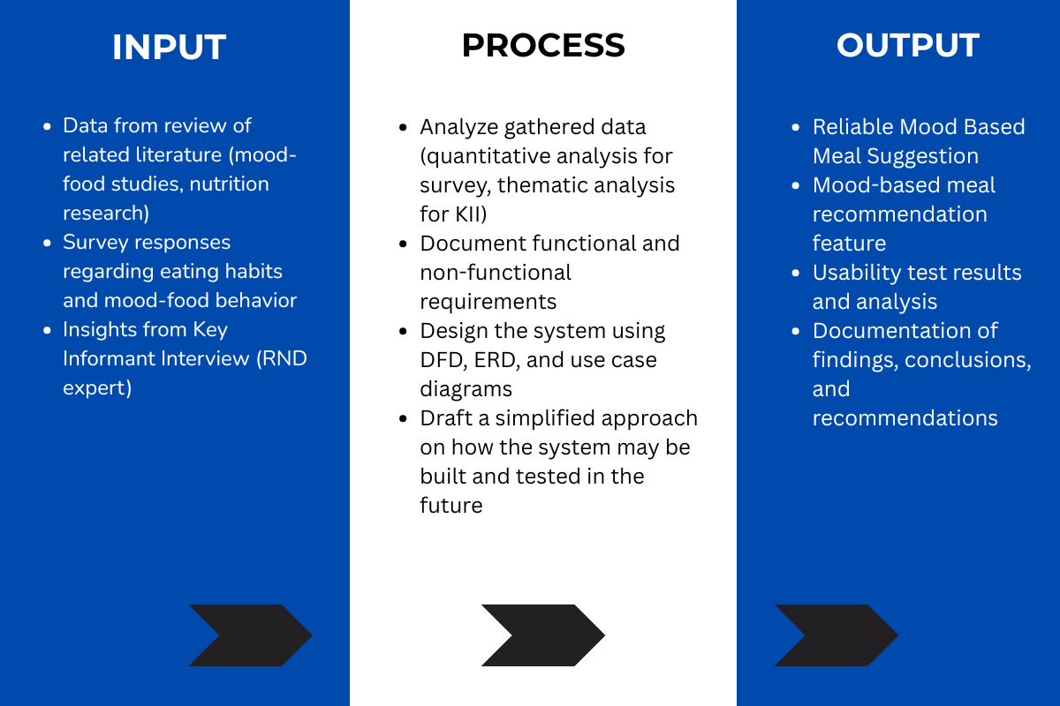
This research uses an Input–Process–Output (IPO) model:

Objectives of the Study
General Objective:
To design and develop a functional web application that provides mood-based meal recommendations based on self-reported user emotions.
Specific Objectives:
- To build a user-friendly mood selection interface.
- To develop mapping logic linking mood categories with meal types based on psychological and nutritional principles.
- To integrate and apply mood-based filtering, while considering user-specific preferences such as allergies and dietary choices (vegan, non-veg).
- To test usability and user satisfaction through actual user feedback.
- To document limitations and suggest future enhancements, such as expert-informed refinements.
Scope and Delimitations
Scope
The VibeBites platform focuses on young adults aged 18-25, who are highly active online and often experience irregular eating patterns due to academic or early career demands. This age group was chosen because they generally exhibit more stable emotions compared to teenagers, who experience hormonal changes, and adults above 26, whose food choices are often influenced by environmental and health-related factors.
The platform will
- Provide a user-friendly interface for selecting moods based on psychological studies by Macht(2016) and Evers et al. (2018) validated through consultation with a psychologist. The platform aims to offer personalized, mood-based meal suggestions that promote mindful eating and emotional well-being among young adults.
- Utilize mood-to-meal mapping logic to recommend meals aligned with emotional states, incorporating both psychological and nutritional principles.
- Conduct usability testing with the target demographic to evaluate the system’s performance, accessibility, and user satisfaction.

Delimitations
The system operates within the following boundaries:
- Mood inputs are restricted to the predefined categories and are based on self-reported emotions; no real-time emotion detection using sensors or artificial intelligence is implemented in this version.
- The platform will not include medical dietary recommendations, calorie counting, or meal-ordering functionalities.
- Meal suggestions are derived from existing datasets, which may not encompass all cuisines or regional dishes.
- The mood-to-meal mapping model has been validated through feedback from a dietitian, and psychologist. However, expert consultation is limited to the design and testing phases and not incorporated as a live system feature.
- The findings are primarily applicable to Filipino young adults (ages 18–25). While insights may be informative for other age groups, they are not directly generalizable to older populations or individuals with specific medical dietary restrictions.
- generalize to older populations or individuals with strict medical dietary restrictions.

Methods
This chapter presents the different steps that the researchers followed in conducting the study. It includes the requirement analysis, requirement documentation, system and software design, development and testing procedures, the implementation plan, and ethical considerations used throughout the research process.
Requirement Analysis
This study employed a Descriptive-Developmental Research Design. The descriptive component focused on collecting data on users’ eating habits, moods, and food preferences through surveys and key informant interviews. The developmental component was applied to design, develop, and evaluate the VibeBites web platform.
Data were collected through a Google Form survey distributed to Filipino young adults, targeting students and early professionals. The survey gathered information about mood-food choices, meal patterns, and dietary challenges.
In this phase, the proponents determined the information requirements needed to develop the VibeBites web application. The system is designed to provide mood-based meal suggestions for individuals, particularly students and young adults who often experience emotional influences on their eating habits.
- Who: The primary users are individuals who want an accessible and engaging tool that suggests meals according to their current mood. Secondary stakeholders include researchers and developers interested in emotion-aware computing and wellness applications.
- What: The activity addressed is the process of choosing meals when influenced by emotions such as stress, happiness, or sadness. Current systems like calorie trackers and food journals primarily log or monitor behavior but do not provide actionable, mood-based meal suggestions. VibeBites introduces a solution that transforms self-reported emotions into concrete food recommendations.
- Where: The system will be accessed via web browsers on desktop or laptop devices, ensuring that users can utilize the platform in both academic and personal environments.
- When: The platform can be used at any time when users need meal ideas, particularly during moments when mood affects food decision-making.
- How: At present, users rely on recipe websites, calorie-counting tools, or manual journaling. These systems focus on nutrition tracking or emotional reflection but lack mood-to-meal recommendations. The proposed system improves this process by incorporating mood-selection icons, applying mood-to-meal mapping logic, and displaying curated suggestions.
The proponents also recognized why existing methods remain popular—applications like MyFitnessPal succeed because they provide structured nutrition data and easy tracking. However, they lack integration between mood and meal selection. VibeBites addresses this limitation by combining emotional self-reporting with personalized meal guidance, providing a system that supports both emotional well-being and healthier food choices.
Requirements Documentation
In real-life applications, requirement documentation establishes the basis for agreement between clients and developers regarding what the software product is expected to do. In the context of this capstone project, the requirement documentation serves as the basis for the panel of examiners and the adviser(s) in determining whether the prototype developed by the researchers will be accepted unconditionally, accepted with conditions, or rejected.
This section enumerates the software features of the proposed VibeBites platform and presents how the system will function. Requirement documentation states what the system will do, but not how it will be implemented, since it is written for both developers and evaluators

Functional Requirements (FR):
FR-01 | - Design and display an interactive mood selection interface where users can choose their current mood from predefined categories (e.g., Happy, Sad, Stressed, Energetic, etc.). | High | - Present a mood selection screen with clear, labeled icons for each mood.  - Ensure mood options are easy to understand and clickable.  - Allow only one mood to be selected at a time before proceeding.  - Save the selected mood for use in generating personalized food suggestions.
 |  | High | - Generate personalized meal suggestions corresponding to selected mood.  - Ensure mapping rules are consistent with nutrition/mood guidelines.
  FR.02
  - The system shall provide mood-to-meal mapping that generates suggestions aligned with the user’s selected mood.
FR.03 | - The system shall retrieve and display personalized meal suggestions from a curated dataset or integrated recipe API based on the user’s selected mood and dietary preferences. | High | - Connect to a structured food dataset or recipe API that includes nutritional values and meal types.  - Filter meal suggestions based on the user’s selected mood and dietary preferences.  - Display top recommended meals that align with the detected mood and user inputs.  - Allow the system to update or refresh meal data when needed for variety and accuracy.
FR.04 | - The system shall display suggested meals in a user-friendly format, including name, description, and optional images. | High | - Present meal suggestions clearly with name, short description, and images where available.  - Maintain responsive and visually appealing displays.
 | - The system shall allow users to refresh or re-generate suggestions based on the same mood input. | Medium | - Provide a “refresh/re-generate” button.  - Display new suggestions without requiring mood re-entry.  - Avoid repeating the same meal options consecutively.
  FR.05
 | - The system shall include a simple and responsive web interface accessible via web browsers. | High | - Ensure layout adapts to various screen sizes (responsive design).  - Provide consistent functionality across Chrome, Firefox, and Edge.  - Prioritize ease of use and minimal navigation complexity.
  FR.06
FR.07 | - The system shall support basic usability testing features (survey/feedback collection). | Medium | - Provide a survey/feedback option accessible from the interface.  - Collect and store user feedback for analysis.  - Ensure anonymity and data privacy.

Non-Functional Requirements (NFR):
NFR.01 | - The platform must be accessible online via web browsers only. | High | - Ensure the system can be accessed on major desktop browsers.  - Provide stable online deployment (e.g., via hosting server).
 | - The interface must be simple, visually clear, and responsive. | High | - Present a clean and minimalistic design.  - Ensure layouts adapt smoothly to different screen resolutions.  - Maintain readability and intuitive placement of elements.
  NFR.02
 | - The system shall display meal suggestions within 5 to 10 seconds following the user’s mood selection. | High | - Consistently display meal suggestions within the 5–10 second range.  - Optimize API calls and dataset queries for performance.  - Implement a visual loading indicator (e.g., spinner or progress bar) during the data-fetching process to enhance user experience.
  NFR.03
 | - The design must prioritize usability and intuitive navigation. | High | - Minimize the number of steps for the mood-to-meal process.  - Provide clear buttons and navigation cues.  - Ensure interface supports first-time user experience effectively.
  NFR.04
 | - The system must handle basic input validation (ensuring mood is selected before results are displayed). | Medium | - Prevent empty submission (no mood selected).  - Display clear error/warning messages.  - Ensure smooth correction without system crash.
  NFR.05

Design of Software, Systems, Product and/or Processes
The design phase involved creating models such as Data Flow Diagrams (DFD), Entity-Relationship Diagrams (ERD), and Use Case Diagrams. These visual models served as the blueprint for building the VibeBites platform.
Entity Relationship (Data Model)
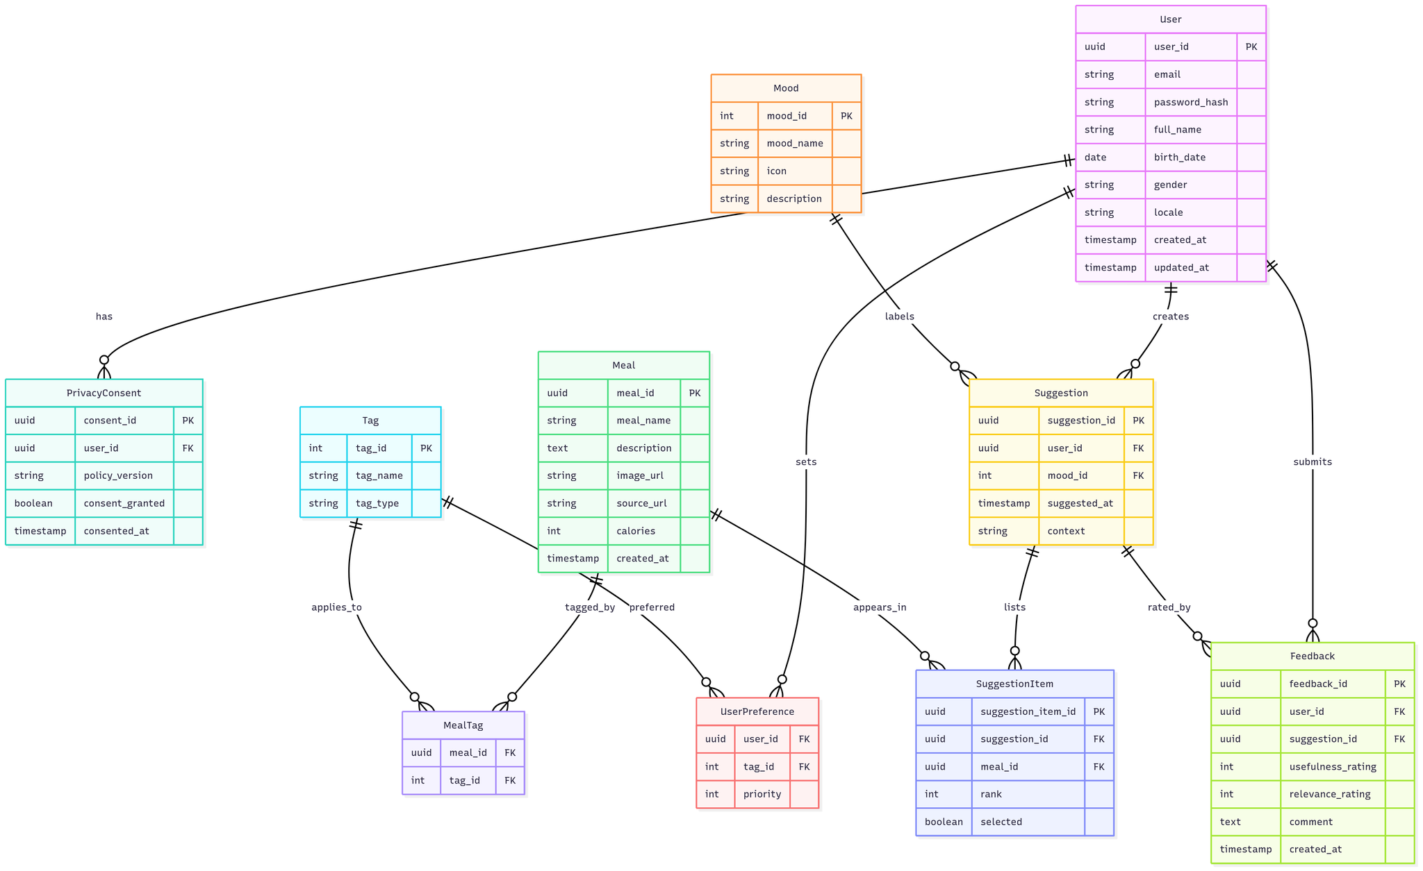
In time, the database has been intended to scale, manage data, and ensure system maintenance.

Figure 1.
Entity Relationship Diagram

Use Case Diagram
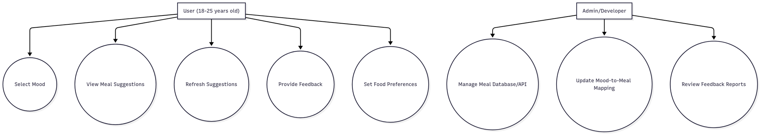
The gathered requirements paved the way in creating the use case diagram wherein the users would perform actions on the system. It comprises the determined listed requirements are shown respectively.

Figure 2.
Use Case Diagram for User and Admin
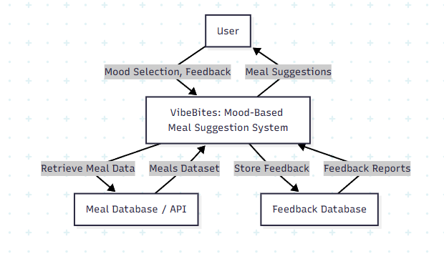
Data Flow Diagram

Figure 3.
Context Diagram
Development and Testing

For this study, the development of VibeBites is still at the planning stage. The researchers drafted a simplified approach on how the system may be built and tested in the future:

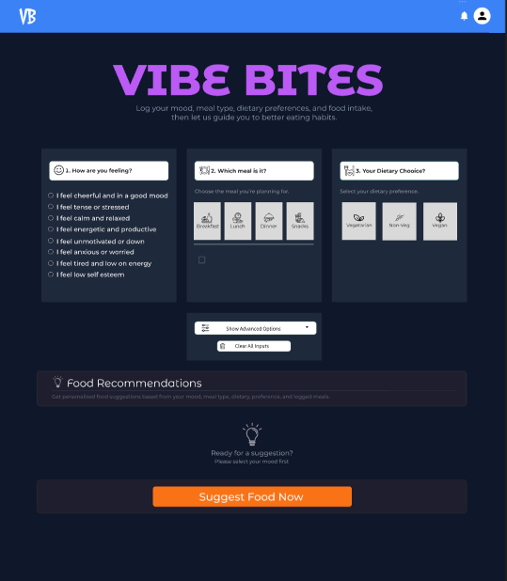

Sample and Setting
The respondents consisted of Filipino young adults, including students and early professionals. Purposive sampling was employed, as the platform was specifically designed for this demographic.
- Population: Individuals, primarily university students and young adults.
- Sample Size: 15-20 respondents, selected through purposive sampling. Aiming to gather preliminary insights on mood-food patterns while keeping the data collection manageable within the available time and resources.
- Setting: The survey was conducted and answered online using Google Forms. Respondents were able to access and complete the questionnaire remotely through their personal devices (desktop/laptop).
- Inclusion Criteria:
Basic web literacy (familiar with using online forms and web browsers)
Provided informed consent to participate in the study
- Exclusion Criteria:
Individuals with strict dietary restrictions that require medical supervision (to ensure ethical considerations, since the system only provides general meal suggestions)

Instrument / Simulation Tool
The primary data-gathering instrument for this study was a online questionnaire, created and distributed via Google Forms. The questionnaire was designed to gather insights about participants’ food decision-making habits, the influence of mood on eating behavior, and their expectations toward the proposed mood-based meal suggestion system.
- Google Form Survey – collected quantitative data on mood-food relationships, eating patterns, and dietary challenges.
- Key Informant Interview (KII) – conducted with Rosalita Maec. Palalon, RND, of Dietitian Rosa, via email and Messenger to validate findings and guide recommendations.
Questionnaire Structure
The instrument was guided by concepts from related studies on mood-food relationships to ensure relevance and validity. It was divided into four (4) parts, each with specific objectives:
- Part I. Awareness & Current Practices (6 items)
Identified existing challenges and strategies in choosing meals.
- Part II. Perceptions on Mood & Eating (5 items)
Assessed the relationship between mood and food choice.
- Part III. Perceived Usefulness of the Proposed System (6 items)
Evaluated expectations regarding system benefits.
- Part IV. Expectations / Features (8 items)
Gathered preferences for system functionalities and usability features.
Scale Used
The questionnaire items (except demographics) used a 5-point Likert scale:
- 1 – Strongly Disagree
- 2 – Disagree
- 3 – Neutral
- 4 – Agree
- 5 – Strongly Agree

Data Analysis
- Quantitative:
  - System Usability Scale (SUS) mean score will be computed and interpreted using standard acceptability benchmarks (average usability score ~68).
  - Descriptive statistics such as mean, standard deviation, frequency, and percentage will be computed for Likert-scale responses.
- Tools Used:
  - Microsoft Excel for data tabulation and descriptive statistics.
Ethical Consideration
The researchers adhered to ethical research standards ensuring integrity, fairness, and respect throughout the study. Research misconduct such as data fabrication, plagiarism, or violation of intellectual property rights was strictly avoided.
- Voluntary Participation: Respondents participated willingly and provided informed consent before answering.
- Privacy & Confidentiality: No sensitive or personally identifiable information was collected. Only general demographic data (e.g., age, gender) were recorded. Responses were stored securely and used solely for academic purposes.. The data will be retained until the completion of the study to allow for review or verification, after which all digital files will be permanently deleted.
- Non-Medical Disclaimer: The VibeBites system provides general meal suggestions based on mood inputs. It is not intended to replace professional medical or dietary advice. This disclaimer was made clear to participants to avoid misinterpretation.
- Right to Withdraw: Respondents were informed they could withdraw at any time without consequences.
- Institutional Approval: Appropriate permissions were secured from the research adviser and the institution prior to conducting the study. The system and procedures followed data privacy principles and institutional ethical guidelines.

References
Dabravolskaj, J., Lamb, M., Qian, W., & Ekwaru, J. P. (2024). Association between diet and
mental health outcomes in a sample of Canadian adults. Preventing Chronic Disease,
21. https://www.cdc.gov/pcd/issues/2024/24_0187.htm
Firth, J., Gangwisch, J. E., Borsini, A., Wootton, R. E., & Mayer, E. A. (2020). Food and
mood: How do diet and nutrition affect mental wellbeing? BMJ, 369, m2382.
https://doi.org/10.1136/bmj.m2382
Firth, J., Marx, W., Dash, S., Al-Khudairy, L., Carney, R., Teasdale, S. B., ... & Sarris, J.
(2019). The effects of dietary improvement on symptoms of depression and anxiety.
Psychosomatic Medicine, 81(3), 265–280.
https://www.ncbi.nlm.nih.gov/pmc/articles/PMC6455094/
Garg, N., Wansink, B., & Inman, J. J. (2007). The influence of incidental affect on
consumers’ food intake. Journal of Marketing, 71(1), 194–206.
https://doi.org/10.1509/jmkg.71.1.194
Ha, O. R., Telzer, E. H., & Shih, J. W. (2023). The role of emotion in eating behavior and
decisions. Frontiers in Psychology, 14.
https://doi.org/10.3389/fpsyg.2023.1134061
Klatzkin, R. R., Gaffney, S., Cyrus, K., Bigus, E., & Brownley, K. A. (2021). Self-reported
emotional eaters consume more food under stress only under certain conditions.
Appetite, 159, 105056.
https://www.ncbi.nlm.nih.gov/pmc/articles/PMC8717738/
Ljubičić, M., Kominiarczuk, A., & Lukić, I. (2023). Emotional eating behavior in a European
population: A cross-sectional study. Foods, 12(4), 872.
https://doi.org/10.3390/foods12040872
Logan, A. C., & Jacka, F. N. (2024). An overview of the potential role of nutrition in mental
health. Nutritional Psychiatry Review.
https://www.ncbi.nlm.nih.gov/pmc/articles/PMC11133159/
Macht, M. (2008). How emotions affect eating: A five-way model. Appetite, 50(1), 1–11.
https://doi.org/10.1016/j.appet.2007.07.002
McLean Hospital. (2025). Fueling the mind: The powerful link between nutrition and mental
health. McLean Hospital.
https://www.mcleanhospital.org/news/fueling-mind-powerful-link-between-nutrition-
and-mental-health
Ntoa, S. (2025). Usability and user experience evaluation in intelligent systems. International
Journal of Human–Computer Interaction, 41(2), 152–166.
https://doi.org/10.1080/10447318.2024.2394724
Suárez-López, L. M., Burgaleta, M., & Ortíz-Moncada, R. (2023). Influence of nutrition on
mental health: A scoping review. Healthcare, 11(15), 2183.
https://doi.org/10.3390/healthcare11152183
Xu, Y., Huang, Y., Li, M., & Wang, W. (2021). Role of dietary factors in the prevention and
treatment of depression: An umbrella review of meta‑analyses of prospective studies.
Translational Psychiatry, 11(1), 1–13.
https://www.nature.com/articles/s41398-021-01590-6
Evers, C., Stok, F. M., & de Ridder, D. T. D. (2018). Feeding your feelings: Emotion
regulation strategies and emotional eating. Personality and Social Psychology Bulletin, 36(6), 792–804.
https://doi.org/10.1177/0146167210371383
Macht, M. (2016). How emotions affect eating: A five-way model. Appetite, 86, 71–79.
https://doi.org/10.1016/j.appet.2014.09.001
MyFitnessPal. (2025). MyFitnessPal app.
https://www.myfitnesspal.com
Ate. (2025). Ate mindful eating app.
https://atemate.com
MoodMission. (2025). MoodMission: Evidence-based coping strategies for stress and low mood.
https://moodmission.com
Palalon, R. M. (2025). Personal interview via online consultation [Key Informant Interview].
Dietitian Rosa.
Chawner, L. S. (2024). A developmental model of emotional eating: Integrating
interoceptive, regulatory, and appetite control processes. Developmental Review, 72,
101133. https://www.sciencedirect.com/science/article/pii/S0273229724000170
Braden, A. L. (2023). Eating when depressed, anxious, bored, or happy: Emotional states and
their associations with disordered and binge eating. Appetite. Advance online
Publication.
https://www.sciencedirect.com/science/article/abs/pii/S0195666323000636
Zhang, Y., Wang, X., Liu, L., & Li, H. (2025). MOPI-HFRS: A multi-objective personalized
health-aware food recommendation system with explainability. In Proceedings of the
17th ACM Conference on Recommender Systems (pp. 103–114).
https://dl.acm.org/doi/abs/10.1145/3690624.3709382
Zhao, Y., Gkion, M., & Wilson, M. L. (2024). Context matters: Investigating the effect of
emotion, season, busyness, and activity on healthy recipe recommendations. In
Proceedings of the 2024 ACM SIGIR Conference on Human Information Interaction
and Retrieval (CHIIR) (pp. 45–57).
https://dl.acm.org/doi/abs/10.1145/3627508.3638328
Ha, O. R., Telzer, E. H., & Shih, J. W. (2023). The Effect of Simulated Contextual Factors on
Recipe Rating and Nutritional Intake Behaviour Frontiers in Psychology, 14, Article
1265074.
https://pubmed.ncbi.nlm.nih.gov/38130967/

Appendices
Appendix A
Executive Summary
This study, titled VibeBites: A Web Platform for Mood-Based Meal Suggestions, explores how emotions influence people’s eating habits and how technology can help users make mindful food choices. The main objective of the study is to design and develop a web-based platform that suggests meals based on the user’s current mood. By connecting emotions with food preferences, the system aims to encourage healthier eating behaviors and promote emotional awareness through personalized meal recommendations. The researchers used the Descriptive-Developmental Research Design to guide the system’s design and development process. The study involved collecting related information through literature reviews and a key informant interview with a registered dietitian to ensure that the system’s meal recommendations are appropriate and evidence-based. The proposed system follows a structured development methodology, starting from planning and analysis to design and prototyping. It was developed using modern web technologies suitable for interactive and responsive applications. VibeBites features a mood detection and meal matching process that connects a user’s emotional state to suitable meal suggestions. The platform is intended to help users become more aware of their emotional eating patterns and make food choices that align with how they feel.

Appendix B
Cover Letter
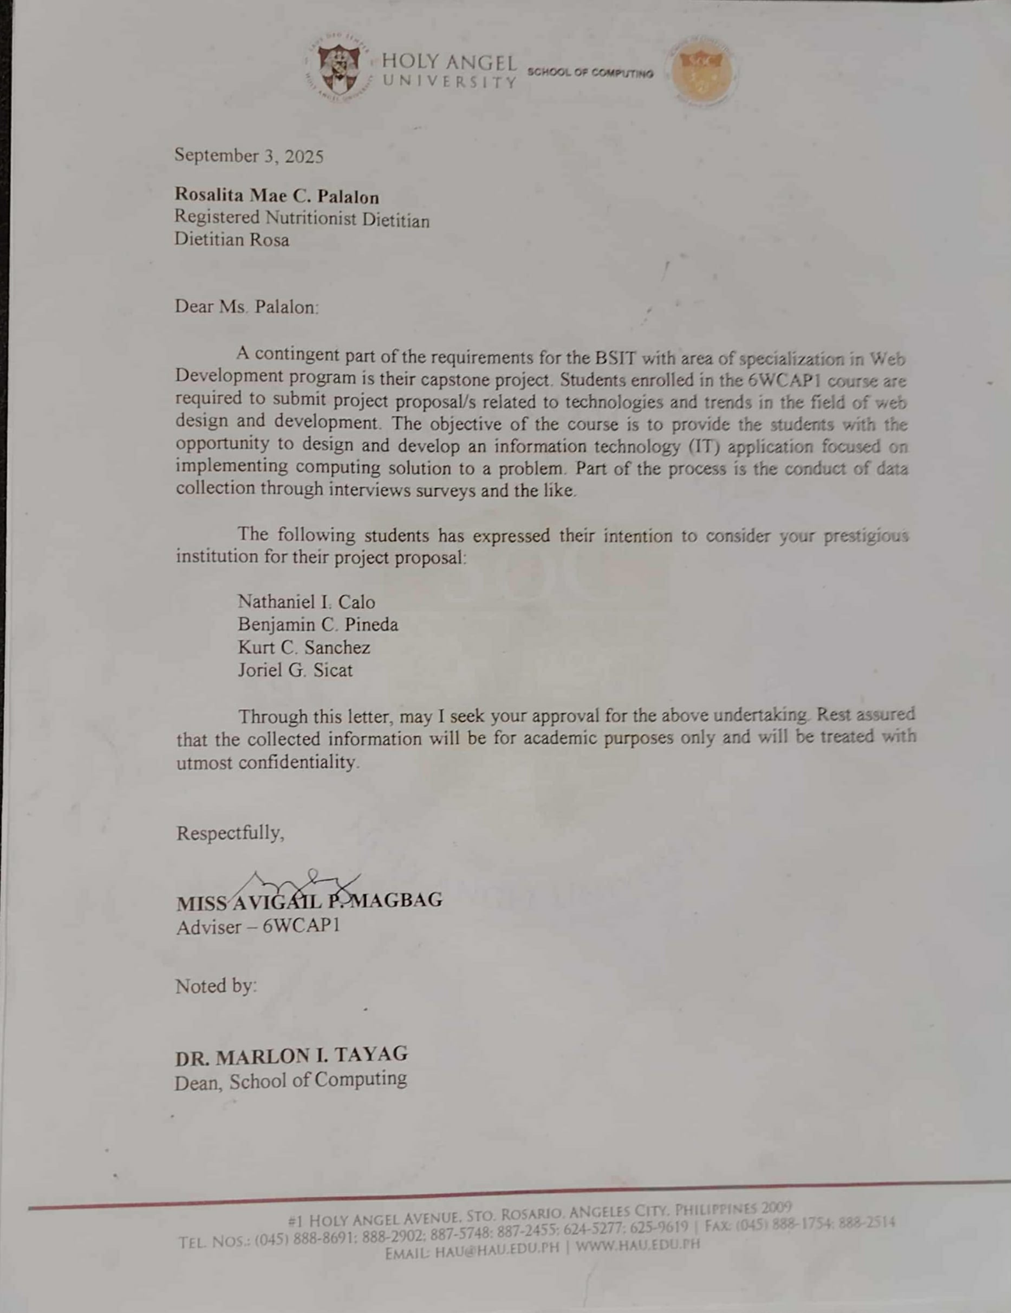

Appendix C
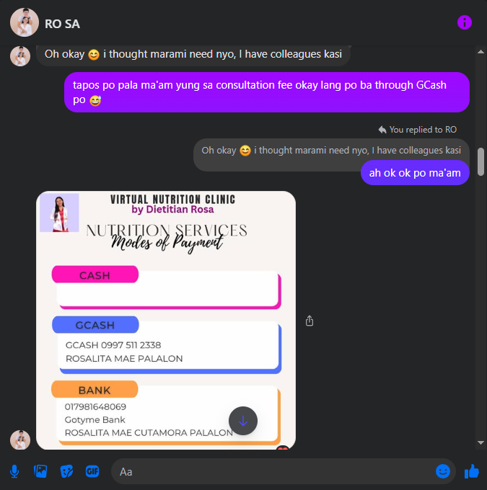
Interview Guide
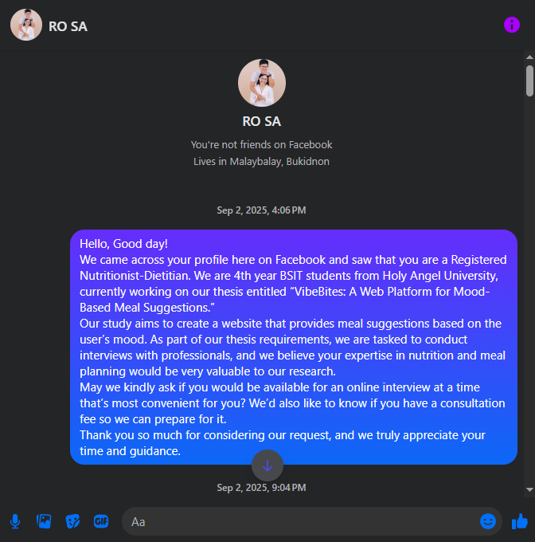
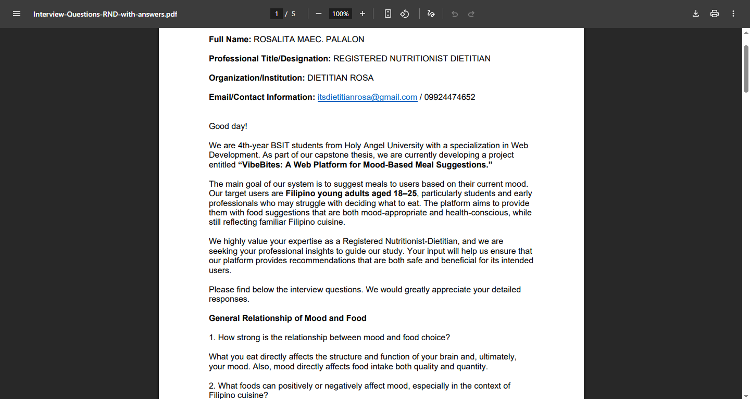

Appendix D
Input–Process–Output (IPO) model

Appendix E
Sample Questionnaire
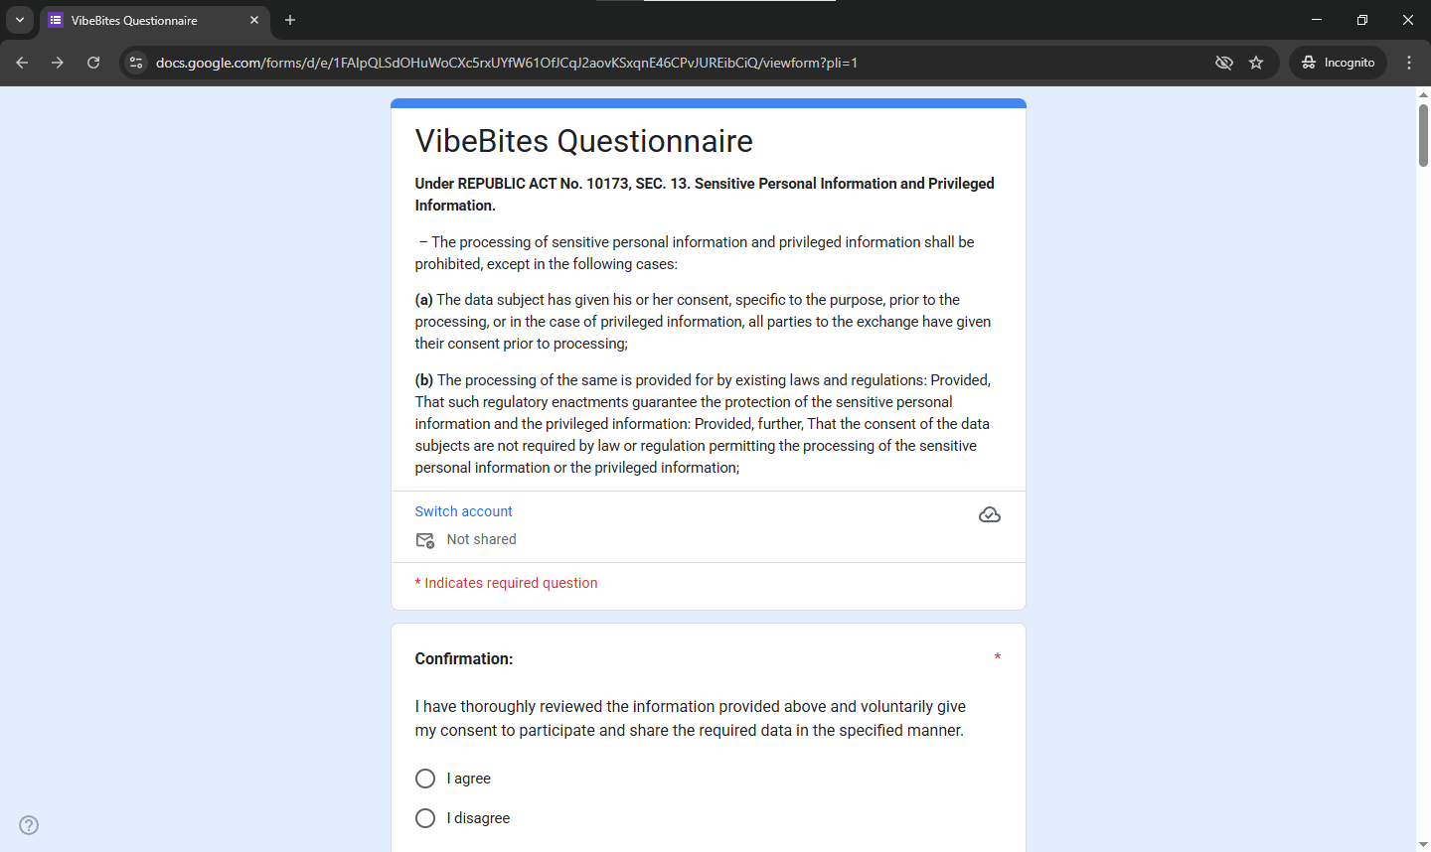
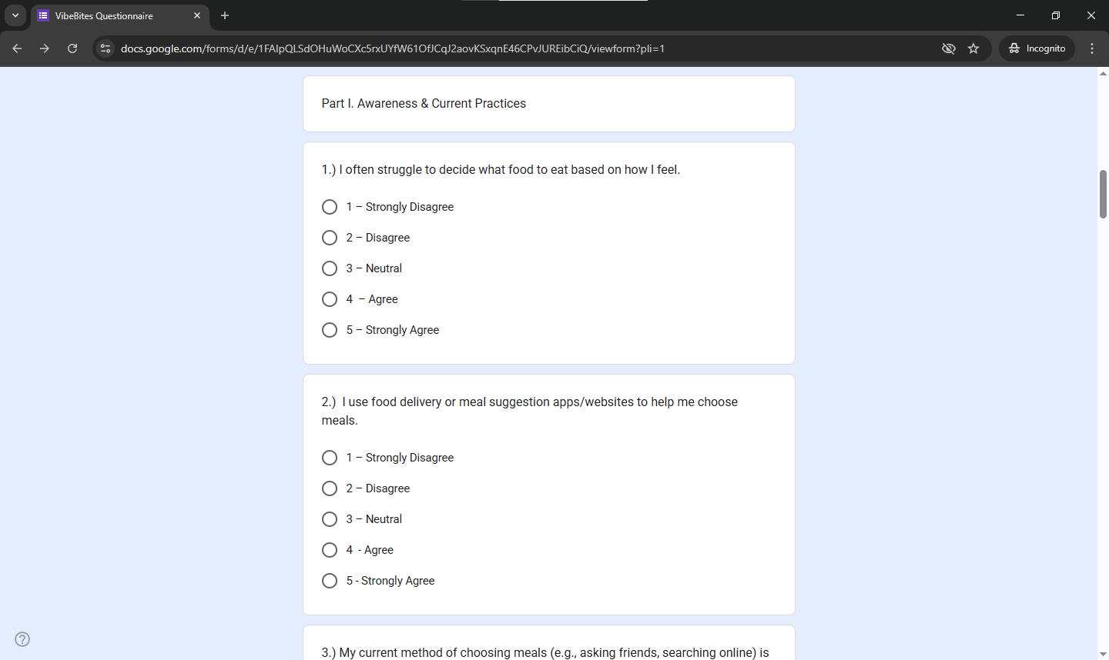

Appendix F
Data Flow Diagram

Appendix G
Use Case Diagram

Appendix H
Entity Relationship Diagram

Appendix I
Screenshots of Web Application

