Spring-Compensated Floating O-Ring Retainer for Vibration-Resilient Carousel Seal
Date: 2026-07-20
Reference: Self-compensating rotary dynamic seal device, method and device assembly method
TRIZ: Parameter Compensation (Principle #15)
Cross-domain application: Each carousel cup O-ring is mounted in a floating annular retainer backed by a wave spring that applies continuous axial preload (5–20 N) toward the cup sealing surface.
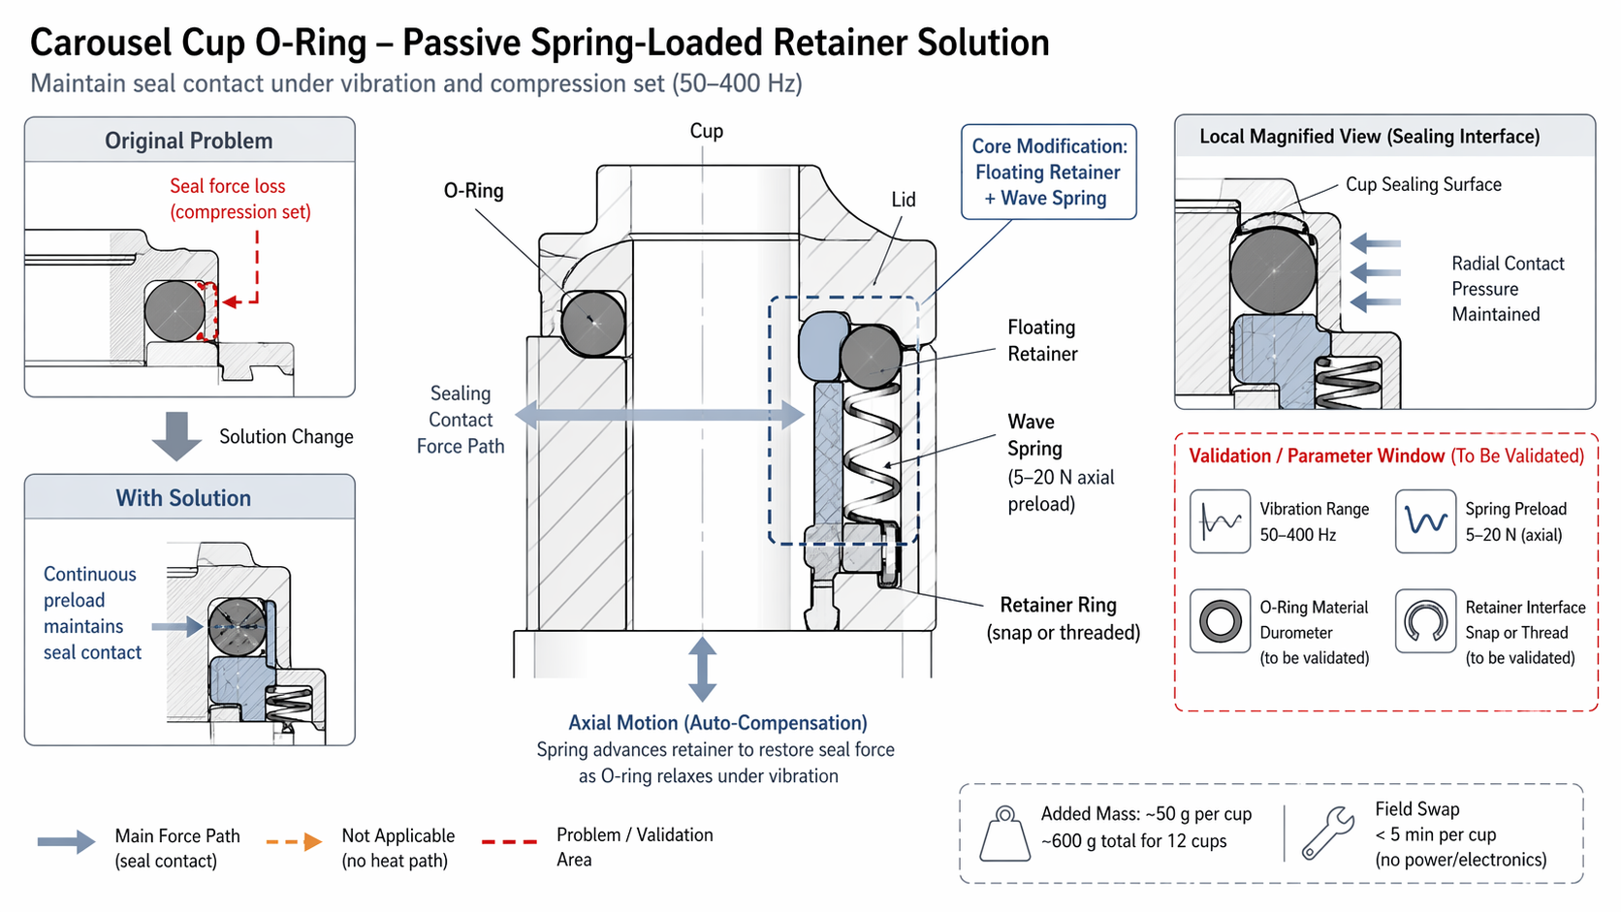

Original Problem
Seal force loss (compression set): Under 50–400 Hz vibration, the O-ring undergoes viscoelastic compression set, reducing radial contact pressure and compromising sub-micron aerosol seal integrity.

Core Modification
Floating Retainer + Wave Spring: As the O-ring relaxes under vibration, the spring automatically advances the retainer to restore radial contact pressure.

Axial Motion (Auto-Compensation)
Spring advances retainer to restore seal force as O-ring relaxes under vibration.

Local Magnified View — Sealing Interface
Component | Function
Cup Sealing Surface | Target sealing interface
O-Ring | Primary seal element
Floating Retainer | Holds O-ring, moves axially under spring force
Wave Spring | 5–20 N axial preload, auto-compensates for compression set
Retainer Ring (snap or threaded) | Secures retainer assembly, enables <5 min field swap

Validation / Parameter Window (To Be Validated)
Parameter | Target / Status
Vibration Range | 50–400 Hz
Spring Preload | 5–20 N (axial)
O-Ring Material Durometer | To be validated
Retainer Interface (snap or thread) | To be validated

System Impact
- Added mass: ~50 g per cup (~600 g total for 12 cups)
- No power or electronics required — fully passive
- Field swap: <5 min per cup
- Integrates into existing cup-lid interface
- Maintains sub-micron aerosol seal integrity under continuous vibration

Note: All parameters to be validated.

