Resonant Backscatter Phase-Array RFID for Vibration-Tolerant Carousel Cup Positioning
Date: 2026-07-20
Reference: Low-frequency RFID tag positioning system based on resonance backscattering
TRIZ: Dynamization (Principle #15)
Analysis Method: Functional modeling

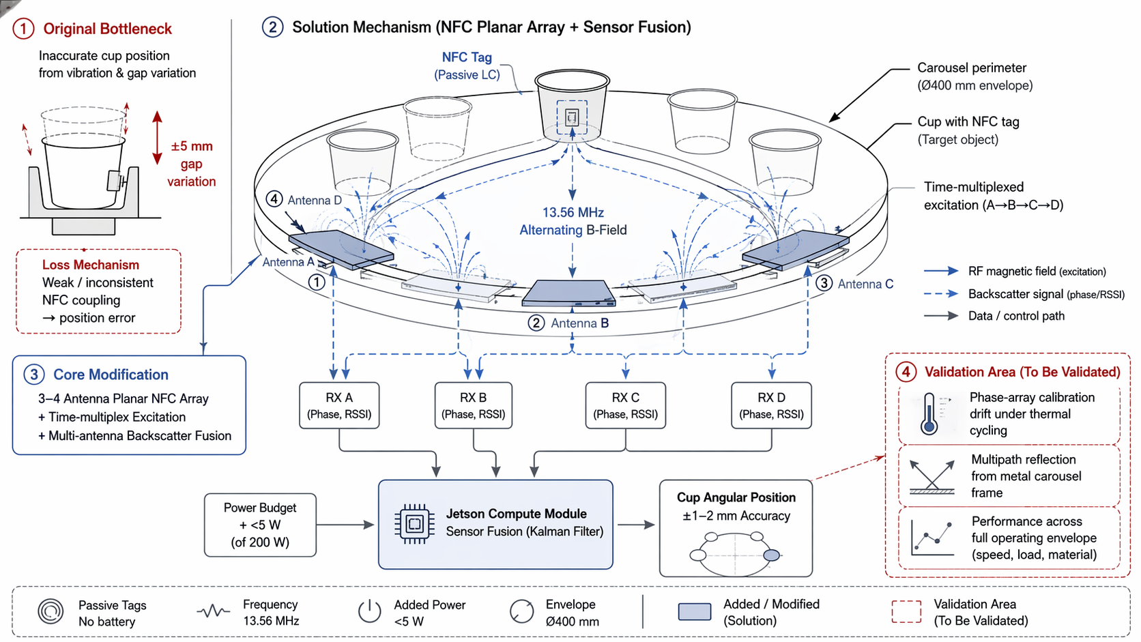
Cross-domain application: A 3–4 antenna planar NFC array mounted around the carousel perimeter drives time-multiplexed alternating magnetic fields at 13.56 MHz, exciting the passive LC resonant circuit in each cup's NFC tag.

Original Bottleneck
Inaccurate cup position from vibration & gap variation: ±5 mm vibration-induced tag-to-reader gap variation causes weak/inconsistent NFC coupling → position error.

Core Modification
- 3–4 Antenna Planar NFC Array
- Time-multiplexed excitation (A→B→C→D)
- Multi-antenna backscatter fusion

Solution Mechanism (NFC Planar Array + Sensor Fusion)
Component | Function | Details
NFC Tag (Passive LC) | Target object | Mounted on each cup, no battery
Antenna A/B/C/D | Excitation & reception | Planar array around carousel perimeter (Ø400 mm envelope)
RX A/B/C/D | Backscatter acquisition | Phase + RSSI from each antenna
Jetson Compute Module | Sensor fusion | Kalman filter fuses multi-antenna data
Cup Angular Position | Output | ±1–2 mm accuracy

System Specifications
- Frequency: 13.56 MHz
- Added power: <5 W (of 200 W budget)
- Envelope: Ø400 mm module
- Passive tags — no battery required

Validation Area (To Be Validated)
Validation Item | Description
Phase-array calibration drift | Under thermal cycling
Multipath reflection | From metal carousel frame
Performance across full operating envelope | Speed, load, material variations

Note: Largest unknown is phase-array calibration drift under thermal cycling and multipath reflection from the metal carousel frame.

