Dual-Layer Piston-Ring and Elastomer Seal for Vibration and Shock-Resilient Carousel Isolation
Date: 2026-07-20
Reference: A novel double-layer dustproof and leak-proof sealed turntable bearing
TRIZ: Segmentation (Principle #1)
Analysis Method: Substance-field analysis

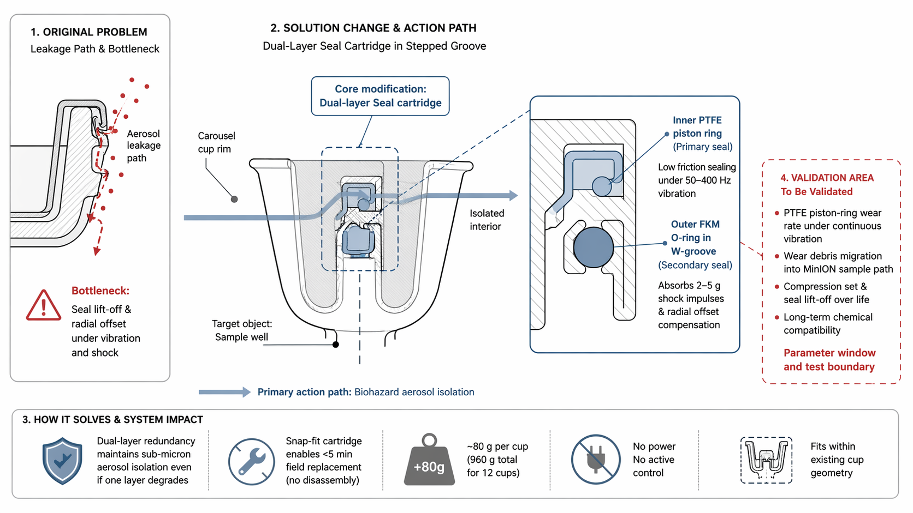
Cross-domain application: Each carousel cup rim is machined with a stepped groove housing a dual-layer seal: an inner PTFE piston ring provides low-friction primary sealing under 50–400 Hz steady-state vibration, while an outer fluoroelastomer O-ring in a W-shaped expansion groove absorbs 2–5 g percussion shock impulses and compensates for radial offset.

Original Problem
Leakage path & bottleneck: Seal lift-off and radial offset under vibration and shock create aerosol leakage paths, compromising biohazard isolation.

Core Modification
Dual-layer seal cartridge in stepped groove: No disassembly required for field replacement.

Seal Layer Detail
Layer | Material / Geometry | Function
Inner (Primary) | PTFE piston ring | Low-friction sealing under 50–400 Hz vibration
Outer (Secondary) | FKM O-ring in W-groove | Absorbs 2–5 g shock impulses, compensates radial offset

How It Solves & System Impact
- Dual-layer redundancy maintains sub-micron aerosol isolation even if one layer degrades
- Snap-fit cartridge enables <5 min field replacement (no disassembly)
- Added mass: ~80 g per cup (960 g total for 12 cups)
- No power, no active control — fully passive
- Fits within existing cup geometry

Validation Area (To Be Validated)
Validation Item | Concern
PTFE piston-ring wear rate | Under continuous vibration
Wear debris migration | Into MinION sample path
Compression set & seal lift-off | Over operational life
Long-term chemical compatibility | With sample materials and cleaning agents

Note: Parameter window and test boundary to be established.

