Variable-Pitch Helical Insert for Dual-Regime Pneumatic Sample Transport
Date: 2026-07-20
Reference: Inclined screw pump for conveying viscous corrosive medium
TRIZ: Space separation (based on Principle #1 Segmentation and Principle #35 Parameter Change)

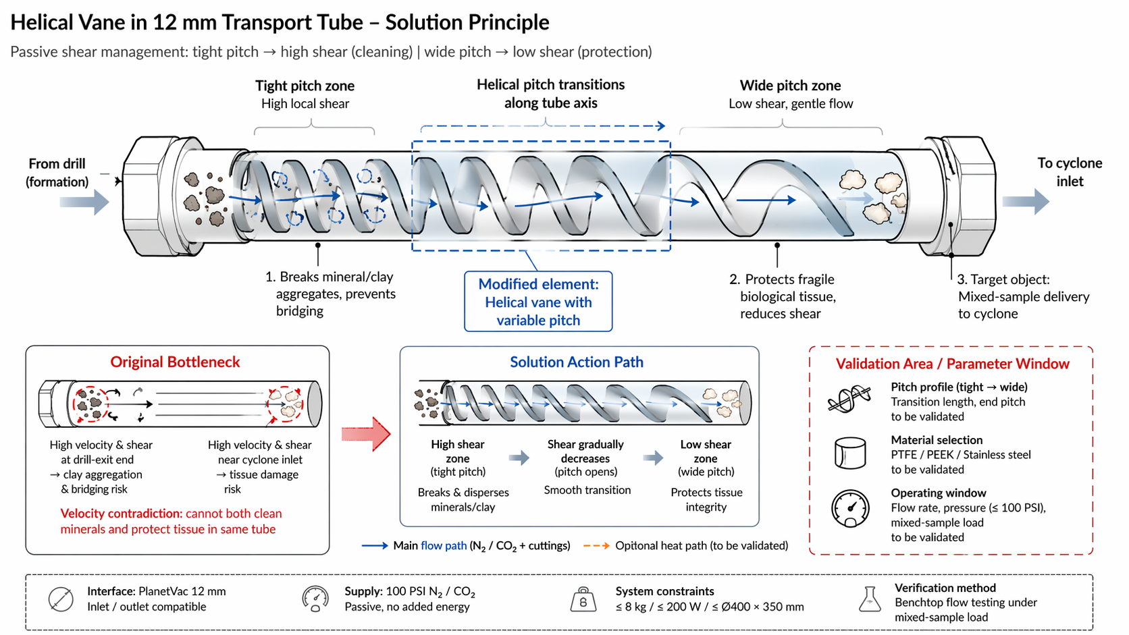
Analysis Method: Physical contradictions
Cross-domain application: Install a polymer or metal helical vane inside the 12 mm transport tube, with pitch transitioning from tight (high local shear, high drag) at the drill-exit end to wide (low shear, gentle flow) near the cyclone inlet.

Original Bottleneck
Velocity contradiction: Cannot both clean minerals (high velocity/shear) and protect tissue (low velocity/shear) in the same tube. High velocity at drill-exit end causes clay aggregation & bridging; high velocity near cyclone inlet causes tissue damage.

Modified Element
Helical vane with variable pitch: Spatial separation along tube axis resolves the velocity contradiction without reconfiguration, active control, or added energy.

Helical Pitch Zones
Zone | Pitch | Function
Tight-pitch zone (drill-exit end) | High local shear | Breaks mineral/clay aggregates, prevents bridging
Transition zone | Pitch gradually opens | Smooth shear decrease
Wide-pitch zone (cyclone inlet) | Low shear, gentle flow | Protects fragile biological tissue, reduces shear damage

System Constraints
- Interface: PlanetVac 12 mm inlet/outlet compatible
- Supply: 100 PSI N₂/CO₂, passive (no added energy)
- System constraints: ≤8 kg / ≤200 W / ≤Ø400 × 350 mm
- Verification: Benchtop flow testing under mixed-sample load

Validation Area / Parameter Window
Parameter | Validation Need
Pitch profile (tight → wide) | Transition length, end pitch
Material selection | PTFE / PEEK / Stainless steel
Operating window | Flow rate, pressure (≤100 PSI), mixed-sample load

Note: Pitch profile and material require benchtop flow testing to confirm blockage clearance and tissue-integrity preservation under mixed-sample load.

