Jetson-Controlled Adaptive Pulsed Pneumatic Flow for Sample-Type Separation
Date: 2026-07-20
Reference: Bidirectional welding wire distribution device
TRIZ: Principle #15 Dynamics and Principle #35 Parameter Change
Analysis Method: Technical contradictions
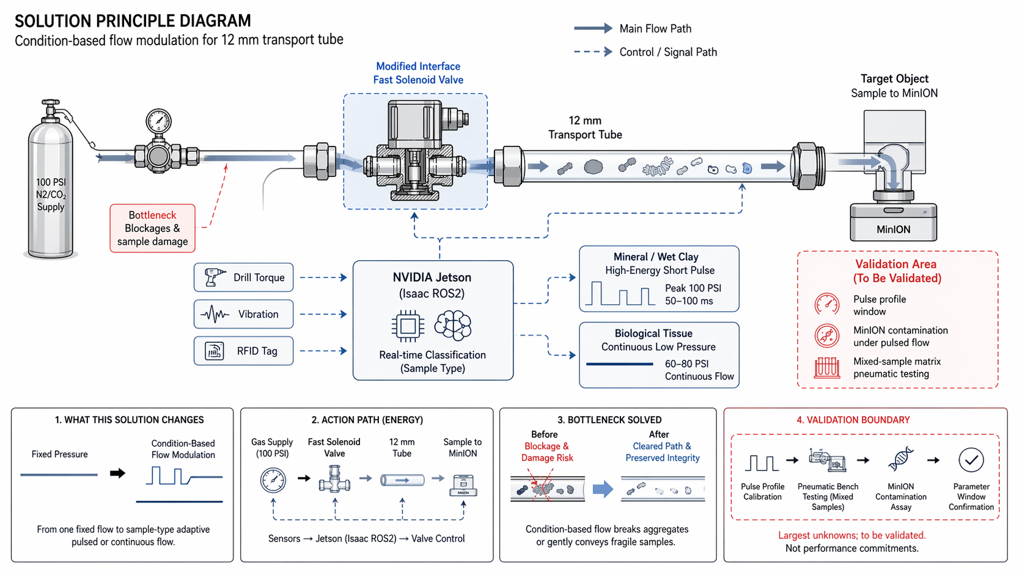
Cross-domain application: Integrate a fast solenoid valve upstream of the 12 mm transport tube, controlled by the NVIDIA Jetson module via Isaac ROS2. Jetson classifies sample type in real time and modulates flow profile accordingly.

Bottleneck
Blockages & sample damage: Fixed-pressure flow cannot simultaneously break mineral aggregates (needs high energy) and protect fragile tissue (needs low energy).

What This Solution Changes
From one fixed flow to sample-type adaptive pulsed or continuous flow.

Real-Time Classification Inputs
- Drill Torque
- Vibration
- RFID Tag

Flow Modulation Profiles
Sample Type | Flow Profile | Parameters
Mineral / Wet Clay | High-energy short pulse | Peak 100 PSI, 50–100 ms
Biological Tissue | Continuous low pressure | 60–80 PSI, continuous flow

Action Path (Energy)
Gas Supply (100 PSI) → Fast Solenoid Valve → 12 mm Transport Tube → Sample to MinION
Control loop: Sensors → Jetson (Isaac ROS2) → Valve Control

Bottleneck Solved
Before: Blockage & damage risk with fixed flow.
After: Cleared path & preserved integrity. Condition-based flow breaks aggregates or gently conveys fragile samples.

System Impact
- Uses existing 100 PSI N₂/CO₂ supply and Jetson compute
- Solenoid valve adds <0.5 kg and <10 W
- No mechanical reconfiguration or dual transport paths needed
- Condition-based flow modulation resolves velocity-integrity contradiction

Validation Area (To Be Validated)
Validation Item | Description
Pulse profile calibration | Tune to sample types and flow conditions
MinION contamination validation | Under pulsed flow — ensure no cross-contamination
Mixed-sample matrix pneumatic testing | Benchtop validation with representative samples
DNA-integrity assay | Confirm biological sample preservation under all flow regimes

Note: Largest unknowns: pulse-profile calibration and MinION contamination validation under pulsed flow. Not performance commitments.

