Inline Expansion Chamber for Pulse Damping and Shear Reduction
Date: 2026-07-20
Reference: Noise reduction and desorption system and vehicle
TRIZ: Space separation (based on Principle #1 Segmentation and Principle #35 Parameter Change)
Analysis Method: Physical contradictions
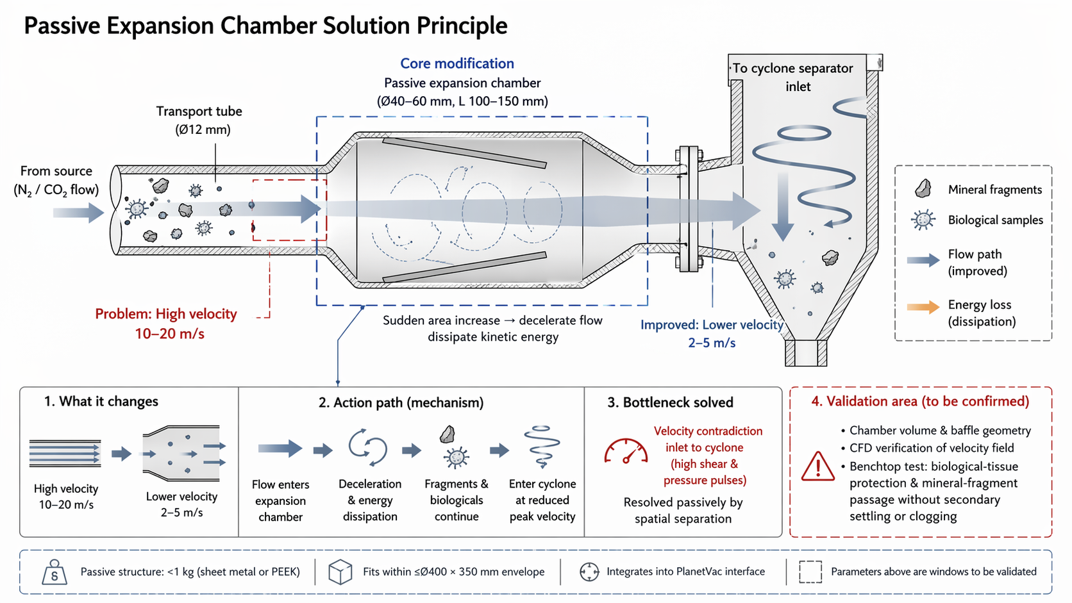
Cross-domain application: Install a passive expansion chamber (40–60 mm diameter, 100–150 mm length) between the 12 mm transport tube exit and the cyclone separator inlet.

Original Problem
High velocity (10–20 m/s): Excessive kinetic energy and shear stress damage fragile biological samples while failing to adequately break mineral aggregates.

Core Modification
Passive expansion chamber (Ø40–60 mm, L 100–150 mm): Sudden cross-section increase decelerates flow from 10–20 m/s to 2–5 m/s, dissipating kinetic energy and smoothing pressure pulses.

Action Path (Mechanism)
- Flow enters expansion chamber — sudden area increase
- Deceleration & energy dissipation via turbulent mixing
- Mineral fragments & biologicals continue at reduced velocity
- Enter cyclone at reduced peak velocity (2–5 m/s)

Bottleneck Solved
Velocity contradiction (inlet to cyclone): High shear & pressure pulses vs. gentle tissue handling. Resolved passively by spatial separation along the flow path.

System Impact
- Passive structure: <1 kg (sheet metal or PEEK)
- Fits within ≤Ø400 × 350 mm envelope
- Integrates into PlanetVac interface
- No active control or added power required
- Uses existing N₂/CO₂ kinetic energy

Validation Area (To Be Confirmed)
Parameter | Validation Need
Chamber volume & baffle geometry | Optimize for flow deceleration and energy dissipation
CFD verification | Velocity field confirmation across operating range
Benchtop test | Biological-tissue protection & mineral-fragment passage without secondary settling or clogging

Note: Parameters above are windows to be validated.

