Vision-Based Real-Time Pose Calibration for Multi-Interface Robotic Sample Delivery
Date: 2026-07-20
Reference: A calibration system, method, device and medium for a robotic arm end effector
TRIZ: Principle #26 (Copying), Principle #24 (Intermediary)
Analysis Method: Functional modeling
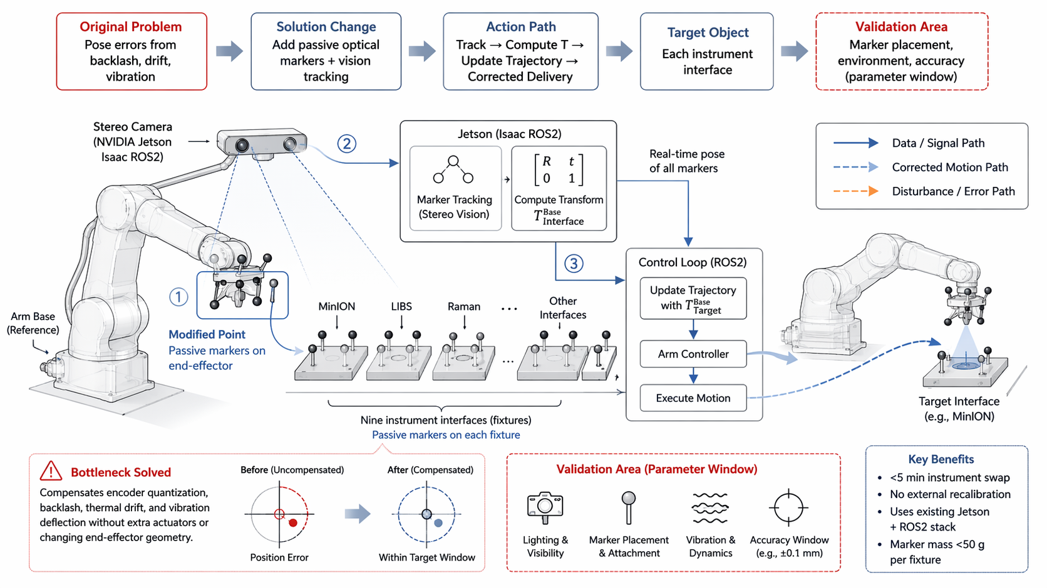
Cross-domain application: Mount passive optical markers on the delivery arm end-effector and on fixture plates at each of nine instrument interfaces; NVIDIA Jetson Isaac ROS2 stereo camera continuously tracks marker poses and computes transformation matrices.

Original Problem
Pose errors from backlash, drift, vibration: Encoder quantization, backlash, thermal drift, and vibration deflection cause accumulated positioning error without extra actuators or changing end-effector geometry.

Solution Change
Add passive optical markers + vision tracking: Before each sample delivery, the control loop updates arm trajectory with corrected coordinates.

Action Path
- Stereo camera tracks marker poses (Jetson Isaac ROS2)
- Compute transform T_Base^Interface
- Update trajectory with corrected target coordinates
- Arm controller executes corrected motion
- Achieve ±0.1 mm MinION precision

System Architecture
Component | Function | Details
Stereo Camera (Jetson Isaac ROS2) | Vision sensing | Tracks passive markers in real time
Passive markers (end-effector) | Reference frame | Modified point on end-effector
Passive markers (9 fixtures) | Target frames | MinION, LIBS, Raman, etc.
Jetson (Isaac ROS2) | Sensor fusion & compute | Marker tracking + transform computation
Control Loop (ROS2) | Trajectory correction | Update trajectory with T_Base^Target
Arm Controller | Motion execution | Executes corrected motion to target interface

Key Benefits
- <5 min instrument swap
- No external recalibration required
- Uses existing Jetson + ROS2 stack
- Marker mass <50 g per fixture
- Calibration persists across field swaps when fixtures reinstalled with markers

Validation Area (Parameter Window)
Parameter | Validation Need
Lighting & Visibility | Marker detection under varying illumination
Marker Placement & Attachment | Repeatable mounting for consistent pose accuracy
Vibration & Dynamics | Tracking stability under 50–400 Hz vibration
Accuracy Window | ±0.1 mm for MinION precision

Note: Marker placement, environment, and accuracy parameter window to be validated.

