Passive Compliant End-Effector Mount with Contact-Force Self-Centering for Multi-Interface Alignment
Date: 2026-07-20
Reference: A purge mechanism for wafer loader
TRIZ: Introduce flexible mechanical field (spring-damper compliance) to absorb positioning error and enable self-centering
Analysis Method: Substance-field analysis

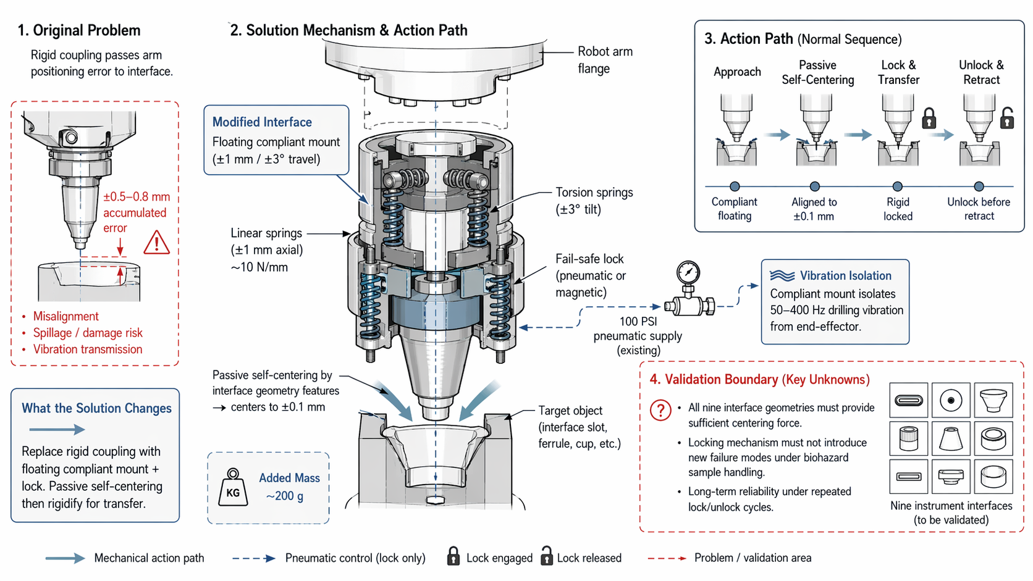
Cross-domain application: Replace the rigid arm-to-end-effector coupling with a floating compliant mount that passively self-centers via contact force from interface geometry features.

Original Problem
Rigid coupling passes arm positioning error to interface: ±0.5–0.8 mm accumulated error causes misalignment, spillage/damage risk, and vibration transmission.

Core Modification
Floating compliant mount (±1 mm / ±3° travel): Linear springs (~10 N/mm) and torsion springs (±3° tilt) allow passive self-centering.

Mechanism Detail
Component | Specification | Function
Linear springs | ±1 mm axial travel, ~10 N/mm stiffness | Axial compliance and preload
Torsion springs | ±3° angular tilt | Angular compliance for tilted approach
Fail-safe lock | Pneumatic or magnetic | Rigidifies mount after alignment for transfer
Metal sleeve | Hard stop | Limits max displacement under 15 Nm torque reaction

Action Path (Normal Sequence)
- Approach — Compliant floating
- Passive Self-Centering — Aligned to ±0.1 mm via interface geometry (USB-C slot chamfer, Raman ferrule taper, etc.)
- Lock & Transfer — Fail-safe lock engages, mount rigidifies
- Unlock & Retract — Lock releases before retraction

System Impact
- Added mass: ~200 g
- No active control or power draw (lock uses existing 100 PSI pneumatic supply)
- Compliant mount isolates 50–400 Hz drilling vibration from end-effector
- Self-centering to ±0.1 mm from ±0.5–0.8 mm arm error

Validation Boundary (Key Unknowns)
Validation Item | Description
All nine interface geometries | Must provide sufficient centering force
Locking mechanism | Must not introduce new failure modes under biohazard sample handling
Long-term reliability | Under repeated lock/unlock cycles

Note: Largest validation gap is ensuring all nine interface geometries provide sufficient centering force.

