Modular Kinematic Adapter Plates for Universal End-Effector Multi-Interface Sample Delivery
Date: 2026-07-20
Reference: Repeated positioning precision testing fixture of high-precision connecting device
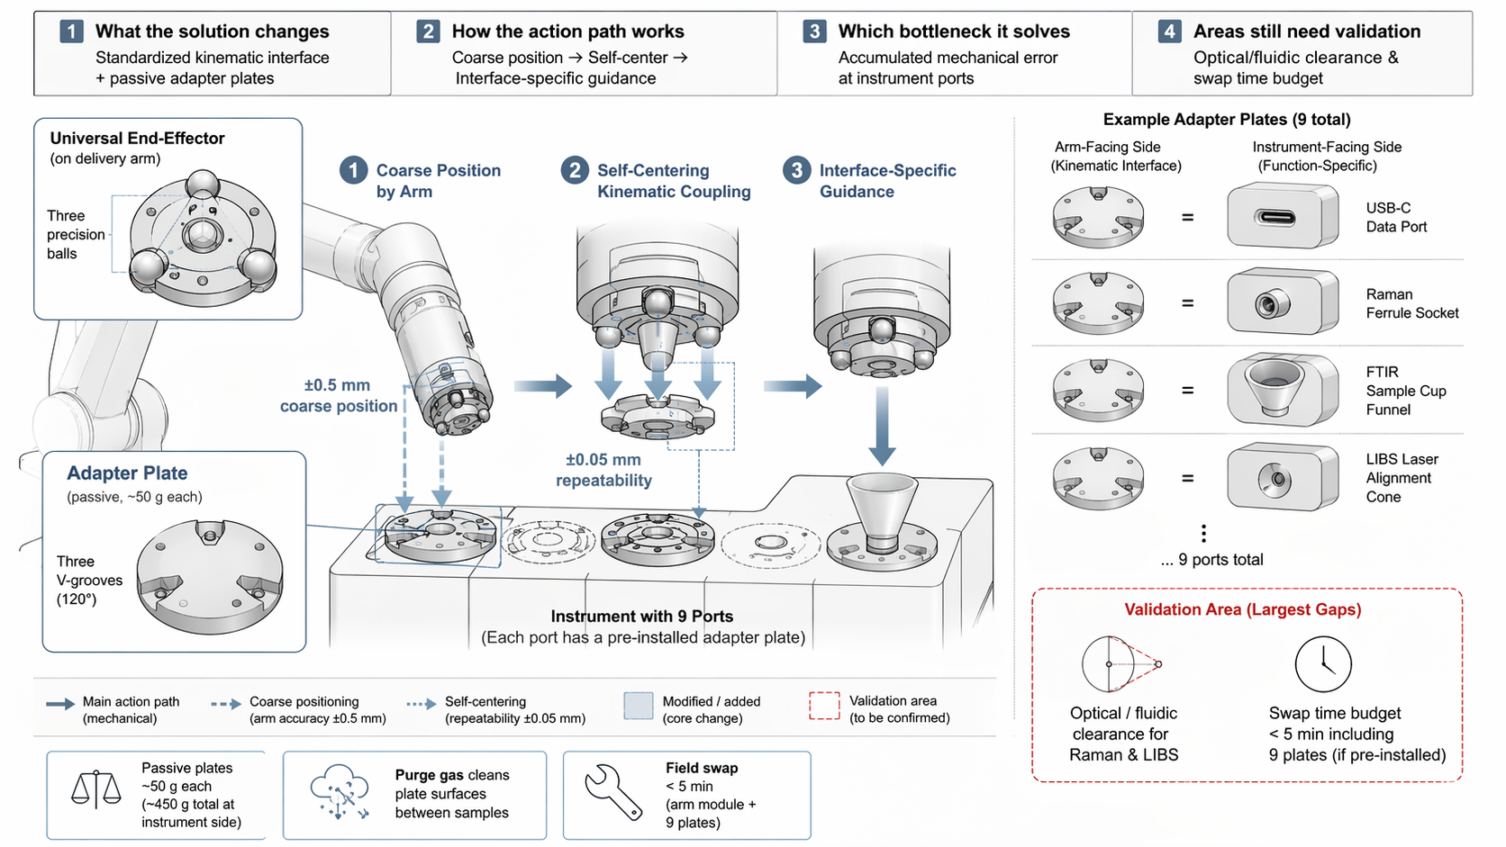
TRIZ: System level separation (based on Principle #1 Segmentation and Principle #6 Universality)
Analysis Method: Physical contradictions
Cross-domain application: Design a universal end-effector with kinematic coupling interface (three precision balls) and passive adapter plates at each of nine instrument ports.

What the Solution Changes
Standardized kinematic interface + passive adapter plates: Coarse position → Self-center → Interface-specific guidance.

System Architecture
Component | Specification | Function
Universal End-Effector | Three precision balls | Coarse position by arm (±0.5 mm)
Adapter Plate (arm-facing) | Three V-grooves (120°) | Kinematic coupling self-center to ±0.05 mm
Adapter Plate (instrument-facing) | Interface-specific geometry | USB-C, Raman ferrule, FTIR funnel, LIBS cone, etc.
Instrument with 9 Ports | Pre-installed adapter plates | Each port has dedicated adapter

Example Adapter Plates (9 Total)
- USB-C Data Port
- Raman Ferrule Socket
- FTIR Sample Cup Funnel
- LIBS Laser Alignment Cone
- ... 5 additional instrument-specific plates

System Impact
- Passive plates: ~50 g each (~450 g total at instrument side, not on arm mass budget)
- Purge gas cleans plate surfaces between samples
- Field swap: <5 min (arm module + 9 plates if pre-installed)
- No active control or power required

Validation Area (Largest Gaps)
Validation Item | Description
Optical / fluidic clearance | For Raman & LIBS adapter plates
Swap time budget | <5 min including 9 plates (if pre-installed)

Note: Largest validation gap is optical/fluidic clearance for Raman and LIBS adapter plates and whether swap time budget accommodates plate installation.

