Electromagnetic Clutch Torque-Path Decoupling for Sub-50ms Biological-Mineral Drill Mode Switching
Date: 2026-07-20
Reference: Novel intelligent electric actuating mechanism
TRIZ: Dynamic parts (Principle #15)
Analysis Method: Technical contradictions
Cross-domain application: Insert a compact electromagnetic clutch between the BLDC motor shaft and the planetary gearbox input, controlled by the Jetson via a dedicated PWM driver.
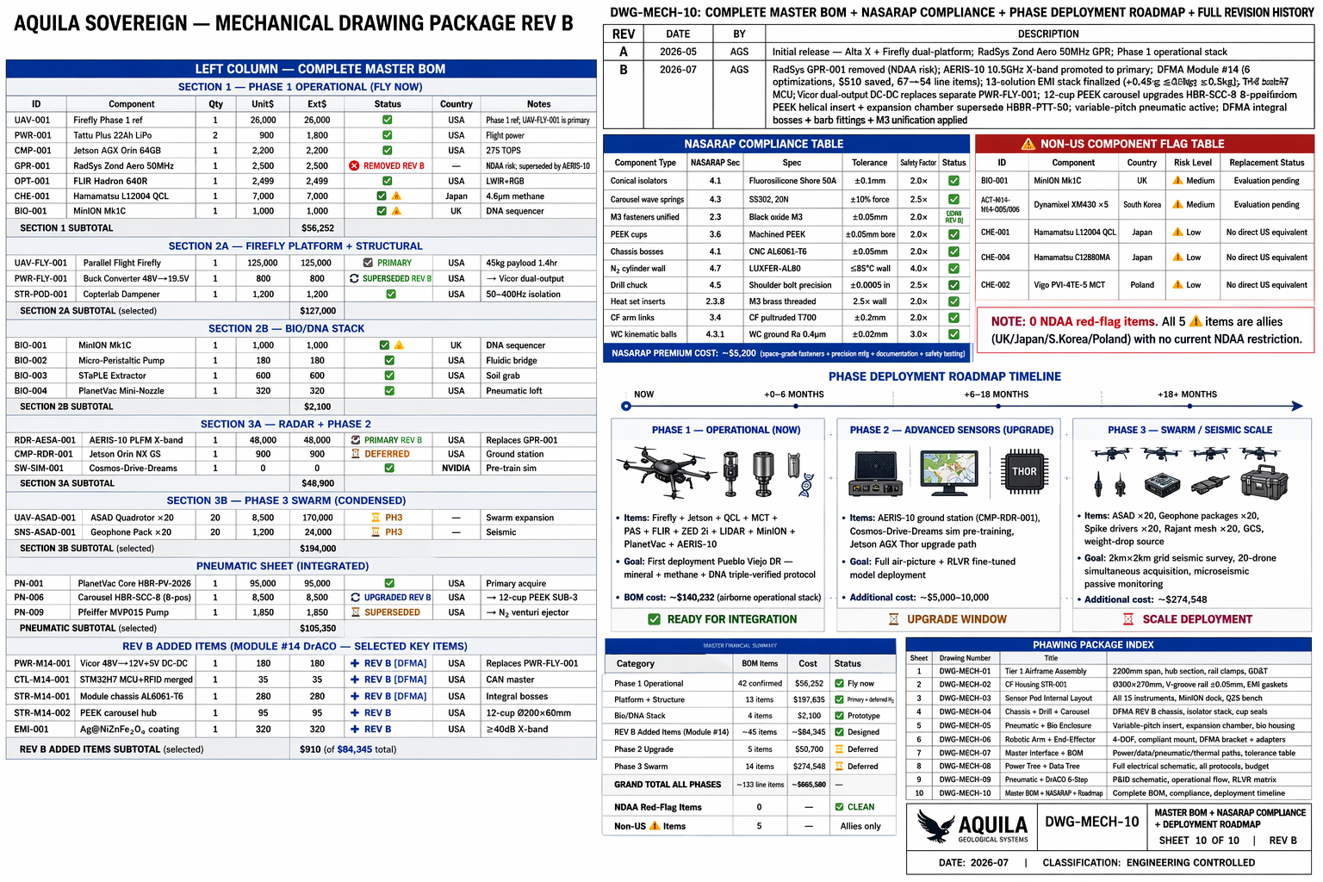

Original Bottleneck
Single BLDC drill cannot optimize for both tissue and mineral: Biological mode needs low inertia & fast response; mineral mode needs high torque percussion. Shock transmitted to seal/MiniON zone.

Core Modification
Electromagnetic clutch: In biological mode, clutch disengages — motor delivers 0.1–0.5 Nm directly with <30 ms response. In mineral mode, clutch engages — transmits full 15 Nm percussion torque.

System Specifications
Mode | Clutch State | Performance
Biological tissue | Disengaged | 0.1–0.5 Nm, <30 ms response, no gearbox inertia
Mineral | Engaged | 15 Nm percussion torque through gearbox
Disengaged state | Isolation | Prevents 2–5g percussion shocks from reaching carousel seal/MiniON

System Impact
- Added mass: ~150 g
- Power consumption: ~15 W holding power
- Fits within 8 kg module mass and 200 W power budget
- Electromagnetic engagement faster than mechanical gear shifting
- Decoupled state provides natural shock isolation barrier

Validation Area (To Be Validated)
Validation Item | Description
Continuous-duty thermal rise | At 40°C ambient
Vibration-rated electrical connector | Qualification for 50–400 Hz gas-hybrid environment

Note: Both are standard industrial engineering tasks with mature supply chains.

