Dual-Motor Segmented Torque Architecture with Sample-Type Adaptive Distribution for 0.1–15 Nm Range
Date: 2026-07-20
Reference: A torque distribution method for a novel dual-motor structure in an energy electric vehicle

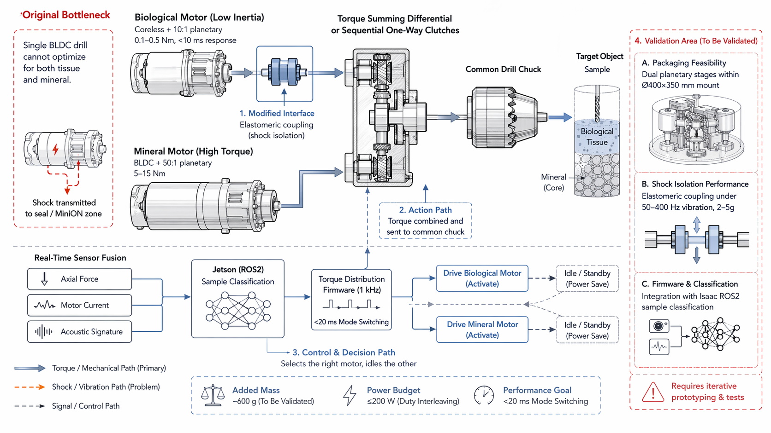
TRIZ: Segmentation (Principle #1)
Analysis Method: Technical contradictions
Cross-domain application: Replace the single BLDC drill with two independent motors driving a common drill chuck via torque-summing differential or sequential one-way clutches.

Original Bottleneck
Single BLDC drill cannot optimize for both tissue and mineral: Low-inertia fast response vs. high-torque percussion are mutually exclusive in a single motor.

Core Modification
Dual-motor segmented torque architecture:

Motor Configuration
Motor | Type | Torque / Response | Function
Biological Motor | Coreless + 10:1 planetary | 0.1–0.5 Nm, <10 ms response | Low-inertia tissue sampling
Mineral Motor | BLDC + 50:1 planetary | 5–15 Nm | High-torque percussion drilling
Elastomeric coupling | Shock isolation | Isolates 2–5g shocks | Prevents shock transmission to seal/MiniON

Control & Decision Path
- Real-time sensor fusion: Axial force + Motor current + Acoustic signature
- Jetson (ROS2) sample classification
- Torque distribution firmware (1 kHz) — <20 ms mode switching
- Selects the right motor, idles the other (power save)

System Impact
- Total added mass: ~600 g (two small planetaries and couplings)
- Power stays within 200 W by duty-cycle interleaving (only one motor active per sample)
- Target object: Sample (biological tissue or mineral core)
- Performance goal: <20 ms mode switching

Validation Area (To Be Validated)
Validation Item | Description
Packaging feasibility | Dual planetary stages within Ø400×350 mm drill mount
Shock isolation performance | Elastomeric coupling under 50–400 Hz vibration, 2–5g
Firmware & classification | Integration with Isaac ROS2 sample classification

Note: Requires iterative prototyping & tests. All are standard mechatronic engineering tasks.

