Hollow Conical Rubber Isolator for Percussion Shock Attenuation Between Drill and Frame
Date: 2026-07-20
Reference: Vehicle-mounted vibration isolation optical platform
TRIZ: Mechanical field evolution to damping field
Analysis Method: Substance-field analysis
Cross-domain application: Replace the rigid bolted interface between the BLDC drill motor housing and the DrACO frame with four hollow conical rubber isolators, one at each mounting corner.
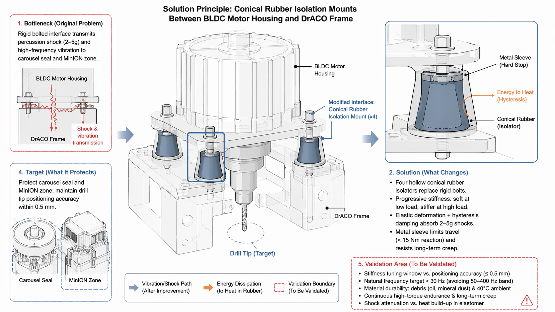

Original Bottleneck
Rigid bolted interface transmits percussion shock (2–5g) and high-frequency vibration: Shock and vibration propagate to carousel seal and MiniON zone.

Core Modification
Conical rubber isolation mounts (×4): Progressive stiffness — compliant enough to absorb shocks, stiff enough to maintain drill tip positioning accuracy within 0.5 mm.

Isolator Detail
Component | Function | Specification
Conical rubber (isolator) | Shock absorption & vibration damping | Progressive stiffness, hysteresis damping
Metal sleeve | Hard stop & creep resistance | Limits max displacement under 15 Nm torque reaction
Material | Nitrile rubber or fluorosilicone | Resistant to oil, mineral dust, 40°C ambient

System Impact
- Converts shock kinetic energy to heat via elastomer hysteresis
- Natural frequency tuned below 30 Hz (avoids 50–400 Hz vibration band)
- Maintains drill tip positioning accuracy within 0.5 mm for Raman/LIBS alignment
- Protects carousel seal and MiniON zone from percussion shock transmission

Validation Area (To Be Validated)
Validation Item | Description
Stiffness tuning window vs. positioning accuracy | ≤0.5 mm target
Natural frequency target | <30 Hz, avoiding 50–400 Hz band
Material durability | Debris (oil, mineral dust) & 40°C ambient
Continuous high-torque endurance & long-term creep | Under repeated percussion loads
Shock attenuation vs. heat build-up | In elastomer under continuous operation

Note: All are standard elastomer engineering tasks but require iterative prototyping and accelerated life testing.

