Passive Phase-Change Thermal Buffer Enclosure for MinION Temperature Stabilization
Date: 2026-07-20
Reference: Passive temperature-stable vehicle-mounted combined inertial navigation device
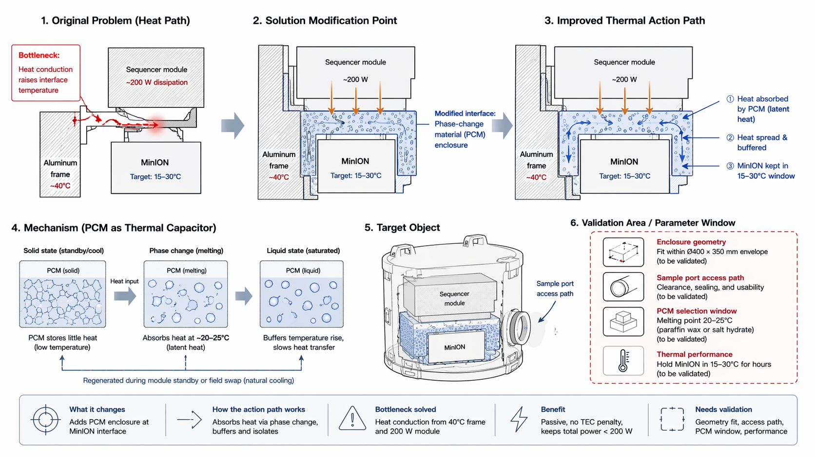
TRIZ: Field evolution: mechanical thermal conduction → phase-change latent heat absorption
Analysis Method: Substance-field analysis
Cross-domain application: Surround the MinION interface zone with a phase-change material enclosure (paraffin wax or salt hydrate with 20–25°C melting point) that absorbs heat via latent heat during phase transition.

Original Problem
Heat conduction raises interface temperature: Aluminum frame at ~40°C and sequencer module at ~200 W dissipation conduct heat to MinION, exceeding its 15–30°C target window.

Core Modification
Phase-change material (PCM) enclosure: Modified interface between aluminum frame and MinION.

Mechanism (PCM as Thermal Capacitor)
- Solid state (standby/cool): PCM stores little heat at low temperature
- Phase change (melting): Absorbs heat at ~20–25°C via latent heat
- Liquid state (saturated): Buffers temperature rise, slows heat transfer
- Regenerated during module standby or field swap (natural cooling)

Improved Thermal Action Path
- Heat absorbed by PCM (latent heat)
- Heat spread & buffered in PCM mass
- MinION kept in 15–30°C window for hours

System Impact
- Avoids 30–50 W TEC penalty
- Keeps total module power under 200 W
- Uses aerospace-proven passive thermal management materials
- Extends MinION stable window for hours without active cooling

Validation Area / Parameter Window
Parameter | Validation Need
Enclosure geometry | Fit within Ø400 × 350 mm envelope
Sample port access path | Clearance, sealing, and usability
PCM selection window | Melting point 20–25°C (paraffin wax or salt hydrate)
Thermal performance | Hold MinION in 15–30°C for hours

Note: Enclosure geometry and sample port access path need validation against Ø400×350mm envelope.

