Negative-Pressure Filtered Enclosure for MinION Dust Isolation
Date: 2026-07-20
Reference: Chip mounting device capable of being isolated from external environment
TRIZ: Field evolution: mechanical barrier → pressure gradient field with filtration
Analysis Method: Substance-field analysis
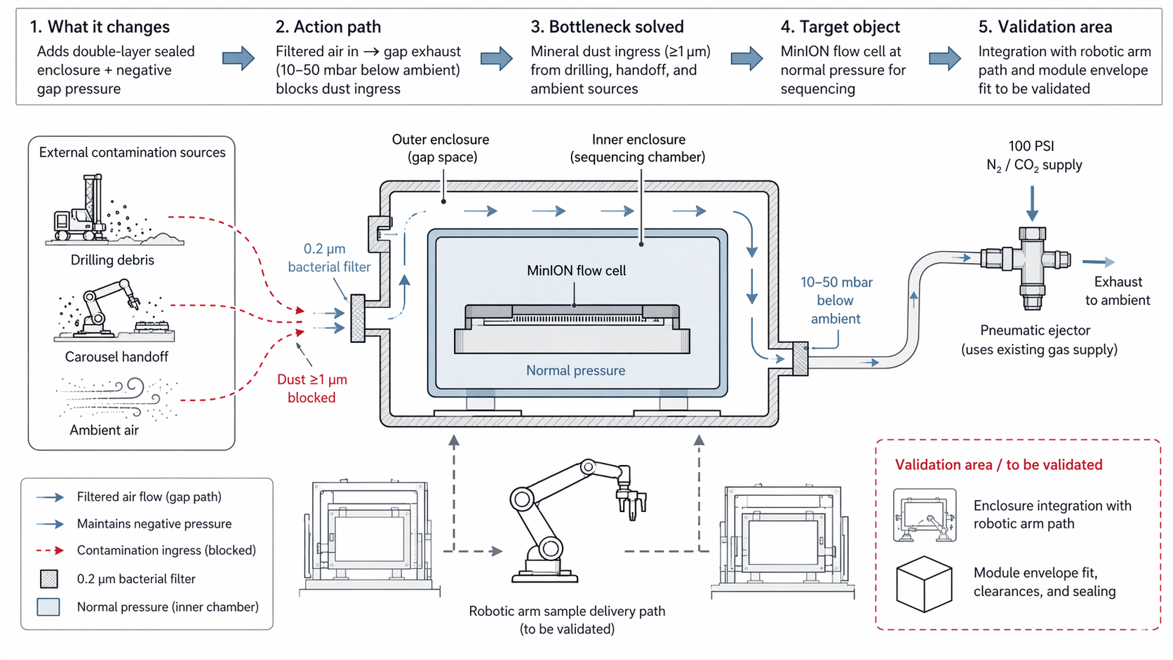
Cross-domain application: Create a double-layer sealed enclosure around the MinION interface with negative-pressure gap and bacterial filtration.

Original Problem
Mineral dust enters MinION flow cell: Contamination from drilling debris, carousel handoff, and ambient sources reaches the 1 nm flow cell.

Core Modification
Double-layer sealed enclosure + negative gap pressure: Inner layer houses flow cell at normal pressure; outer gap held at 10–50 mbar below ambient.

Action Path
- 0.2 µm bacterial filter on gap inlet allows only filtered air inflow
- Pneumatic ejector (existing 100 PSI N₂/CO₂ supply) maintains negative pressure
- Dust ≥1 µm blocked by pressure gradient and mechanical filtration
- MinION flow cell protected at normal pressure for sequencing

System Impact
- Leverages shared gas supply without adding active filtration power
- Uses proven semiconductor FOUP contamination control architecture
- Maintains zero cross-contamination for MinION
- No electrical power required for filtration

Validation Area (To Be Validated)
Parameter | Validation Need
Enclosure integration | With robotic arm sample delivery path
Module envelope fit | Clearances and sealing within Ø400 × 350 mm

Note: Enclosure integration with robotic arm path and module envelope fit need validation.

