Passive Condensation Pipe for MinION Humidity Control
Date: 2026-07-20
Reference: High-humidity stable incubator and high-humidity stable control method thereof
TRIZ: Field evolution: mechanical humidity barrier → thermal gradient condensation
Analysis Method: Substance-field analysis
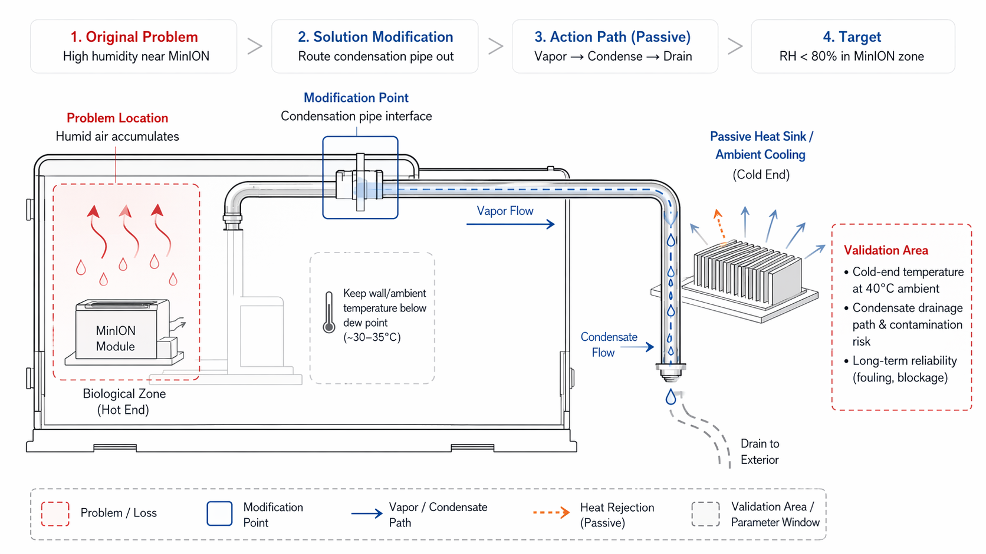
Cross-domain application: Route a condensation pipe from the MinION enclosure to the module exterior, with hot end in the biological zone and cold end exposed to passive heat sink or ambient cooling.

Original Problem
High humidity near MinION: Humid air accumulates in the biological zone, risking condensation damage to the sequencer.

Core Modification
Condensation pipe interface: Passive thermal gradient mechanism removes excess moisture.

Action Path (Passive)
- Vapor flows from hot biological zone to cold end
- Cold end temperature drops below dew point (~30–35°C in tropical conditions)
- Excess water vapor condenses on pipe interior
- Condensate drains externally
- MinION zone humidity reduced to <80% RH

System Impact
- Avoids active dehumidifier power consumption
- Stays within 200 W budget
- Passive thermal gradient — no moving parts
- Target: RH <80% in MinION zone

Validation Area
Parameter | Validation Need
Cold-end temperature | Achievable at 40°C ambient
Condensate drainage path | Avoid contamination risk
Long-term reliability | Fouling, blockage prevention

Note: Effectiveness depends on achieving sufficient cold-end cooling under worst-case 40°C ambient.

